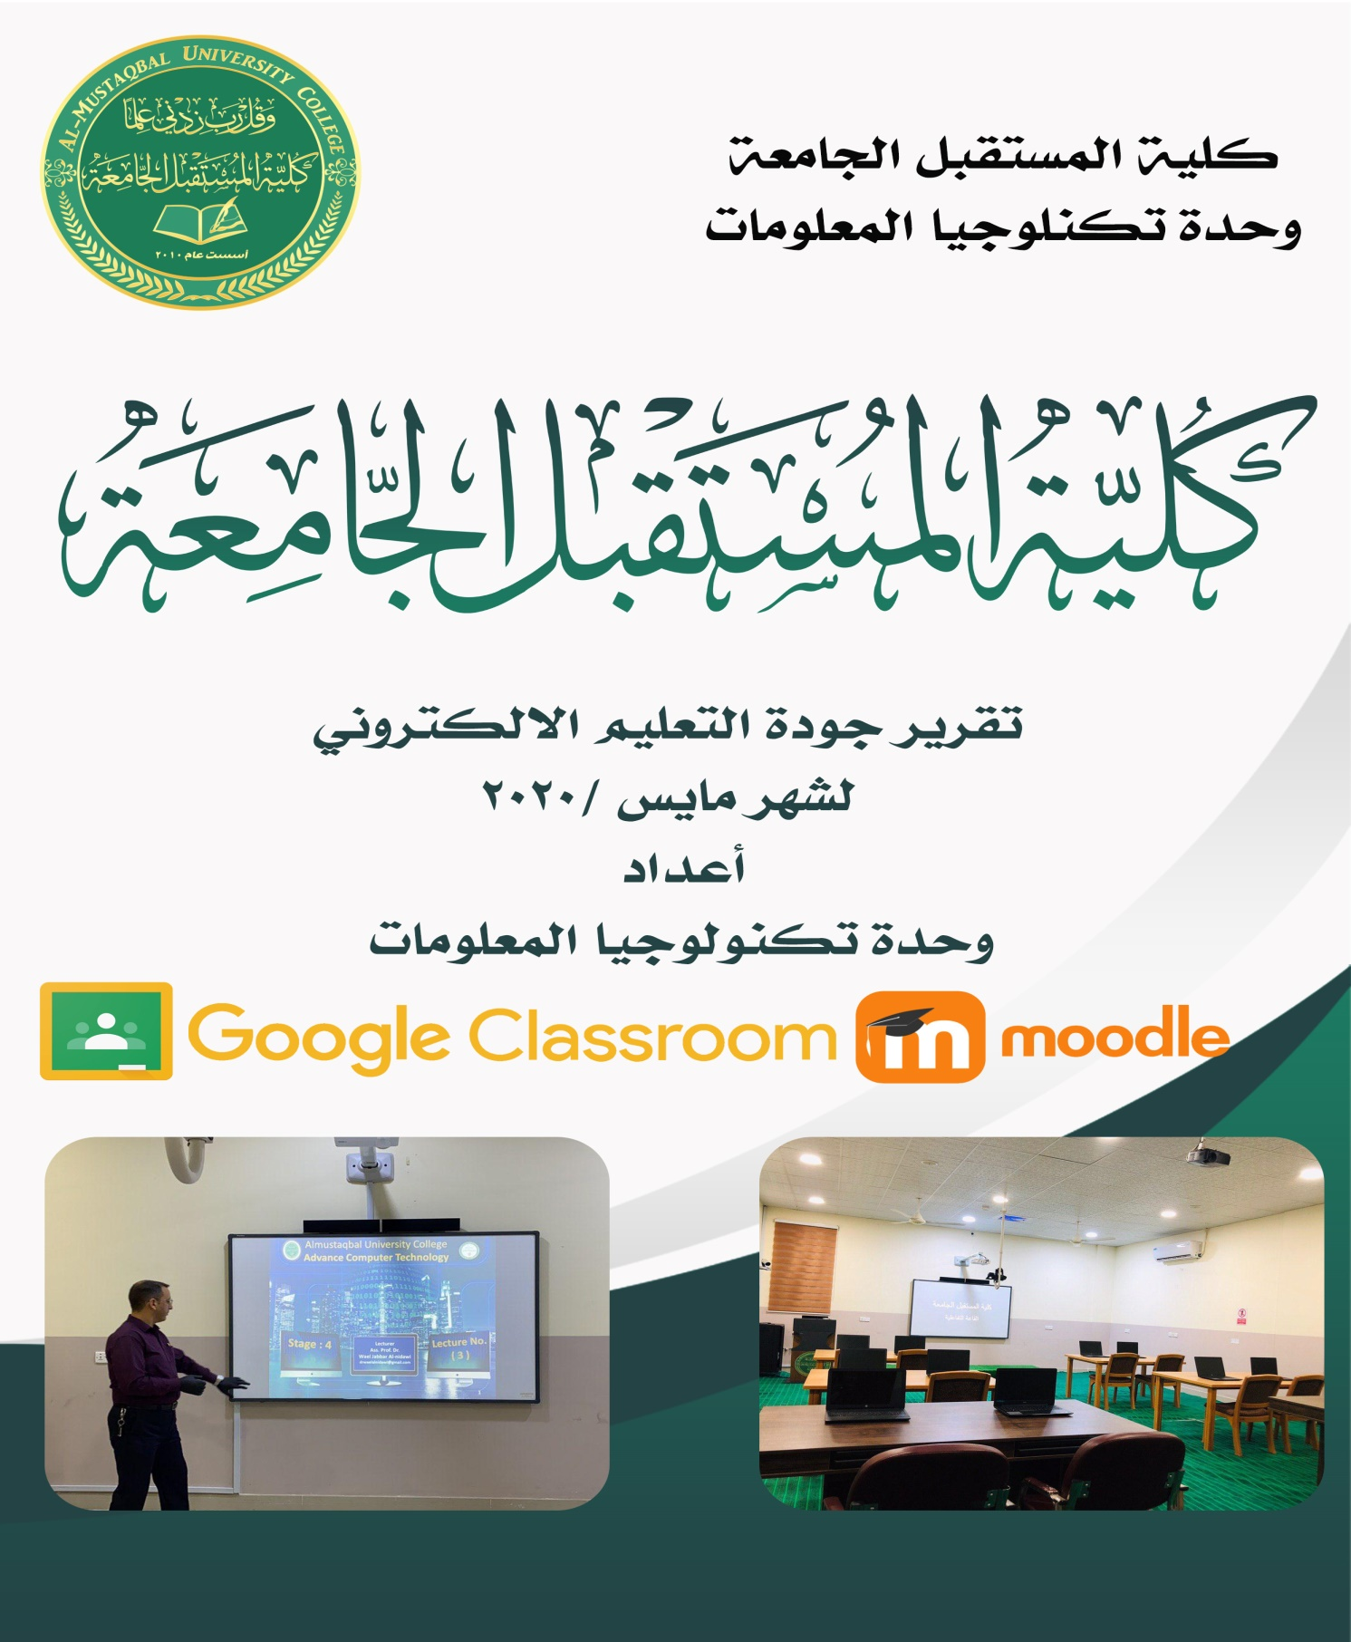
المقدمة
استنادا ً الى توجهيات معالي السيد وزير التعليم العالي والبحث العلمي في اعتماد التعليم الألكتروني في استكمال السنة الدراسية الحالية وتوصيات مجلس كلية المستقبل الجامعة برئاسة الأستاذ المساعد الدكتور ( حسن شاكر مجدي) .ومن اجل اكمال متطلبات الامتحانات الالكترونية ولاجل ضمان حقوق الطلبة وتوثيق كافة النشاطات والاعمال التي يوديها الطالب وتفاعله في المنصات والمحافظة على المستوى العلمي للطلبة. فقد باشرت وحدة تكنولوجيا المعلومات وباشراف مباشر من السيد العميد بعدد من الفعاليات لتعزيز جودة العملية التعليمية وكما يلي :-
- تم انشاء واكمال كافة عنوانين الطلبة والتدريسين على خدمات الكوكل والجيميل ( ( Gmail والاشتراك بالمنصة التعليمية واستخدام ( G suite for education ) للتعليم"، حيث يمكن للاساتذ إتاحة فرص التعلم باستخدام الادوات المجانية والامنة لادارة العملية التعليمة وتسهيل المهام الادارية . حيث يساعد الطلاب وأعضاء هيئة التدريس على أن يكونوا أكثر كفاءة وإنتاجية. وبفضل تكنولوجيا الواقع الافتراضي، يمكن لأعضاء هيئة التدريس والطلاب المشاركة في إنشاء تجارب شاملة واعداد التقارير والمشاركة في الاختبارات المتعددة . المخططـات ادناه ( 1.1 -1.7) توضح تفاعل الطلبة والتدريسين وتقدم العمل وجميع الانشطة والفعاليات الخاصة بالتعليم الالكتروني كما مؤشرة في منصة ال G suite for education. وكما نرفـــق نماذج ( فقرة 5) للاقسام وحسابات التدريسين على المنصة المذكورة وتفاعلهم مع الطلبة من خلال رفع الملفات الفديوية والاعلانات واجراء الاختبارات المتعددة والواجبات والتقرير وتعدد انواع الفعاليات الاخرى .
- لتعزيز تجربة كليتنا في مجال التعليم الالكتروني ومن اجل ادامة التواصل مع طلبتنا في ظل المرحلة الحالية ولتعزيز عملية التعليم باستخدام انظمة التعليم الالكتروني . باشرت وحدة تكنلوجيا المعلومات ووحدة التعليم الالكتروني بعقد سلسلة من الورش التدريبية للأقسام العلمية وانشاء الفديوهات التعليمية للطلبة وتشيكل فرق من المبرمجين لغرض حل المشاكل الفنية للطلبة والتدريسين . كما تم حث جميع الكوادر التدريسية والفنية والادارية بالمشاركة في الورش والدورات التي اقيمت من قبل الفريق الوزاري في مجال التعليم الالكتروني .
- اشارة الى توجيهات الوزارة بضرورة انشاء قاعات تفاعلية افتراضية في الجامعات والكليات . حيث ان الكلية اول الكليات التي نفذت قاعات افتراضية تفاعلية وقاعة ذكية تفاعلية لتسجيل المحاضرات الالكترونية .
- بناء على متطلبات تطبيق التعليم الالكتروني في الكورس الثاني ولغرض متابعة تنفيذ اليات تطبيق التعليم الالكتروني من قبل التدريسين والطلبة في الاقسام العلمية . ت تشكيل لجنة لاسناد ومتابعة جودة التعليم الالكتروني بموجب الامر الاداري) 456 ). ولغرض متابعة تنفيذ ومتابعة متطلبات التعليم الالكتروني والوقوف على اهم المشاكل والتحديات تم تعميم عدد من استمارات متابعة جودة التعليم الالكتروني كا ( استمارة حضور الطلبة ، استمارة متابعة وتوثيق جودة التعليم للاقسام ، استمارة خلاصة متابعة الطلبة الشهري ) مرفق ( نموذج 1 ،2 ،3 ) فقرة 4.1

- اشارة الى مؤشرات الاعتماد الوطني للتعليم الالكتروني في الجامعات والكليات العراقية نرفق اهم الموشرات والاحصائيات الخاصة بتنفيذ التعليم الالكتروني في كلية المستقبل الجامعة وكما يلي :

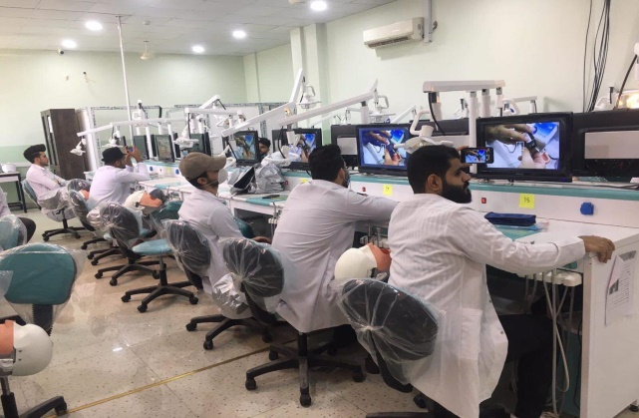
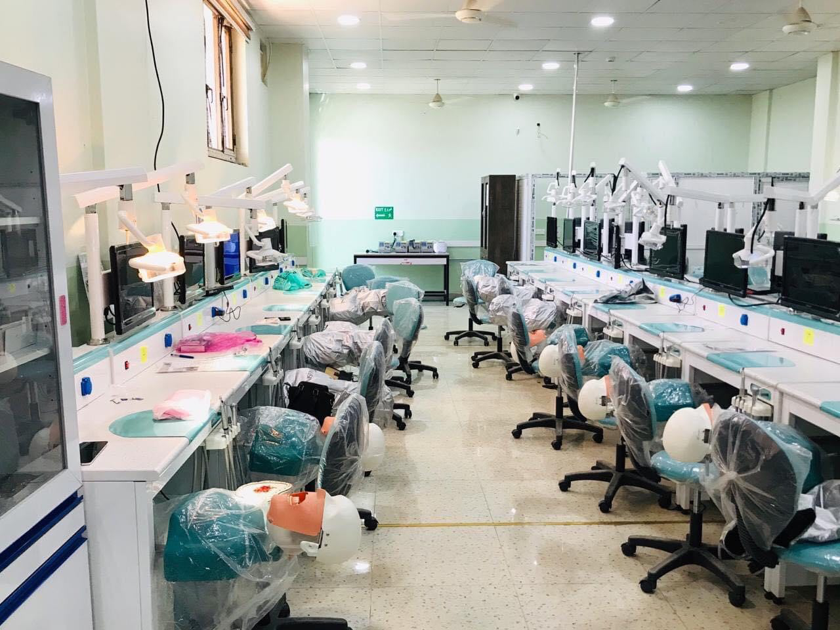
مختبر طب الاسنان ( الفانتوم )

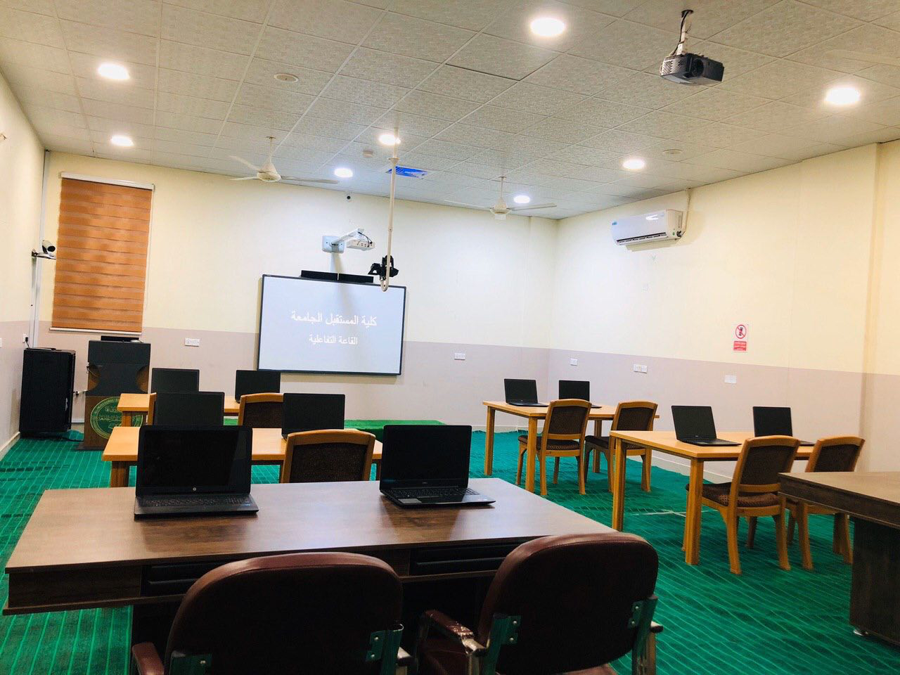
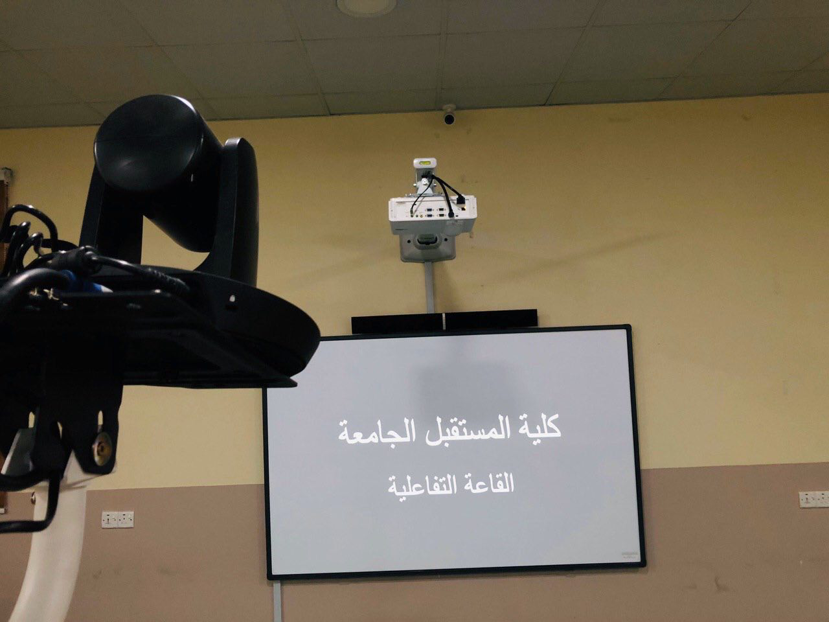
القاعة الذكية ( التفاعلية )

استمرار الديمومة المعرفية عبر التعليم الإلكتروني في المختبرات الهندسية
تنفيذا لتوجيهات عمادة كلية المستقبل الجامعة بالاهتمام بالجانب العملي ليكون مكملا للمعلومات النظرية ، نفذ التدريسي( د. حمزة محمد رضا يحيى )و(م. حنين مهدي صالح )من قسم هندسة الطب الحياتي سلسلة من المحاضرات الفيديوية للتجارب العملية في مختبر الإلكترونيات الرقمية بهدف التواصل العلمي والمعرفي مع طلبة المرحلة الثالثة في القسم المذكور.
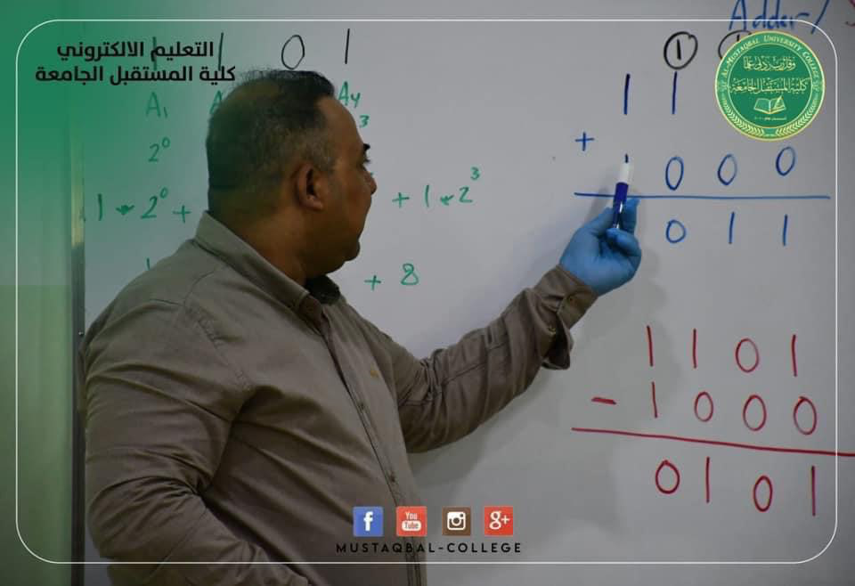

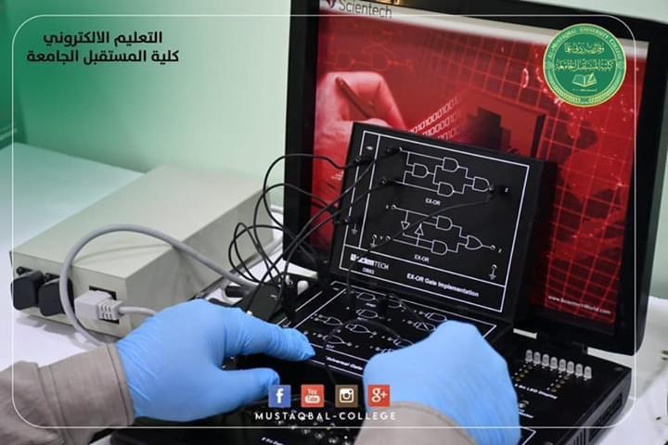
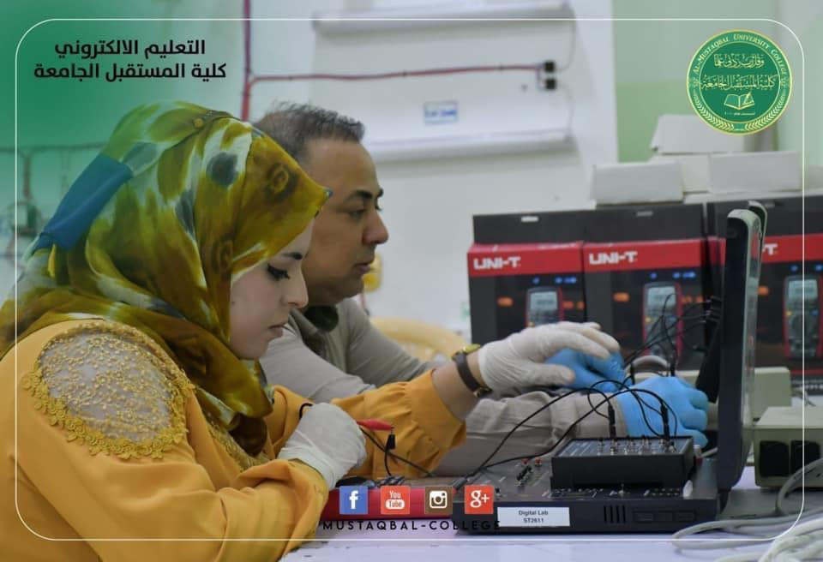

5.1الجدول ادناه يوضح ملخص احصائيات التعليم الالكتروني لكلية المستقبل الجامعة

نسبة عدد التدريسيين من اصحاب الصفوف الالكترونية التفاعلية في المؤسسة الواحدة
 | اسم المؤسسة التعليمية | عدد التدريسيين الكلي | عدد التدريسيين المستخدمين | نوع المنصة المستخمة | عدد الصفوف الافتراضية ضمن المؤسسة | النسبة المئوية | الملاحظات
 | كلية المستقبل الجامعة | 312 | 295 | Google classroom | 672 | 95% | لا يوجد
نسبة عدد الطلاب المتفاعلين في الصفوف الالكترونية التفاعلية في المؤسسة الواحدة
 | اسم المؤسسة التعليمية | عدد الطلاب الكلي | عدد الطلاب اصحاب العناوين الالكترونية الرسمية | عدد الطلاب الحقيقي في الصفوف الافتراضية | النسبة المئوية | الملاحظات
 | كلية المستقبل الجامعة | 10750 | 10471 | 10471 | 97% | لا يوجد
الموارد والمصادر التعليمية الالكترونية المفتوحة وجودة المورد

 | اسم المؤسسة التعليمية | عدد الموارد التعليمية المنتجة | عدد التدريسيين المنتجين | نوع الموارد التعليمية المنتجة | عدد الموارد التعليمية الالكترونية | النسبة المئوية | الملاحظات
 | كلية المستقبل الجامعة | 4 | 305 | , PDF, DOC PPT, video | 10375 | 100% | لا يوجد
البنى التحتية البرمجية للمؤسسة التعليمية ادارة تعلم – ادارة طلاب
 | اسم المؤسسة التعليمية | نوع البنى التحتية البرمجية | عدد التدريسيين المستفيدين | عدد الطلاب المستفيدين | النسبة المئوية  للاعتماد في المؤسسة | الملاحظات
 | كلية المستقبل الجامعة | Google classroom & moodle | 295 | 10471 | 100% | لا يوجد
البنى التحتية للمؤسسة التعليمية المادية والشبكات
 | اسم المؤسسة التعليمية | التوصيف والملاحظات
 | كلية المستقبل الجامعة | تمتلك الكلية شبكة داخلية مطورة باستخدام نظام الكيبل الضوئي موزعة على جميع بنايات الكلية ومركز معلومات يحوي الانظمة الكترونية الخاصة بالطلبة نظام الموارد البشرية وكذلك الكلية مسجلة ضمن G Suite for Education وكل طالب سيمتلك بريد الكتروني خاص بالكلية.
الابتكارات التعليمية الالكترونية والتطوير والتعلم مدى الحياة
 | اسم المؤسسة التعليمية | نوع البرامجيات التطويرية | عدد التدريسيين المستفيدين | عدد الطلاب المستفيدين | النسبة المئوية  للاعتماد في المؤسسة | الملاحظات
 | كلية المستقبل الجامعة | coursera | 100 | 2000 | 10% | لا يوجد

  - المخطط رقم (1) يبين عدد التدريسيين المفعلين للتعليم الالكتروني مقارنة بالعدد الكلي لكل قسم

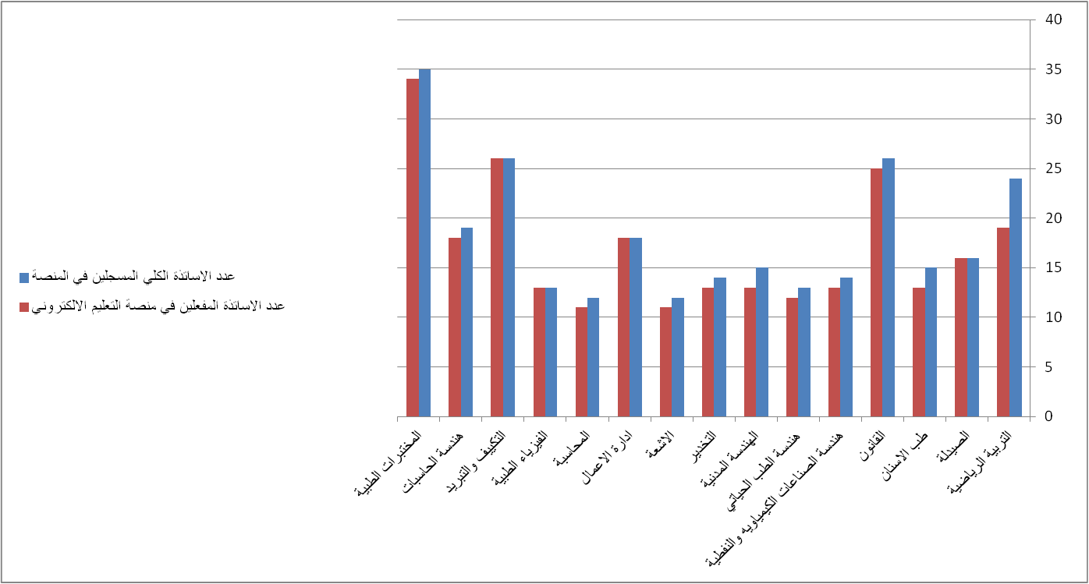

  - مخطط رقم (2 ) يبين نسبة تزايد عدد الصفوف الالكترونية خلال انطلاق الكورس الثاني
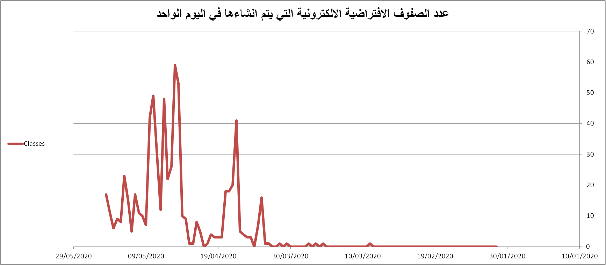
  - مخطط رقم ( 3) يوضح عملية زيادة مستوى تفاعل الاساتذه مع المنصة منذ انطلاق الكورس الثاني في شهر شباط ولحد تاريخ هذا اليوم
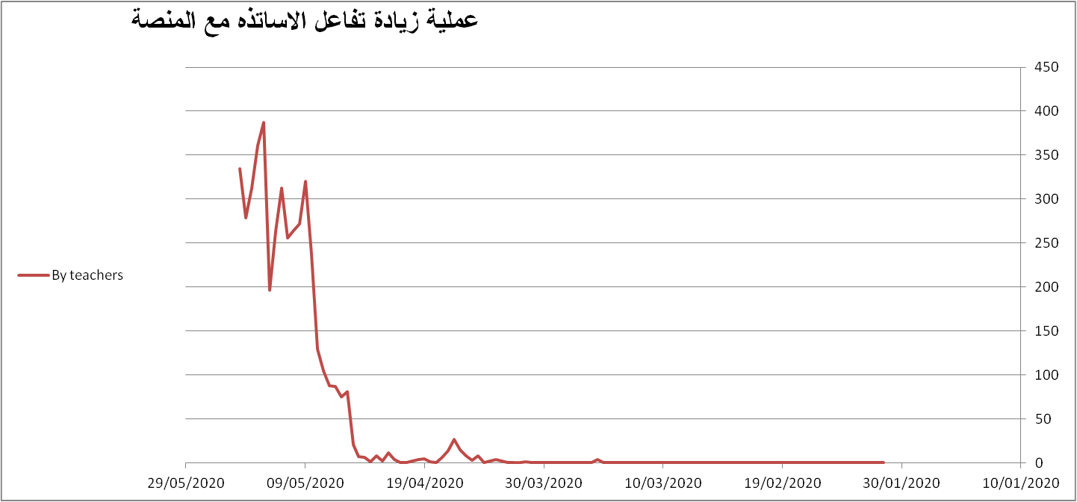
  - مخطط رقم (4) يوضح مستوى تفاعل الطلبة مع المنصة منذ انطلاق الكورس الثاني في شهر شباط ولحد تاريخ هذا اليوم
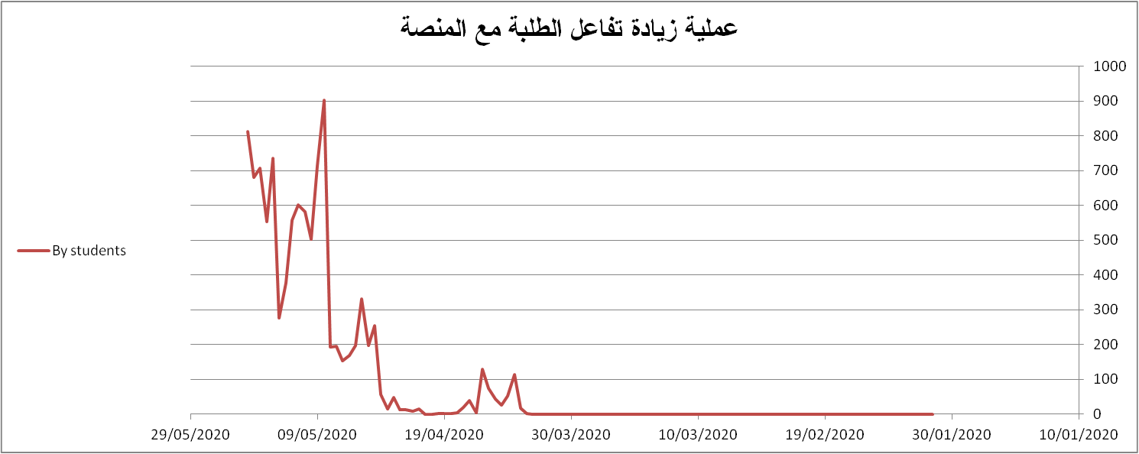

  - مخطط رقم (5) يوضح عملية زيادة عدد الصفوف الفعالة مع المنصة منذ انطلاق الكورس الثاني في شهر شباط ولحد تاريخ هذا اليوم

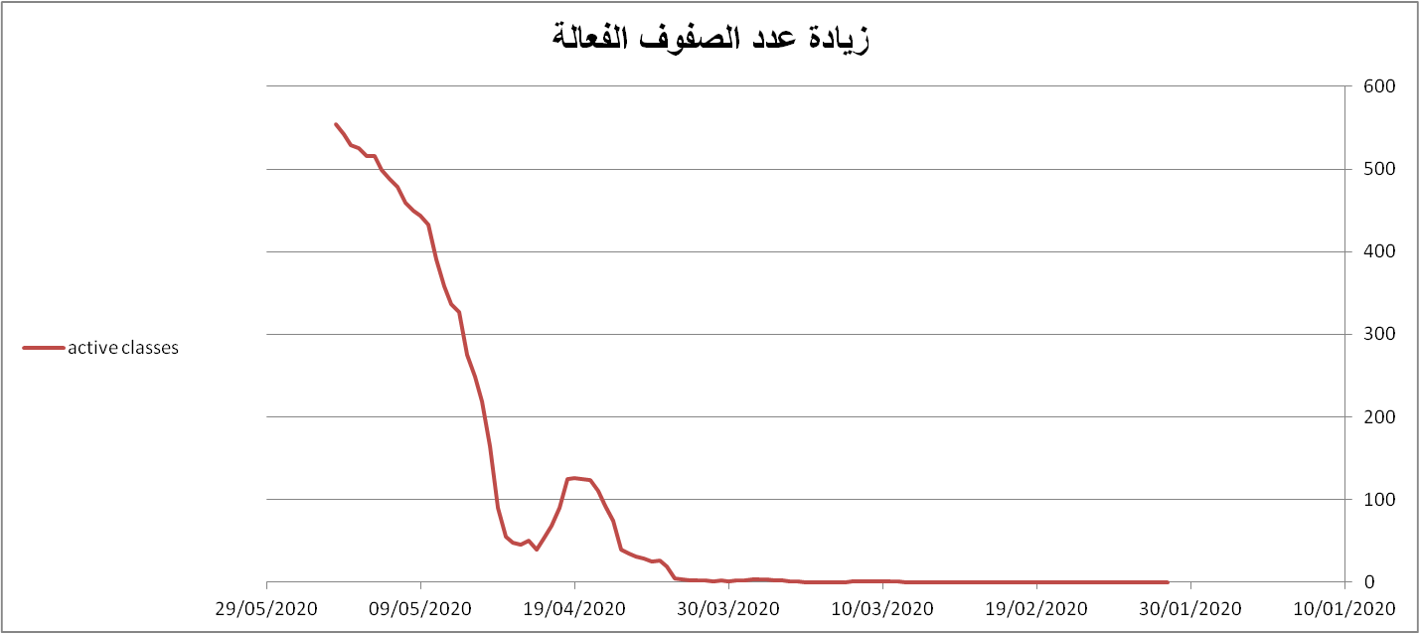

  - مخطط رقم (6) يوضح المنصات المعتمدة من قبل الكادر التدريسي حيث ان معظم الكادر كان يستخدم منصة ( Google classroom ) وحسب راي التدريسين ان استخامهم لتلك المنصة لكون الطلبة يفضلونها كونها سهلة الاستخدم مع ضعف ورداءة الانترنت
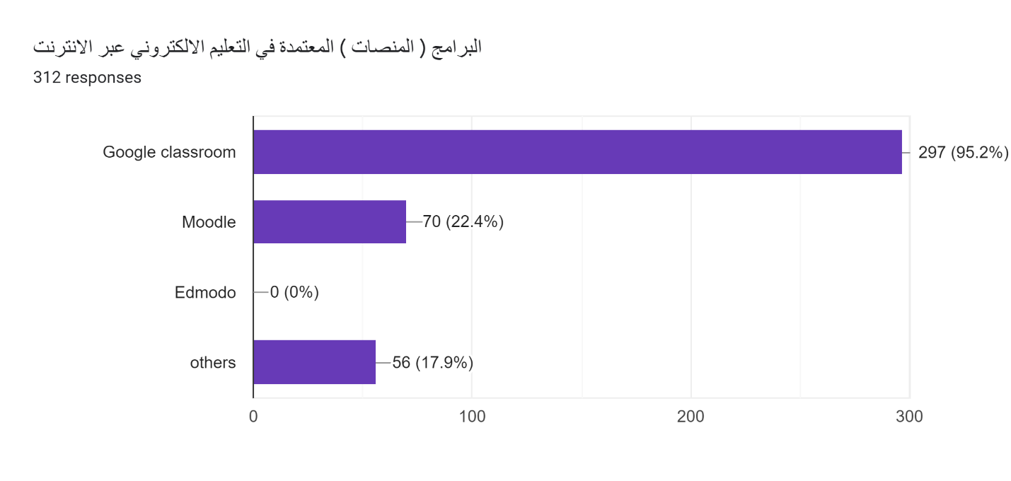
  - مخطط رقم (7) يوضح نسبة التواصل الالكتروني بين الاساتذة والطلاب حيث كانت نسبة التواصل الالكتروني مع الطلبة هي :67% وعدم التواصل :33%
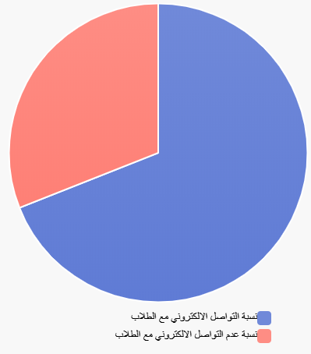

4.1 الاجراءات المتبعة من قبل الكلية لتنفيذ الية تطبيقة التعليم الالكتروني:
تم اصدار امر اداري لجودة التعليم الالكتروني لغرض المتابعة والاشراف على سير العملية التعلمية والوقوف على اهم المشاكل والتحديات التي تواجه التدريسين والطلبة حيث تقوم اللجنة بالتالية :
- متابعة تفاعل الطلبة مع الصفوف الالكترونية والاساتذة والاستجابة في حل مشاكلهم عن طريق ممثلين الاقسام.
- متابعة تنفيذ المحاضرات الالكترونية التفاعيلة حسب الجدوال المعد للتدريسين وحسب الايام والاوقات.
- التدريب وعمل الورشة التعليمية للكادر التدريسي والطلبة في مجال التعليم الالكتروني
- عقد الاجتمعات الدورية من قبل العمادة مع ممثلي الجودة والتعلييم الالكتروني للوقوف على اهم المشاكل والتحديات التي توجهة تنفيذ الية تطبيق التعليم الالكتروني
- حديد الاحتياجات التدريبية للكادر التدريسي في مشاريع التعليم اإللكتروني ( نظام إدارة التعلم، أجهزة العرض التفاعلي، المحتوى االالكتروني، . الخ) من خالل الاستبانات الالكترونية
- تقديم الدعم المستمر للتدريسين والطالب وتوجيهم دائما نحو الاستخدام المناسب لاستخدام المنصات التعليمية
- اعداد وتقديم التقاير الاسبوعية والشهرية لمتابعة جودة التعليم الالكترونية وكما مرفق نماذج واستمارات المتابعة اليومية والاسبوعية والشهرية ( نموذج 4.1، 4.2 ،4.3 ) .

نموذج ( 4.1) تقرير المتابعة الالكترونية لقسم طب الاسنان للفصل الدراسي الثاني لشهر ايار 2020

اسم التدريسي واللقب العلمي | القسم الدراسي | المرحلة الدراسية | اسم المادة الدراسية | نوع المادة الدراسية | نوع المنصة الالكترونية المستخدمة | نوع المحاضرة | عنوان المحاضرة المنجز | وقت المحاضرة | تاريخ المحاضرة | نسبة الانجاز من المنهج الكلي | عدد الطلبة الكلي | عدد الطلبة الحضور | نوع التقييم ان وجد
ا. م. د. احمد محمد عباس | طب الاسنان | الثانية | الانسجة العامة | نظري | Google classroom | Pdf, Video | الجهاز العصبي | 12:00:00 PM | 5/18/2020 | 50 | 170 | 100 | اختبار يومي
ا.م. د. احمد محمد عباس | طب الاسنان | الثانية | الانسجة العامة | عملي | Google classroom | Pdf, Video | الجهاز العصبي | 4:00:00 PM | 5/18/2020 | 50 | 170 | 100
أ.د.عذراء يحيى محمد | طب الاسنان | الثانية | Oral histology | نظري | Google classroom | Pdf, Video | Alveolar process | 2:04:00 PM | 9/5/2020 | 40 | 170 | 148 | اختبار يومي
أ.د.عذراء يحيى محمد | طب الاسنان | الثانية | Oral histology | عملي | Google classroom | Video | Alveolar bone | 3:04:00 AM | 9/5/2020 | 40 | 170 | 148 | اختبار يومي
ضحى مالك حسن | طب الاسنان | الثانية | ماده سنيه | عملي | Google classroom | Pdf, power point, Video | CEMENTS | 4:18:00 PM | 5/3/2020 | 35 | 170 | 170 | اختبار يومي
م د.ضحى مالك | طب الاسنان | الثانية | DENTAL MATERIAL | نظري | Google classroom | Pdf, power point, Video | سمنت | 2:16:00 PM | 5/10/2020 | 35 | 170 | 100 | اختبار يومي
م د.ضحى مالك حسن | طب الاسنان | الثانية | ماده سنيه | عملي | Google classroom | Pdf, power point, Video | سمنت | 4:18:00 PM | 5/10/2020 | 35 | 170 | 100 | اختبار يومي
م د.ضحى مالك حسن الخفاجي | طب الاسنان | الثانية | ماده سنيه | نظري | Google classroom | Pdf, power point, Video | سمنت | 2:16:00 PM | 5/3/2020 | 35 | 170 | 100 | اختبار يومي
م. د فرح باقر احمد الفاضلي | طب الاسنان | الأولى | اللغة العربية | نظري | Google classroom | Pdf, Video | اقسام الكلام | 12:00:00 PM | 5/16/2020 | 10% | 288 | 203 | واجب بيتي
م. د فرح باقر احمد الفاضلي | طب الاسنان | الأولى | لغة عربية | نظري | Google classroom | Pdf, Video, other | الفعل الماضي | 9:00:00 PM | 5/21/2020 | 30% | 288 | 245 | واجب بيتي
م. د. عماد الرفاعي | طب الاسنان | الثانية | التشريح العام | نظري | Google classroom | Pdf, Video, other | Major salivary glands II | 12:00:00 PM | 5/14/2020 | 35 | 165 | 56
م. د. عماد الرفاعي | طب الاسنان | الثانية | التشريح العام | عملي | Google classroom | Pdf, Video, other | Major salivary glands II | 12:00:00 PM | 5/14/2020 | 35 | 165 | 56
م. د. عماد الرفاعي | طب الاسنان | الثالثة | جراحة الفم والوجه والفكين | نظري | Google classroom | Pdf, Video | Local anesthesia: maxillaty techniques | 12:00:00 PM | 10/5/2020 | 33 | 112 | 70
م. د. عماد الرفاعي | طب الاسنان | الثالثة | جراحة الفم والوجه والفكين | عملي | Google classroom | Pdf, Video | Local anesthesia: maxillary techniques | 12:00:00 PM | 10/5/2020 | 33 | 112 | 70
م.د ندى حسن حسين | طب الاسنان | الأولى | medical chemistry | نظري | Google classroom | power point, Video | inorganic chemistry | 2:04:00 PM | 5/10/2020 | 40 | 288 | 200 | اختبار يومي
م.د ندى حسن حسين | طب الاسنان | الأولى | medical chemistry | عملي | Google classroom | Pdf, Video | preparation of different types of solution | 4:06:00 PM | 5/10/2020 | 45 | 288 | 200 | اختبار يومي
م.د.رواءماجد محمد | طب الاسنان | الثالثة | Microbiology | نظري | Google classroom | Pdf, power point, Video | Bacterial classification | 2:30:00 AM | 5/1/2020 | 20 | 119 | 78 | اختبار شهري
م.م : سجاد ثامر كاظم الخفاجي | طب الاسنان | الأولى | حقوق الانسان | نظري | Google classroom | Pdf, power point | تعريف حقوق الانسان ومميزات الشخصية الطبيعية | 2:30:00 PM | 5/16/2020 | 20% | 294 | 233 | لايوجد
م.م : سجاد ثامر كاظم عبد | طب الاسنان | الأولى | حقوق انسان | نظري | Google classroom | Pdf, power point | مميزات الشخصية الطبيعية | 3:00:00 PM | 5/23/2020 | 20% | 294 | 233 | لايوجد
م.م د ضحى مالك حسن | طب الاسنان | الثانية | الماده السنيه | نظري + عملي | Google classroom | Pdf, power point, Video | filling materials (amalgum) | 2:18:00 PM | 5/17/2020 | 60% | 170 | 170 | اختبار شهري
م.م سهى عبد الحسين | طب الاسنان | الأولى | COMPUTER | عملي | Google classroom | Pdf, Video | MICROSOFT EXEL | 2:00:00 PM | 5/12/2020 | 30 | 285 | 273
م.م سهى عبد الحسين | طب الاسنان | الأولى | computer | نظري | Google classroom | Pdf, Video | device manager servicesand applications | 2:00:00 PM | 5/12/2020 | 30 | 285 | 273 | اختبار يومي
م.م عطاء خليل حسين | طب الاسنان | الأولى | Medical biology | نظري | Google classroom | Pdf, Video | Histology | 2:30:00 PM | 5/9/2020 | 40 | 299 | 243 | اختبار يومي
م.م عطاء خليل حسين | طب الاسنان | الأولى | احياء طبيه | نظري | Google classroom | Pdf, Video | Connective tissue | 2:30:00 PM | 5/16/2020 | 50% | 288 | 242 | اختبار يومي
م.م علي جهاد حميد | طب الاسنان | الثالثة | Pharmacology | نظري | Google classroom | Pdf, Video | Antihistamine | 8:30:00 PM | 5/11/2020 | 10 | 119 | 100
م.م علي جهاد حميد | طب الاسنان | الثالثة | Pharmacology | عملي | Google classroom | Pdf, Video | Local Anesthetics | 8:30:00 PM | 5/13/2020 | 10 | 119 | 100
م.م علي جهاد حميد | طب الاسنان | الثالثة | Pharmacology | عملي | Google classroom | Pdf, Video | Local Anesthetics | 8:30:00 PM | 5/13/2020 | 10 | 119 | 100
م.م علي جهاد حميد | طب الاسنان | الثالثة | Pharmacology | نظري | Google classroom | Pdf, Video | Anti-inflammatory Analgesics and Antipyretics Drugs | 4:00:00 PM | 5/20/2020 | 30% | 119 | 119 | اختبار شهري
م.م علي جهاد حميد | طب الاسنان | الثالثة | Pharmacology | عملي | Google classroom | Pdf, Video | Non Steroidal Anti-inflammatory Drugs Application | 8:00:00 PM | 5/20/2020 | 30% | 119 | 119 | اختبار شهري
م.م نور فتحي كاظم | طب الاسنان | الثالثة | Dental radiology | نظري | Google classroom | Pdf, Video, other | Extra oral radiographic techniques | 4:00:00 PM | 7/6/2020 | 15 | 119 | 99 | اختبار يومي
م.م. دعاء عادل عبود | طب الاسنان | الأولى | احياء طبية | عملي | Google classroom | Pdf, power point, Video | Connective tissue | 4:06:00 PM | 5/16/2020 | 50% | 288 | 216 | اختبار شهري
م.م. دعاء عادل عبود | طب الاسنان | الأولى | احياء طبية | عملي | Google classroom | Pdf, power point, Video | Histology | 4:00:00 PM | 5/9/2020 | 40 | 223 | 66 | اختبار شهري
م.م. ذوالفقار احمد حمزه | طب الاسنان | الثانية | Biochemistry | نظري + عملي | Google classroom | Pdf, power point | Vitamins | 2:04:00 PM | 5/20/2020 | 40% | 170 | 143 | اختبار يومي
م.م. عمار هادي شعلان | طب الاسنان | الثالثة | Community dentistry | نظري | Google classroom | Pdf, power point, Video | Primary health care | 4:00:00 PM | 5/15/2020 | 40 | 120 | 110 | اختبار يومي
م.م. نور فتحي كاظم | طب الاسنان | الثالثة | Dental radiology | نظري | Google classroom | Pdf, Video, other | Common disease of teeth and supporting structure | 4:00:00 PM | 4/30/2020 | 20 | 119 | 98 | اختبار يومي
م.م. نور فتحي كاظم | طب الاسنان | الثالثة | Dental radiology | عملي | Google classroom | power point, Video, other | محاضرة اشعة عملي ١&٢ | 8:00:00 PM | 5/14/2020 | 10 | 119 | 90
م.م. نور فتحي كاظم | طب الاسنان | الثالثة | Dental radiology | نظري | Google classroom | Pdf, other | Digital radiology | 4:00:00 PM | 5/14/2020 | 30 | 119 | 95 | اختبار يومي
م.م.ذوالفقار احمد حمزه | طب الاسنان | الثانية | Biochemistry | نظري | Google classroom | Pdf, power point | Detoxication | 2:04:00 PM | 5/13/2020 | 30 | 172 | 95 | اختبار يومي
م.م.ذوالفقار احمد حمزه | طب الاسنان | الثانية | Biochemistry | عملي | Google classroom | Pdf, power point | Total cholesterol test | 4:06:00 PM | 5/13/2020 | 35 | 172 | 95 | اختبار يومي
م.م.عمار هادي شعلان | طب الاسنان | الأولى | اخلاق طبية | نظري | Google classroom | Pdf | مقدمة عن الأخلاق الطبية | 4:00:00 PM | 5/11/2020 | 30 | 288 | 250 | اختبار شهري
م.مخلد لؤي | طب الاسنان | الأولى | التشريح الاسنان | نظري | Google classroom | Pdf, power point, Video | permanent premolars | 2:00:00 PM | 5/14/2020 | 85 | 288 | 80 | اختبار يومي

نموذج ( 4.2 ) استمارة تسجيل حضور الطلبة الخاصة في لجنة تسجيل الحضور لشهر ايار 2020
استمارة تسجيل حضور الطلبة الخاصة في لجنة تسجيل الحضور لشهر ايار
ت | اسم التدريسي واللقب العلمي | اسم المادة الدراسية | نوع المادة (نظري -عملي) | المرحلة الدراسية | سجل أسماء المحاضرة الاولى | سجل أسماء المحاضرة الثانية | سجل أسماء المحاضرة الثالثة | سجل أسماء المحاضرة الرابعة | سجل أسماء المحاضرة الخامسة | الملاحظات
1 | د. نور هادي عيسى | فيزياء طبية | عملي | الاولى | تم | تم | تم
2 | د. علي كاظم محمد | حاسوب | نظري | الاولى | تم | تم | تم
3 | د. مروة كاظم خضير | انسجة | نظري | الاولى | تم | تم
4 | م.م سجاد ثامر | حقوق انسان | نظري | الاولى |  |  | تم |  |  | المحاضرة رقم 1 و2 تم انجازها من قل م.م افراح عباس
5 | م.م ضحى عدنان محمود | كيمياء عضوية | نظري +عملي | الاولى | تم | تم | تم | تم
6 | م.م امجد كاظم عبيد | اللغة الانكليزية | نظري | الاولى | تم | تم | تم
7 | م.م اشرف عيسى محمود | تشريح بشري | نظري +عملي | الاولى | تم | تم | تم | تم
8 | م.م احمد مجيد موسى | حسابات صيدلانبة | نظري +عملي | الاولى | تم | تم | تم | تم | تم
9 | م.م مريم احمد علي | histology | عملي | الاولى |  | تم | تم |  |  | كانت هناك محاضره 1 تم القائها على برنامج الcall free conference بتاريخ 5/5/2020 لعدم حصولي على الايميل الرسمي في وقتها
10 | د.وليد عبد |  |  |  |  |  |  |  |  | منسب من قسم اخر وليس لديه كلاس روم
11
13 | د. جبار فرج الوكيل | صيدلة فيزياوية | نظري | الثانية | تم | تم | تم
14 | د. فاطمة عدنان علي | عقاقير | نظري | الثانية | تم | تم | تم
15 | د. شيماء منذر محمد | فسلجة | نظري عملي | الثانية | تم | تم | تم
16 | د. مروة كاظم خضير | طفيليات وفايروسات | نظري | الثانية | تم | تم | تم | تم
17 | د. صابرين فرحان جواد | كيمياء عضوية | نظري +عملي | الثانية | تم | تم | تم
18 | م.م امجد كاظم عبيد | اللغة الانكليزية | نظري | الثانية | تم | تم | تم
19 | م.م الاء سلمان حسين | صيدلة فيزياوية | عملي | الثانية | تم | تم | تم
20 | م.م مريم احمد علي | طفيليات وفايروسات | عملي | الثانية |  | تم | تم |  |  | كانت هناك محاضره 1 تم القائها على برنامج الcall free conference بتاريخ 3/5/2020 لعدم حصولي على الايميل الرسمي في وقتها
21 | م.م زهراء ابراهيم جواد | عقاقير | عملي | الثانية | تم | تم |  |  |  | تاخير المحاضره وذلك بسبب تاخير الايميل بسبب عطل فني

نموذج ( 4.3) استمارة متابعة حضور الطلبة
كلية المستقبل الجامعة |  |  |  |  |  | اسم التدريسي : د . ازهر محسن عبد
القسم : هندسة التكييف والتبريد |  |  |  |  |  | اسم المادة طاقة متجددة
المرحلة : الرابعة مسائي |  |  |  |  |  | نوع الدراسة : سنوي
استمارة متابعة حضور الطلبة لشهر ايار 2020
ت | اسم الطالب | عدد ساعات االمحاضرة = |  |  |  | درجة الاختبار
 |  | يكتب تاريخ الماحاضرة 1 | يكتب تاريخ الماحاضرة 2 | يكتب تاريخ الماحاضرة 3 | يكتب تاريخ الماحاضرة 4 | Q1 | Q2 | Q3
1 | احمد جبار موسى اعكاشي
2 | احمد جلاوي كريم ظاهر
3 | احمد طالب جاسم جودي
4 | احمد عبد الحسن محمد عبد الخضر
5 | احمد علي جابر علي
6 | احمد فاضل عباس نعمة
7 | احمد فلاح حسن علوان
8 | الحسين عباس حسن ناجي
9 | امير ابراهيم حسن عبد الثامر
10 | امير سعود هاتف عبد الله
11 | امير محمد فرحان طعان
12 | اياد كاظم صالح حسين
13 | ثامر فليح جبر شبيب
14 | جبار ثجيل حمادي فياض
15 | حسام جابر يوسف عمران
16 | حسام سعدون عباس حسن
17 | حسام يوسف حسين سلمان
18 | حسن شاكر حديد حسن
19 | حسن كريم كاظم مصحب
20 | حسن مجيد حسن معين
21 | حسين احمد علي حسن
22 | حسين علي كنيش مطلوب
23 | حيدر حاكم كاظم هريبد
24 | حيدر عباس علي محمد
25 | حيدر محمد علي مجيد علي
26 | رعد احمد عبد كاظم
27 | رعد دوهان عويز ساجت
28 | رعد عبد الهادي جاسم عبيس
29 | رعد محمد عبيد شاطي
30 | سامر عدنان عبد الامير كريم
31 | سعد ناظم لفتة حسون
32 | سمير سعد رحيم حسين
33 | صادق حسن شراثي سمرمد
34 | صفاء حسين فاضل جاسم
35 | صفاء فلاح عليوي جاسم
36 | عبد الرسول عجمي عنيد مجلي
37 | عدنان فرحان عيسى جلاب
38 | علاء حسين علي عبد
39 | علي احمد مهدي حبيب
40 | علي جواد هادي حسن
41 | علي رهك كاظم عمران
42 | علي عادل محسن عبدالحسين
43 | علي عبد الالة سلمان عباس
44 | علي عبد الشهيد يحيى علي
45 | علي محسن محي صالح
46 | فراس عبد الرحيم راضي حسين
47 | قاسم عبد الكريم عبيد خضير
48 | قائد ناجي حسن كاظم
49 | كرار عبد الجبار هاشم حبيب
50 | مثنى تمكين شداد هاوي
51 | مثنى حامد هاتف عباس
52 | مجدي سامي فاضل عمران
53 | محمد شاكر محمد طاهر
54 | محمد فيصل عبد الحسين جودي
55 | محمد ليث شاكر عبد الجبار
56 | محمد مهدي اسماعيل محمود
57 | مروة صفاء هادي عبود
58 | مسار عادل عبد زيد نصار
59 | مصطفى محمد رضا مهدي
60 | مظفر محمد نعمة عودة
61 | وسام عبد الحسن محمد سلمان
62 | ولاء عبد الرضا جابر نجم
63 | وليد مجباش شهد كبيح
64 | ياسر علي شاكر نصر
65 | يحيى مجيد حميد كاظم
عدد حضور الطلبة |  | 32 | 41 | 39
نسبة حضور الطلبة
ملاحضة / يتم تاشير حالة الطالب وفق الاتي :
اللون الأخضر يمثل (الحضور )
اللون الأصفر يمثل (متقطع )
اللون الأحمر يمثل (غياب )

5.1 تقرير وحدة التعليم الالكترونية من لوحة التحكم المركزية لمنصة التعليم الالكترونية ( G Suite for Education ) والتي توضح عدد الطلبة المتفاعلين مع الصفوف الالكترونية وعدد المحتويات الوجبات والتبليغات التي نفذها التدريسي خلال الفصل الدراسي الثاني – لشهر ايار 2020

جدول ( 5.1 ) تقرير استخدام منصة ( Google classroom ) لقسم هندسة تقنيات التكييف والتبريد

Creation Date & Time | Owner Organization | Class Owner Email (Teacher) | Course Name | No of students | No of assignments | No of Announcements
2020-05-02T18:23:45.100Z | Department of Air Conditioning and Refrigeration Techniques  Techniques | AbdulKareem.Abdulwahab@mustaqbal-college.edu.iq | الرسم الهندسي | 113 |  | 19
2020-04-19T11:22:19.185Z |  | AbdulKareem.Abdulwahab@mustaqbal-college.edu.iq | Fluid Mechanics 2 | 101 |  | 15
2020-05-12T23:14:57.949Z |  | atheersaleh@mustaqbal-college.edu.iq | Thermodynamics 2 ( Lab.) | 99
2020-04-07T15:24:34.674Z |  | atheersaleh@mustaqbal-college.edu.iq | تحليلات هندسية | 116 | 3 | 6
2020-04-07T15:18:49.185Z |  | atheersaleh@mustaqbal-college.edu.iq | Thermodynamics 2 | 103 |  | 5
2020-04-06T06:58:54.952Z |  | azhermuhson@mustaqbal-college.edu.iq | Renewable energy | 71 | 7 | 29
2020-04-10T21:04:48.733Z |  | dr.alihamzaalwan22@mustaqbal-college.edu.iq | Power Plants 2 | 65 |  | 7
2020-05-09T10:59:09.761Z |  | dr.athraa.al-abbasy@mustaqbal-college.edu.iq | Heat Transfer Laboratory | 117 |  | 2
2020-05-09T10:48:47.439Z |  | dr.athraa.al-abbasy@mustaqbal-college.edu.iq | مختبر ديناميك الحرارة | 113 |  | 30
2020-05-04T13:13:56.448Z |  | dr.athraa.al-abbasy@mustaqbal-college.edu.iq | TEST | 0 | 1 | 5
2020-05-03T18:23:52.088Z |  | dr.athraa.al-abbasy@mustaqbal-college.edu.iq | HEAT TRANSFER | 112 | 4 | 10
2020-05-02T18:27:24.654Z |  | dr.athraa.al-abbasy@mustaqbal-college.edu.iq | ديناميك الحرارة | 117 | 2 | 29
2020-04-08T10:49:21.057Z |  | dr.bilalabdalraheem23@mustaqbal-college.edu.iq | Dr.Bilal Abid Alraheem | 69 | 2
2020-04-08T03:13:24.998Z |  | dr.essamzuheir25@mustaqbal-college.edu.iq | دوائر سيطره | 70 | 3
2020-04-08T09:57:57.563Z |  | dr.qusayrasheed24@mustaqbal-college.edu.iq | منظومات التكييف والتبريد - الفصل الدراسي الثاني | 71 | 1 | 51
2020-04-30T08:40:57.748Z |  | falah.thaher@mustaqbal-college.edu.iq | مختبر انتقال حراره | 0 |  | 15
2020-04-18T07:16:18.255Z |  | falah.thaher@mustaqbal-college.edu.iq | انتقال حراره | 0 |  | 212
2020-05-09T06:23:49.259Z |  | farged.ghaleb@mustaqbal-college.edu.iq | مختبر تكييف فصل الثاني | 99 |  | 6
2020-05-03T18:26:06.247Z |  | luayhashemabbud@mustaqbal-college.edu.iq | قسم التكييف والتبريد | 112 | 3 | 229
2020-04-07T12:08:36.405Z |  | luayhashemabbud@mustaqbal-college.edu.iq | الميكانيك الهندسي - المرحلة الاولى | 116 | 3 | 7
2020-04-07T11:59:02.789Z |  | luayhashemabbud@mustaqbal-college.edu.iq | التصميم الميكانيكي - المرحلة الثالثة | 111 | 4 | 122
2020-04-30T11:56:25.010Z |  | mohsen-aleiwi@mustaqbal-college.edu.iq | صيانة اجهزة تكييف والتبريد \ المرحلة الثالثة | 0 |  | 37
2020-04-20T11:25:03.610Z |  | mohsen-aleiwi@mustaqbal-college.edu.iq | ورش تكييف وتبريد \ المرحلة الاولى | 0 |  | 19
2020-04-30T18:58:03.287Z |  | murtadha_almasoody@mustaqbal-college.edu.iq | صف تجريبي | 0 |  | 7
2020-04-07T16:54:18.040Z |  | murtadha_almasoody@mustaqbal-college.edu.iq | Math.2 | 103 |  | 91
2020-04-07T16:53:30.785Z |  | murtadha_almasoody@mustaqbal-college.edu.iq | Engineering Materials | 81 |  | 56
2020-05-11T17:59:01.856Z |  | mustafamohammed@mustaqbal-college.edu.iq | Maintenance AC System | 111 |  | 4
2020-04-16T22:51:18.126Z |  | mustafamohammed@mustaqbal-college.edu.iq | Air conditioning 1 | 101 | 2 | 45
2020-04-08T06:25:49.286Z |  | noorabbasmahdi26@mustaqbal-college.edu.iq | Refrigeration Systems | 75 | 7 | 58
2020-05-15T15:27:17.654Z |  | omarahmed@mustaqbal-college.edu.iq | مشروع التخرج | 6 |  | 114
2020-05-10T16:52:32.655Z |  | omarahmed@mustaqbal-college.edu.iq | التنمية المستدامة | 109 |  | 178
2020-05-09T14:27:10.919Z |  | omarahmed@mustaqbal-college.edu.iq | مختبر تكنولوجيا الكهرباء | 113
2020-05-04T12:54:15.314Z |  | omarahmed@mustaqbal-college.edu.iq | الطلبة الغير ممتحنين في مادة الهندسة الكهربائية والالكترونية | 11 | 1 | 5
2020-05-03T13:16:26.672Z |  | omarahmed@mustaqbal-college.edu.iq | كادر قسم التكييف والتبريد | 13 |  | 2
2020-05-02T18:35:53.205Z |  | omarahmed@mustaqbal-college.edu.iq | تطبيقات حاسبة | 113 | 3 | 4
2020-04-07T16:21:43.125Z |  | omarahmed@mustaqbal-college.edu.iq | تكنولوجيا الكهرباء | 117 | 1 | 62
2020-04-07T12:34:18.187Z |  | omarahmed@mustaqbal-college.edu.iq | Electrical and Electronics Eng.(2) | 111 | 2 | 42
2020-05-02T18:30:55.334Z |  | osama.abdelbari@mustaqbal-college.edu.iq | الرياضيات | 114 | 1
2020-04-08T09:38:20.852Z |  | osama.abdelbari@mustaqbal-college.edu.iq | Math | 62 | 1 | 3
2020-04-20T12:50:36.479Z |  | rusul.abbas@mustaqbal-college.edu.iq | مختبر ميكانيك الموائع/2 | 55
2020-05-08T21:04:56.561Z |  | sarmad.salih@mustaqbal-college.edu.iq | تطبيقات الحاسوب Microcontroller | 99 | 1 | 5
2020-04-11T16:46:56.343Z |  | sarmad.salih@mustaqbal-college.edu.iq | تطبيقات الحاسوب Microcontroller‬‎‬‬‬‬‬‬ | 100 | 1 | 16
2020-04-15T20:51:02.057Z |  | yousif_mohsen@mustaqbal-college.edu.iq | Thermodynamic laboratory second class | 25
2020-04-15T16:02:57.591Z |  | yousif_mohsen@mustaqbal-college.edu.iq | Thermodynamic laboratory first class | 35 |  | 17
2020-04-07T14:09:33.321Z |  | zahra.fakhri.hussain@mustaqbal-college.edu.iq | Refrigeration And Air Conditioning | 110 | 3 | 13
2020-04-07T17:19:01.440Z |  | zahraa.kareem@mustaqbal-college.edu.iq | تطبيقات حاسبة3 | 112 | 2 | 7
2020-04-07T16:59:26.948Z |  | zahraa.kareem@mustaqbal-college.edu.iq | رسم انظمة تكييف | 112 | 2
2020-04-07T14:11:03.910Z |  | zainabhussain@mustaqbal-college.edu.iq | رسم ميكانيكي | 99 | 2 | 5
2020-04-07T14:09:00.527Z |  | zainabhussain@mustaqbal-college.edu.iq | المرحلة الثالثة | 106 |  | 35
2020-04-08T12:16:44.397Z |  | zainabsaad11@mustaqbal-college.edu.iq | كيمياوي | 19 |  | 31
2020-04-08T12:10:49.344Z |  | zainabsaad11@mustaqbal-college.edu.iq | كيمياء - تكييف وتبريد | 80 |  | 5
2020-04-08T12:08:52.108Z |  | zainabsaad11@mustaqbal-college.edu.iq | تطبيقات حاسبة 4 | 74 | 2 | 21

جدول ( 5.2 ) تقرير استخدام منصة ( Google classroom ) لقسم طب الاسنان

No | Creation Date & Time | Owner Organization | Classroom Link | Enrollment Code | Class Owner Email (Teacher) | Course Name | No of students | No of assignments | No of Announcements
1 | 2020-04-12T21:36:06.674Z | /Administration Structure/Department of Dentistry | https://classroom.google.com/c/NzYxNjQ2MjQ4NjVa | mpsungk | ahmed.mohammed@mustaqbal-college.edu.iq | General Histology / Dentistry Department/ Al Mustaqbal University College | 166 | 7 | 5
2 | 2020-04-14T21:58:16.966Z |  | https://classroom.google.com/c/NzY3MjM5ODkzMTFa | xexhnvm | ali.abdrasul@mustaqbal-college.edu.iq | 2nd Class | 164 | 4 | 8
3 | 2020-04-14T21:49:03.002Z |  | https://classroom.google.com/c/NzY3MjM5ODkxODha | 63jyexi | ali.abdrasul@mustaqbal-college.edu.iq | 3rd Class | 118 | 3 | 24
4 | 2020-04-13T17:57:45.246Z |  | https://classroom.google.com/c/NzYzNjY1MTMwNTZa | nejknwc | ali.zaki@mustaqbal-college.edu.iq | general pathology Almustaqbal | 118 | 5 | 1
5 | 2020-05-09T09:17:45.494Z |  | https://classroom.google.com/c/ODM2NjA3NjU5MDJa | 4wlxzt3 | ali_ihsan@mustaqbal-college.edu.iq | التشريح الاسنان | 0 |  | 1
6 | 2020-04-15T16:06:29.593Z |  | https://classroom.google.com/c/OTE0NjUwNzE1MTla | w3kxl76 | ali_ihsan@mustaqbal-college.edu.iq | التشريح العام العملي | 229 | 1 | 1
7 | 2020-04-12T09:44:38.475Z |  | https://classroom.google.com/c/NzYxMTgwNDg3OTJa | gwjrhun | ali_ihsan@mustaqbal-college.edu.iq | Periodontology | 66 |  | 1
8 | 2020-04-10T17:32:42.854Z |  | https://classroom.google.com/c/NjQzMTcyNjU0Mzda | 2bjzyg3 | ammar_hadi@mustaqbal-college.edu.iq | Community Dentistry | 120 | 4 | 79
9 | 2020-04-10T17:31:42.604Z |  | https://classroom.google.com/c/NjQzMTcyNjU0MjNa | epxiqhd | ammar_hadi@mustaqbal-college.edu.iq | Medical Terminology | 256 | 2
10 | 2020-04-13T12:21:07.233Z |  | https://classroom.google.com/c/NjQ0OTQ3MjY5OTJa | jjqlotc | ataa_khalil@mustaqbal-college.edu.iq | المرحلة الاولى | 252 |  | 38
11 | 2020-04-14T09:24:18.678Z |  | https://classroom.google.com/c/NzY1MzMxNjY2MDRa | pjhpl2k | dhuah.malek@mustaqbal-college.edu.iq | dentistry department/AL-MUSTAQBAL COLLEGE | 167 | 4 | 15
12 | 2020-05-22T10:30:23.331Z |  | https://classroom.google.com/c/MTA1MTk1NDMwNTY1 | hwxwxyx | dr.ahmed@mustaqbal-college.edu.iq | Conservative Dentistry | 55 |  | 1
13 | 2020-04-12T10:56:51.260Z |  | https://classroom.google.com/c/NjQ0MDIxNDYxOTJa | vczfh4i | duaa_adel@mustaqbal-college.edu.iq | Medical biology lab | 234 | 3 | 98
14 | 2020-04-14T21:08:59.256Z |  | https://classroom.google.com/c/NzY3MjEzOTUwODNa | 642pfer | imadalrifae@mustaqbal-college.edu.iq | Oral Surgery | 119 | 6 | 5
15 | 2020-04-14T21:08:15.282Z |  | https://classroom.google.com/c/NzY3MjEzOTUwMzRa | yqioru4 | imadalrifae@mustaqbal-college.edu.iq | Human Anatomy | 165 | 5 | 3
16 | 2020-04-14T15:03:35.541Z |  | https://classroom.google.com/c/NzY2MTM2MDIyMzZa | x2vgggt | mohammed.faires@mustaqbal-college.edu.iq | physiology (D. mohammed faires) | 166 | 4 | 1
17 | 2020-05-14T10:08:15.338Z |  | https://classroom.google.com/c/MTAyMzcwOTQxOTc1 | mtut4hd | mukhaled.loyay@mustaqbal-college.edu.iq | التشريح الاسنان | 255 | 2 | 4
18 | 2020-04-13T10:44:30.957Z |  | https://classroom.google.com/c/NjQ0OTQ0MjU1MDBa | qfvfi6i | noor.fathi@mustaqbal-college.edu.iq | Dental radiology | 118 | 6 | 4
19 | 2020-04-13T16:25:26.609Z |  | https://classroom.google.com/c/NzYzMTcwNjIzNjNa | fk3bad7 | suha.abd@mustaqbal-college.edu.iq | طب اسنان | 254 | 4 | 5

جدول ( 5.3 ) تقرير استخدام منصة ( Google classroom ) لقسم الصيدلة

No | Creation Date & Time | Owner Organization | Classroom Link |  | Enrollment Code | Class Owner Email (Teacher) | Course Name | No of students | No of assignments | No of Announcements
1 | 2020-05-06T10:30:42.298Z | /Administration Structure/Department of Pharmacy | https://classroom.google.com/c/ODI2NDQ2NzgwNjha | r4zoben |  | ahmed.khalid@mustaqbal-college.edu.iq | PHARMACOLOGY | 116 | 4
2 | 2020-05-03T23:22:55.969Z |  | https://classroom.google.com/c/ODE3MTExNzcwOTla | pokrfge |  | ahmed.khalid@mustaqbal-college.edu.iq | PHARMACOGNOSY III | 177 | 3 | 7
3 | 2020-05-13T09:57:48.477Z |  | https://classroom.google.com/c/MTAxOTM1MTUwMzY5 | pvrw55z |  | ahmed_majeed@mustaqbal-college.edu.iq | pharmaceutical calculations | 65 | 2
4 | 2020-05-13T09:55:32.726Z |  | https://classroom.google.com/c/MTAxOTQ2MTQ5Nzkw | vav2jfa |  | ahmed_majeed@mustaqbal-college.edu.iq | pharmaceutical calculations | 52 | 2
5 | 2020-05-13T09:52:35.341Z |  | https://classroom.google.com/c/MTAxOTUwMDczMzEz | ngcvn6n |  | ahmed_majeed@mustaqbal-college.edu.iq | pharmaceutical calculations | 45 | 2
6 | 2020-05-13T09:50:30.775Z |  | https://classroom.google.com/c/MTAxOTM4ODY2MjQy | d7fr6u5 |  | ahmed_majeed@mustaqbal-college.edu.iq | pharmaceutical calculations | 45 | 2
7 | 2020-05-12T08:58:01.239Z |  | https://classroom.google.com/c/MTI0ODMzNzMzMzY5 | ktuce5o |  | ahmed_majeed@mustaqbal-college.edu.iq | practical pharmaceutical calculations | 183
8 | 2020-05-05T07:08:20.910Z |  | https://classroom.google.com/c/OTk3NTA2MDUzNzRa | uyv2nq5 |  | ahmed_majeed@mustaqbal-college.edu.iq | practical pharmaceutical technology | 173 | 2 | 1
9 | 2020-05-05T06:44:39.421Z |  | https://classroom.google.com/c/OTk3NDY5NDU3MTla | kjv7v2i |  | ahmed_majeed@mustaqbal-college.edu.iq | pharmaceutical calculations | 217 | 4 | 1
10 | 2020-05-04T14:36:43.116Z |  | https://classroom.google.com/c/OTk1ODE1NjM2NjNa | ejigsw6 |  | alaa_allabban@mustaqbal-college.edu.iq | Practical Physical Pharmacy | 198 | 1 | 1
11 | 2020-05-01T11:48:22.689Z |  | https://classroom.google.com/c/OTUwOTkxMjkxOTFa | vtzjnir |  | ali.jihad@mustaqbal-college.edu.iq | Pharmacology - Pharmacy Department | 176
12 | 2020-04-14T10:24:21.953Z |  | https://classroom.google.com/c/NzY1NDI5Mzc0MjZa | sxbh55y |  | ali.jihad@mustaqbal-college.edu.iq | Pharmacology Dentistry Dept. | 120 | 4 | 84
13 | 2020-05-06T07:08:12.982Z |  | https://classroom.google.com/c/ODI2MTEzMDgzODRa | n4lfdge |  | ali.kadhim@mustaqbal-college.edu.iq | Computer Science | 215 | 3 | 12
14 | 2020-05-05T01:08:57.906Z |  | https://classroom.google.com/c/ODIxOTE4MTc2MDha | ofujlbg |  | amjed.kadhim@mustaqbal-college.edu.iq | Intermediate English, Third-Year Students | 171 |  | 8
15 | 2020-05-04T20:49:44.591Z |  | https://classroom.google.com/c/ODIxMjkwNTM0MDVa | hjfkabu |  | amjed.kadhim@mustaqbal-college.edu.iq | Pre-Intermediate English, Second-Year Students | 187 |  | 8
16 | 2020-05-04T20:13:22.967Z |  | https://classroom.google.com/c/ODIxMDQ4MjYzNzZa | pj6mamu |  | amjed.kadhim@mustaqbal-college.edu.iq | English for Beginners, First-Year Students | 205 |  | 7
17 | 2020-05-10T20:20:34.739Z |  | https://classroom.google.com/c/MTI0NDQ1NDA1NjE1 | nd4keya |  | duha.adnan@mustaqbal-college.edu.iq | organic chemistry I | 216 | 1 | 19
18 | 2020-05-01T14:34:21.142Z |  | https://classroom.google.com/c/OTkxMTY4MzU0NTVa | o6teux4 |  | fatima.adnan@mustaqbal-college.edu.iq | Pharmacognosy I | 203 | 3 | 43
19 | 2020-04-25T22:58:11.420Z |  | https://classroom.google.com/c/Nzk1NDEyNjA4NzVa | im5weez |  | fatima.adnan@mustaqbal-college.edu.iq | pharmacology I | 174 | 1 | 85
20 | 2020-05-02T20:14:22.462Z |  | https://classroom.google.com/c/ODE1Mjc0ODUyOTla | tiatd4p |  | jabarfaraj@mustaqbal-college.edu.iq | Physical Pharmacy | 199 |  | 16
21 | 2020-05-02T19:55:21.075Z |  | https://classroom.google.com/c/ODE1Mjc0ODUxODVa | 54ivolf |  | jabarfaraj@mustaqbal-college.edu.iq | Pharmaceutical Technology | 178 |  | 8
22 | 2020-05-04T21:06:07.971Z |  | https://classroom.google.com/c/ODIxMzQ4ODU3NDFa | bvek43u |  | marwa.kadim@mustaqbal-college.edu.iq | Histology | 214 |  | 4
23 | 2020-05-04T21:01:16.409Z |  | https://classroom.google.com/c/ODIxMzI3MzgyNTha | 6im65a4 |  | marwa.kadim@mustaqbal-college.edu.iq | Medical Parasitology and Virology | 204 |  | 7
24 | 2020-05-05T19:43:43.381Z |  | https://classroom.google.com/c/ODI0Njk1MjAxMTZa | wlou5dk |  | sabrean.f.jawaad@mustaqbal-college.edu.iq | Organic Chemistry III . LAB | 198 |  | 44
25 | 2020-05-05T18:02:47.596Z |  | https://classroom.google.com/c/ODI0NDI0NDY4OTFa | hux4qw3 |  | sabrean.f.jawaad@mustaqbal-college.edu.iq | Organic Chemistry III | 199 | 2 | 12
26 | 2020-05-01T19:42:30.354Z |  | https://classroom.google.com/c/OTkxODgyNTMyODJa | fxc3hnp |  | shaimaamunther@mustaqbal-college.edu.iq | PHYSIOLOGY II | 204 | 4 | 7
27 | 2020-05-01T15:23:02.306Z |  | https://classroom.google.com/c/OTkxMzgxMTY1ODJa | aoeejpy |  | shaimaamunther@mustaqbal-college.edu.iq | PRACTICAL PHYSIOLOGY II | 204 | 5
28 | 2020-04-30T20:06:25.279Z |  | https://classroom.google.com/c/OTkwMTk2MTAzMDha | ystjwu3 |  | shaimaamunther@mustaqbal-college.edu.iq | BIOCHEMISTRY II | 178 | 4 | 69
29 | 2020-05-12T03:12:39.116Z |  | https://classroom.google.com/c/ODQzNzE4MjYwNjNa | yajnrlv |  | thulfigar.ali@mustaqbal-college.edu.iq | Practical Pharm. Chem. | 174 | 2 | 10
30 | 2020-05-05T21:49:01.951Z |  | https://classroom.google.com/c/ODI0OTk3MTc0NDRa | yu6nmss |  | thulfigar.ali@mustaqbal-college.edu.iq | Organic Pharm. Chem. I | 177 | 1
31 | 2020-05-04T23:46:18.119Z |  | https://classroom.google.com/c/ODIxNjk4NDA3NTJa | l2fbo2y |  | zahraa.ibrahim@mustaqbal-college.edu.iq | مختبر العقاقير / المرحلة الثالثة | 175 | 4
32 | 2020-05-04T23:41:02.755Z |  | https://classroom.google.com/c/ODIxNjQ3NjQyMzJa | 4xkkckp |  | zahraa.ibrahim@mustaqbal-college.edu.iq | مختبر العقاقير/ المرحلة الثانية | 192 | 4
33 | 2020-05-06T00:27:26.492Z |  | https://classroom.google.com/c/MzM3MzQ0MDkwODJa | n7ebscf |  | zainab_ghaleb@mustaqbal-college.edu.iq | Practical Biochemistry | 173 | 2 | 88

جدول ( 5.4 ) تقرير استخدام منصة ( Google classroom ) لقسم المحاسبة
No | Creation Date & Time | Owner Organization | Classroom Link | Enrollment Code | Class Owner Email (Teacher) | Course Name | No of students | No of assignments | No of Announcements
2 | 2020-04-17T18:44:22.965Z | /Administration Structure/Department of Accounting | https://classroom.google.com/c/ODU5MDg4NjAxODZa | t2bmmp2 | ahmed.fakhir@mustaqbal-college.edu.iq | مهارات حاسوب 2 | 129
3 | 2020-04-17T18:42:34.860Z |  | https://classroom.google.com/c/OTE4ODk5NTMzMjRa | v2oioto | Ezzulddin.Hasan@mustaqbal-college.edu.iq | مالية عامة | 131 | 1 | 1
4 | 2020-04-17T18:41:00.806Z |  | https://classroom.google.com/c/OTE4ODk5NTMyNzBa | 6dwwn6f | Ezzulddin.Hasan@mustaqbal-college.edu.iq | محاسبة وحدات غير ربحية | 131 |  | 6
5 | 2020-04-17T18:38:15.195Z |  | https://classroom.google.com/c/OTE4ODk5NTMyMjBa | hypstee | Ezzulddin.Hasan@mustaqbal-college.edu.iq | محاسبة انكليزي 2 | 133 |  | 27
6 | 2020-04-17T18:32:32.653Z |  | https://classroom.google.com/c/OTE4ODk5NTMxMjVa | egdnlxv | Ezzulddin.Hasan@mustaqbal-college.edu.iq | محاسبة حكومية 2 | 133 |  | 34
7 | 2020-04-17T18:30:41.866Z |  | https://classroom.google.com/c/OTE4ODk5NTMwMTFa | sdxg5cf | Ezzulddin.Hasan@mustaqbal-college.edu.iq | تدقيق ورقابة | 91 | 2 | 7
8 | 2020-04-17T18:27:05.614Z |  | https://classroom.google.com/c/OTE4ODk5NTI5Njla | zmtwkk2 | Ezzulddin.Hasan@mustaqbal-college.edu.iq | نظام محاسبي موحد 2 | 91 | 1 | 5
9 | 2020-04-17T18:23:02.651Z |  | https://classroom.google.com/c/OTE4ODk5NTI4NTBa | nsosyz4 | Ezzulddin.Hasan@mustaqbal-college.edu.iq | محاسبة المصادر الطبيعية | 92 |  | 5
10 | 2020-04-14T16:54:58.457Z |  | https://classroom.google.com/c/OTE4ODk5NTI3OTJa | ou6xdat | Ezzulddin.Hasan@mustaqbal-college.edu.iq | محاسبة مالية متقدمة | 94 | 5 | 7
11 | 2020-04-29T22:22:37.825Z |  | https://classroom.google.com/c/NzY2NTQxMDEwMTFa | tph557a | Ezzulddin.Hasan@mustaqbal-college.edu.iq | محاسبة كلفة 2 | 94 | 2 | 290
12 | 2020-04-25T12:45:37.928Z |  | https://classroom.google.com/c/ODA4MDkyNTMyNTZa | sconby7 | mohammed.abdulrasool@mustaqbal-college.edu.iq | محاسبـــة متوسطـــة 2 | 77 | 2 | 7
13 | 2020-04-29T07:29:59.887Z |  | https://classroom.google.com/c/OTM0ODgxODYxOTla | w52w7zo | mohammed.abdulrasool@mustaqbal-college.edu.iq | محاسبـــة ماليـــة 2 | 177 |  | 1
14 | 2020-04-27T13:35:26.247Z |  | https://classroom.google.com/c/ODA1Njk0OTcwMTJa | pssjfmx | zainalabden.aboad@mustaqbal-college.edu.iq | احصاء حيوي /تقنيات التخدير / المرحله الثانية | 106 |  | 12
15 | 2020-04-25T12:53:38.879Z |  | https://classroom.google.com/c/OTgwNzg0ODA0Nzha | 63s4zxj | zeenahamza@mustaqbal-college.edu.iq | اللغة الانكليزية 3-4 | 130 |  | 59
16 | 2020-04-25T12:52:14.744Z |  | https://classroom.google.com/c/OTM0ODgxODYyNTla | qzzkxby | zeenahamza@mustaqbal-college.edu.iq | رياضيات عامة 1 | 169 | 2 | 28
17 | 2020-04-25T12:50:38.449Z |  | https://classroom.google.com/c/OTM0ODgxODYyNDZa | goieqyh | zeenahamza@mustaqbal-college.edu.iq | حقوق الانسان | 169
18 | 2020-04-25T12:49:19.131Z |  | https://classroom.google.com/c/OTM0ODgxODYyMzRa | c5o4vsu | zeenahamza@mustaqbal-college.edu.iq | الاقتصاد الجزئي | 173 |  | 50
19 | 2020-04-25T12:47:12.570Z |  | https://classroom.google.com/c/OTM0ODgxODYyMjVa | do5oahu | zeenahamza@mustaqbal-college.edu.iq | الاحصاء | 172
20 | 2020-04-25T12:39:08.043Z |  | https://classroom.google.com/c/OTM0ODgxODYyMTFa | 5gm5mly | zeenahamza@mustaqbal-college.edu.iq | قراءات محاسبية بالانكليزي | 171
21 | 2020-04-17T18:34:37.745Z |  | https://classroom.google.com/c/OTM0ODgxODYxNTZa | nftonb3 | zeenahamza@mustaqbal-college.edu.iq | بحوث عمليات | 133

جدول ( 5.5 ) تقرير استخدام منصة ( Google classroom ) لقسم تقنيات التخدير
No | Creation Date & Time | Owner Organization | Classroom Link | Enrollment Code | Class Owner Email (Teacher) | Course Name | No of students | No of assignments | No of Announcements
1 | 2020-05-02T11:46:50.517Z | /Administration Structure/Department of Anesthesia Techniques | https://classroom.google.com/c/ODE0NjgwMzU4MTRa | mql3jsr | adyan.abdul-munim@mustaqbal-college.edu.iq | قسم الاشعة/ المرحلة الاولى | 0 |  | 2
2 | 2020-05-02T11:38:30.131Z |  | https://classroom.google.com/c/ODE0NjgwMzI4NDha | ry23bme | adyan.abdul-munim@mustaqbal-college.edu.iq | قسم التخدير/ المرحلة الثانية | 105 |  | 32
3 | 2020-05-14T19:29:16.750Z |  | https://classroom.google.com/c/ODUzNjc2NzczMDha | l6h2sxz | ali.jalil@mustaqbal-college.edu.iq | Physiology | 141
4 | 2020-05-01T18:28:51.129Z |  | https://classroom.google.com/c/OTkxNjkwODg2MjNa | 4takl3i | ali.jaseeem@mustaqbal-college.edu.iq | الباطنية | 117 | 2 | 107
5 | 2020-05-05T18:42:29.762Z |  | https://classroom.google.com/c/ODI0Mzk1MDY0OTZa | fc3ydkf | alifadhilz@mustaqbal-college.edu.iq | أجهزة تخدير نظري stage2 | 107 | 3 | 13
6 | 2020-05-18T18:35:34.218Z |  | https://classroom.google.com/c/ODYyMjI2ODYzODVa | nqbwhzv | bashar.hadi@mustaqbal-college.edu.iq | التشريـــــح / الكورس الثاني | 178 |  | 1
7 | 2020-05-01T20:26:24.633Z |  | https://classroom.google.com/c/OTkxODkzMTU0NzVa | r3v6vlg | bashar.hadi@mustaqbal-college.edu.iq | اسس الجراحة / الكورس الثاني | 114 |  | 4
8 | 2020-05-11T10:59:13.583Z |  | https://classroom.google.com/c/MTAwODYzOTUwODU3 | w7shej4 | dhafar.basim@mustaqbal-college.edu.iq | كليه المستقبل الجامعة | 169 | 1 | 7
9 | 2020-05-06T17:32:06.832Z |  | https://classroom.google.com/c/ODI3ODE0Mjg2ODRa | undefined | dhafar.basim@mustaqbal-college.edu.iq | اللغة الإنگليزية | 100 | 1 | 1
10 | 2020-05-17T15:07:28.211Z |  | https://classroom.google.com/c/MTI1Nzc0NjM1ODI0 | r2sdhcv | doaaa.al-hadee@mustaqbal-college.edu.iq | تجارب | 0 |  | 11
11 | 2020-05-06T11:24:19.843Z |  | https://classroom.google.com/c/ODI2NTU4MzE2NTFa | 4wv4c5g | doaaa.al-hadee@mustaqbal-college.edu.iq | التنمية المستدامة | 150 | 2 | 12
12 | 2020-04-29T12:59:10.536Z |  | https://classroom.google.com/c/OTQzMDM2MjY1NDla | b2pnwhv | doaaa.al-hadee@mustaqbal-college.edu.iq | سلوك مهني | 191 | 3 | 19
13 | 2020-05-01T19:33:02.211Z |  | https://classroom.google.com/c/OTkxODc5MzMzOTla | xglun4b | hasan_swain_boty@mustaqbal-college.edu.iq | التخدير العملي + الاجهزة العملي | 108 |  | 10
14 | 2020-04-30T19:31:18.116Z |  | https://classroom.google.com/c/OTkwMDYxNjMzOTla | vlolvse | mohammed.abulzahra@mustaqbal-college.edu.iq | التخدير النظري والعملي | 116 | 2 | 5
15 | 2020-05-07T18:12:16.424Z |  | https://classroom.google.com/c/MTI0MDI3NTcwODg2 | ie3evvd | rasha_fadhel@mustaqbal-college.edu.iq | الفسلجة التطبيقية _ المرحلة الثانية | 116 | 3
16 | 2020-05-15T12:14:30.255Z |  | https://classroom.google.com/c/ODU1NjMxMTU0ODFa | ofdsuwo | rawaamagid@mustaqbal-college.edu.iq | مصطلحات | 87 |  | 82
17 | 2020-05-01T16:26:37.212Z |  | https://classroom.google.com/c/OTkxNTAzOTk5MDZa | netcd6t | rawaamagid@mustaqbal-college.edu.iq | Microbiology | 191 | 1 | 7
18 | 2020-05-01T15:42:16.979Z |  | https://classroom.google.com/c/OTkxMzk3NjYzMDda | ewhzt5b | rawaamagid@mustaqbal-college.edu.iq | Medical Microbiology | 115 | 1 | 2
19 | 2020-05-07T07:52:45.685Z |  | https://classroom.google.com/c/OTczNjg0NTYxODZa | lax54pm | zienab.mohsen@mustaqbal-college.edu.iq | organic chemistry (قسم الاشعة) | 0 |  | 1
20 | 2020-05-07T07:45:02.250Z |  | https://classroom.google.com/c/ODI5ODY4ODEwMzha | nor2sow | zienab.mohsen@mustaqbal-college.edu.iq | biochemistry (قسم التخدير) | 199 | 1 | 1
جدول ( 5.6 ) تقرير استخدام منصة ( Google classroom ) لقسم هندسة الطب الحياتي

No | Creation Date & Time | Owner Organization | Classroom Link | Enrollment Code | Class Owner Email (Teacher) | Course Name | No of students | No of assignments | No of Announcements
1 | 2020-04-30T15:32:55.443Z | /Administration Structure/Department of Biomedical Engineering | https://classroom.google.com/c/OTg5NDcyMDE2NzVa | yybkxfl | a.a.alakam@mustaqbal-college.edu.iq | Design of Machine Elements | 9 | 2
2 | 2020-04-30T11:59:18.350Z |  | https://classroom.google.com/c/OTQ3MTczNjg2MDRa | wfehf6u | a.a.alakam@mustaqbal-college.edu.iq | Thermodynamics | 57 | 2 | 1
3 | 2020-04-30T20:14:07.272Z |  | https://classroom.google.com/c/ODExMDQ1NzM2MDJa | pexe45h | alaa.mohammed@mustaqbal-college.edu.iq | Math.II | 52 | 2 | 1
4 | 2020-04-30T20:11:46.873Z |  | https://classroom.google.com/c/ODExMDQ1NzM1NjFa | a4ljrcv | alaa.mohammed@mustaqbal-college.edu.iq | Math.I | 93 | 3 | 9
5 | 2020-04-28T18:57:10.440Z |  | https://classroom.google.com/c/OTg0ODMyMjE5MTNa | xjgv7i4 | ameenal-juboori@mustaqbal-college.edu.iq | Artificial Organs 2 | 11 |  | 1
6 | 2020-04-28T18:56:13.238Z |  | https://classroom.google.com/c/OTg0ODMyMjE4Njha | 7xmhufk | ameenal-juboori@mustaqbal-college.edu.iq | Mechanics of the musculoskeletal System | 49 |  | 1
7 | 2020-04-28T18:55:09.802Z |  | https://classroom.google.com/c/OTg0ODMyMjE4NDZa | qspo6ub | ameenal-juboori@mustaqbal-college.edu.iq | Engineering Mechanics 2 | 91 |  | 31
8 | 2020-04-30T14:54:21.397Z |  | https://classroom.google.com/c/OTg5MzIxNDcyMjRa | eqgymtx | amir_najah@mustaqbal-college.edu.iq | Numerical anaylsis | 58 | 3 | 66
9 | 2020-04-30T14:53:12.073Z |  | https://classroom.google.com/c/OTg5MzIxNDcxNjZa | dbugvof | amir_najah@mustaqbal-college.edu.iq | General physics | 93 | 3
10 | 2020-04-30T14:51:51.824Z |  | https://classroom.google.com/c/OTg5MzIxNDcxMTVa | tg5i4d3 | amir_najah@mustaqbal-college.edu.iq | Biomaterials Science 2 | 48 | 2 | 1
11 | 2020-04-28T15:15:12.185Z |  | https://classroom.google.com/c/OTg0MjE1MzU1NTVa | rapwjkt | hamza.alkhafaji@mustaqbal-college.edu.iq | مختبر الإلكترونيات الرقمية | 57 |  | 38
12 | 2020-04-17T03:30:34.005Z |  | https://classroom.google.com/c/NzczMzk3OTQ2NjVa | m752q4l | hamza.alkhafaji@mustaqbal-college.edu.iq | الإلكترونيات الرقمية | 56 |  | 3
13 | 2020-04-17T03:28:35.327Z |  | https://classroom.google.com/c/NzczMzk3OTQ1NDda | gr4mvqb | hamza.alkhafaji@mustaqbal-college.edu.iq | دوائر كهربائية 2 | 48 |  | 54
14 | 2020-03-08T21:46:40.009Z |  | https://classroom.google.com/c/NjI1ODIyNTcwNzZa | u56t5ij | hamza.alkhafaji@mustaqbal-college.edu.iq | الدوائر الكهربائية للتيار المتناوب | 92 |  | 21
15 | 2020-05-11T10:34:32.153Z |  | https://classroom.google.com/c/ODQwMTcxOTA0NDVa | ggfrbts | khalid.alammar@mustaqbal-college.edu.iq | Medical physics | 228
16 | 2020-04-30T14:44:54.232Z |  | https://classroom.google.com/c/OTg5MzA5OTcxMjBa | 6j3lhe6 | khalid.alammar@mustaqbal-college.edu.iq | Medical Laser | 57 |  | 1
17 | 2020-05-25T09:49:22.023Z |  | https://classroom.google.com/c/MTA1NzE2OTk3OTk1 | undefined | mukald.a.salih@mustaqbal-college.edu.iq | Electrical Technology | 20 |  | 1
18 | 2020-05-07T17:12:45.027Z |  | https://classroom.google.com/c/MTI0MDEzMzI4NzU3 | dm6hgvv | mukald.a.salih@mustaqbal-college.edu.iq | Microcontroller & Microprocessor | 10 |  | 3
19 | 2020-05-07T12:11:50.683Z |  | https://classroom.google.com/c/ODMwNDg2NzkwMDVa | uuhnixs | mustafa.turki@mustaqbal-college.edu.iq | Control Systems 2 | 10 |  | 128
20 | 2020-05-08T12:37:32.483Z |  | https://classroom.google.com/c/MTI0MTYwOTAxMzI2 | hfru5xl | safaa.hashim@mustaqbal-college.edu.iq | المرحله الاولى | 67 |  | 3
21 | 2020-05-08T12:35:26.105Z |  | https://classroom.google.com/c/MTI0MTYwOTAxMjYy | 53pnkf7 | safaa.hashim@mustaqbal-college.edu.iq | المرحله الثانيه | 36 |  | 5
22 | 2020-05-15T14:38:31.485Z |  | https://classroom.google.com/c/MTI1NTc1MjM2ODI5 | 2oyq75y | saif.salih@mustaqbal-college.edu.iq | Medical measurement lab. II | 10 | 1 | 7
23 | 2020-05-15T14:37:40.942Z |  | https://classroom.google.com/c/MTI1NTc1MjM2ODE0 | pwiyfie | saif.salih@mustaqbal-college.edu.iq | Biomedical instrumentation Design | 9 | 1 | 9
24 | 2020-05-02T00:16:47.620Z |  | https://classroom.google.com/c/ODE0MDU2MDk0Njha | rklkr6c | shaima.ibraheem@mustaqbal-college.edu.iq | Electronic Devices and Applications | 11 |  | 4
25 | 2020-05-02T00:12:06.900Z |  | https://classroom.google.com/c/OTkyMDA3NTkyMDBa | bindk2j | shaima.ibraheem@mustaqbal-college.edu.iq | Introduction to Biomedical Engineering | 91

جدول ( 5.7 ) تقرير استخدام منصة ( Google classroom ) لقسم هندسة تقنيات البناء والانشاءات

No | Creation Date & Time | Owner Organization | Classroom Link | Enrollment Code | Class Owner Email (Teacher) | Course Name | No of students | No of assignments | No of Announcements
1 | 2020-05-03T18:26:09.239Z | /Administration Structure/Department of Building and Constructions Techniques | https://classroom.google.com/c/OTk0MDA4Njc3NDNa | fdvhguu | abdulhadi.meteab@mustaqbal-college.edu.iq | هندسة الطرق -٢ / المرحلة الرابعة | 22 | 3 | 1
2 | 2020-05-02T07:00:54.494Z |  | https://classroom.google.com/c/ODE0MjUzNzk3MDla | vzzjnvf | alaahussein@mustaqbal-college.edu.iq | Theory of Structures | 59
3 | 2020-05-02T07:00:05.774Z |  | https://classroom.google.com/c/ODE0MjUzNzk3MDBa | 2mvvbv4 | alaahussein@mustaqbal-college.edu.iq | تقنية الخرسانة | 47 |  | 16
4 | 2020-05-02T06:58:20.114Z |  | https://classroom.google.com/c/ODE0MjUzNzk2ODha | qc6zqwj | alaahussein@mustaqbal-college.edu.iq | Structural Analysis | 22 |  | 2
5 | 2020-04-06T22:39:42.021Z |  | https://classroom.google.com/c/MjQzMzQyMjU1NjJa | hj4mcpb | alimajdi@mustaqbal-college.edu.iq | Fluid | 1 |  | 2
6 | 2020-03-31T09:40:01.643Z |  | https://classroom.google.com/c/NTgxNjA4MjYwNTZa | s3f7smo | alimajdi@mustaqbal-college.edu.iq | Fluid Mechanics | 1
7 | 2020-05-06T22:53:00.594Z |  | https://classroom.google.com/c/ODI4Nzg1NzQ5NTla | mtk4jjm | aqeelabdulhassan@mustaqbal-college.edu.iq | Steel Structures | 21 | 1 | 1
8 | 2020-05-02T17:17:06.549Z |  | https://classroom.google.com/c/OTkyNzgwNDc5MjRa | ixjxq34 | aqeelabdulhassan@mustaqbal-college.edu.iq | Engineering Management third stage | 62 | 3 | 1
9 | 2020-05-02T17:16:06.319Z |  | https://classroom.google.com/c/OTkyNzgwNDc5MTRa | rxqxe44 | aqeelabdulhassan@mustaqbal-college.edu.iq | Advance mathematics second stage | 48 | 3 | 1
10 | 2020-05-18T20:36:04.582Z |  | https://classroom.google.com/c/ODYyNzI0ODMyMjJa | pa6sprr | gahdeer.haider@mustaqbal-college.edu.iq | تقنيه خرسانه مرحله ثالثه ست غدير حيدر | 22 |  | 5
11 | 2020-05-18T20:34:24.774Z |  | https://classroom.google.com/c/ODYyNzQyMzM2MDVa | fobsqg3 | gahdeer.haider@mustaqbal-college.edu.iq | ميكانيك موائع مرحله ثانيه ست غدير حيدر | 31 |  | 1
12 | 2020-05-18T17:07:18.039Z |  | https://classroom.google.com/c/MTMyNDM5MTU3OTMw | 6o5xfwe | gahdeer.haider@mustaqbal-college.edu.iq | حاسبات مرحله اولى ست غدير حيدر | 33 |  | 66
13 | 2020-05-15T11:07:43.032Z |  | https://classroom.google.com/c/MTI1NTM5MzY4Mjcw | vl75g2b | maryamhameed@mustaqbal-college.edu.iq | test | 0 |  | 111
14 | 2020-05-01T17:29:00.491Z |  | https://classroom.google.com/c/OTkxNjM0Nzk0MjBa | wkwmjil | maryamhameed@mustaqbal-college.edu.iq | Engineering Analysis | 59 | 2 | 4
15 | 2020-05-01T17:18:44.608Z |  | https://classroom.google.com/c/OTkxNjI0OTY0ODZa | dqxsowu | maryamhameed@mustaqbal-college.edu.iq | Mechanical Engineering | 77 | 1 | 18
16 | 2020-05-04T20:55:48.888Z |  | https://classroom.google.com/c/ODIxMjU5MzMxNTVa | 63pygii | mays.abdal_redha@mustaqbal-college.edu.iq | تطبيقات الحاسبة (2) | 57 |  | 3
17 | 2020-05-04T20:36:13.752Z |  | https://classroom.google.com/c/ODIxMjU5MTQ3ODZa | 3u4yniy | mays.abdal_redha@mustaqbal-college.edu.iq | تطبيقات الحاسبة (1) | 43 | 1 | 19
18 | 2020-05-04T18:57:20.023Z |  | https://classroom.google.com/c/ODIwOTY3MDgyOTFa | k2pdo6c | mays.abdal_redha@mustaqbal-college.edu.iq | English language | 45 |  | 8
19 | 2020-05-03T20:41:19.341Z |  | https://classroom.google.com/c/OTk0MTA1OTMzNTZa | zzk2lqt | mays.abdal_redha@mustaqbal-college.edu.iq | معامل | 75 | 2 | 2
20 | 2020-05-07T11:46:05.526Z |  | https://classroom.google.com/c/MTIzOTEyOTQ5MjUy | vrw34un | munther.latif@mustaqbal-college.edu.iq | ALMUSTAQBAL UNIVERSITY COLLEGE / 2ND GRADE | 28
21 | 2020-05-07T11:42:40.375Z |  | https://classroom.google.com/c/MTIzOTEyOTQ5MTM2 | ztg2rrn | munther.latif@mustaqbal-college.edu.iq | ALMUSTAQBAL UNIVERSITY COLLEGE \ 1ST STAGE | 61 |  | 6
22 | 2020-05-04T12:45:03.992Z |  | https://classroom.google.com/c/OTYwNDI1NjU0MzBa | flux2mb | oday.hamzah@mustaqbal-college.edu.iq | Engineering Hydrology | 21 | 3 | 117
23 | 2020-05-04T19:46:04.935Z |  | https://classroom.google.com/c/ODIxMTM4MjUzNTNa | 526lqbc | ruqayah.hayder@mustaqbal-college.edu.iq | English/ المرحلة الثالثة | 53 | 1 | 3
24 | 2020-05-04T19:44:49.180Z |  | https://classroom.google.com/c/ODIxMDc4MzQ3NDda | khso7b7 | ruqayah.hayder@mustaqbal-college.edu.iq | Constructional technology/المرحله الثانيه | 46 | 1 | 85
25 | 2020-05-04T19:40:00.404Z |  | https://classroom.google.com/c/ODIxMDc4MzQ2MzVa | 67stss6 | ruqayah.hayder@mustaqbal-college.edu.iq | Engineering foundation/ المرحله الرابعه | 21 | 1
26 | 2020-05-02T06:26:38.916Z |  | https://classroom.google.com/c/ODE0MzQ5NTg5MjJa | 3b74k2s | tameemmohammed@mustaqbal-college.edu.iq | المساحة 2 | 44 | 2 | 76
27 | 2020-05-02T06:12:25.115Z |  | https://classroom.google.com/c/ODE0MzI3MTU5MjVa | 2vwfk3v | tameemmohammed@mustaqbal-college.edu.iq | هندسة الطرق | 55 |  | 17
28 | 2020-05-03T18:42:36.969Z |  | https://classroom.google.com/c/OTkzOTU2MDYwNzFa | me224kb | yasir.mohammed@mustaqbal-college.edu.iq | Soil Mechanics | 60 | 1
29 | 2020-05-02T13:45:20.516Z |  | https://classroom.google.com/c/OTkyNjQ0OTM0MDBa | 4twqeqx | yessarameer@mustaqbal-college.edu.iq | الهندسة الوصفية المرحلة الاولى | 66 |  | 3
30 | 2020-05-02T13:35:20.293Z |  | https://classroom.google.com/c/OTkyNjQ0OTMzNTRa | b4t5t63 | yessarameer@mustaqbal-college.edu.iq | مقاومة مواد المرحلة الثانية | 45
31 | 2020-05-02T13:30:24.319Z |  | https://classroom.google.com/c/OTkyNjQ0OTMyNTRa | vtvijvv | yessarameer@mustaqbal-college.edu.iq | تصاميم خرسانية المرحلة الثالثة | 61 |  | 10

جدول ( 5.8 ) تقرير استخدام منصة ( Google classroom ) لقسم ادارة الاعمال
No | Creation Date & Time | Owner Organization | Classroom Link |  | Enrollment Code | Class Owner Email (Teacher) | Course Name | No of students | No of assignments | No of Announcements
1 | 2020-05-02T05:49:27.432Z | /Administration Structure/Department of Business Administration |  | https://classroom.google.com/c/ODE0MzE2OTgxNjFa | abzn3lj | abadulmahdi.raheem@mustaqbal-college.edu.iq | المرحلة الاولى / الاقتصاد الجزئي | 0 |  | 14
2 | 2020-05-01T21:19:58.255Z |  |  | https://classroom.google.com/c/OTkxOTg5MTc4MDJa | gq7bmnb | abadulmahdi.raheem@mustaqbal-college.edu.iq | المرحلة الاولى | 131 |  | 10
3 | 2020-05-03T23:55:37.586Z |  |  | https://classroom.google.com/c/ODE3MTcxNzcxNjRa | qvbajjr | abbas.abdali@mustaqbal-college.edu.iq | ا.م.د. عباس عبد علي الباوي | 68 |  | 3
4 | 2020-05-01T22:31:31.951Z |  |  | https://classroom.google.com/c/OTkyMTA1NTkyODZa | jfdfop6 | abbas.abdali@mustaqbal-college.edu.iq | ا.م.د.عباس عبد علي الباوي | 124
5 | 2020-05-01T21:18:46.210Z |  |  | https://classroom.google.com/c/OTkyMDI1NjI1NzZa | 26fx2vh | amjed_hameed@mustaqbal-college.edu.iq | Knowledge Management ادارة المعرفة | 68 | 1
6 | 2020-05-20T01:26:20.964Z |  |  | https://classroom.google.com/c/ODY3Mjk2ODExNTJa | 6so57m7 | aqeel.alwan@mustaqbal-college.edu.iq | المرحلة الثالثة | 0
7 | 2020-05-05T01:48:14.096Z |  |  | https://classroom.google.com/c/ODIxOTkyOTUzNjZa | 2ctuc7z | fawzi.allawi@mustaqbal-college.edu.iq | رأس المال الفكري | 64 | 2 | 34
8 | 2020-05-05T01:46:07.654Z |  |  | https://classroom.google.com/c/ODIxOTkyOTUyODNa | 5q5nrkq | fawzi.allawi@mustaqbal-college.edu.iq | اللغة العربية 2 | 128 | 3 | 25
9 | 2020-05-01T19:30:06.138Z |  |  | https://classroom.google.com/c/OTkxODI3NjI1MTZa | etwrn67 | hameed.jassem@mustaqbal-college.edu.iq | السلوك التنضيمي | 79 |  | 7
10 | 2020-05-01T19:25:45.754Z |  |  | https://classroom.google.com/c/OTkxODI3NjI0MzJa | nen6a3r | hameed.jassem@mustaqbal-college.edu.iq | ادارة التأمين | 30 |  | 2
11 | 2020-05-01T18:42:02.089Z |  |  | https://classroom.google.com/c/OTkxNzg2OTMzMjJa | wt24rx6 | huda.hadi@mustaqbal-college.edu.iq | ادارة المحفظة الاستثمارية/ المرحلة الرابعة | 66 |  | 66
12 | 2020-05-01T22:50:46.769Z |  |  | https://classroom.google.com/c/OTkyMDgxOTEwMzNa | tj5srft | ibrahim.rasool@mustaqbal-college.edu.iq | ا.م.د.ابراهيم رسول هاني | 68 |  | 8
13 | 2020-05-01T23:04:36.730Z |  |  | https://classroom.google.com/c/OTkyMTE5OTM2OTla | gwx3jpy | mejbel.rafiq@mustaqbal-college.edu.iq | ا.د.مجبل رفيق مرجان | 64 |  | 9
14 | 2020-05-05T06:43:32.697Z |  |  | https://classroom.google.com/c/ODIyMzkyNDIyOTZa | f7tj73h | muayyad.abdulhussain@mustaqbal-college.edu.iq | بحوث العمليات / أ.د. مؤيد الفضل | 54 | 1
15 | 2020-05-10T21:58:20.323Z |  |  | https://classroom.google.com/c/ODM3ODAyODUwNDBa | zufut6l | mustafa_adnan@mustaqbal-college.edu.iq | مصطفى عدنان مدلول البكري | 0 |  | 6
16 | 2020-05-04T17:35:56.498Z |  |  | https://classroom.google.com/c/ODIwNjExNzY5ODZa | xxk43er | naseem.khudhair@mustaqbal-college.edu.iq | تطبيقات ادارة المشاريع ( المرحلة الثالثة ) | 51 |  | 65
17 | 2020-05-04T17:31:19.276Z |  |  | https://classroom.google.com/c/ODIwNjEwNDkyMTNa | a46xemg | naseem.khudhair@mustaqbal-college.edu.iq | ادارة الجودة (المرحلة الرابعة ) | 68 |  | 6
18 | 2020-05-11T08:57:25.029Z |  |  | https://classroom.google.com/c/ODM5OTI1NzM0Mzda | flpbrkt | raad.bahlool@mustaqbal-college.edu.iq | بحوث التسويق المرحلة الثانية | 34 |  | 2
19 | 2020-05-02T10:33:19.036Z |  |  | https://classroom.google.com/c/ODE0NTYzNDk1MzBa | tg7m3qn | raad.bahlool@mustaqbal-college.edu.iq | دراسة الجدوى وتقييم المشاريع - المرحلة الثالثة | 51 |  | 3
20 | 2020-05-01T20:15:38.478Z |  |  | https://classroom.google.com/c/OTkxOTI0MzQ4MjNa | 464stum | safa.saleem@mustaqbal-college.edu.iq | حوكمة الشركات / م.م صفا سليم ناجي | 36 |  | 4
21 | 2020-05-03T21:44:30.168Z |  |  | https://classroom.google.com/c/ODE2ODQwNjYwMjBa | 3juvq2t | saja.najeh@mustaqbal-college.edu.iq | محاسبة مالية | 135 | 1 | 3
22 | 2020-05-03T21:42:59.233Z |  |  | https://classroom.google.com/c/ODE2ODQwNjYwMDZa | cej6qrj | saja.najeh@mustaqbal-college.edu.iq | محاسبة تكاليف | 55 | 1 | 6
23 | 2020-05-01T23:36:12.369Z |  |  | https://classroom.google.com/c/OTkyMTE0MTI2NDBa | 3sw3uxt | sarah.amer@mustaqbal-college.edu.iq | الإحصاء / الكورس الثاني | 132 | 1 | 5
جدول ( 5.9 ) تقرير استخدام منصة ( Google classroom ) لقسم الهندسة الكيمياوية

No | Creation Date & Time | Owner Organization | Classroom Link | Enrollment Code | Class Owner Email (Teacher) | Course Name | No of students | No of assignments | No of Announcements
1 | 2020-04-30T20:25:00.584Z | /Administration Structure/Department of Chemical Engineering and Petroleum Industries | https://classroom.google.com/c/OTkwMTg1NDQzNjla | undefined | anwar.qasim@mustaqbal-college.edu.iq | The Safety in Petroleum industries | 47
2 | 2020-05-01T12:18:12.192Z |  | https://classroom.google.com/c/OTkxMDEyNTk4Njda | undefined | dr.malikmustafa@mustaqbal-college.edu.iq | Chemical Eng. Principles 1 / first stage | 59
3 | 2020-05-01T12:11:25.190Z |  | https://classroom.google.com/c/OTUxMDczNzE4Njda | undefined | dr.malikmustafa@mustaqbal-college.edu.iq | Heat Transfer 2 / Third stage | 42 | 1 | 7
4 | 2020-05-16T15:11:00.763Z |  | https://classroom.google.com/c/MTI1NzEwODIzMTQz | ec26kld | fadhel.mohammed@mustaqbal-college.edu.iq | كليه المستقبل | 73 |  | 12
5 | 2020-05-11T17:06:27.637Z |  | https://classroom.google.com/c/ODQxNTU0ODU2MTda | 3f2y6yh | fadhel.mohammed@mustaqbal-college.edu.iq | هندسه الكيمياوي | 9 |  | 7
6 | 2020-04-30T22:14:15.390Z |  | https://classroom.google.com/c/ODExNDM2NzA3MTBa | undefined | khalid.omran@mustaqbal-college.edu.iq | Physical Chemistry | 47 |  | 2
7 | 2020-04-26T13:45:39.184Z |  | https://classroom.google.com/c/OTM1NzQ4NTI1Njha | undefined | khalid.omran@mustaqbal-college.edu.iq | Thermodynamics | 52 | 2 | 1
8 | 2020-05-16T15:58:30.351Z |  | https://classroom.google.com/c/ODU3ODA4MDI0MjFa | nkd2pqi | laith.salim@mustaqbal-college.edu.iq | Numerical Analysis | 0 |  | 16
9 | 2020-05-02T19:04:14.040Z |  | https://classroom.google.com/c/ODE1MjE3OTYzNDla | undefined | mahdi_shanshal@mustaqbal-college.edu.iq | Fluid Flow | 47 |  | 37
10 | 2020-05-04T09:09:04.426Z |  | https://classroom.google.com/c/OTU5NDM0MzMwMTha | undefined | marwa.abdul@mustaqbal-college.edu.iq | Oil and Gas Processing | 35 |  | 22
11 | 2020-05-08T09:33:36.843Z |  | https://classroom.google.com/c/MTI0MTQ2MDY3NDg1 | yy2i52x | riad.f.hassan@mustaqbal-college.edu.iq | Chemical Engineering and Petroleum Industries Department | 44 |  | 2
12 | 2020-05-03T19:36:47.492Z |  | https://classroom.google.com/c/OTk0MTE2OTAxMzVa | qjdbhzr | rusul_sattar@mustaqbal-college.edu.iq | DCE | 54 |  | 106
13 | 2020-05-03T19:33:56.478Z |  | https://classroom.google.com/c/OTk0MDM2NjcyNjFa | undefined | rusul_sattar@mustaqbal-college.edu.iq | Engineering statistics and Measurement | 47 |  | 14
14 | 2020-04-11T20:12:14.220Z |  | https://classroom.google.com/c/NjQzNzc0NjAxMDla | undefined | saadoon@mustaqbal-college.edu.iq | Environmental Pollution | 47 | 3 | 3
15 | 2020-04-11T20:02:29.864Z |  | https://classroom.google.com/c/NzYwOTE5MjA5NDNa | undefined | saadoon@mustaqbal-college.edu.iq | Reactor Design | 48 | 2 | 5
16 | 2020-05-25T10:12:47.656Z |  | https://classroom.google.com/c/MTMzNTAyMjg5NTM2 | undefined | sally.isam@mustaqbal-college.edu.iq | Equipment Design | 35
17 | 2020-05-01T15:17:18.165Z |  | https://classroom.google.com/c/OTkxMzU4Mjg3MzNa | undefined | sara.ibrahim@mustaqbal-college.edu.iq | Numerical Methods | 45 |  | 47
18 | 2020-05-01T15:10:32.613Z |  | https://classroom.google.com/c/OTkxMzMxOTU1NzRa | undefined | sara.ibrahim@mustaqbal-college.edu.iq | Engineering Mathematics II | 47
19 | 2020-04-30T21:51:22.833Z |  | https://classroom.google.com/c/ODExMzM5NzczNDBa | undefined | sata.kathum@mustaqbal-college.edu.iq | Mass Transfer-II Third Class | 48 |  | 2
20 | 2020-05-01T14:05:00.305Z |  | https://classroom.google.com/c/OTUxNDI5MTY1MDFa | undefined | shahad.falih@mustaqbal-college.edu.iq | Materials Science and Engineering | 47 |  | 9
21 | 2020-05-01T13:52:21.323Z |  | https://classroom.google.com/c/OTUxMzk5NTg1NDRa | xt3vac3 | shahad.falih@mustaqbal-college.edu.iq | Chemical Eng. Properties of Petroleum Fuels | 48 |  | 6

جدول ( 5.10 ) تقرير استخدام منصة ( Google classroom ) لقسم هندسة تقنيات الحاسبات

No | Creation Date & Time | Owner Organization | Classroom Link | Enrollment Code | Class Owner Email (Teacher) | Course Name | No of students | No of assignments | No of Announcements
1 | 2020-05-07T20:01:47.663Z | /Administration Structure/Department of Computer Engineering Techniques | https://classroom.google.com/c/ODMxMDc2MzI4OTFa | djiurdb | abdullah.jabar.hussain@mustaqbal-college.edu.iq | كلية المستقبل الجامعه-قسم هندسة النفط- المرحله الاولى-الميكانيك الهندسي | 61 |  | 25
2 | 2020-05-07T19:54:56.224Z |  | https://classroom.google.com/c/ODMxMDc2MzI3Mjha | hslcfwo | abdullah.jabar.hussain@mustaqbal-college.edu.iq | كلية المستقبل الجامعه-قسم هندسة الحاسبات-المرحله الثانيه-رياضيات2 | 109 |  | 20
3 | 2020-05-07T19:16:43.992Z |  | https://classroom.google.com/c/ODMxMDc2MzIxMDBa | 2wxyqon | abdullah.jabar.hussain@mustaqbal-college.edu.iq | رياضيات-1 المرحله الاولى هندسة حاسبات- كلية المستقبل الجامعه | 98 |  | 10
4 | 2020-05-06T19:29:51.649Z |  | https://classroom.google.com/c/ODI4MTIxODk3MjVa | maxv63k | ahmadrida@mustaqbal-college.edu.iq | Real Time System Design/third stage | 91 |  | 2
5 | 2020-05-07T23:34:10.043Z |  | https://classroom.google.com/c/ODMyNjI0MzQ4NTJa | pufcqkk | ahmed.adnan@mustaqbal-college.edu.iq | Artificial Inelegance | 87 |  | 71
6 | 2020-05-07T23:30:44.324Z |  | https://classroom.google.com/c/ODMyNjI0MzQ4MDha | yvqmgzy | ahmed.adnan@mustaqbal-college.edu.iq | Measurement and Instrument | 106
7 | 2020-05-07T23:23:20.691Z |  | https://classroom.google.com/c/ODMyNjI0MzQ3MDJa | yahm6mw | ahmed.adnan@mustaqbal-college.edu.iq | Electricity Lab | 38 |  | 63
8 | 2020-05-07T18:48:03.614Z |  | https://classroom.google.com/c/ODMxOTI0NDkwNzVa | 57pmruj | ali.rashid@mustaqbal-college.edu.iq | Digital Electronic الالكترونيك الرقمي | 99 |  | 2
9 | 2020-05-07T10:31:09.863Z |  | https://classroom.google.com/c/OTc0MDE1NTQ0Nzha | 7wqm77k | alial-safi@mustaqbal-college.edu.iq | Network Simulation | 88 |  | 1
10 | 2020-05-07T10:28:43.682Z |  | https://classroom.google.com/c/OTczOTUwMDU4MTha | iot5otq | alial-safi@mustaqbal-college.edu.iq | Multimedia Computing | 56 | 1 | 1
11 | 2020-05-12T17:45:54.992Z |  | https://classroom.google.com/c/ODQ2MjExNzIxOTVa | sz44vcr | aliyousif@mustaqbal-college.edu.iq | التحليلات الهندسية | 82
12 | 2020-05-04T21:14:31.118Z |  | https://classroom.google.com/c/ODIxMzQzMjg0NzVa | 5vhl2jg | dhifaf_talal@mustaqbal-college.edu.iq | Digital Communication | 90 | 1 | 1
13 | 2020-05-07T20:36:11.909Z |  | https://classroom.google.com/c/ODMyMTQ2NzQ2NDha | zaipazv | dr.waelal-nidawi@mustaqbal-college.edu.iq | Advanced computer technology تكنلوجيا الحاسبات المتقدمه | 56 |  | 6
14 | 2020-05-04T21:32:16.863Z |  | https://classroom.google.com/c/ODIxNDA5MzUwMTZa | ramuyi7 | hasan.muwafaq@mustaqbal-college.edu.iq | Electrical circuit laboratory | 89 | 1 | 9
15 | 2020-05-04T21:24:26.212Z |  | https://classroom.google.com/c/ODIxNDA5MzQ5MDBa | 3vtb72p | hasan.muwafaq@mustaqbal-college.edu.iq | Microprocessor Architecture (Second Cource) | 107 | 2
16 | 2020-05-04T20:03:03.430Z |  | https://classroom.google.com/c/ODIxMTAzNTgyNzda | db7ady7 | hasan.muwafaq@mustaqbal-college.edu.iq | Electromagnetic Fields | 51 | 2 | 4
17 | 2020-05-09T23:55:40.411Z |  | https://classroom.google.com/c/ODM3MjkzNjk2MTha | uyt3idb | hussein.ali@mustaqbal-college.edu.iq | Control System Engineering Fundamentalsl سيطرة | 90 | 2 | 97
18 | 2020-05-07T18:24:53.852Z |  | https://classroom.google.com/c/MTI0MDMzNzQ4MjE1 | c3tznfe | hussein_awadh@mustaqbal-college.edu.iq | Computer Networks | 91 | 1 | 5
19 | 2020-05-01T10:47:06.703Z |  | https://classroom.google.com/c/OTUwNjI5ODY4MzJa | nomrfwj | hussein_awadh@mustaqbal-college.edu.iq | Bio-Computers Design Lab 2 | 10
20 | 2020-05-07T12:17:00.583Z |  | https://classroom.google.com/c/ODMwNTg0MDU5NjFa | mofw6qm | jabar.talib@mustaqbal-college.edu.iq | الدوائر الكهربائية: المرحلة الاولى : المستوى الثاني | 95 |  | 55
21 | 2020-05-20T10:43:04.691Z |  | https://classroom.google.com/c/MTA0NDUxNzcxNDQw | h3wm627 | jafer.sadeq@mustaqbal-college.edu.iq | حقوق الانسان والديمقراطية | 0 |  | 4
22 | 2020-05-20T10:39:52.668Z |  | https://classroom.google.com/c/MTA0NDQ5OTM1NjY3 | fmi6hpe | jafer.sadeq@mustaqbal-college.edu.iq | مادة حقوق الانسان | 79 |  | 9
23 | 2020-05-17T20:59:25.512Z |  | https://classroom.google.com/c/MTI1ODA0NzY2OTI2 | rzxlnyu | jafer.sadeq@mustaqbal-college.edu.iq | مادة حقوق الانسان والديمقراطية | 68 |  | 6
24 | 2020-05-07T18:55:01.486Z |  | https://classroom.google.com/c/ODMxOTU0OTAxNDNa | wu5pupz | layth.abdulkareem@mustaqbal-college.edu.iq | بروتوكولات- الفصل الثاني | 58 | 3 | 82
25 | 2020-05-08T00:34:15.428Z |  | https://classroom.google.com/c/ODMyNTYyNzQ1MTZa | ivmbojx | musaddaqmahir@mustaqbal-college.edu.iq | Fourth stage | 52 |  | 119
26 | 2020-05-08T18:14:23.293Z |  | https://classroom.google.com/c/MTI0MjQyMDExOTIx | urvqfgt | sura.mousa@mustaqbal-college.edu.iq | هندسة تقنيات الحاسوب | 106
27 | 2020-05-14T23:52:05.856Z |  | https://classroom.google.com/c/ODU0MzEzNTM3NTRa | hwzciqe | waleed.ali@mustaqbal-college.edu.iq | وليد علي | 22
28 | 2020-05-07T10:58:16.471Z |  | https://classroom.google.com/c/OTc0NTAxNjYyNTNa | k2h7b5c | zahraaniema@mustaqbal-college.edu.iq | تركيب الحاسبة | 96 |  | 5
29 | 2020-05-07T10:54:50.251Z |  | https://classroom.google.com/c/OTc0NTAxNTkyODha | rnxu2rk | zahraaniema@mustaqbal-college.edu.iq | Electronic | 108 |  | 2

جدول ( 5.11 ) تقرير استخدام منصة ( Google classroom ) لقسم القانون

No | Creation Date & Time | Owner Organization | Classroom Link | Enrollment Code | Class Owner Email (Teacher) | Course Name | No of students | No of assignments | No of Announcements
1 | 2020-04-15T10:51:39.836Z | Administration Structure/Department of Law | https://classroom.google.com/c/NzY4NDQ5NTc4NjVa | 7qfk3ar | adelabdul-hussein20@mustaqbal-college.edu.iq | تحقيق جنائي وطب عدلي - كورس ثاني | 0 |  | 23
2 | 2020-04-15T10:48:35.504Z |  | https://classroom.google.com/c/NzY4NDQ5NTc4MTRa | 6or3ush | adelabdul-hussein20@mustaqbal-college.edu.iq | تحقيق جنائي وطب عدلي - المرحلة الرابعة - كورس ثاني | 131 | 2 | 3
3 | 2020-05-20T20:02:36.207Z |  | https://classroom.google.com/c/ODY5NTQzMTc0NTVa | qsbwka3 | aqeelmuslimalmamoori@mustaqbal-college.edu.iq | اللغة الانكليزية . المرحلة الاولى . قسم الحاسبات | 75
4 | 2020-04-30T20:46:39.419Z |  | https://classroom.google.com/c/ODExMjI2Njg0Mzha | qeecz2h | aqeelmuslimalmamoori@mustaqbal-college.edu.iq | اللغة الانكليزية / الطب الحياتي المرحلة الثالثة / الدراسة الصباحية + المسائية | 47 |  | 18
5 | 2020-04-16T20:59:25.830Z |  | https://classroom.google.com/c/NzcyODkxNzIwNzFa | xysp32p | aqeelmuslimalmamoori@mustaqbal-college.edu.iq | اللغة الانجليزية , هندسة تقنيات الحاسبات , المرحلة الثانية | 106 |  | 42
6 | 2020-04-15T13:20:08.734Z |  | https://classroom.google.com/c/OTE0MjU5MzE1NzBa | tbvhy6e | aqeelmuslimalmamoori@mustaqbal-college.edu.iq | Fourth Year 2 | 127 | 1 | 15
7 | 2020-04-15T13:16:08.582Z |  | https://classroom.google.com/c/OTE0MjU4OTk4MjJa | tht4cku | aqeelmuslimalmamoori@mustaqbal-college.edu.iq | Third Year ( Morning and Evening Studies )2 | 216 | 1 | 5
8 | 2020-04-15T13:11:38.993Z |  | https://classroom.google.com/c/OTE0MjU4OTk3MTFa | 2rkoane | aqeelmuslimalmamoori@mustaqbal-college.edu.iq | Second Year (Morning and evening Studies ) 2 | 154 | 2 | 10
9 | 2020-04-15T13:06:16.600Z |  | https://classroom.google.com/c/OTE0MjM1MDk3Nzda | yvqmvmz | aqeelmuslimalmamoori@mustaqbal-college.edu.iq | First year students (2) | 234 | 1 | 7
10 | 2020-05-07T20:32:28.529Z |  | https://classroom.google.com/c/ODMyMTczNDE4Nzla | beripqu | assadghali@mustaqbal-college.edu.iq | بحوث التخرج | 8
11 | 2020-04-14T20:09:09.334Z |  | https://classroom.google.com/c/NzY3MTcwNTQ0OTNa | iceeyjd | assadghali@mustaqbal-college.edu.iq | منظمات دولية مسائي | 0 |  | 2
12 | 2020-04-14T20:08:03.544Z |  | https://classroom.google.com/c/NzY3MTcwNTQ0Njda | izrjotc | assadghali@mustaqbal-college.edu.iq | دولي عام مسائي | 0 |  | 27
13 | 2020-04-14T20:06:48.667Z |  | https://classroom.google.com/c/NzY3MTY4NTY4MzZa | dqdwvn3 | assadghali@mustaqbal-college.edu.iq | نظم سياسية مسائي | 0
14 | 2020-04-14T19:49:20.515Z |  | https://classroom.google.com/c/NzY3MDczMTQzNjBa | zwtxzu6 | assadghali@mustaqbal-college.edu.iq | منظمات دولية صباحي | 129 |  | 4
15 | 2020-04-14T19:47:53.291Z |  | https://classroom.google.com/c/NzY3MDczMTQzMDNa | fkefgne | assadghali@mustaqbal-college.edu.iq | دولي عام صباحي | 221 | 2 | 16
16 | 2020-04-14T19:45:31.402Z |  | https://classroom.google.com/c/NzY3MDczMTQyMzla | 5xasxuq | assadghali@mustaqbal-college.edu.iq | نظم سياسية صباحي | 157 | 1 | 1
17 | 2020-05-08T20:12:31.418Z |  | https://classroom.google.com/c/ODM1NDkwNDU4Nzla | rctkiuz | dr.abdulrahman2020@mustaqbal-college.edu.iq | بحوث التخرج | 11 |  | 33
18 | 2020-05-08T20:10:16.043Z |  | https://classroom.google.com/c/MTI0MjYxOTg4MzI3 | dnuaqdo | dr.abdulrahman2020@mustaqbal-college.edu.iq | منهج البحث القانوني (صباحي و مسائي ) | 139 |  | 12
19 | 2020-05-08T20:07:17.772Z |  | https://classroom.google.com/c/ODM1NDYzNzM5NDBa | ero5qsj | dr.abdulrahman2020@mustaqbal-college.edu.iq | القانون التجاري (صباحي و مسائي) | 115 | 1 | 77
20 | 2020-05-08T15:55:40.828Z |  | https://classroom.google.com/c/MTI0MjAxNzQxNTk3 | avqkem7 | dr.abdulrahmanadain@mustaqbal-college.edu.iq | بحوث التخرج | 4
21 | 2020-04-18T10:18:27.088Z |  | https://classroom.google.com/c/OTE5OTA1MTUyNjVa | apjl6l6 | dr.abdulrahmanadain@mustaqbal-college.edu.iq | قانون التنفيذ / المسائي | 0 |  | 66
22 | 2020-04-18T10:12:27.059Z |  | https://classroom.google.com/c/OTE5ODkwNDg5ODha | i3vavww | dr.abdulrahmanadain@mustaqbal-college.edu.iq | تاريخ القانون / المسائي | 0 |  | 4
23 | 2020-04-14T22:58:27.600Z |  | https://classroom.google.com/c/NzY3NDQ5NTcxMjla | a5frnqf | dr.abdulrahmanadain@mustaqbal-college.edu.iq | قانون التنفيذ / الصباحي | 128 |  | 1
24 | 2020-04-14T22:48:01.024Z |  | https://classroom.google.com/c/NzY3NDQ5NTY4OTNa | a7ttb24 | dr.abdulrahmanadain@mustaqbal-college.edu.iq | تاريخ القانون / الصباحي | 250
25 | 2020-05-08T13:20:12.486Z |  | https://classroom.google.com/c/MTI0MTc4MzQ3OTE1 | 2qfinzx | fatimaal-muselmawi@mustaqbal-college.edu.iq | المرحلة الرابعة | 19 |  | 49
26 | 2020-04-21T17:20:27.844Z |  | https://classroom.google.com/c/OTI2MTU5ODQzNDNa | tur4t5w | fatimaal-muselmawi@mustaqbal-college.edu.iq | حقوق عينية | 133 | 1 | 70
27 | 2020-05-07T20:00:59.933Z |  | https://classroom.google.com/c/ODMyMDczMjcxOTVa | noho5lj | fatimadahsh@mustaqbal-college.edu.iq | بحوث التخرج | 13
28 | 2020-04-14T20:57:26.980Z |  | https://classroom.google.com/c/NzY3MjU4NDYwMDBa | x6mrenx | fatimadahsh@mustaqbal-college.edu.iq | العقود المسماة_مسائي | 1 |  | 4
29 | 2020-04-14T20:56:32.592Z |  | https://classroom.google.com/c/NzY3MjU0NDA0NTFa | tyf2wxb | fatimadahsh@mustaqbal-college.edu.iq | عقود مسماة_كورس ثاني_مرحلة ثالثة | 224 | 1 | 3
30 | 2020-04-14T20:54:56.440Z |  | https://classroom.google.com/c/NzY3MjU0NDA0Mjla | 7xg73tx | fatimadahsh@mustaqbal-college.edu.iq | القانون المدني_مسائي | 0 |  | 3
31 | 2020-04-14T20:36:14.974Z |  | https://classroom.google.com/c/NzY3MjI3OTE0NDFa | irbgsue | fatimadahsh@mustaqbal-college.edu.iq | الالتزامات_كورس ثاني_مرحلة ثانية | 157 | 2 | 3
32 | 2020-04-16T19:20:08.810Z |  | https://classroom.google.com/c/MzM2NjIyNDU0MzVa | zm4tphh | habeeb.aubead20@mustaqbal-college.edu.iq | المدخل لدراسة القانون / ك2 | 0 |  | 30
33 | 2020-04-16T19:17:15.248Z |  | https://classroom.google.com/c/MzM2NjIyNDUzOTZa | eiuyx4h | habeeb.aubead20@mustaqbal-college.edu.iq | المدخل لدراسة القانون / ك2 | 251 | 1 | 34
34 | 2020-04-21T09:12:09.161Z |  | https://classroom.google.com/c/NzIxMjU4NzkxNDNa | je5cyta | husseinjabbar20@mustaqbal-college.edu.iq | القانون الأداري | 159 |  | 14
35 | 2020-04-21T09:11:42.524Z |  | https://classroom.google.com/c/NzIxMjU4NzkxMzBa | rjidppi | husseinjabbar20@mustaqbal-college.edu.iq | القانون الأداري | 0 |  | 11
36 | 2020-04-17T13:19:10.130Z |  | https://classroom.google.com/c/OTE4NDI2MjMzOTJa | kshtgjv | ismailsasa20@mustaqbal-college.edu.iq | المرحلة الأولى الدراسة المسائية | 0 |  | 4
37 | 2020-04-17T13:07:17.217Z |  | https://classroom.google.com/c/OTE4NDE0ODY2ODJa | pqqrm7u | ismailsasa20@mustaqbal-college.edu.iq | القانون الدستوري/ المرحلة الأولى الدراسة الصباحية الكورس الثاني | 241 |  | 16
38 | 2020-04-14T20:30:04.292Z |  | https://classroom.google.com/c/NzY3MDk3MjgwNzRa | 5aoumnr | mahammedalabasi@mustaqbal-college.edu.iq | العقوبات العام - الدراسة المسائية ك 2 | 48 |  | 2
39 | 2020-04-14T19:48:19.238Z |  | https://classroom.google.com/c/NzY3MDE4MzExODNa | mjrl5pv | methaqtaleb20@mustaqbal-college.edu.iq | المدخل لدراسة الشريعة (المسائي) | 0 |  | 3
40 | 2020-04-14T19:46:15.695Z |  | https://classroom.google.com/c/NzY3MDE4MzExMTda | soaj3rw | methaqtaleb20@mustaqbal-college.edu.iq | المدخل لدراسة الشريعة | 247 | 1 | 18
41 | 2020-04-16T18:44:42.908Z |  | https://classroom.google.com/c/OTE3MTM4NjA3ODJa | qjljl3s | mohammedsami20@mustaqbal-college.edu.iq | عقوبات عام لطلاب الثاني صباحي فقط | 103 | 1 | 8
42 | 2020-05-02T17:26:03.184Z |  | https://classroom.google.com/c/OTkyODU0NjA5MjRa | 3nhkaw7 | mustafa.habeeb@mustaqbal-college.edu.iq | المالية العامة /1 | 89 | 1 | 30
43 | 2020-04-24T19:50:35.977Z |  | https://classroom.google.com/c/OTM0MjQ4MzczNjJa | y5v6dgd | naseefjassim@mustaqbal-college.edu.iq | بحوث التخرج - المرحلة الرابعة - 2019 - 2020 | 11 |  | 80
44 | 2020-04-15T08:11:49.081Z |  | https://classroom.google.com/c/OTEzODUxNjEyMDNa | jmjhw5f | naseefjassim@mustaqbal-college.edu.iq | التنمية المستدامة - كورس ثاني | 0 |  | 10
45 | 2020-04-15T08:10:01.731Z |  | https://classroom.google.com/c/NzY4MTA0ODE4OTda | wchik6c | naseefjassim@mustaqbal-college.edu.iq | التنمية المستدامة - المرحلة الاولى -كورس ثاني | 242 | 1 | 44
46 | 2020-04-15T08:07:55.537Z |  | https://classroom.google.com/c/NzY4MTQyNTg2ODha | i5exsbu | naseefjassim@mustaqbal-college.edu.iq | قانون دولي خاص - كورس ثاني - مسائي | 0 |  | 9
47 | 2020-04-15T08:06:01.478Z |  | https://classroom.google.com/c/NzY4MTA0ODE3OTFa | bkypd4k | naseefjassim@mustaqbal-college.edu.iq | قانون دولي خاص - المرحلة الرابعة - كورس ثاني | 133 | 1 | 36
48 | 2020-05-08T12:30:20.633Z |  | https://classroom.google.com/c/MTI0MTY5MDA0NDc3 | f2k7kxa | nawras.ahmed@mustaqbal-college.edu.iq | متابعة بحوث م. م. نورس أحمد | 10 |  | 12
49 | 2020-04-17T17:44:31.072Z |  | https://classroom.google.com/c/OTE4OTg1MTI5ODNa | st3kmgo | nawras.ahmed@mustaqbal-college.edu.iq | المالية العامة - المرحلة الثانية- كورس ثاني | 42 |  | 9
50 | 2020-04-17T17:41:36.449Z |  | https://classroom.google.com/c/OTE4OTg1MTI3NDBa | w3e4oxf | nawras.ahmed@mustaqbal-college.edu.iq | العقوبات الخاص - المرحلة الثالثة- الكورس الثاني | 221 |  | 8
51 | 2020-04-17T16:36:29.144Z |  | https://classroom.google.com/c/OTE4ODY3MDMxMDha | x6npdwa | qasim_jebur@mustaqbal-college.edu.iq | اللغة العربية/المرحة الالى -مسائي- قسم القانون | 0 |  | 15
52 | 2020-04-15T19:07:39.014Z |  | https://classroom.google.com/c/NzY5ODMxNjc5MjBa | eze4yqx | qasim_jebur@mustaqbal-college.edu.iq | اللغة العربية | 164 |  | 92
53 | 2020-05-07T20:12:31.552Z |  | https://classroom.google.com/c/ODMxOTUwNTY0NDBa | 5gvuu6g | rahim.almaamouri20@mustaqbal-college.edu.iq | بحوث التخرج | 10 |  | 5
54 | 2020-04-14T20:41:06.066Z |  | https://classroom.google.com/c/MzM2NDQ0MjUwOTJa | mvjk7su | rahim.almaamouri20@mustaqbal-college.edu.iq | المرحلة الرابعة الدراسة المسائية | 0
55 | 2020-04-14T20:38:08.165Z |  | https://classroom.google.com/c/MzM2NDQ0MjUwNTNa | pufur5a | rahim.almaamouri20@mustaqbal-college.edu.iq | الاوراق التجارية المرحلة الرابعة الكورس الثاني | 132 | 2 | 4
56 | 2020-04-14T20:34:27.242Z |  | https://classroom.google.com/c/MzM2NDQ0MjUwMTda | d7aztth | rahim.almaamouri20@mustaqbal-college.edu.iq | المرحلة الثالثة الدراسة المسائية | 0 |  | 3
57 | 2020-04-14T20:14:33.952Z |  | https://classroom.google.com/c/NzY3MTU5NDYyMDFa | b3kboxu | rahim.almaamouri20@mustaqbal-college.edu.iq | المرافعات المدنية المرحلة الثالثة الكورس الثاني | 220 | 2 | 6
58 | 2020-05-08T12:24:06.273Z |  | https://classroom.google.com/c/MTI0MTY4NjgyNTA3 | vz22wda | saadghazi@mustaqbal-college.edu.iq | بحوث التخرج | 17 |  | 13
59 | 2020-04-14T21:14:25.731Z |  | https://classroom.google.com/c/NzY3MjczMDE0NTda | 6shu4gm | saadghazi@mustaqbal-college.edu.iq | المرحلة الرابعة مسائي / دولي انساني | 0 |  | 4
60 | 2020-04-14T21:12:53.402Z |  | https://classroom.google.com/c/NzY3MjczMDE0MzZa | xcmaw6f | saadghazi@mustaqbal-college.edu.iq | المرحلة الرابعة / دولي انساني | 127 |  | 3
61 | 2020-04-14T21:11:02.359Z |  | https://classroom.google.com/c/NzY3MjczMDE0MTBa | yxbf3s6 | saadghazi@mustaqbal-college.edu.iq | المرحلة الثالثة مسائي / اصول جزائية | 0
62 | 2020-04-14T21:09:35.845Z |  | https://classroom.google.com/c/NzY3MjEyNzc4NzVa | pwycch6 | saadghazi@mustaqbal-college.edu.iq | المرحلة الثالثة / اصول جزائية | 227 | 1 | 1
63 | 2020-04-14T21:07:53.542Z |  | https://classroom.google.com/c/NzY3MjEyNzc4Mjla | fi3fxbp | saadghazi@mustaqbal-college.edu.iq | المرحلة الثالثة مسائي / قضاء اداري | 0
64 | 2020-04-14T21:05:59.075Z |  | https://classroom.google.com/c/NzY3MjEyNzc3OTRa | k7axtkp | saadghazi@mustaqbal-college.edu.iq | المرحلة الثالثة / قضاء اداري | 220 | 1 | 3
65 | 2020-05-14T21:52:11.735Z |  | https://classroom.google.com/c/ODU0MTM0MjMwODla | xwjl5uy | sajad.thamir@mustaqbal-college.edu.iq | حقوق الانسان / طب الاسنان | 213 |  | 14
66 | 2020-05-11T21:08:48.014Z |  | https://classroom.google.com/c/ODQyNTU3Mzk0MTNa | 22l773h | sajad.thamir@mustaqbal-college.edu.iq | حقوق الانسان / قسم الصيدلة / | 185 |  | 22
67 | 2020-05-08T20:22:33.754Z |  | https://classroom.google.com/c/ODM1NDkzOTA1MzFa | juoj25r | sajad.thamir@mustaqbal-college.edu.iq | مادة الديمقراطية / المرحلة الاولى / المسائي | 51 |  | 12
68 | 2020-05-02T20:36:21.532Z |  | https://classroom.google.com/c/ODE1MjQzNzQwOTJa | 7ih7esj | sajad.thamir@mustaqbal-college.edu.iq | مادة الديمقراطية / المرحلة الاولى | 53 |  | 18
69 | 2020-05-02T20:21:17.694Z |  | https://classroom.google.com/c/ODE1MjQzNzQwMjJa | undefined | sajad.thamir@mustaqbal-college.edu.iq | الديمقراطية | 46 |  | 42
70 | 2020-04-16T12:21:25.267Z |  | https://classroom.google.com/c/OTE2MTUzMzIwMDZa | xs4uffn | teebmohmed@mustaqbal-college.edu.iq | قسم القانون -علم العقاب-المرحلة الاولى | 243 |  | 2
71 | 2020-04-16T12:10:29.456Z |  | https://classroom.google.com/c/OTE2MjEzMDI1Njda | kotitch | teebmohmed@mustaqbal-college.edu.iq | كلية المستقبل الجامعه... قسم القانون | 0
72 | 2020-05-02T18:09:01.742Z |  | https://classroom.google.com/c/OTkyODQzNjg3MzVa | fyalncg | thamerabduljabbar@mustaqbal-college.edu.iq | القضاء الدستوري | 156 | 3
73 | 2020-04-14T20:51:41.771Z |  | https://classroom.google.com/c/NzY3MjUyMDExMDFa | 65sghiz | thamerabduljabbar@mustaqbal-college.edu.iq | شركات تجارية / مسائي | 0 |  | 12
74 | 2020-04-14T20:50:21.205Z |  | https://classroom.google.com/c/NzY3MTgwNTkwNDVa | a6ghl5j | thamerabduljabbar@mustaqbal-college.edu.iq | شركات تجارية | 216 | 4
75 | 2020-04-14T20:48:59.796Z |  | https://classroom.google.com/c/NzY3MTgwNTkwMjJa | 5asvb2b | thamerabduljabbar@mustaqbal-college.edu.iq | أحوال شخصية / مسائي | 0 |  | 83
76 | 2020-04-14T20:46:13.637Z |  | https://classroom.google.com/c/NzY3MTgwNTg5ODda | itivhxw | thamerabduljabbar@mustaqbal-college.edu.iq | أحوال شخصية / وصايا ومواريث | 157 | 9 | 1
77 | 2020-04-14T20:45:03.289Z |  | https://classroom.google.com/c/NzY3MTgwNTg5NTha | 2lpwxsf | thamerabduljabbar@mustaqbal-college.edu.iq | أصول فقه إسلامي / مسائي | 0 |  | 17
78 | 2020-04-14T20:43:38.692Z |  | https://classroom.google.com/c/NzY3MTgwNTg5MzVa | qn7jcen | thamerabduljabbar@mustaqbal-college.edu.iq | أصول فقه إسلامي | 131 | 6 | 16
79 | 2020-04-14T19:31:17.361Z |  | https://classroom.google.com/c/NzY3MDUwNDIyMzNa | vo2kisy | yaseenalhendi@mustaqbal-college.edu.iq | الحاسوب-الكورس الثاني-الدراسة الصباحيةوالمسائية -المرحلة الثانية | 155 | 1 | 43
80 | 2020-05-08T17:26:30.857Z |  | https://classroom.google.com/c/MTI0MjI4Mjc5ODA5 | zghoqnj | zaidabudlameer@mustaqbal-college.edu.iq | بحوث التخرج | 8 |  | 9
81 | 2020-04-19T20:19:08.334Z |  | https://classroom.google.com/c/OTIxMDI2Mzg2Njla | rxmqxpn | zaidabudlameer@mustaqbal-college.edu.iq | قانون العمل و الضمان الأجتماعي | 134 | 1 | 197

جدول ( 5.12 ) تقرير استخدام منصة ( Google classroom ) لقسم تقنيات المختبرات الطبية

No | Creation Date & Time | Owner Organization | Classroom Link | Enrollment Code | Class Owner Email (Teacher) | Course Name | No of students | No of assignments | No of Announcements
1 | 2020-05-07T23:58:33.344Z | /Administration Structure/Department of Pathological Analysis Techniques | https://classroom.google.com/c/ODMyNzg4Mjc5MTRa | 5nakeuj | aamer.mousa@mustaqbal-college.edu.iq | advance clinical biochemistry | 87 |  | 1
2 | 2020-05-04T09:38:47.402Z |  | https://classroom.google.com/c/OTU5NTU5NTAzNTVa | 4rcrnnp | aamer.mousa@mustaqbal-college.edu.iq | biochemistry | 15
3 | 2020-05-04T09:34:14.540Z |  | https://classroom.google.com/c/OTU5NTU5MTgyMDha | y4jgnyr | aamer.mousa@mustaqbal-college.edu.iq | biochemistry | 83 |  | 2
4 | 2020-05-04T00:05:24.058Z |  | https://classroom.google.com/c/ODE3MTUxMzY0MDNa | qdd2idk | aamer.mousa@mustaqbal-college.edu.iq | advance clinical biochemistry | 94 |  | 2
5 | 2020-05-19T21:54:16.064Z |  | https://classroom.google.com/c/ODY2ODM4OTgyNDBa | yxck5ai | abdali.dakhil@mustaqbal-college.edu.iq | English Language / Evening / Analysis | 90 | 1
6 | 2020-05-19T20:11:05.930Z |  | https://classroom.google.com/c/ODY2MTM1NjUwMDha | aadwvqz | abdali.dakhil@mustaqbal-college.edu.iq | English Language / Day/ Analysis Dep. | 139 | 1
7 | 2020-05-19T13:13:54.570Z |  | https://classroom.google.com/c/MTMyNjM1NjMyNTEy | whlvclw | abdali.dakhil@mustaqbal-college.edu.iq | English for Third Stage | 114 | 1
8 | 2020-05-19T11:39:50.270Z |  | https://classroom.google.com/c/MTMyNjA2NzI5MzMz | w6ugpkj | abdali.dakhil@mustaqbal-college.edu.iq | English for Second Stage | 155 | 1
9 | 2020-05-12T12:10:34.807Z |  | https://classroom.google.com/c/MTI0ODc0MzY0OTQ5 | op7zz3u | abdali.dakhil@mustaqbal-college.edu.iq | English Language | 0 | 1 | 1
10 | 2020-05-08T02:50:12.278Z |  | https://classroom.google.com/c/ODMzMTExMDY3NTFa | anmkuwd | ahlam.mousa@mustaqbal-college.edu.iq | Blood transfusion fourth stage 2 | 85 | 2 | 21
11 | 2020-05-08T00:24:46.938Z |  | https://classroom.google.com/c/ODMyODEyMDQ4MzJa | 6c3vire | ahlam.mousa@mustaqbal-college.edu.iq | Blood transfusion four stage | 95 | 1 | 22
12 | 2020-05-01T00:01:43.050Z |  | https://classroom.google.com/c/ODExNjEzNTg3NTda | m2tj4b6 | ali.hussein@mustaqbal-college.edu.iq | علم الاحياء البشري /ا.د علي حسين دمن (صف2) | 131 |  | 1
13 | 2020-05-01T00:00:27.079Z |  | https://classroom.google.com/c/ODExNjEzNTg2OTda | hkr3sto | ali.hussein@mustaqbal-college.edu.iq | علم الاحياء البشري/ا.د علي حسين دمن (صف1) | 192 | 2 | 2
14 | 2020-05-08T20:02:08.166Z |  | https://classroom.google.com/c/ODM1NDQyNTIxMzVa | s5omhtl | ali.s.moalif@mustaqbal-college.edu.iq | Histology | 91 | 2 | 30
15 | 2020-03-23T16:42:11.542Z |  | https://classroom.google.com/c/NjU1NDYzODQ2NDJa | exbhcew | ali.s.moalif@mustaqbal-college.edu.iq | Histology | 144 | 2 | 17
16 | 2020-05-15T14:00:32.266Z |  | https://classroom.google.com/c/MTI1NTcyOTU3MTU3 | 6m3lzct | amalhesham@mustaqbal-college.edu.iq | السلامه المختبريه | 51
17 | 2020-05-01T18:12:06.466Z |  | https://classroom.google.com/c/OTkxNzM0NTQyODla | c3hfnxm | amalhesham@mustaqbal-college.edu.iq | السلامه المختبريه(4) | 114 | 3
18 | 2020-05-01T18:09:34.115Z |  | https://classroom.google.com/c/OTkxNjk2Mzc0OTFa | outd42d | amalhesham@mustaqbal-college.edu.iq | السلامه المختبريه(3) | 146 | 3
19 | 2020-04-30T11:58:17.011Z |  | https://classroom.google.com/c/OTQ3MTgzNzc4OTJa | bite5yq | amalhesham@mustaqbal-college.edu.iq | السلامه المختبريه (2) | 130 | 3
20 | 2020-04-30T11:54:39.238Z |  | https://classroom.google.com/c/ODA5Njg0NzY0MzRa | ykhufgz | amalhesham@mustaqbal-college.edu.iq | السلامه المختبريه (1) | 189 | 3 | 1
21 | 2020-04-30T11:37:05.587Z |  | https://classroom.google.com/c/ODA5NjE1NjIzNjda | jozk3yy | amalhesham@mustaqbal-college.edu.iq | Hematology | 168 | 2
22 | 2020-05-03T20:43:29.371Z |  | https://classroom.google.com/c/OTk0MTcyNDYyMzRa | ixsdbhz | dhuha.salman@mustaqbal-college.edu.iq | الفسلجة البشرية (الدراسة المسائية) | 91 | 2 | 5
23 | 2020-05-03T20:42:09.073Z |  | https://classroom.google.com/c/OTk0MTcyNDUyNDZa | cyrnmri | dhuha.salman@mustaqbal-college.edu.iq | الفسلجة البشرية (الدراسة الصباحية ) | 113 | 4 | 3
24 | 2020-05-01T12:24:18.759Z |  | https://classroom.google.com/c/OTUxMTI3MDE3NzFa | t2wwjtq | dr.abidali@mustaqbal-college.edu.iq | مادة الطفيليات الطبية / المرحلة الثانية مسائي | 92 | 2 | 1
25 | 2020-05-01T17:19:52.723Z |  | https://classroom.google.com/c/OTkxNjMxNjYxMjVa | jajwnav | dr.fuad.g.hassan@mustaqbal-college.edu.iq | Clinical Immunity course 2 مسائي | 87 | 6 | 3
26 | 2020-05-01T17:17:41.452Z |  | https://classroom.google.com/c/OTkxNjEwNDEwMDda | l5usbv2 | dr.fuad.g.hassan@mustaqbal-college.edu.iq | Clinical immunity Course 2 صباحي | 95 | 6 | 6
27 | 2020-05-15T07:41:57.677Z |  | https://classroom.google.com/c/MTI1NTIwMTA4NDg5 | dcns7df | dr.sadiq_jaafer@mustaqbal-college.edu.iq | الكيمياء العامه 2-الاول مسائي فعلي(د صادق جعفر باقر) | 51 | 1 | 7
28 | 2020-04-24T20:03:44.559Z |  | https://classroom.google.com/c/OTM0MjgyOTg5NjFa | hkwxkqd | dr.sadiq_jaafer@mustaqbal-college.edu.iq | الكيمياء العامه 2 - الاول مسائي (4) - د صادق جعفر باقر‬‬‬‬‬ | 110 | 1 | 54
29 | 2020-04-24T20:00:36.050Z |  | https://classroom.google.com/c/OTM0MzEyMjE2MDRa | jjfmebe | dr.sadiq_jaafer@mustaqbal-college.edu.iq | الكيمياء العامه 2 - الاول مسائي(3) - د صادق جعفر باقر‬‬‬‬‬ | 143 | 1 | 123
30 | 2020-04-24T19:44:47.770Z |  | https://classroom.google.com/c/OTM0MTUwMDk0NDNa | qlxvbym | dr.sadiq_jaafer@mustaqbal-college.edu.iq | الكيمياء العامه 2 - الاول صباحي(2) - د صادق جعفر باقر‬‬‬‬‬ | 132 | 1 | 9
31 | 2020-04-24T19:40:19.049Z |  | https://classroom.google.com/c/OTM0MTUwMDk0MDBa | vyz4uif | dr.sadiq_jaafer@mustaqbal-college.edu.iq | الكيمياء العامه 2 - الاول صباحي (1)- د صادق جعفر باقر‬‬‬‬‬ | 192 | 1 | 1
32 | 2020-05-12T18:34:46.360Z |  | https://classroom.google.com/c/ODQ2NDQ2MjY3NjJa | pqphrxt | eman.mobder@mustaqbal-college.edu.iq | الانسجة البشرية/ م.د ايمان مبدر /صف4 | 124 |  | 2
33 | 2020-05-12T18:29:39.947Z |  | https://classroom.google.com/c/ODQ2NDQ2MjY1NzZa | a2lbtym | eman.mobder@mustaqbal-college.edu.iq | الانسجة البشرية/م.د ايمان مبدر/صف 3 | 154 |  | 2
34 | 2020-05-04T00:24:41.423Z |  | https://classroom.google.com/c/ODE3MTUxNzU5NjNa | kra62kh | eman.mobder@mustaqbal-college.edu.iq | immunology | 166 |  | 6
35 | 2020-05-15T14:09:00.106Z |  | https://classroom.google.com/c/MTI1NTczODU5NDk3 | ddzrrs4 | emanwahab@mustaqbal-college.edu.iq | تشريح عام /م.م ايمان وهاب (صف5)‬‎ ‬‎‏‬‬‬‬‬ | 50
36 | 2020-05-08T09:41:59.748Z |  | https://classroom.google.com/c/OTc4NjM4OTE1NDZa | tk5dqjl | emanwahab@mustaqbal-college.edu.iq | تشريح عام /م.م ايمان وهاب (صف4)‬‎ ‬‎‬‬‬‬‬ | 111 | 3
37 | 2020-05-07T14:22:48.169Z |  | https://classroom.google.com/c/MTIzOTYxNzUwNzU0 | 7maeic6 | emanwahab@mustaqbal-college.edu.iq | Second Stage / Medical Microbiology | 145 | 2 | 21
38 | 2020-05-07T13:56:13.770Z |  | https://classroom.google.com/c/MTIzOTUxNjM2OTkx | hw35lrc | emanwahab@mustaqbal-college.edu.iq | تشريح عام /م.م ايمان وهاب (صف3) | 142 | 2 | 2
39 | 2020-05-07T11:53:17.433Z |  | https://classroom.google.com/c/ODMwNDE2MzUyMzFa | bhho5d2 | farah.safaa@mustaqbal-college.edu.iq | انسجه ( Histology ) م.م فرح صفاء | 67 | 3 | 43
40 | 2020-05-07T11:44:16.165Z |  | https://classroom.google.com/c/ODMwNDE2MzQ5ODJa | w7qtue2 | farah.safaa@mustaqbal-college.edu.iq | انسجه (Histology) م .م فرح صفاء | 218 | 3 | 17
41 | 2020-05-05T19:42:56.820Z |  | https://classroom.google.com/c/ODI0NzAwNDQxODZa | ijr4cfs | fatimahashim@mustaqbal-college.edu.iq | طفيليات طبية / د. فاطمة هاشم عباس | 83 | 2 | 29
42 | 2020-05-01T22:34:55.827Z |  | https://classroom.google.com/c/OTkyMDkzMTkwODRa | efg7d3q | fatimahashim@mustaqbal-college.edu.iq | طفيليات طبية / د.فاطمة هاشم عباس | 93 | 2 | 6
43 | 2020-05-05T15:23:07.636Z |  | https://classroom.google.com/c/OTk4NDAwMzMxMzZa | mpoqpdq | hebasaleh@mustaqbal-college.edu.iq | histopathology (مسائي) | 85 | 2 | 1
44 | 2020-05-02T08:50:55.692Z |  | https://classroom.google.com/c/ODE0NTA0NzE2MjNa | yrk5d66 | hebasaleh@mustaqbal-college.edu.iq | histopathology الصباحي | 95 | 2 | 26
45 | 2020-04-30T10:11:25.609Z |  | https://classroom.google.com/c/OTQ2ODU1NDk0MDVa | edbhxq2 | israasaleh@mustaqbal-college.edu.iq | Computer Applications & Bio Statistics (Evening Study) | 131 | 6 | 33
46 | 2020-04-30T10:07:47.158Z |  | https://classroom.google.com/c/OTQ2ODU1NDkyOTZa | fo335us | israasaleh@mustaqbal-college.edu.iq | Computer Applications & Bio Statistics(morning study) | 162 | 7 | 66
47 | 2020-05-08T06:58:22.457Z |  | https://classroom.google.com/c/MTI0MTMwNDk3NDcw | 4pilryd | laithahmedimran@mustaqbal-college.edu.iq | 3rd stage | 132 |  | 51
48 | 2020-05-07T13:23:54.366Z |  | https://classroom.google.com/c/MTIzOTQyNzMyMTQy | ldgamlh | marwa.hashim@mustaqbal-college.edu.iq | Clinical biochemistry | 91 | 1 | 3
49 | 2020-05-10T22:08:53.964Z |  | https://classroom.google.com/c/ODM4MjQwMzAxNzBa | ugxgmzw | marwaalsaffar@mustaqbal-college.edu.iq | الفايروسات والفطريات | 0 |  | 62
50 | 2020-05-02T19:03:43.956Z |  | https://classroom.google.com/c/ODE1MTkwNjAxMTBa | 37yxcra | marwaalsaffar@mustaqbal-college.edu.iq | الفايروسات والفطريات | 166 |  | 20
51 | 2020-05-15T16:46:13.935Z |  | https://classroom.google.com/c/MTI1NTc4MzE3NjI2 | w2kiein | mohammedhaider@mustaqbal-college.edu.iq | اجهزة مختبرات /م.م. محمد حيدر حمد/ صف 5 | 52 | 1 | 4
52 | 2020-05-07T19:42:06.300Z |  | https://classroom.google.com/c/ODMyMTEyOTM0MzFa | 75l2fqi | mohammedhaider@mustaqbal-college.edu.iq | Histopathology | 131 | 1 | 6
53 | 2020-05-01T18:32:19.914Z |  | https://classroom.google.com/c/OTkxNzgxODA4MjRa | ilebsq5 | mohammedhaider@mustaqbal-college.edu.iq | اجهزة المختبرات /م.م محمد حيدر (صف 3) | 148 | 2 | 6
54 | 2020-05-01T18:28:20.615Z |  | https://classroom.google.com/c/OTkxNzcxODE3OTNa | lwvxzzv | mohammedhaider@mustaqbal-college.edu.iq | اجهزة المختبرات/م.م محمد حيدر (صف4) | 98 | 2
55 | 2020-05-08T10:48:54.572Z |  | https://classroom.google.com/c/ODMzODYzNDYxMDha | 22tkzpe | mustafa.jawad@mustaqbal-college.edu.iq | علم المناعة/ المرحلة الثالثة/ الدراسة المسائية | 130
56 | 2020-05-08T10:33:21.034Z |  | https://classroom.google.com/c/ODMzODQyODc1OTda | 76d7drx | mustafa.jawad@mustaqbal-college.edu.iq | التشريح العام /المرحلة الاولى (صف 2) | 130
57 | 2020-05-08T10:02:48.248Z |  | https://classroom.google.com/c/OTc4NzA5ODY0NTBa | rzb56pg | mustafa.jawad@mustaqbal-college.edu.iq | التشريح العام /المرحله الاولى (صف 1) | 193 |  | 121
58 | 2020-05-04T14:07:42.838Z |  | https://classroom.google.com/c/OTk1NzU0MTI3NTNa | 5hd2iij | prof.dr.habeeb@mustaqbal-college.edu.iq | بكتيريا تشخيصية / المرحلة الرابعة/ مسائي/ أ.د. حبيب صاحب نهر | 68 |  | 5
59 | 2020-05-04T14:05:17.023Z |  | https://classroom.google.com/c/OTk1NjYwMTcxNDRa | ywklwfn | prof.dr.habeeb@mustaqbal-college.edu.iq | بكتيريا تشخيصية / المرحلة الرابعة/ صباحي/ أ.د. حبيب صاحب نهر | 97 |  | 9
60 | 2020-05-07T19:16:17.721Z |  | https://classroom.google.com/c/ODMyMDI1NTczOTVa | o3en5gv | saifalshalah@mustaqbal-college.edu.iq | parasitology ,second stage | 145 |  | 6
61 | 2020-05-04T20:37:37.754Z |  | https://classroom.google.com/c/ODIxMjgyMjI5MTla | vbtehjc | saifalshalah@mustaqbal-college.edu.iq | Histopathology | 163 | 1 | 4
62 | 2020-05-11T13:51:56.311Z |  | https://classroom.google.com/c/MTI0NjAxODY3MzUx | zbjmpqm | sara.fadhil@mustaqbal-college.edu.iq | Cell biology | 82 |  | 1
63 | 2020-05-11T13:50:49.206Z |  | https://classroom.google.com/c/MTI0NjAxODY3MjU0 | 7y2xvlm | sara.fadhil@mustaqbal-college.edu.iq | General biology | 99 | 1 | 53
64 | 2020-05-10T16:50:35.902Z |  | https://classroom.google.com/c/MTI0NDA1MTY5NjYy | 7pqs7ji | sara.fadhil@mustaqbal-college.edu.iq | Cell biology | 33
65 | 2020-05-10T16:49:37.102Z |  | https://classroom.google.com/c/MTI0NDA1MTY5NjQ1 | 2k6ohqd | sara.fadhil@mustaqbal-college.edu.iq | General biology | 99 | 1
66 | 2020-05-10T16:46:05.711Z |  | https://classroom.google.com/c/MTI0NDA1MTY5NjAx | uyi5ooi | sara.fadhil@mustaqbal-college.edu.iq | Hematology Dr. sara Fadhil | 133 | 1 | 3
67 | 2020-05-16T11:26:58.610Z |  | https://classroom.google.com/c/MTI1NzAxODA1ODQ3 | 2yxtwje | Sarah.AbdelRahim@mustaqbal-college.edu.iq | الكيمياء العامه العملي /م.م ساره عبد الرحيم / صف 5 | 52
68 | 2020-05-07T07:42:09.560Z |  | https://classroom.google.com/c/ODI5NzcxNDk1NzVa | 76kbao6 | Sarah.AbdelRahim@mustaqbal-college.edu.iq | الكيمياء العامه العملي/م.م ساره عبد الرحيم (صف4) | 114 | 2
69 | 2020-05-07T07:39:57.745Z |  | https://classroom.google.com/c/ODI5NzcxNDk1NDBa | gfvvhim | Sarah.AbdelRahim@mustaqbal-college.edu.iq | الكيمياء العامه العملي/م.م ساره عبد الرحيم (صف3) | 147 | 2 | 15
70 | 2020-05-07T07:38:00.660Z |  | https://classroom.google.com/c/MTIzODY5OTI1NDAz | kolswiu | Sarah.AbdelRahim@mustaqbal-college.edu.iq | الكيمياء العامه العملي/م.م ساره عبد الرحيم (صف2) | 131 | 2
71 | 2020-05-07T07:34:53.353Z |  | https://classroom.google.com/c/ODI5ODUxODMwOTZa | oppe44m | Sarah.AbdelRahim@mustaqbal-college.edu.iq | الكيمياء العامه العملي/ م.م ساره عبد الرحيم (صف1) | 194 | 2 | 4
72 | 2020-05-15T13:37:19.026Z |  | https://classroom.google.com/c/MTI1NTYwNDA1NTU4 | 34kkve7 | suadad.safaa@mustaqbal-college.edu.iq | Computer Applications II | 52 | 1 | 1
73 | 2020-05-05T18:12:19.444Z |  | https://classroom.google.com/c/ODI0NDM2NDQyNDda | cldkyxm | suadad.safaa@mustaqbal-college.edu.iq | Computer Applications II (Class 4) | 109 | 3 | 1
74 | 2020-05-01T18:57:28.129Z |  | https://classroom.google.com/c/OTkxODIwMzg1OTVa | k6uftxj | suadad.safaa@mustaqbal-college.edu.iq | Computer Applications II (Class 3) | 145 | 3 | 6
75 | 2020-05-01T00:50:12.457Z |  | https://classroom.google.com/c/ODExNzgxMTY3MTRa | ysox4xc | suadad.safaa@mustaqbal-college.edu.iq | Computer Applications  (Class 2) | 143 | 3
76 | 2020-04-30T22:18:02.019Z |  | https://classroom.google.com/c/ODExMzkzMzA1MjZa | rqvwobg | suadad.safaa@mustaqbal-college.edu.iq | Computer Applications II (Class 1) | 195 | 3
77 | 2020-05-19T19:49:07.369Z |  | https://classroom.google.com/c/ODY2NDY2NzQwOTZa | eijwn6u | taif.hussien@mustaqbal-college.edu.iq | فسلجه -مرحله ثانية مسائي | 90 | 1 | 140
78 | 2020-05-15T17:13:21.542Z |  | https://classroom.google.com/c/MTI1NjEwMzkyNTk2 | 5tv536s | thamerabdalhamza@mustaqbal-college.edu.iq | General Chemistry (II) First Class | 52 |  | 2
79 | 2020-04-30T21:26:42.368Z |  | https://classroom.google.com/c/ODExMzAxNDMwNjha | 6gmcfo2 | thamerabdalhamza@mustaqbal-college.edu.iq | General Chemistry (II) First Class | 133 |  | 1
80 | 2020-04-30T21:24:07.427Z |  | https://classroom.google.com/c/ODExMjk5ODQ5MTVa | hhvmsnf | thamerabdalhamza@mustaqbal-college.edu.iq | General Chemistry (II) First Class | 111 |  | 2
81 | 2020-04-29T21:57:33.355Z |  | https://classroom.google.com/c/ODA4MTM1NzIxNTRa | ddttzmu | thamerabdalhamza@mustaqbal-college.edu.iq | General Chemistry (II) First Calss | 146
82 | 2020-04-29T13:42:03.345Z |  | https://classroom.google.com/c/OTQzMjQzNzM5MjVa | pquozuf | thamerabdalhamza@mustaqbal-college.edu.iq | General Chemistry (II) First Class | 194 |  | 53
83 | 2020-05-03T20:19:20.068Z |  | https://classroom.google.com/c/OTk0MDE0NDM1OTZa | nyc3x6e | ulaabbas@mustaqbal-college.edu.iq | احياء جزيئي عملي / المرحلة الثانية - مسائي | 89 | 2 | 12
84 | 2020-05-03T20:15:17.889Z |  | https://classroom.google.com/c/OTk0MDE0NDM0Njha | m2gfjti | ulaabbas@mustaqbal-college.edu.iq | احياء جزيئي عملي / المرحلة الثانية - صباحي | 146 | 2
85 | 2020-05-08T12:49:36.405Z |  | https://classroom.google.com/c/MTI0MTMzNTE4OTg5 | g2uqim7 | wafaahufdhy@mustaqbal-college.edu.iq | كرار بهاء | 0 | 1 | 66
86 | 2020-05-01T11:15:15.253Z |  | https://classroom.google.com/c/OTUwOTUxODA2NzFa | h6qbge7 | wafaahufdhy@mustaqbal-college.edu.iq | Clinical Biochemistry | 169 | 5
87 | 2020-05-26T16:08:35.745Z |  | https://classroom.google.com/c/MTMzNzI3NTY3OTI2 | spxxrky | wissam.sarmad@mustaqbal-college.edu.iq | English class | 0
88 | 2020-05-26T16:04:15.183Z |  | https://classroom.google.com/c/MTMzNzI1MTM4Njkz | y5yjaun | wissam.sarmad@mustaqbal-college.edu.iq | English class | 0 |  | 68
89 | 2020-05-04T18:33:39.315Z |  | https://classroom.google.com/c/ODIwNjMyNzcwMjBa | qskabm5 | zahraa.abdalmahdi@mustaqbal-college.edu.iq | جراثيم عملي | 91
90 | 2020-05-04T18:28:43.242Z |  | https://classroom.google.com/c/ODIwNjMyNDk2Njla | zzpr5t7 | zahraa.abdalmahdi@mustaqbal-college.edu.iq | اجهزه مختبرات /م.م زهراء عبد المهدي (صف 2) | 129 |  | 21
91 | 2020-05-04T18:25:28.997Z |  | https://classroom.google.com/c/ODIwNjMyNDk1NTVa | fxkkuvk | zahraa.abdalmahdi@mustaqbal-college.edu.iq | اجهزه مختبرات /م.م زهراء عبد المهدي (صف 1) | 192 |  | 37
92 | 2020-05-14T21:02:35.354Z |  | https://classroom.google.com/c/ODU0MDMyMzY3NzZa | neklxpo | zahraahaleem@mustaqbal-college.edu.iq | المتحسسات البايولوجية Biosensor الدراسة المسائي | 108 | 1 | 6
93 | 2020-05-01T19:17:49.617Z |  | https://classroom.google.com/c/OTkxODQ2MTI2NDZa | ci3gblc | zahraahaleem@mustaqbal-college.edu.iq | Bio Sensor | 124 | 1 | 19
94 | 2020-05-01T18:43:19.629Z |  | https://classroom.google.com/c/OTkxNzQwNzE2Nzda | 5lccdnk | zahraahaleem@mustaqbal-college.edu.iq | Human Genetic ( الوراثة البشرية ) المسائي | 132 | 2 | 12
95 | 2020-05-01T18:39:48.028Z |  | https://classroom.google.com/c/OTkxNzQwNzE1ODRa | vcuychq | zahraahaleem@mustaqbal-college.edu.iq | Human Genetic ( الوراثة البشرية ) الصباحي | 167 | 2 | 8
96 | 2020-05-15T02:37:38.975Z |  | https://classroom.google.com/c/ODU0NjM2Mjk3MTla | jvv3wjf | zainab.hasan@mustaqbal-college.edu.iq | علم الاحياء البشري/م.م زينب حسن (صف5) | 50 | 1 | 30
97 | 2020-05-01T13:29:00.087Z |  | https://classroom.google.com/c/OTUxMzU3ODc5MTBa | gulptvh | zainab.hasan@mustaqbal-college.edu.iq | علم الاحياء البشري/م.م زينب حسن (صف4) | 113 | 1 | 9
98 | 2020-05-01T13:27:06.185Z |  | https://classroom.google.com/c/OTUxMzU3ODc4ODJa | 2e65qxi | zainab.hasan@mustaqbal-college.edu.iq | علم الاحياء البشري/ م.م زينب حسن (صف 3) | 145 | 2 | 13
99 | 2020-05-21T18:03:39.816Z |  | https://classroom.google.com/c/ODcxOTAxNzIxNDha | ehiciyk | zaman.salman.hamza@mustaqbal-college.edu.iq | ِAnatomy تشريح عام / م. د زمن سلمان حمزة (صف 5) | 0 |  | 51
100 | 2020-05-21T18:01:44.360Z |  | https://classroom.google.com/c/ODcxOTAxNzIwOTBa | udeonwh | zaman.salman.hamza@mustaqbal-college.edu.iq | ِAnatomy تشريح عام / م. د زمن سلمان حمزة (صف 4) | 0 |  | 32
101 | 2020-05-21T17:59:02.396Z |  | https://classroom.google.com/c/ODcxOTAxNzIwMjla | okqpphy | zaman.salman.hamza@mustaqbal-college.edu.iq | ِAnatomy تشريح عام / م. د زمن سلمان حمزة (صف 3) | 0 |  | 5
102 | 2020-05-01T09:03:26.565Z |  | https://classroom.google.com/c/OTUwNjE4NzAzNDda | 7d5pofm | zaman.salman.hamza@mustaqbal-college.edu.iq | Histology 4 | 0 |  | 14
103 | 2020-04-30T19:36:20.140Z |  | https://classroom.google.com/c/OTg5OTI3MjUzODda | 4u2z5ra | zaman.salman.hamza@mustaqbal-college.edu.iq | Histology Group A | 0 |  | 7
104 | 2020-04-30T18:10:44.987Z |  | https://classroom.google.com/c/OTg5OTI3MDIyNTha | 734itbq | zaman.salman.hamza@mustaqbal-college.edu.iq | Histology 3 | 0 |  | 18
105 | 2020-04-30T17:55:26.784Z |  | https://classroom.google.com/c/OTg5OTE1ODI4NTla | qd77o5q | zaman.salman.hamza@mustaqbal-college.edu.iq | Histology الانسجة البشري/م.د زمن سلمان (صف2) | 134 |  | 39
106 | 2020-04-30T17:44:37.435Z |  | https://classroom.google.com/c/OTg5ODQyODcwMjda | j2ii4cc | zaman.salman.hamza@mustaqbal-college.edu.iq | Histology الانسجه البشري /م.د زمن سلمان (صف1) | 194 | 1 | 11

جدول ( 5.13 ) تقرير استخدام منصة ( Google classroom ) لقسم الفيزياء الطبية
No | Creation Date & Time |  | Owner Organization |  |  | Classroom Link | Enrollment Code |  | Class Owner Email (Teacher) |  | Course Name |  | No of students | No of assignments |  |  | No of Announcements
1 |  | 2020-05-09T07:20:00.610Z |  | /Administration Structure/Department of Medical Physics | https://classroom.google.com/c/MTI0MzQxNjE5NDQz |  |  | svksamj |  | ali.fahim@mustaqbal-college.edu.iq |  | Biochemistry | 0 |  |  | 12
2 |  | 2020-05-06T20:51:53.176Z |  |  | https://classroom.google.com/c/ODI4NDkwMjYzOTZa |  |  | 737hxlm |  | ali.fahim@mustaqbal-college.edu.iq |  | Organic chemistry (نظري+عملي) | 55
3 |  | 2020-05-06T20:40:48.762Z |  |  | https://classroom.google.com/c/ODI4MzU2MjAzMzNa |  |  | 7fsxxjq |  | ali.fahim@mustaqbal-college.edu.iq |  | Organic chemistry (نظري + عملي) | 101 |  | 1
4 |  | 2020-05-06T20:34:53.786Z |  |  | https://classroom.google.com/c/ODI4MzYwMjc0NjRa |  |  | wlzi6rf |  | ali.fahim@mustaqbal-college.edu.iq |  | Organic chemistry (نظري + عملي) | 98 |  | 1 | 1
5 |  | 2020-05-08T11:44:17.382Z |  |  | https://classroom.google.com/c/MTI0MTYyMDkxMzIz |  |  | x7scan5 |  | amani.ali@mustaqbal-college.edu.iq |  | تلوث بيئي | 81 |  | 1 | 3
6 |  | 2020-05-08T11:42:30.534Z |  |  | https://classroom.google.com/c/MTI0MTYyMDkxMjY3 |  |  | ljljwou |  | amani.ali@mustaqbal-college.edu.iq |  | تلوث بيئي | 82 |  | 1 | 3
7 |  | 2020-05-08T11:38:07.986Z |  |  | https://classroom.google.com/c/MTI0MTUwNTE2MDA1 |  |  | fgp6cne |  | amani.ali@mustaqbal-college.edu.iq |  | الأحصاء الفيزيائي (عملي) | 123 |  | 1 | 21
8 |  | 2020-05-08T11:36:12.790Z |  |  | https://classroom.google.com/c/MTI0MTUwNTE1OTU0 |  |  | ntwnvye |  | amani.ali@mustaqbal-college.edu.iq |  | الأحصاء الفيزيائي (عملي) | 123 |  | 1 | 21
9 |  | 2020-05-08T11:33:19.668Z |  |  | https://classroom.google.com/c/MTI0MTUwNTE1ODk3 |  |  | gpcmdfu |  | amani.ali@mustaqbal-college.edu.iq |  | كهربائية ومغناطيسية (عملي) | 101 |  |  | 8
10 |  | 2020-05-08T10:59:06.422Z |  |  | https://classroom.google.com/c/MTI0MTUwNTExMDEz |  |  | sep4j54 |  | amani.ali@mustaqbal-college.edu.iq |  | كهربائية ومغناطيسية ( عملي ) | 96 |  | 1 | 1
11 |  | 2020-05-11T22:09:30.703Z |  |  | https://classroom.google.com/c/ODQyOTEyNDg2MzFa |  |  | vhszgsm |  | dhay.ali@mustaqbal-college.edu.iq |  | الكترونيك رقمي نظري للمناقشة صباحي | 0
12 |  | 2020-05-06T07:55:09.621Z |  |  | https://classroom.google.com/c/OTY5MDM1ODAzODBa |  |  | fw22vhn |  | dhay.ali@mustaqbal-college.edu.iq |  | كهربائية ومغناطيسية(نظري) | 102 |  | 2 | 1
13 |  | 2020-05-06T07:51:42.251Z |  |  | https://classroom.google.com/c/ODI2MTM2Mzk2MTha |  |  | tl3jtd3 |  | dhay.ali@mustaqbal-college.edu.iq |  | إلكترونيك رقمي | 81 |  | 2 | 2
14 |  | 2020-05-06T07:50:12.851Z |  |  | https://classroom.google.com/c/ODI2MTM2Mzk1NjNa |  |  | den5mqg |  | dhay.ali@mustaqbal-college.edu.iq |  | إلكترونيك رقمي | 80 |  | 2
15 |  | 2020-05-04T20:49:50.328Z |  |  | https://classroom.google.com/c/ODIxMzQwNTQ0Mjda |  |  | jkvj6e6 |  | dhay.ali@mustaqbal-college.edu.iq |  | الكهربائية والمغناطيسية (نظري) | 102 |  | 2 | 27
16 |  | 2020-05-20T20:35:12.327Z |  |  | https://classroom.google.com/c/ODY5NTU5OTMxNzVa |  |  | 6732xvu |  | forat_hamza@mustaqbal-college.edu.iq |  | الميكانيك التحليلي | 121 |  | 1 | 15
17 |  | 2020-05-20T20:25:02.251Z |  |  | https://classroom.google.com/c/ODY5NTU5OTI5NDla |  |  | i5vngmw |  | forat_hamza@mustaqbal-college.edu.iq |  | الميكانيك التحليلي | 118 |  | 1 | 29
18 |  | 2020-05-08T18:10:21.051Z |  |  | https://classroom.google.com/c/MTI0MjQxNjA4MzQw |  |  | 4mqdpgb |  | forat_hamza@mustaqbal-college.edu.iq |  | Bio Sensor | 0 |  |  | 8
19 |  | 2020-05-04T20:15:29.548Z |  |  | https://classroom.google.com/c/ODIxMTQ0NDM1NjBa |  |  | w73fb36 |  | forat_hamza@mustaqbal-college.edu.iq |  | Medical Imaging | 123 |  | 2 | 121
20 |  | 2020-05-04T20:13:13.575Z |  |  | https://classroom.google.com/c/ODIxMTQ0NDM0NjRa |  |  | wymy4gr |  | forat_hamza@mustaqbal-college.edu.iq |  | Medical Imaging | 133 |  | 2 | 73
21 |  | 2020-05-14T22:49:11.032Z |  |  | https://classroom.google.com/c/ODU0MjA5NTY2NTBa |  |  | b7up5ls |  | mortadha.mohamed@mustaqbal-college.edu.iq |  | anatomy ( مسائي ) | 85 |  |  | 12
22 |  | 2020-05-14T21:53:08.684Z |  |  | https://classroom.google.com/c/ODU0MDkwMzg4NTJa |  |  | loaaekg |  | mortadha.mohamed@mustaqbal-college.edu.iq |  | anatomy(صباحي) | 82 |  |  | 32
23 |  | 2020-05-09T12:58:11.392Z |  |  | https://classroom.google.com/c/MTAwNDA5MjkzNzAz |  |  | z6teofl |  | noor.alhuda@mustaqbal-college.edu.iq |  | الفيزياء الطبيه | 0 |  |  | 1
24 |  | 2020-05-06T15:56:20.071Z |  |  | https://classroom.google.com/c/ODI2Njg0ODcwNzJa |  |  | ootwwou |  | noor.alhuda@mustaqbal-college.edu.iq |  | الفيزياء الطبيه | 82 |  | 3
25 |  | 2020-05-06T15:39:25.934Z |  |  | https://classroom.google.com/c/ODI2Njg0ODYxNTha |  |  | u676sho |  | noor.alhuda@mustaqbal-college.edu.iq |  | الفيزياء الطبيه‬‬‬‬‬ | 83 |  | 3 | 12
26 |  | 2020-05-06T15:34:56.829Z |  |  | https://classroom.google.com/c/ODI2Njg0ODU5NDNa |  |  | 5rglaoo |  | noor.alhuda@mustaqbal- |  | الفيزياء الطبيه | 199 |  | 3 | 5
27 |  | 2020-05-06T19:04:15.601Z |  |  | https://classroom.google.com/c/ODI4MDUyMzYzNjBa |  |  | 4g4lovp |  | noor.diaa@mustaqbal-college.edu.iq |  | بصريات فيزيائية (عملي) | 122 |  |  | 9
28 |  | 2020-05-06T18:50:48.437Z |  |  | https://classroom.google.com/c/ODI3OTQ5MzczNzVa |  |  | q22mx2u |  | noor.diaa@mustaqbal-college.edu.iq |  | الفيزياء الحياتية | 102 |  |  | 8
29 |  | 2020-05-06T08:43:01.342Z |  |  | https://classroom.google.com/c/ODI2MjY5NzkyMjVa |  |  | cj7zkuq |  | noor.diaa@mustaqbal-college.edu.iq |  | بصريات فيزيائية (عملي) | 124 |  |  | 19
30 |  | 2020-05-06T08:35:21.134Z |  |  | https://classroom.google.com/c/ODI2MjY5NzkwNjRa |  |  | vxm6yvt |  | noor.diaa@mustaqbal-college.edu.iq |  | ميكانيك (نظري & عملي) | 0 |  |  | 3
31 |  | 2020-05-06T08:22:10.359Z |  |  | https://classroom.google.com/c/ODI2MjUxMDM3OTVa |  |  | kauhwhu |  | noor.diaa@mustaqbal-college.edu.iq |  | الفيزياء الحياتية | 102
32 |  | 2020-05-12T19:32:46.874Z |  |  | https://classroom.google.com/c/ODQ2Njk2NDU4MTFa |  |  | etefbxf |  | noora.aziz@mustaqbal-college.edu.iq |  | الفيزياء | 0 |  |  | 9
33 |  | 2020-05-08T22:59:46.280Z |  |  | https://classroom.google.com/c/ODM1NzY0ODc4MjBa |  |  | m4dobp2 |  | noora.aziz@mustaqbal-college.edu.iq |  | أخلاقيات مهنة | 82 |  | 3 | 5
34 |  | 2020-05-06T18:29:50.889Z |  |  | https://classroom.google.com/c/ODI3OTc1NjQ3ODBa |  |  | oddglt5 |  | noora.aziz@mustaqbal-college.edu.iq |  | أخلاقيات مهنة | 80 |  | 3 | 12
35 |  | 2020-05-04T20:46:27.441Z |  |  | https://classroom.google.com/c/ODIxMjcyMzQ4NTJa |  |  | iydgzwl |  | ola.ali@mustaqbal-college.edu.iq |  | برمجة الحاسوب | 98 |  | 1 | 1
36 |  | 2020-05-04T20:45:14.043Z |  |  | https://classroom.google.com/c/ODIxMjcyMzQ4MzFa |  |  | ognen2h |  | ola.ali@mustaqbal-college.edu.iq |  | برمجه الحاسوب | 100 |  | 1 | 5
37 |  | 2020-05-04T20:42:40.809Z |  |  | https://classroom.google.com/c/ODIxMjcyMzQ3OTJa |  |  | 3ocjdkv |  | ola.ali@mustaqbal-college.edu.iq |  | لغه الحاسوب | 124 |  | 1 | 4
38 |  | 2020-05-04T20:40:29.471Z |  |  | https://classroom.google.com/c/ODIxMjcyMzQ3NjBa |  |  | udd45ft |  | ola.ali@mustaqbal-college.edu.iq |  | لغه الحاسوب | 126 |  | 1
39 |  | 2020-05-08T20:39:24.699Z |  |  | https://classroom.google.com/c/MTI0MjcwNzEyODU4 |  |  | hwre6ms |  | ruaa.salam@mustaqbal-college.edu.iq |  | الفيزياء النووية(نظري)/الدراسة المسائية- المرحلة الثالثة | 82 |  | 2
40 |  | 2020-05-08T20:37:50.359Z |  |  | https://classroom.google.com/c/MTI0MjcwNzEyNzk0 |  |  | 4gukqyd |  | ruaa.salam@mustaqbal-college.edu.iq |  | الفيزياء النووية(نظري)/الدراسة الصباحية - المرحلة الثالثة | 78 |  | 2 | 25
41 |  | 2020-05-08T20:36:30.902Z |  |  | https://classroom.google.com/c/MTI0MjYzOTU2MzA3 |  |  | f7eseoo |  | ruaa.salam@mustaqbal-college.edu.iq |  | الميكانيك التحليلي/الدراسة المسائية -المرحلة الثانية | 84 |  | 2 | 22
42 |  | 2020-05-08T20:33:54.925Z |  |  | https://classroom.google.com/c/MTI0MjYzOTU2MjQ2 |  |  | cbzojnn |  | ruaa.salam@mustaqbal-college.edu.iq |  | الميكانيك التحليلي/الدراسة الصباحية - المرحلة الثانية | 51 |  | 2 | 5
43 |  | 2020-05-08T13:56:26.026Z |  |  | https://classroom.google.com/c/MTI0MTg0ODEzMTQ5 |  |  | vv5bktp |  | rusul.abdulameer@mustaqbal-college.edu.iq |  | تطبيقات الليزر في الطب | 81 |  | 1
44 |  | 2020-05-07T20:10:11.575Z |  |  | https://classroom.google.com/c/ODMyMTI0ODE1MjFa |  |  | vxd7ex3 |  | rusul.abdulameer@mustaqbal-college.edu.iq |  | تطبيقات الليزر في الطب | 79 |  | 1
45 |  | 2020-05-07T20:08:28.785Z |  |  | https://classroom.google.com/c/ODMyMTI0ODE0ODNa |  |  | cs2hsiz |  | rusul.abdulameer@mustaqbal-college.edu.iq |  | احصاء فيزيائي (نظري) | 124 |  | 1 | 1
46 |  | 2020-05-07T20:05:30.613Z |  |  | https://classroom.google.com/c/ODMyMTIxMjM4OTRa |  |  | vc7abew |  | rusul.abdulameer@mustaqbal-college.edu.iq |  | احصاء فيزيائي (نظري) | 124 |  | 1 | 1
47 |  | 2020-05-06T15:28:42.573Z |  |  | https://classroom.google.com/c/MTIzNzE5MzczNTkz |  |  | froqkvo |  | yassin.hasan@mustaqbal-college.edu.iq |  | البصريات الفيزيائية (نظري) | 125 |  |  | 69
48 |  | 2020-05-06T12:15:30.201Z |  |  | https://classroom.google.com/c/MTIzNjc0NTUwNjY0 |  |  | rkuotbq |  | yassin.hasan@mustaqbal-college.edu.iq |  | البصريات الفيزيائية (نظري) | 123
49 |  | 2020-05-07T00:45:53.933Z |  |  | https://classroom.google.com/c/ODI5MTAyMzE3OTJa |  |  | hyv7fnd |  | zainab.jawad@mustaqbal-college.edu.iq |  | الميكانيك | 0 |  |  | 12
50 |  | 2020-05-07T00:45:10.673Z |  |  | https://classroom.google.com/c/ODI5MTAyMzE3ODBa |  |  | pix5yjg |  | zainab.jawad@mustaqbal-college.edu.iq |  | الرياضيات | 0 |  |  | 185
51 |  | 2020-05-07T00:40:53.524Z |  |  | https://classroom.google.com/c/ODI5MTAyMzE3MTNa |  |  | bdccdf3 |  | zainab.jawad@mustaqbal-college.edu.iq |  | الميكانيك | 102 |  | 2 | 1
52 |  | 2020-05-07T00:37:19.819Z |  |  | https://classroom.google.com/c/ODI5MTAyMzE2MzRa |  |  | fzlh6oo |  | zainab.jawad@mustaqbal-college.edu.iq |  | الميكانيك | 94 |  | 2 | 40
53 |  | 2020-05-07T00:12:53.958Z |  |  | https://classroom.google.com/c/ODI5MDMwMjIwMDZa |  |  | sssevhv |  | zainab.jawad@mustaqbal-college.edu.iq |  | التحليل العقدي | 126 |  |  | 12
54 |  | 2020-05-06T23:48:55.383Z |  |  | https://classroom.google.com/c/ODI5MDEyMjg5ODBa |  |  | d4cnz6v |  | zainab.jawad@mustaqbal- |  | التحليل العقدي | 125 |  |  | 56

