**2. Earth Structure**

**2.1 Earth Envelopes:**

The earth physical environment is traditionally divided into five major envelopes:

1- **Atmosphere**: The outer gaseous envelope (***Air envelope***).

**2- Hydrosphere:** The aqueous envelope (***Water envelope***).

**3- Lithosphere**: The outer solid earth envelope up to 100 km (mainly earth crust and uppermost of mantle).

**4- Biosphere**: The livings envelope.

**5- Interior of the Earth** : Extending from lithosphere to center of the earth (mainly earth mantle and core)

**2.2 Solid Earth Envelopes:**

The principal divisions of solid earth include (Fig. 2.1):

1- **Earth Crust** : consists of continental and oceanic crust separated by ***Conrad discontinuity***.

**2- Earth Mantle** : subdivided into ; upper mantle , transition and lower mantle . Earth mantle is separated from earth crust by ***Moho Discontinuity*** .

**3- Earth Core** : subdivided into outer core ( liquid state ) and inner core ( solid state). Earth core is separated from earth mantle by ***Gutenberg Discontinuity.***

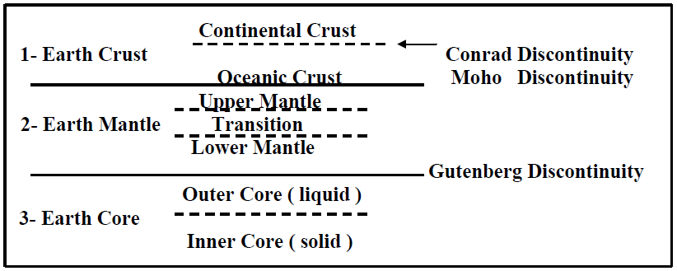

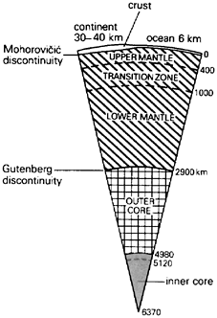

**Fig (2.1). Earth structure and its discontinuities.**

* + 1. **Earth Crust :**

**Crust:** The outermost layer is the crust, a very thin outer skin that ranges from about 7 to more than 70 kilometers

The crust extends from earth surface to the mantle (***Moho or Mdiscontinuity***).

The crust is subdivided into two parts (Fig2.1):

1. **Outer** – known as ***Sial*** (Silica-Alumina) or ***granitic layer***.
2. **Inner** – known as ***Sima*** (Silica-Magnesia) or ***basaltic layer***.

***Sial or granitic layer***

1. It is composed of less dense materials.
2. Light colored materials.
3. It is rich in silica (SiO2) and alumina (Al2O3).
4. It has got similarity in composition of rock granite.
5. It is with an average density 2.7 gm/cm3.
6. average thickness 25 km.

***Sima or basaltic layer***

1. It is made up of dense.
2. dark colored materials.
3. It is rich in magnesia (MgO) plus silica.
4. It is similar to those which comes out of the volcanoes.
5. It is with an average density 2.9 gm/cm3.
6. It is average thickness 20 km (Fig. 2.2).

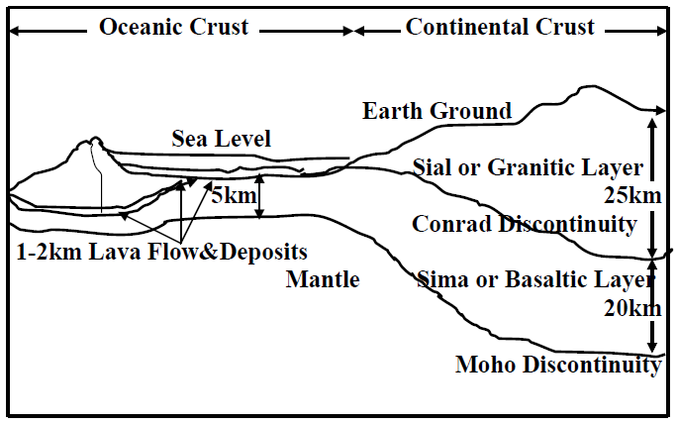

**Fig. (2.2). Earth crust subdivisions**

**1- Continental crust:** In most regions, the continental crust is about 35 kilometer thickness, but it may exceed 70 kilometers in areas of prominent mountains.

The continental crust consists of many types of rocks. One of the most common in the upper crust is the igneous rock **granite**.

**2- Oceanic crust:** Compared with continental crust, oceanic crust is quite thin, average only 7 kilometers in thickness.

In addition, the oceanic crust is very uniform in composition, being mainly composed of the dark igneous **basalt**.

On average, continental rocks are less dense (weigh less in equal amount) than oceanic rocks, which partially explains the lower position of the ocean floor compared to the continents. (Fig. 2.3).

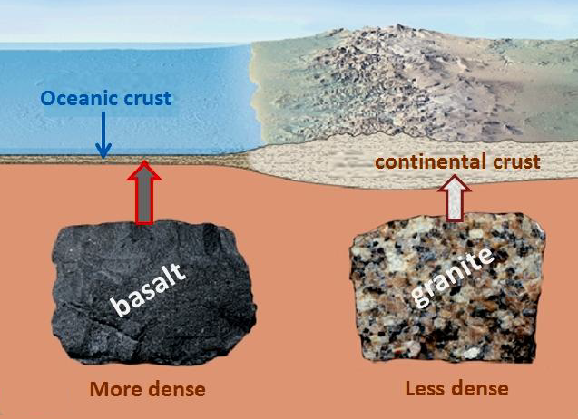

* + 1. **Earth Mantle:**

It extends from ***Moho discontinuity*** to about 2900 km which is the boundary of mantle-core ( Gutenberg - discontinuity ) that is identified by ***P***-wave observations. The materials in mantle are about two or three times as dense as those of earth surface. It is believed that its composition is similar to peridotite rock with high density. The average density is about 4.5 gm/cm3. From seismic observations, it has been found that a major change or discontinuity occurs at the boundary between mantle and outer core named ***Gutenberg discontinuity***.

2.2.3**Earth Core:**

It is located below Gutenberg discontinuity from depth 2900 km to earth center. It is subdivided into two parts:

1. **Outer Core:** It surrounds the inner core which is liquid, its composition is similar to that of the inner core, mainly iron and nickel. It is of 2100 km in thickness and average density 10-15 gm/cm3.
2. **Inner Core:** It is estimated to be of about 850 km in thickness. It is solid with the same composition and contains very high density materials with an average density 17 gm/cm3.

In addition to earth's four major layers, scientists have identified two other divisions of earth's interior: (**Astheno sphere – Lithosphere**).

**Lithosphere**:

Situated above the asthenosphere, called the lithosphere. It includes the uppermost mantle and overlying crust and behaves as a strong, rigid layer.

In contrast to the hot, weak zone below, the lithosphere is strong because it composed of comparatively cool rocks. (Fig.2.4).

**Astheno sphere:**

It located within the upper mantle, between the depths 100-660 kilometers and is composed of hot, rocky material that is capable of very slow movement.

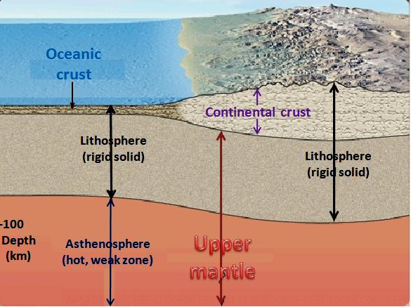

**(Fig .2.4)**

**2.3 Variations of Physical Conditions with Depth:**

The variations of some physical conditions (pressure, temperature, density and seismic velocities) with depth from earth surface:

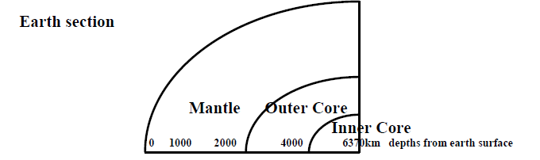

**The pressure:**

It is increases gradually with increasing depth due to increasing rock column.

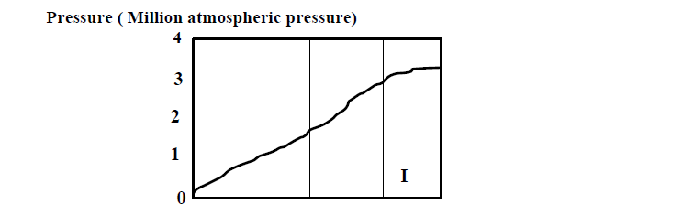

**The temperature:**

It is increases quickly with depth in the upper part (crust rocks) but with gradual increase downward to the earth core reaching 5000◦C in core rocks.

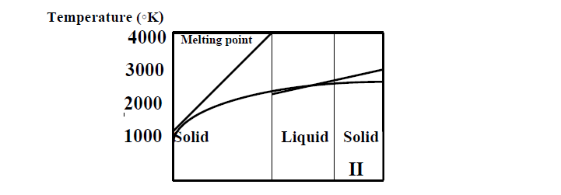

**The density:**

It increases gradually with depth (with about 1gm/cm3 per 1000 km depth), but with abrupt increase abruptly at the core boundary due to the presence of iron and nickel which are the main components of the core.

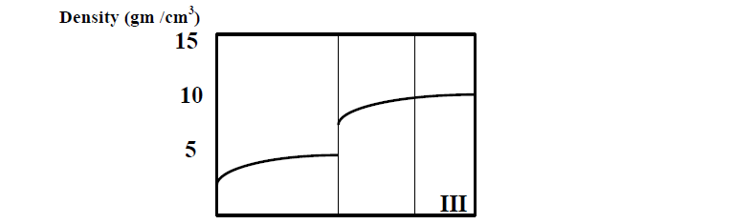

**The Concerning seismic wave velocities**

It is observed the increase in ***P*** and ***S***-wave velocities due to its transport from the ***continental (granitic)*** layer to the ***oceanic*** (***basaltic)*** layer. In the mantle, the increase becomes sharply reaching more than 8 km/sec for ***P***-wave (and more than 5km/sec for ***S***-wave). In the core, ***P***-wave velocity decreases in the outer core, with the absence of ***S***- wave that confirms the liquidity state of the outer core. In the inner core, ***P*** and ***S*** wave are present and increase with depth reaching more than 11.5 km/sec for ***P***- wave velocity and about 3 km/sec for ***S***-wave velocity.

