

|  |  |
| --- | --- |
| **رامي قيس مالك** | **اسم التدريسي** |
| **تقنيات رقمية** | **اسم المادة** |
| **Arithmetic Operations** | **عنوان المحاضرة** |
| **5** | **رقم المحاضرة** |
| **rami.qays@mustaqbal-college.edu.iq** | **الايميل الجامعي للتدريسي** |

**Arithmetic Operations**

**Introduction:**

Many arithmetical operations are carried out in digital systems like computers and calculators. The most common of these operations are addition, subtraction and multiplication. The aim of this lecture is to understand the principle used by digital systems to perform those operations.

**1.** **Binary addition:**

The addition of two binary numbers is similar to that of two decimal numbers.

Let us consider the following case: 3 5 4 + 6 6 3 = 10 1 7

For binary number, the principle is the same. However, only four cases can be met while adding binary numbers:

0 + 0 = 0

1 + 0 = 1

1 + 1 = 0 + a carry out of 1

1 + 1 + 1 = 1 + a carry out of 1.

**Example 1:**

Let us add the following binary numbers: A = 1001 (9)10, B = 1111 (15)10.

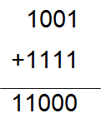

•We begin by adding the two LSB (Least Significant Bit): 1 + 1 = 0 + carry out of 1.

•Then we add that carry to the two bits situated directly at the left: 0 + 1 + 1(Carry) = 0 + carry out of 1.

• The same operation is performed for the next rank.

• Then for the most significant bits, we have: 1 +1 + 1(Carry from the previous rank) = 11.

• Finally, the result of the operation gives us 11000 (24)10.

**2. Signed numbers:**

In order to differentiate positive numbers to negative numbers, a specific bit can be added in front of the binary number. That bit is called bit of sign. The bit of sign is 0 for positive numbers and 1 for negative numbers.

**Example 2:**

+9 = 01001

-24 = 111000

• For negative binary numbers, there are two other types of notation: The one’s complement notation;

• The two’s complement notation.

**1.The one’s complement notation:**

The one’s complement notation of a binary number is simply obtained by complementing each bit of the number. Let us write for example the one’s complement of the following binary number: 10010110

10010110 Exact notation

01101001 One’s complement notation

**Remark 1:**

For negative binary numbers, we should not forget the bit of sign:

11101 Exact notation

10010 One’s complement notation.

Notice that the bit of sign is not complemented.

**2. The two’s complement notation**

The two’s complement notation of a binary number is obtained by adding 1 to the one’s complement notation of that number.

110110 Exact notation

001001 One’s complement notation

+ 1

001010 Two’s complement notation

For signed number, remember that the bit of sign remains unchanged.

We can recapitulate all what we have studied concerning one’s and two’s complementation in the following table:

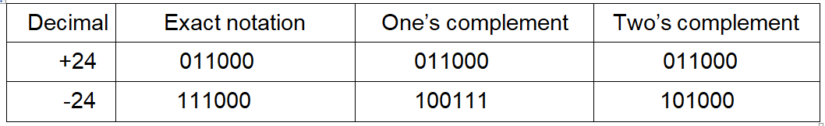

Notice that for positive numbers, exact notation does not differ from one’s complement and two’s complement notation.

**3. Conversion from one’s complement and two’s complement notation to exact notation:**

To convert from the one’s complement notation to the exact notation, each bit of the one’s complement notation should just be complemented back.

111000 Exact notation.

100111 One’s complement notation.

111000 Exact notation.

Notice that the bit of sign does not change.

To convert from two’s complement notation to the exact notation, the two’s complemented number should just be two’s complemented back.

1001 Exact notation

0110 One’s complement notation.

+ 1

0111 Two’s complement notation

1000 One’s complement notation.

+ 1

1001 Exact notation

**4. Addition of two signed numbers:** Depending on the sign of the two numbers to be added, many cases can be studied.

**Case 1: Two positive numbers:** Let us add +4 to +9.

+9 = 01001

+4 = 00100

+13 01101

The two numbers to be added should have the same number of bit and they should also be written in two’s complement notation.

**Case 2: Positive number and negative number (less than the positive number):** Let us add +9 and -4.

Decimal Exact notation 2’s complement

+9 01001 01001

-4 10100 + 11100

100101

The first bit 1 is not taken in consideration. The second bit 0 is the bit of sign, so the result of the operation is 00101 = 510.

**Case 3: Positive number and negative number (greater than the positive number):** The result of this operation should give a negative number written in two’s complement notation. Therefore, that result should later on be converted from two’s complement notation to exact notation.

Decimal Exact notation 2’s complement

-9 11001 10111

+4 00100 + 00100

11011 Result in 2’s complement notation

Let us convert now the result from two’s complement to exact notation

11011

10100

+ 1

10101 Final result

The final result is 10101= -510.

**5. Multiplication of binary numbers:**

The multiplication of two binary numbers is similar to that of two decimal numbers. Let us multiply 910 (10012) and 310(00112).

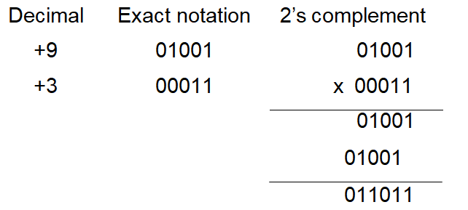

The final result gives us 0110112 = 2710. The bits of first number (9) have just been multiplied by each of those of the second number (3), beginning from the right to the left. It should also be noticed that, while passing from one line to the next, we should shift from one position to the left.

