**Power Supply Voltage Regulator**

Introduces the operation of power supply circuits built using filters, rectifiers, and then the ac voltage, then filtering to a dc level, and, finally, regulating to obtain a desired fixed dc voltage. The regulation is usually obtained from an IC voltage regulator unit, which takes a dc voltage and provides a somewhat lower dc voltage, which remains the same even if the input dc voltage varies or the output load connected to the dc voltage changes.

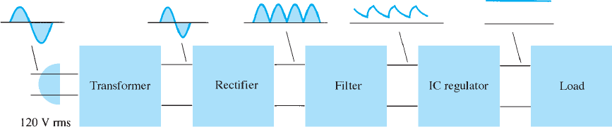

* Transformer
* Full Wave Bridge Rectifier Circuit
* Filter Circuit
* Regulator Circuit

Transformer

Here, we are talking about a 5V power supply system. So, the transformer used in this circuit is a step-down transformer and has a rating of 230V input AC supply and 6V output AC supply. So it converts the 230V AC supply into a 6V AC supply. The rating of the transformer depends upon the requirement of the output voltage of the circuit. If you want to make a 12V circuit, then you must take a transformer whose output is 12V.

Rectifier

The rectifier is a very important part of this circuit. It converts the 6V AC supply coming from the transformer output into 6V DC Supply. Here, you can see a full-wave bridge rectifier circuit is used for the rectification. The rectifier circuit has four PN Junction Diodes and each of them is rated IN 4007. Here, the diodes D2 and D4 convert the positive half cycle whereas the diodes D1 and D3 convert the negative half cycles. The full-wave bridge rectifier is the most efficient rectifier circuit as it converts both cycles. Also, it is a very cheaper and low-power losing device.

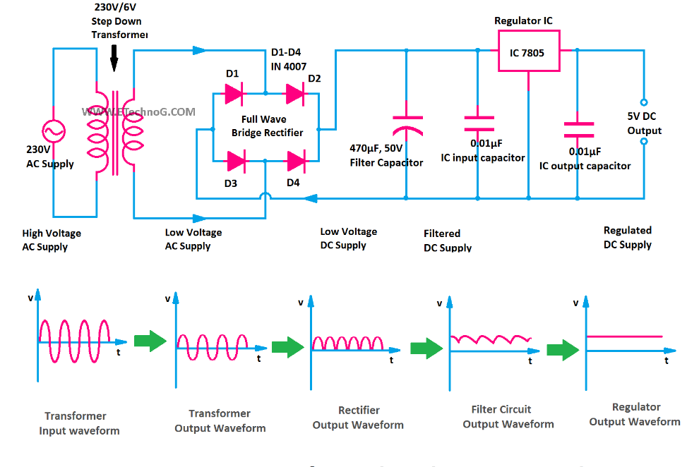

Filter Circuit

The output of the rectifier circuit is not pure. There are some AC components called ripple available in the output DC supply of the rectifier. So a filter circuit is required to filter the impure DC into pure DC. Here, in the above circuit diagram, a pure capacitor filter is used.

You can see a 470 micro-farad, 50V electrolytic capacitor is used to filter the DC supply. In a DC power circuit, always an electrolytic capacitor should be used. The positive terminal of the capacitor is to be connected to the positive wire and the negative terminal of the capacitor is to be connected to the negative wire.

# Discrete transistor voltage regulation.

Two types of transistor voltage regulators are the series voltage regulator and the shunt voltage regulator. Each type of circuit can provide an output dc voltage that is regulated or maintained at a set value even if the input voltage varies or if the load connected to the output changes.

# Series Voltage Regulation

The basic connection of a series regulator circuit is shown in the block diagram of Figure. The series element controls the amount of the input voltage that gets to the output.

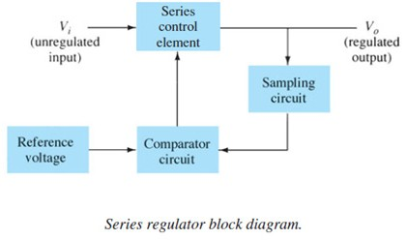

The output voltage is sampled by a circuit that provides a feedback voltage to be compared to a reference voltage.

* If the output voltage increases, the comparator circuit provides a control signal to cause the series control element to decrease the amount of the output voltage—thereby maintaining the output voltage.
* If the output voltage decreases, the comparator circuit provides a control signal to cause the series control element to increase the amount of the output voltage.

**Series Regulator Circuit** A simple series regulator circuit is shown in Fig. Transistor *Q* 1 is the series control element, and Zener diode *D Z* provides the reference voltage. The regulating operation can be described as follows:

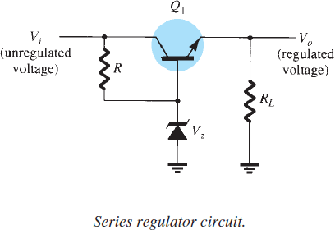

1. If the output voltage decreases, the increased base-emitter voltage causes transistor *Q* 1 to conduct more, thereby raising the output voltage—maintaining the output constant.

* If the output voltage increases, the decreased base-emitter voltage causes transistor *Q* 1 to conduct less, thereby reducing the output voltage—maintaining the output constant.

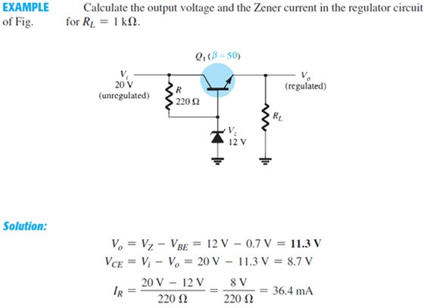

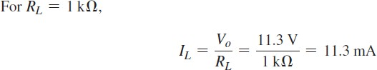



**Improved Series Regulator** An improved series regulator circuit is shown in Fig.

15.15 . Resistors *R* 1 and *R* 2 act as a sampling circuit, with Zener diode *D Z* providing a reference voltage, and transistor *Q* 2 then controls the base current to transistor *Q* 1 to vary the current passed by transistor *Q* 1 to maintain the output voltage constant.

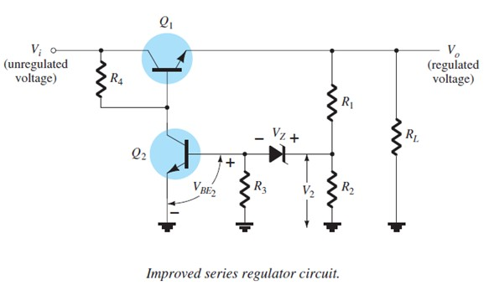

If the output voltage tries to increase, the increased voltage, *V* 2 , sampled by *R* 1 and *R* 2 , causes the base-emitter voltage of transistor *Q* 2 to go up (since *V Z* remains fixed). If *Q* 2 conducts more current, less goes to the base of transistor *Q* 1 , which then passes less current to the load, reducing the output voltage— thereby maintaining the output voltage constant. The opposite takes place if the output voltage tries to decrease, causing less current to be supplied to the load, to keep the voltage from decreasing.

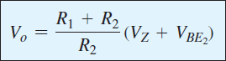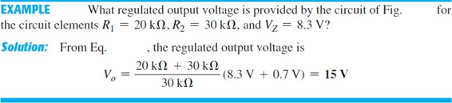

**Op-Amp Series Regulator** Another type of series regulator is shown in Fig. The op-amp compares the Zener diode reference voltage with the feedback voltage

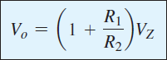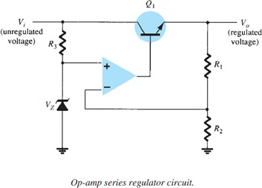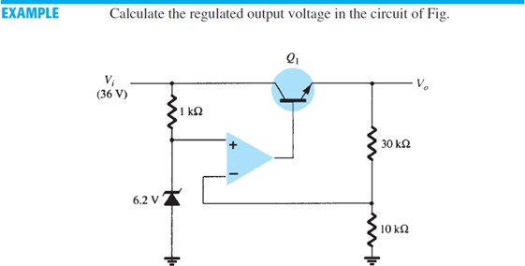from sensing resistors *R* 1 and *R* 2. If the output voltage varies, the conduction of transistor *Q* 1 is controlled to maintain the output voltage constant. The output voltage will be maintained at a value of