Al-Mustaqbal University College

1

Department of Medical Instrumentation Techniques Engineering

Class: Three

Subject: Medical electronic system lab

Lecturer: Dr. zahraa hashim and Eng. Raneen moaied

Experiment No.: 1

# Full Wave Rectifier

Objective: -

* To calculate and draw the DC output voltages of full- wave rectifiers.

# Circuit elements:

AC power

diode bridge network Resistor Oscilloscope

# **Theory**

The process of converting the AC current into DC current is called rectification. Rectification can be achieved by using a single diode or group of diodes. These diodes which convert the AC current into DC current are called rectifiers.

Rectifiers are generally classified into two types: half wave rectifier and full wave rectifier.

**Full wave rectifier:**

A full wave rectifier is a type of rectifier which converts both half cycles of the AC signal into pulsating DC signal. The full wave rectifier is further classified into two types: center tapped full wave rectifier and full wave bridge rectifier.

Procedure:

1. Connect the circuit as shown in Figure (1) using silicon diode.

2. Increase the variable DC voltage from zero in steps of (0.1 volts) up to (1 volts), then in step of (0.5 volt) up to (4 volt), and record the voltage across the (1KΩ) resistance (Vr).

3. Tabulate your results in a table as shown in table (1).

4. Connect the circuit shown in Figure (2) using Si diode.

5. Increase the variable DC voltage from zero in steps of (0.2 volts) up to (1 volt), then in steps of (1 volt) up to (4 volts) and for each step record the current lowing in the circuit.

6. Tabulate your result in a table as shown in table (2).

**Note**:

For the reverse c/cs of (Si) diode the reverse current is very small compare with the current of (Ge) diode, so it assumed to be zero..

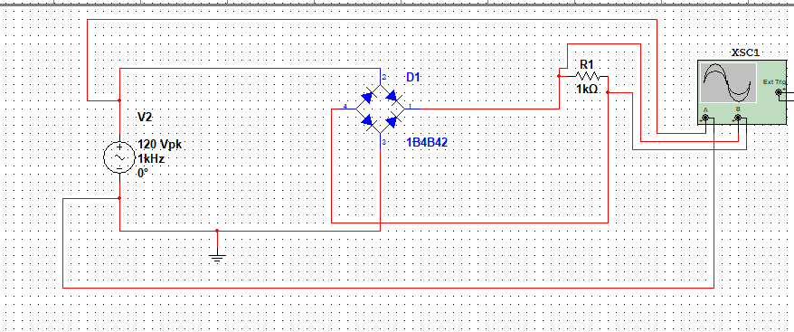

Fig.1 bridge rectifier circuit

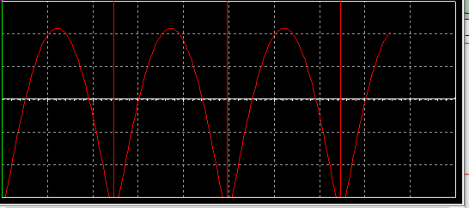

Fig. 2 result of bridge rectifier



