

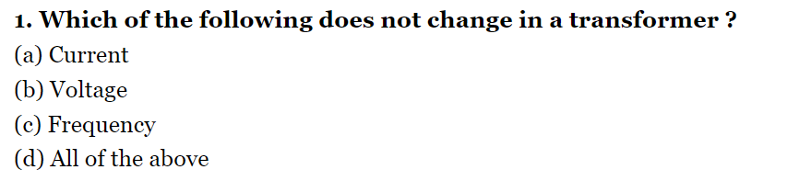

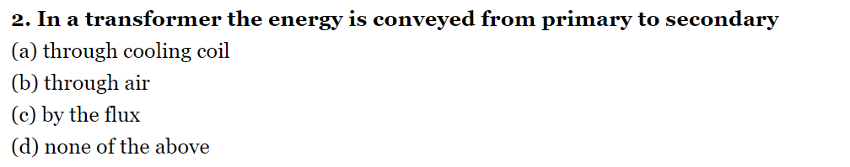

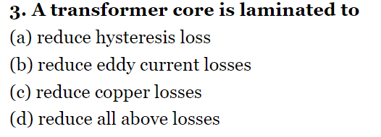

**4- The highest voltage for transmitting in Iraq**

**a-11 kv**

**b- 33 kv**

**c-132 kv**

**d- 400**

**5- types of cores transformers**

**a- There are two types of cores**

**b-There are three types of cores**

**c-There are four types of cores**

**d-There are one type of cores**

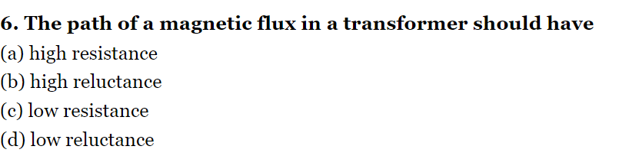

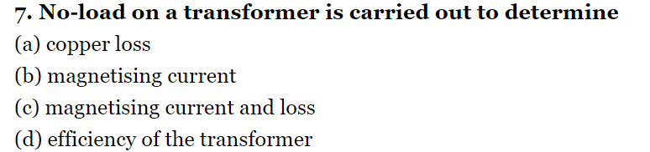

**8-** **efficiency of transformer: 𝜂 =**

**a- $\frac{V1}{V2}$**

**b- $\frac{P2}{P1}$**

**c- $\frac{N1}{N2}$**

**d- $\frac{I1}{I2}$**

**9- EMF of transformers =**

**a- 4.44 f Φm N**

**b- 44.4 f Φm N**

**c- 0.444 f Φm N**

**d- 444 f Φm N**



