Experiment No.: 3

Experiment name: Full Wave Rectifier

Objective: -

- To calculate and draw the DC output voltages of full- wave rectifiers.
- Without smoothing capacitor and with smoothing capacitor.

Circuit elements:

AC power
diode bridge network Resistor Oscilloscope

Theory
The process of converting the AC current into DC current is called rectification. Rectification can be achieved by using a single diode or group of diodes. These diodes which convert the AC current into DC current are called rectifiers.
Rectifiers are generally classified into two types: half wave rectifier and full wave rectifier.

Full wave rectifier:
A full wave rectifier is a type of rectifier which converts both half cycles of the AC signal into pulsating DC signal. The full wave rectifier is further classified into two types: center tapped full wave rectifier and full wave bridge rectifier.

The Full Wave Bridge Rectifier
Another type of circuit that produces the same output waveform as the full wave rectifier circuit above is that of the Full Wave Bridge Rectifier. This type of single-phase rectifier uses four individual rectifying diodes connected in a closed loop “bridge” configuration to produce the desired output. The main advantage of this bridge circuit is that it does not require a special Centre tapped transformer, thereby reducing its size and cost. The single secondary winding is connected to one side of the diode bridge network and the load to the other side as shown below.

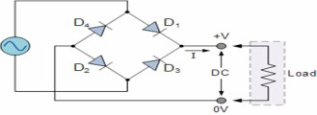
The four diodes labeled D1 to D4 are arranged in “series pairs” with only two diodes conducting current during each half cycle. During the positive half cycle of the supply, diodes D1 and D2 conduct in series while diodes D3 and D4 are reverse biased and the current flows through the load as shown below.

During the negative half cycle of the supply, diodes D3 and D4 conduct in series, but diodes D1 and D2 switch “OFF” as they are now reverse biased. The current flowing through the load is the same direction as before.
Full-wave Rectifier with Smoothing Capacitor:
The smoothing capacitor converts the full-wave rippled output of the rectifier into a smoother DC output voltage. we can see the effect it has on the rectified output waveform as shown.

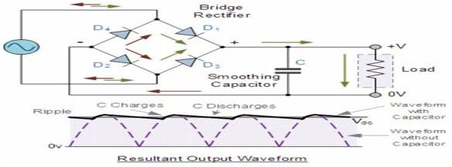

Procedure:
