**Digital Signal Processing (DSP) Lab**

**Exp.2 Generations of Discrete Time Functions**

**1. Generation of unit sample:**

**MATLAB Code:**

clc;

clear

n= -5:1:5;

y = [0 0 0 0 0 1 0 0 0 0 0];

figure(1)

stem(n,y,'r','linewidth',2);

ylabel ('Amplitude');

xlabel ('Samples');

title ('Unit Impulse Signal');

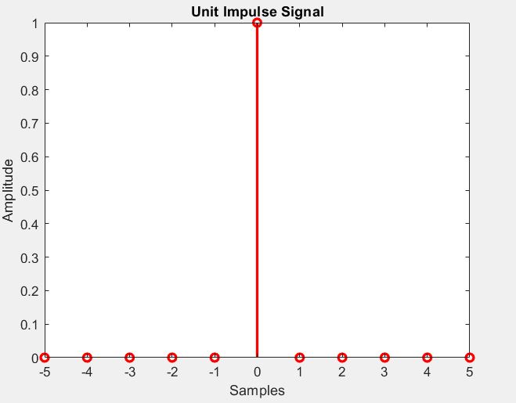

**Fig. (1): Generation of unit sample**

**2. Generation of unit step sequence**

**MATLAB Code:**

clc;

clear

n = -4:1:4;

y1 = [0 0 0 0 1 1 1 1 1];

figure(2)

stem (n, y1,'b','linewidth',2);

ylabel ('Amplitude');

xlabel ('Samples');

title ('Unit step');

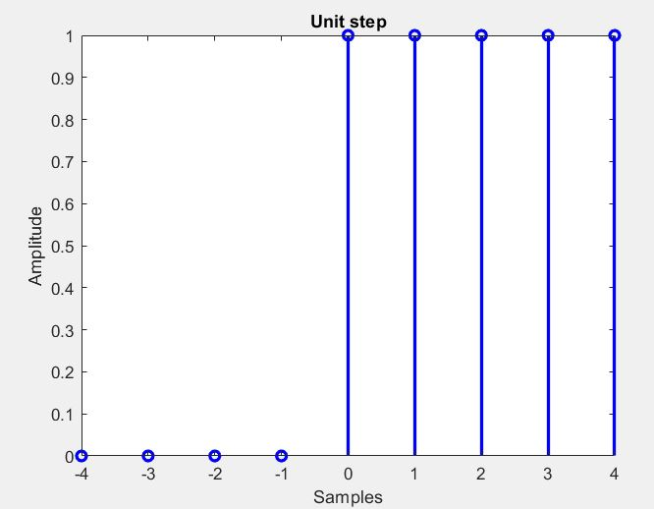

Fig. (2): Generation of unit step sequence

**3. Generation of ramp signal**

clc;clear

close all

n1 = input ('Enter the value for end of the sequence ');

x = 0: n1;

y=x;

figure(3)

stem(x,y,'k','linewidth',2);

ylabel('Amplitude');

xlabel ('Samples');

title ('Ramp sequence');

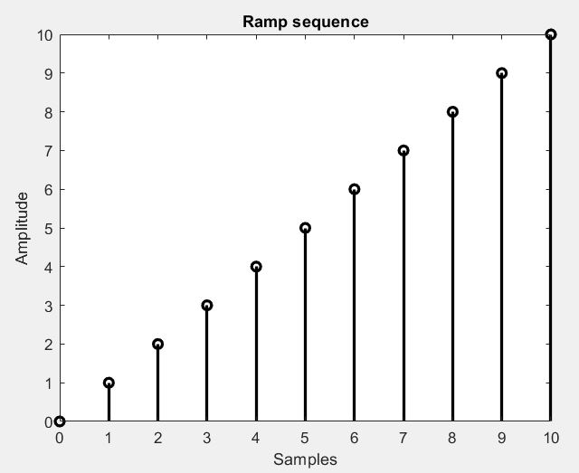

Fig. (3): Generation of ramp signal

**4. Generation of exponential signal**

**MATLAB Code:**

clc;clear

n=input ('enter the length of exp seq');

t=0:0.1: n;

a=input ('enter the amp');

y=exp(a*t);

subplot (2,1,1)

plot(t,y,'r','linewidth',2);

ylabel('Amplitude');

xlabel ('time');

title ('exp sequence');

grid

subplot (2,1,2)

stem(t,y,'b','linewidth',2);

ylabel('Amplitude');

xlabel ('time');

title ('exp sequence');

grid

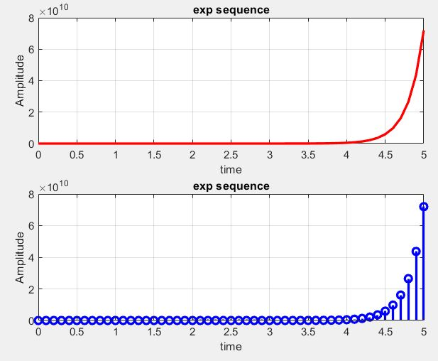

Fig.(4): Generation of exponential signal

**Discussion:**

Q1/ Generate the following signal by using MATLAB code:

1. x(n) = δ (n-2)
2. x(n) = u (n+4)
3. x(n) = exp^-a *n
4. x(n) = cos (2*pi*f)n