**المحاضرة التاسعة / التشريح والفسلجه/قسم هندسة الأجهزة الطبية**

**الأستاذ الدكتور خيري عبدالله / الجهاز العصبي المحيطي**

**Lec . 9 / Peripheral Nervous System**

* **Peripheral Nervous System , all nerves(bundles of axons ) conduct information to and from central nervous system .**
* **Bodies of nerve cells are present in brain , spinal cord and ganglia .**

**Anatomically peripheral nervous system consists of all nerves that branch out from brain and spinal cord .( cranial nerves 12 + Spinal nerves 31 ) .**

**Physiologically spinal nerves include :**

**1 – Somatic Nervous System . ( 14 nerves ) .**

**2 – Autonomic nervous System . ( 17 nerves ) .**

**Number of vertebrates = 33 .**

**Autonomic nervous System subdivided to :**

**A – Sympathetic nervous System .**

**B – Parasympathetic nervous System .**

**C – Enteric nervous system .**

* **Autonomic Nervous System involuntary control , Cardiac muscle , smooth muscles and glands .**
* **Sympathetic Nervous System activate ( Fight or Flight ) due to Secretion of adrenalin in response during threat or danger .**
* **Parasympathetic Nervous System restores the body to a state of calm due to secretion of Acetylcholine .**
* **Enteric nervous System , part of autonomic nervous system includes a number of Circuits that control motor functions , local blood flow , secretion , mucosal transmission , and modulate immune responses and endocrine functions .**

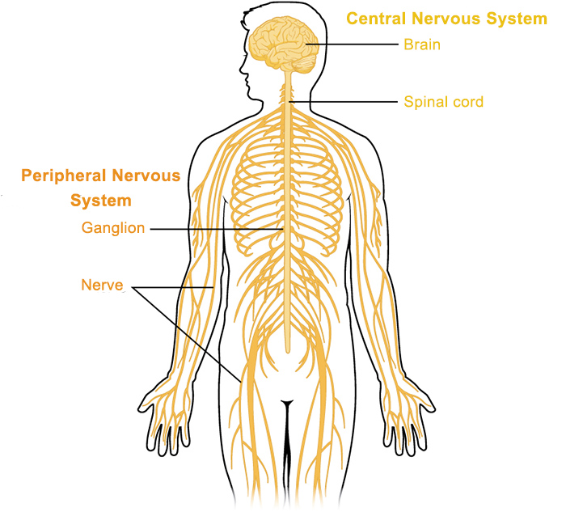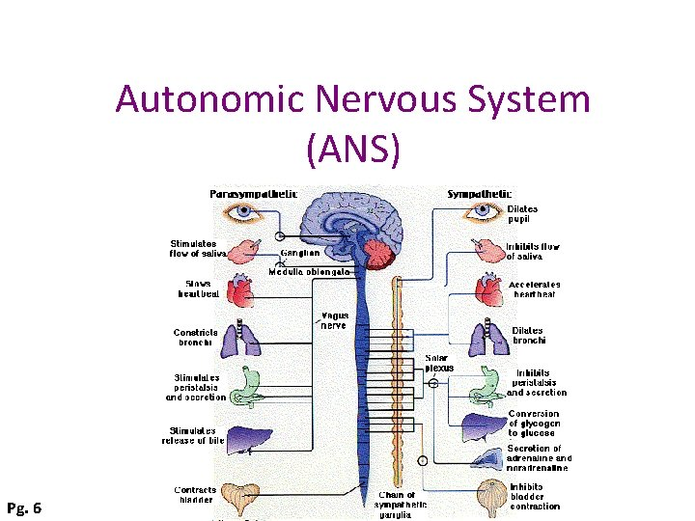

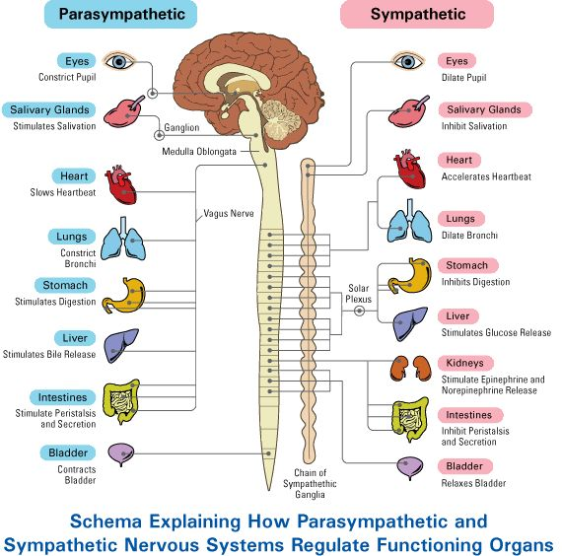

**General characterizations of somatic nervous system**

**1 – Somatic nervous system include some cranial and some spinal nerves , which are working under voluntary control .**

**2 – Somatic nervous system have : cervical spinal nerves ( C1 – C4 )**

**, Brachial plexus ( C5 – T1 ) , and lumbosacral plexus ( L1- Co1 ) .**

**3 – Sensory nervous system is a part of somatic nervous system and transmits signals from sense organs such as taste , touch , hearing to the spinal cord then to the brain**

**Ganglia : ganglia of nervous system are collection of neuronal bodies found in the voluntary and autonomic branches ( involuntary ) of peripheral nervous system . Ganglia are synaptic relay stations between neurons . ( Information enters the ganglia excites the neuron in the ganglia and then exits ) . Present in brain and on dorsal roots of spinal nerves on both sides of vertebral column . Main diseases of nervous system :**

**1 – Alzheimer’s disease : is the most common cause of dementia ( slowly memory lose ) , it is progressive neurologic disorder that cause shrink ( atrophy ) of brain cells .**

**2 – Parkinson disease : brain disorder leads to shaking stiffness , of arms , walking and talking in elderly people due to damage**

**of nerve sheath .**

**Electrodiagnostic evalution of nerves :**

**Electromyography : (EMG) record electrical activity in muscles detect nerve damage , by using flat electrodes are placed on the skin and with a low electrical current stimulate the nerves . The doctor will record nerve responses to electric current ( MRI ) .**

