**Lec -2- The Cell**

All living things are made up of cells. The cell is the basic unit of structure and function.

**Components of cell**

* [**Cell wall**](https://en.wikipedia.org/wiki/Cell_wall)**:** extra layer of protection and gives structural support (only found in [plant cells](https://en.wikipedia.org/wiki/Plant_cells)).
* 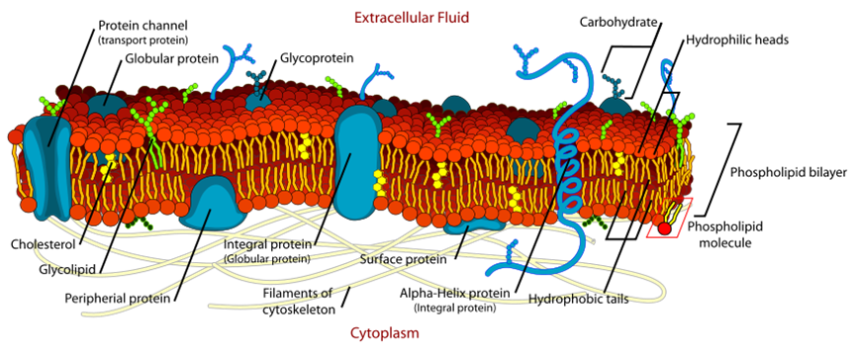 **Cell membrane:** The biological structure that separates the interior of a cell from its outer environment, all living cells, prokaryotic and eukaryotic, are surrounded by a plasma membrane.

**Structure:**

Cell membrane is complex structures composed of two layers, known as the phospholipid bilayer that associated integral and peripheral proteins, and carbohydrates.

1. The inner layer of the plasma membrane faces the cytoplasm, and the outer layer faces the extracellular environment.
2. The proteins are scattered throughout the membrane; therefore, they form a mosaic pattern. In addition, this description is called the fluid-mosaic model of membrane structure.
3. The phospholipid bilayer contain of
4. **The hydrophilic heads** (water loving) polar of the phospholipid molecules attracted to water outside and inside of the cell
5. **The hydrophobic tails** (water fearing) nonpolar tails repelled by water areas face away
6. In addition to phospholipids, there are two other types of lipids in the plasma membrane.
7. **Glycolipids** have a structure similar to phospholipids except that the hydrophilic head is a variety of sugars joined to form a straight or branching carbohydrate chain.
8. **Cholesterol** is another lipid component of animal cell membranes; present in both layers, and **helps maintain the structural integrity of the membrane.**
9. Proteins are found inserted into this lipid bilayer and are classified into **integral proteins and peripheral proteins.**
10. The plasma membrane is asymmetrical: the two halves are not identical. The carbohydrate chains of the glycolipids and proteins occur only on the **outside surface** and the cytoskeletal filaments attach to proteins only on the **inside surface.**

**Function of cell membrane:**

1. The cell membrane is the interface between a cell and its environment.
2. The plasma membrane envelops the cell and maintains its structural and functional integrity.
3. It assists in controlling interaction between cells.
4. Regulating what goes in and out of the cell.

* [**Cytoplasm**](https://en.wikipedia.org/wiki/Cytoplasm)**:** contents of the main fluid-filled space inside cells, [chemical reactions](https://en.wikipedia.org/wiki/Chemical_reactions) also happen in this jelly-like substance.
* **Nucleus:** The nucleus is structure bound by **a double membrane called the nuclear envelope in**[**eukaryotic**](https://en.wikipedia.org/wiki/Eukaryote)[**cells**](https://en.wikipedia.org/wiki/Cell_(biology)). This membrane separates the contents of the nucleus from the [cytoplasm](https://www.thoughtco.com/cytoplasm-defined-373301), and its contains most of the cell's [genetic material](http://en.wikipedia.org/wiki/Genetics), organized as multiple long linear [DNA](http://en.wikipedia.org/wiki/DNA) molecules in complex with a large variety of [proteins](http://en.wikipedia.org/wiki/Protein), such as [histones](http://en.wikipedia.org/wiki/Histone), to form [chromosomes](http://en.wikipedia.org/wiki/Chromosome), and controls the cell's growth and reproduction.

**The function of the nucleus** is to maintain the integrity of genes and to control the activities of the cell by regulating [gene expression](http://en.wikipedia.org/wiki/Gene_expression)

* 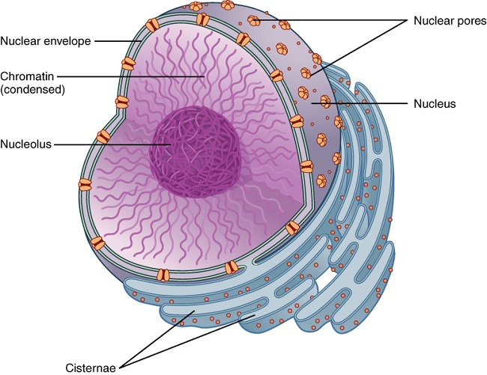**Nucleolus:** is the largest structure in the cell nucleus. The nucleolus is responsible for the production of ribosomes; this process is referred to as the ribosome biogenesis. The nucleolus is formed around specific chromosomal regions and it is made up of DNA, RNA and associated proteins.
* **Endoplasmic reticulum (ER)** is network of membranous canals that shares part of its membrane with that of the nucleus.

1. [Endoplasmic reticulum](https://en.wikipedia.org/wiki/Endoplasmic_reticulum) (**rough**) – major site of membrane [protein synthesis](https://en.wikipedia.org/wiki/Protein_synthesis).
2. 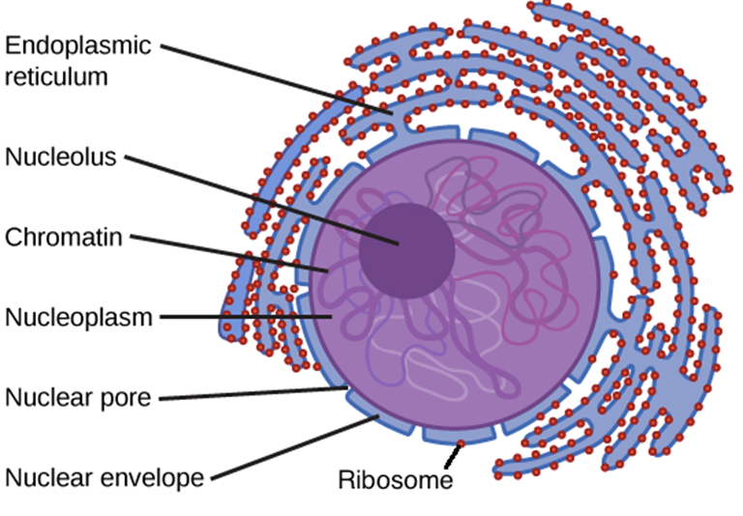[Endoplasmic reticulum](https://en.wikipedia.org/wiki/Endoplasmic_reticulum) (**smooth**) – major site of [lipid synthesis](https://en.wikipedia.org/wiki/Lipid_synthesis).

* [**Lysosome**](https://en.wikipedia.org/wiki/Lysosome)**s**: are tiny sacs filled with fluid containing enzymes (i.e. proteins that act as biological catalysts) which digest large molecules, also responsible for breaking down and getting rid of waste products of the cell.

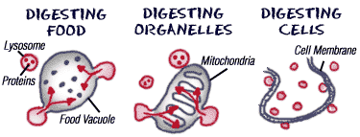

* [Ribosome](https://en.wikipedia.org/wiki/Ribosome): is the site of protein synthesis in the cell. Each ribosome consists of **large subunit** and a **small subunit**. Using the templates and instructions provided by two different types of RNA, ribosomes synthesize a variety of proteins that are essential to the survival of the cell.

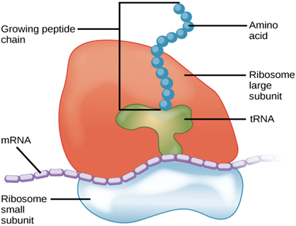

* **Golgi apparatus:** These are tiny vesicles surrounded by a membrane; the simplest unit of the Golgi apparatus is the cisterna. Golgi apparatus site of protein glycosylation in the [endomembrane](https://en.wikipedia.org/wiki/Endomembrane) system, also collect proteins and lipids made in the ER and add additional substances.

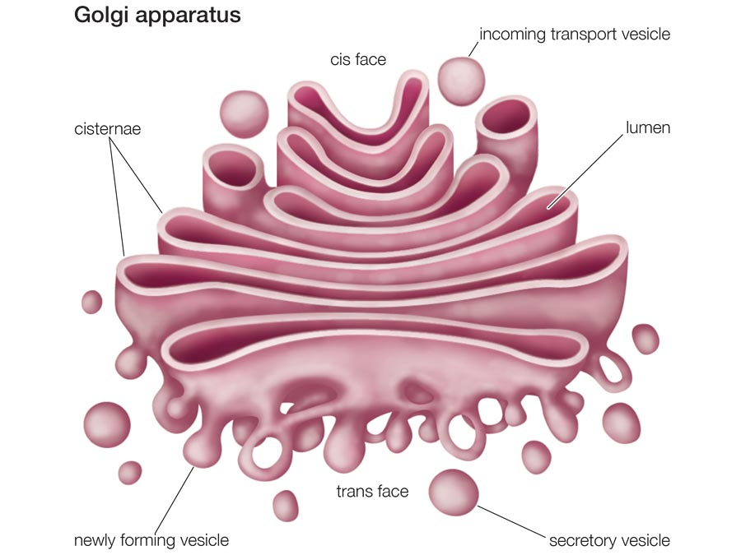

* [**Centrosome**](https://en.wikipedia.org/wiki/Centrosome)**:** an associated pair of cylindrical shaped protein structures ([centrioles](https://en.wikipedia.org/wiki/Centriole)) that organize [microtubules](https://en.wikipedia.org/wiki/Microtubule), microtubular structures found near the nucleus, and aid in forming the [mitotic spindle](https://en.wikipedia.org/wiki/Spindle_apparatus) during [cell division](https://en.wikipedia.org/wiki/Cell_cycle) in [eukaryotes](https://en.wikipedia.org/wiki/Eukaryote).
* [**Chloroplast**](https://en.wikipedia.org/wiki/Chloroplast)**:** key [organelle](https://en.wikipedia.org/wiki/Organelle) for [photosynthesis](https://en.wikipedia.org/wiki/Photosynthesis) (only found in [plant cells](https://en.wikipedia.org/wiki/Plant_cells)), are disc-shaped organelles found in the cytosol of a cell. They have outer and inner membranes with an intermembrane space between them, the center, there are membranes discs known as thylakoids, arranged in interconnected stacks called grana (singular, granum).

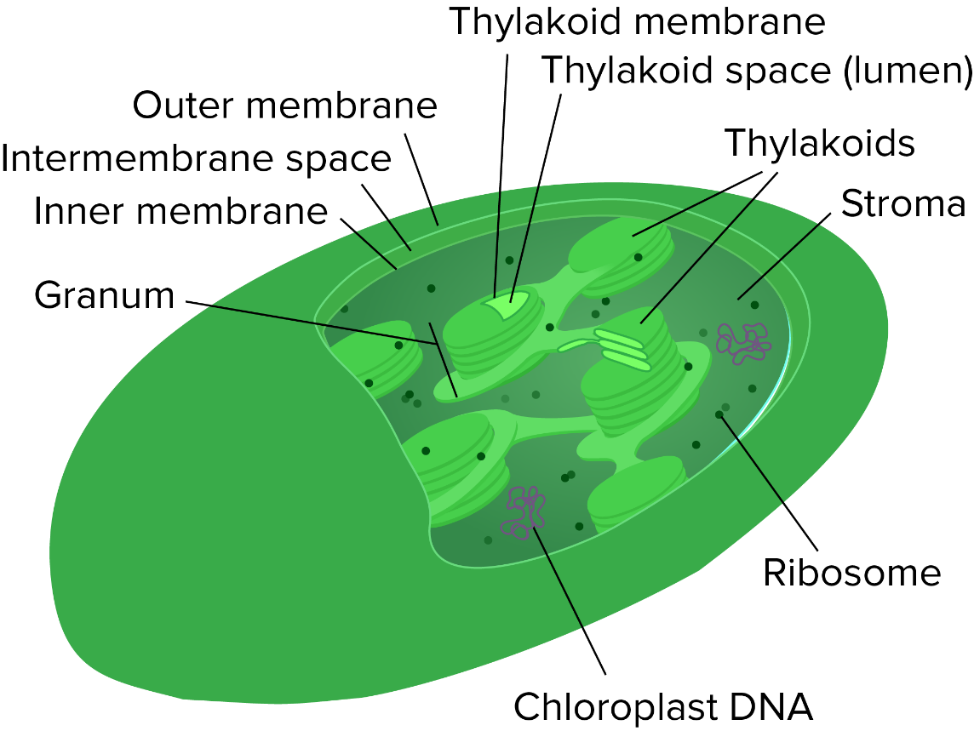

* [**Cytoskeleton**](https://en.wikipedia.org/wiki/Cytoskeleton)**:** protein filaments inside cells ([microfilaments](https://en.wikipedia.org/wiki/Microfilaments), [microtubules](https://en.wikipedia.org/wiki/Microtubules), and [intermediate filaments](https://en.wikipedia.org/wiki/Intermediate_filaments)). These protein structures together maintain cell shape, anchor organelles, and cause cell movement.

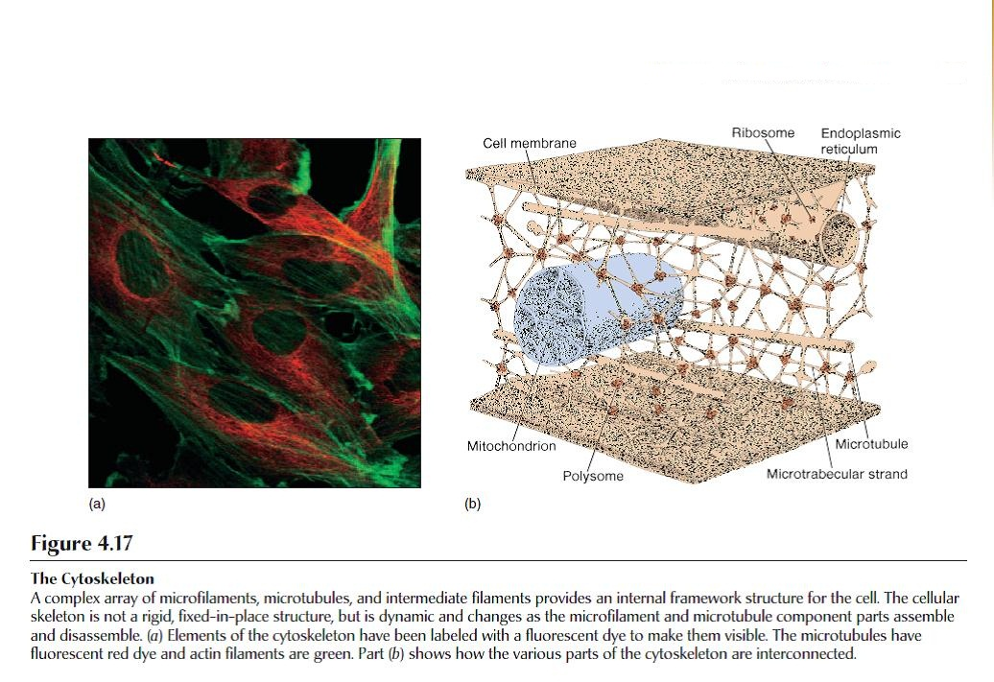

* [**Mitochondria**](https://en.wikipedia.org/wiki/Mitochondrion)**:** major energy-producing organelle by releasing energy in the form of [ATP](https://en.wikipedia.org/wiki/Adenosine_triphosphate) by the breakdown of carbohydrates and fatty acids, which is converted to ATP by the process of oxidative phosphorylation.

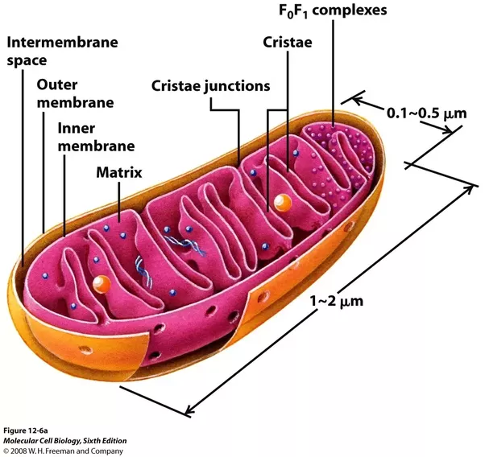**Structure**

Mitochondria are surrounded by a double-membrane system, consisting of inner and outer mitochondrial membranes separated by an intermembrane space. The inner membrane forms numerous folds (cristae), which extend into the interior (or matrix) of the organelle. Each of these components plays distinct functional roles, with the matrix and inner membrane representing the major working compartments of mitochondria.

* [**Vacuole**](https://en.wikipedia.org/wiki/Vacuole)**:** A vacuole is an organelle found in plant, fungi cells, animals and many single-cell organisms. A membrane, called the tonoplast, and storage material, surrounds the single large vacuole of the cell.
* [**Peroxisomes**](https://en.wikipedia.org/wiki/Peroxisomes)**–** a very small organelle that uses oxygen to breakdown and detoxify long fatty acids and other molecules.
* [**Pili**](https://en.wikipedia.org/wiki/Pilus)**–** Also, called fimbria is used for conjugation and sometimes movement.
* CILIA AND FLAGELLA

| BASIS FOR COMPARISON | | CILIA | FLAGELLA |
| --- | --- | --- | --- |
| Meaning | | Cilia are short, hair like appendages extending from the surface of a living cell. | Flagella are long, threadlike appendages on the surface of a living cell. |
| Found in | | Eukaryotic cell. | Prokaryotic cell as well as in eukaryotic cells. |
| Length | | Short. | Longer. |
| Type of motion | | Cilia show rotational motion like a motor; they are very fast moving. | Flagella show slow, wave-like. |
| Role | | They play their primary role in locomotion, aeration (respiration), etc. | They are helpful in locomotion only. |
| Occurs in | It occurs all over the cell surface. | It is present at both the ends or sometimes all over the surface. | |

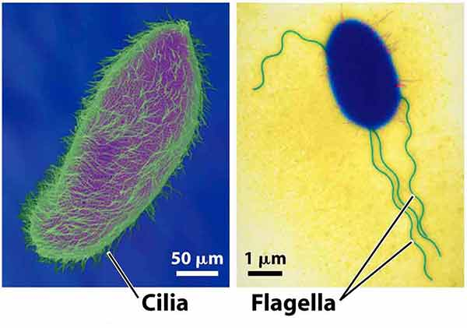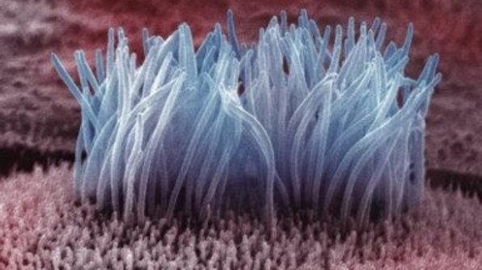

* [**Microvilli**](https://en.wikipedia.org/wiki/Microvilli)**:** increases surface area for absorption of nutrients from surrounding medium.

