المحاضرة السابعة / المرحلة الثانية / قسم هندسة الاجهزة الطبية
الاستاذ الدكتور خيري عبدالله
Vascular System
There are five types of blood vessels : Arteries , Arterioles , Capillaries , Venules , Veins .
Blood vessels :
1 - Arteries carry blood away from heart through aorta which is branched to arteries then arterioles to capillaries . The capillaries merge to bring blood into venous system .
2 - Arteries transport blood cells , nutrition , oxygen and hormones to the tissue and all organ of the body .
3 - Veins carry waste products and carbon dioxide away from tissues .
4 - Arteries and Veins have 3 layers , except capillaries single layer .
Histology of blood vessels :
Arteries and veins have three layers :
1 – Tunica Intima .
2 – Tunica Media .
3 – Tunica Adventitia
Tunica intima : inner layer , one layer of epithelial cells blood vessels . It is a simple squamous epithelium , resting on basement membrane .
Tunica Media :
1 – It is the middle layer .
2 – It is consist of concentric elastic fibers and smooth muscle cells . In large blood vessels elastic fibers and smooth muscle cells are separated in two layers .
2 – Tunica media is thicker in arteries than veins .
Tunica Adventitia :
1 – It is outer most layer consist of simple squamous epithelial cells resting on basement membrane .
2 – It is thicker in veins than arteries , plenty of connective tissue .
3 – Blood vessels ( Vasa vasorum ) and nerve are present in this layer .
Capillaries :
1 – Capillaries are numerous and the smallest blood vessels 5 – 10 micrometers in diameter .
2 – Capillaries are composed of only intima , thin wall .
3 – It form the connection between arteries and veins .
4 - It is the site of exchange of many substances with surrounding tissues ( water , Oxygen , Carbon dioxide , urea , glucose , Lactic acid , Uric acid , Creatinine ) .
Types of Capillaries : three types
1 – Continuous Capillaries : means without pores , just one layer of endothelial cells (simple squamous epithelial cells ) , present in brain ( blood – brain barrier ) , and in skin ( blood – skin barrier .
2 – Fenestrated Capillaries : These capillaries have pores , 10 – 80 micrometers in diameter , present in renal glomerulus , lungs , intestine , endocrine glands .
3 – Sinusoidal Capillaries ( discontinuous capillaries ) :
It is special type of capillaries , it is open in sinusoids of liver , spleen and bone marrow , 30 – 40 micrometer in diameter .
Veins :
Capillaries merge into venules which merge into veins . Veins collect or drain blood from tissues and organs and return to 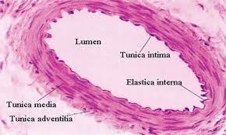the heart through superior and inferior vena cava , both of them empty into the right atrium of the heart .
Coronary vessels : 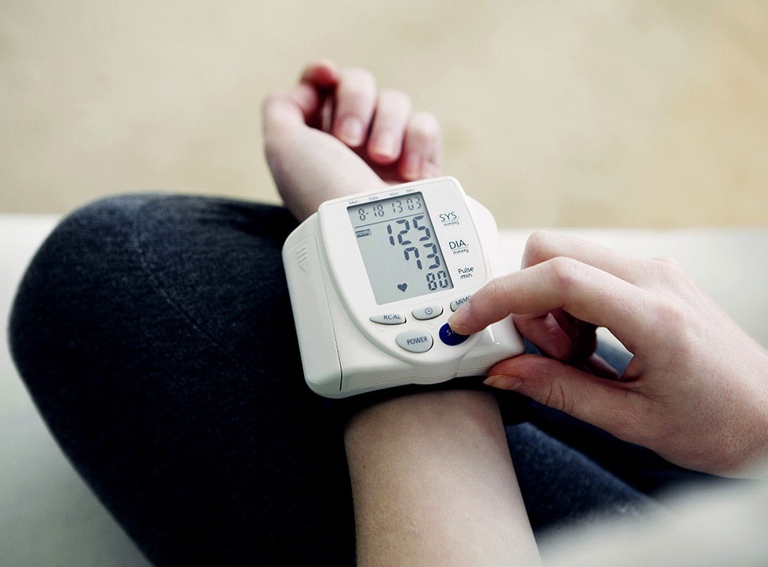
Coronary Vessels :
Heart is supplied with oxygen and nutrient through small coronary arteries ( right and left ) , these branches merged from aorta , then blood returns back to the right atrium by coronary veins .

Pulmonary circulation :
Circulatory system of lungs , blood pumped via pulmonary arteries to the lungs and return oxygenated to the heart via pulmonary veins . Gas exchange occurs in the lungs where CO2
Is released from the blood and oxygen absorbed . The pulmonary vein returns with oxygen rich in blood to the left atrium .

