|  |  |  |
| --- | --- | --- |
| **AL-Mustaqbal University College**  **Department of Medical Physics**  **The Second Stage**  **Semiconductors**  **Dr. Rusul Abdul Ameer** | **شعار المستقبل جديد فقط.jpg** | **كلية المستقبل الجامعة**  **قسم الفيزياء الطبية**  **المرحلة الثانية**  **أشباه موصلات** |

**Lecture .4**

**Diffusion**

Movement of particles from regions of high concentration to regions of low concentration.

Diffusion current Density is a current in a semiconductor caused by the diffusion of charge carriers (holes and/or electrons). This is the current which is due to the transport of charges occurring because of non-uniform concentration of charged particles in a semiconductor. The drift current, by contrast, is due to the motion of charge carriers due to the force exerted on them by an electric field. Diffusion current can be in the same or opposite direction of a drift current. The diffusion current and drift current together are described by the drift–diffusion equation.

### Diffusion current versus drift current

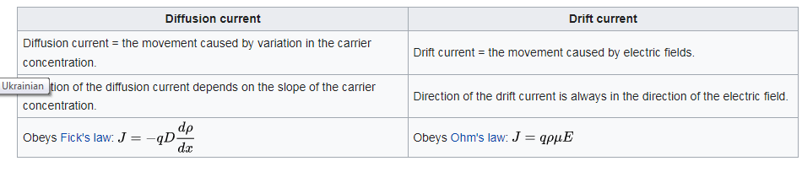

## What is Electric Potential?

Electric potential is the amount of work done when a charged particle is moved from one place to another in an electric field. Here, the charged particle is either positively charged or negatively charged. Usually, the electric potential is measured for the movement of the charged particle from a reference point to a specific point. Moreover, this movement should not accelerate the charged particle. Typically, the reference point we take is Earth.

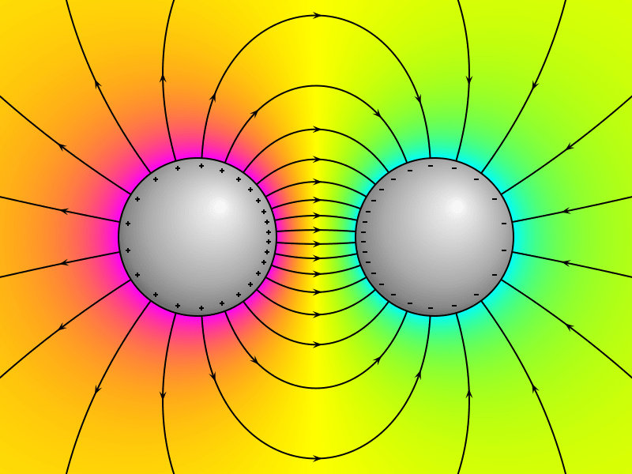

The SI unit for the measurement of electric potential is [Volt](https://www.differencebetween.com/difference-between-amps-and-vs-volts/) (V). This is an extensive property of substances. When determining the value of electric potential, we can do it either in a static or a dynamic electric field. The electric potential at the reference point is considered as zero. Practically, electric potential is a continuous value which is a function of space.

## What is Electric Field?

Electric field is the surrounding of an electric charge unit which can exert a force on other charged particles in the field. We can abbreviate this term as E-field as well. The charged particles in the electric field can be either attracted or repelled by the central charge unit, depending on the electrical charges and their magnitude.

When considering the atomic scale, an electric field is responsible for the attractive force between the atomic nucleus and the [electrons](https://www.differencebetween.com/difference-between-ions-and-vs-electrons/). This attractive force is the glue that holds the nucleus and electrons together to make up the structure of an atom. Also, these attraction forces are important in chemical bond formation. The unit of measurement for electric field is volt per meter (V/m). This unit is exactly equal to the unit Newton per coulomb (N/C) in the SI unit system.

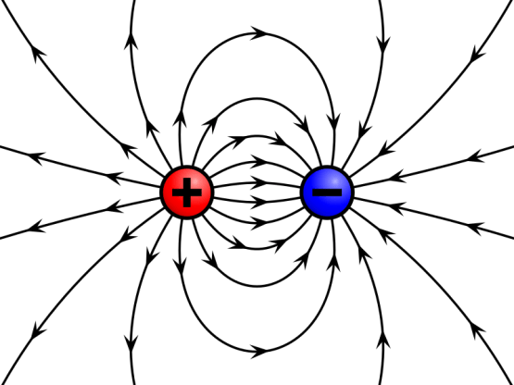

## What is the Difference Between Electric Potential and Electric Field?

The key difference between electric potential and electric field is that electric potential refers to the work need to be done in order to move a unit charge from one place to another, under the influence of an electric field, whereas electric field is the surrounding of an electrical charge which can exert a force on other charges in the field. In other words, electric potential measures the work done by an electric field, while electric field measures the force exerted on a charged particle in the field other than the central charged unit.

**\*\*\***The terms electric potential and electric field are useful in physical chemistry, under the subcategory of electrochemistry. The key difference between electric potential and electric field is that electric potential refers to the work need to be done in order to move a unit charge from one place to another, under the influence of an electric field whereas electric field is the surrounding of an electrical charge which can exert a force on other charges in the field.

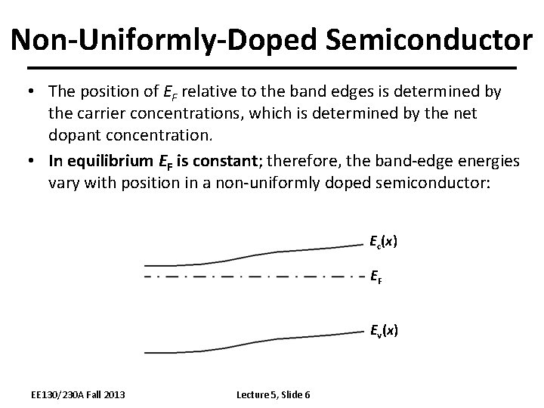

# The "Non-Uniformly Doped Semiconductor " mean that is non uniformly doped, the electrons will tend to diffuse from higher concentration towards the lower concentration. leaving behind positively charged donor ions.

# Carrier Generation and Recombination

Carrier generation is a process where electron-hole pairs are created by exciting an electron from the valence band of the semiconductor to the conduction band, thereby creating a hole in the valence band. Recombination is the reverse process where electrons and holes from the conduction respectively valence band recombine and are annihilated. In semiconductors several different processes exist which lead to generation or recombination, the most important ones are:

* photon transition or optical generation/recombination,
* phonon transition or Shockley-Read-Hall generation/recombination,
* Auger generation/recombination or three particle transitions, and
* impact ionization.

In thermal equilibrium the generation and recombination processes are in dynamic equilibrium. When the system is supplied with additional energy, for example through the absorption of photons or the influence of temperature, additional carriers are generated.

