**Lec -10-**

**Virology**: Is the science that deals with discovery, isolation, identification, characterization, pathogenicity, and classification of viruses.

**Virus**: Is an infectious particle which is obligate intracellular parasite require a hosts to cause damage, they contain only one type of nucleic acid either RNA or DNA.

**General features of viruses**

Sub microscopic entity (No cellular) consisting of a single nucleic acid (either DNA or RNA not both) surrounded by a protein coat and capable of replication only within the living cells of bacteria, animals or plants. **Obligate Intracellular Parasite**

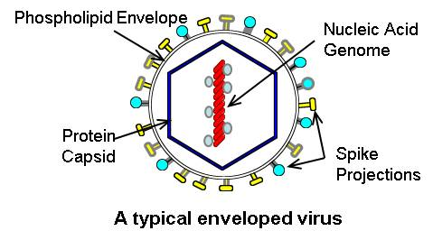

**Virus Structure**

1. Nucleic Acid
2. Lipid Envelope
3. Protein capsid
4. Spike projections

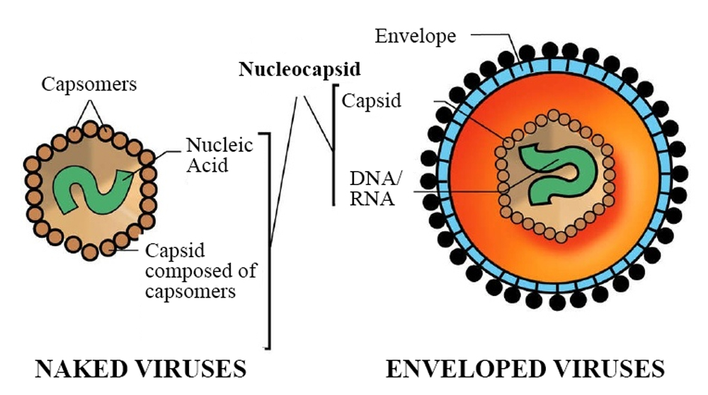

**General Features**

* Non cellular
* Have no nucleus, ribosomes or mitochondria, they depend on the host for protein synthesis and ATP production
* Have no motility
* Replicate by binary fission (= asexual reproduction which involves the splitting of the parent cell into two progenies).

**A virus is an infectious agent made up of**

* nucleic acid (DNA or RNA) wrapped in
* a protein coat called a capsid.

**All viruses contain the following two components:**

1. **Nucleic acid genome**
2. **Capsid**: That covers the genome. Capsid with Nucleic acid is called the **nucleocapsid.**

**Capsid composed of** units called capsomers

The function of the capsid

* To protect viral nucleic acid from harmful effects.
* The capsid gives shape of virus.
* Mediated attachment of viruses to specific receptor on surface of host cells.
* Act as antigen that induce neutralizing antibodies and activate cytotoxic T-cell to kill virus- infected cells.

1. **Envelope**: A lipid- containing membrane that surrounds some virus particles

Virus-encoded glycoproteins are exposed on the surface of the envelope. These projections are called **peplomers**

* **Transmission of Viruses**
  + Respiratory transmission (Influenza A virus)
  + Faecal-oral transmission (Enterovirus )
  + Blood-borne transmission (Hepatitis B virus)
  + Sexual Transmission (HIV)
  + Animal or insect vectors (Rabies virus)

**Life Cycle**

However, the details of virus infection and replication vary greatly with host type; all viruses share 6 basic steps in their replication cycles. These are:

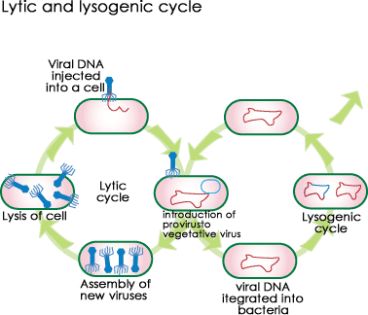

1. Attachment
2. Penetration
3. Uncoating
4. Replication
5. Assembly
6. Release

As shown in,

**The first stage in viral infection is attachment of virus to specific receptor on the surface of host**

Next, **penetration occurs, either of the whole virus or just the contents of the capsid.** If the entire capsid enters, the genetic material must be uncoated

(**Uncoating is removing the capsid proteins(** to make it available to the cell's replication machinery.

Replication of genetic material takes place, as well as the production of capsid and tail proteins.

Once all of the necessary parts have been replicated, individual virus particles are assembled and released.

Release often takes place in a destructive manner:  **A- Lysis of infected cell.**

**B- Budding (without lysis) through the outer cell membrane.**