**Lec -6- Blood**

**Blood** liquid connective tissue, that delivers necessary substances such as nutrients and oxygen to the cells and transports metabolic waste products away from those cells.

* It can cross the tissues.
* Has red color.
* Has volume of 5-6 liters, this is 7-8% of the total body weight.
* Has pH of 7.3-7.4 (alkaline).

**Composition of the Blood**

**The blood composed of two parts**

1. **Liquid part** called **plasma** constitute about 55% of whole blood consists of 90% water, and 8-9%solids (contains proteins, glucose, mineral ions, hormones, carbon dioxide and vitamins).
2. 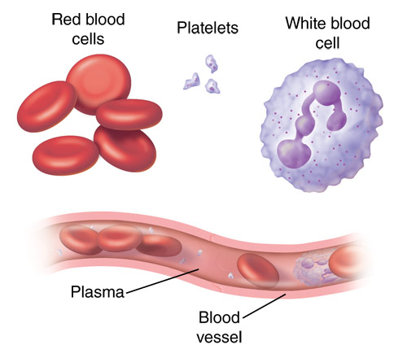**Cellular part** (formed elements) 45 % include **RBC, WBC and platelets**.

**Blood cells**:

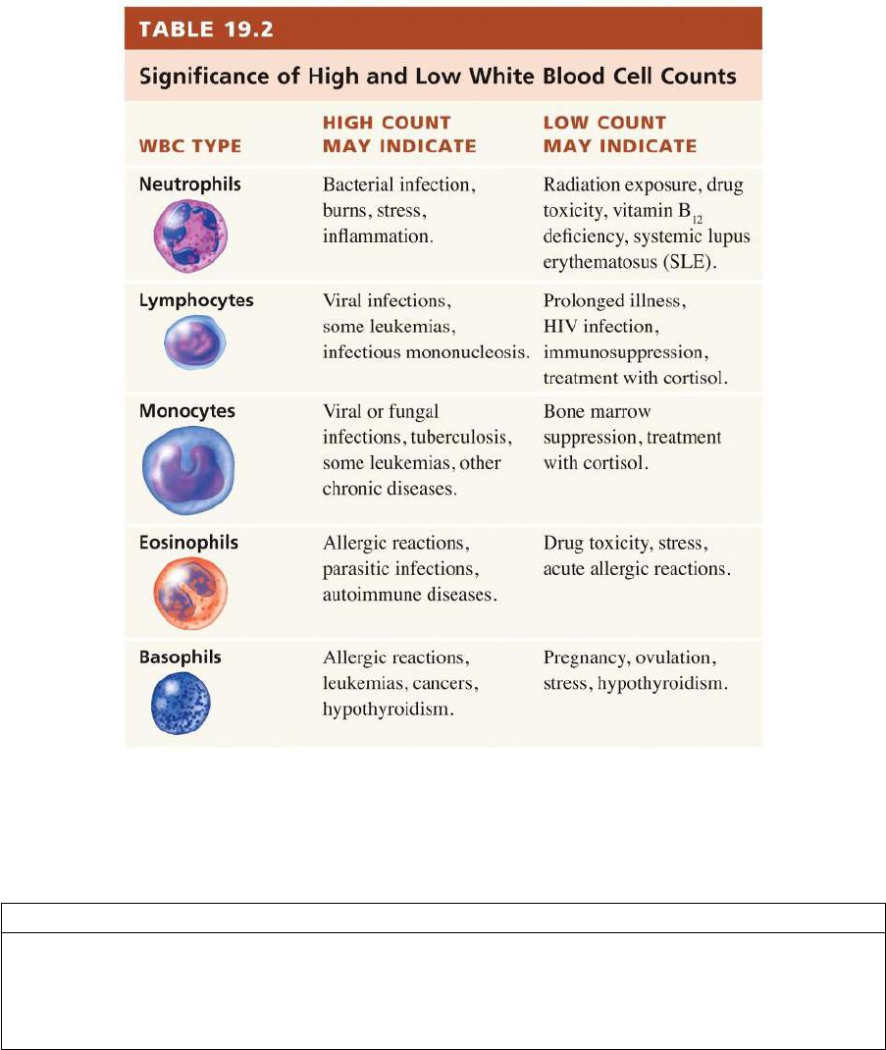**• Red blood cells (Erythrocytes):** which carry oxygen on surface by hemoglobin protein to the tissues.  
**• White blood cells (Leucocytes):** which fight infections **• Platelets:** smaller cells that help blood to clot.

**The plasma**

**A liquid makes up about half of the content of blood, contains proteins that help blood to clot, transport substances through the blood, and perform other functions.**

**Other important components include:**

* Serum (The term serum refers to plasma from which the clotting proteins have been removed. Most of the proteins remaining are albumin and immunoglobulins)
* Blood-clotting factors (to facilitate coagulation)
* Immunoglobulins (antibodies)
* lipoprotein particles
* Various other proteins
* Various electrolytes (mainly sodium and chloride)

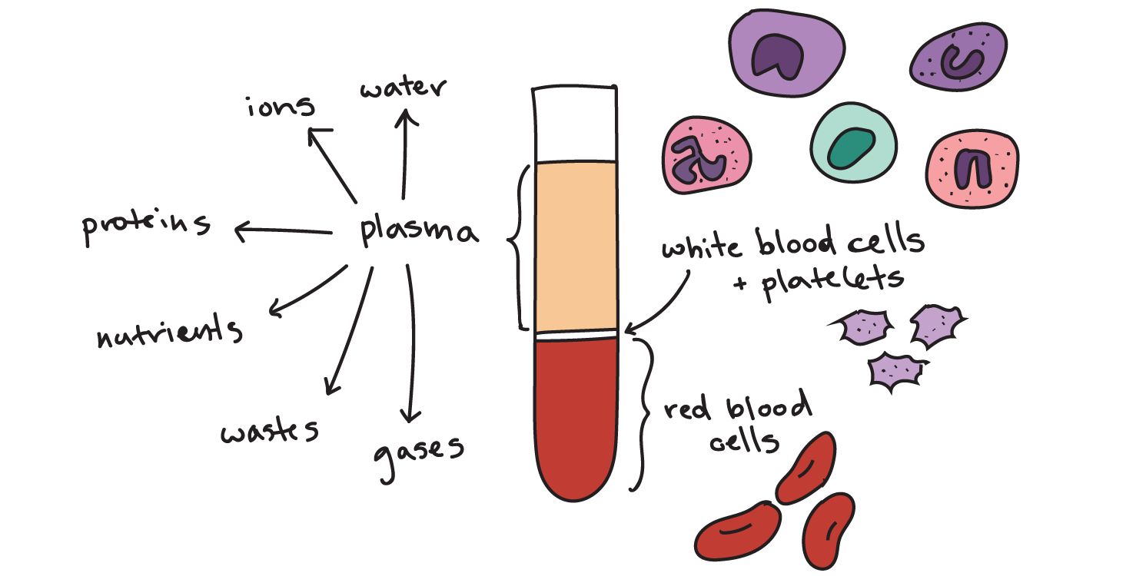

**Functions of Blood**

1. Transportation and distribution

* Transport the oxygen to cells and tissues
* Transport the nutrients such as amino acids, fatty acids, and glucose
* Transport the Waste products such as CO2
* Transporting hormones

1. Regulatory Function:

* Regulate and maintain the pH of the blood between pH 7.35–7.45 (Buffer systems).
* Regulate plasma osmotic pressure,
* Regulate the temperature level of the body

1. Protective function

* Control blood loss (Platelets)
* Fighting infections (WBC and antibodies)

**Lymph**

**Lymphatic system** is part of the immune system, which help to maintain the body’s fluid balance and protect it from pathogens. The major components of the lymphatic system include **lymph**, **lymphatic vessels**, and **lymphatic organs** that contain lymphoid tissues.

**Lymph** is a clear fluid that flows around the body in the lymphatic system. Lymph contains water, proteins, salts, lipids, white blood cells, and other substances that must be returned to the blood.

**Lymphatic vessels** are structures that absorb fluid that diffuses from blood vessel capillaries into surrounding tissues.

This fluid is directed toward **lymph nodes (**These structures filter lymph of pathogens, such as bacteria and viruses, also filter cellular waste, dead cells and lymph nodes are house immune cells called lymphocytes.) to be filtered

And, Ultimately **re-enters blood circulation** through veins located near the heart.

**Lymphoid organs:** The lymphatic system is composed of:

* **Primary lymphoid organs:** These organs include the **bone marrow** and the **thymus**. They create special immune system cells called lymphocytes.
* **Secondary lymphoid organs:** These organs include the **lymph nodes**, the **spleen**, the **tonsils** and certain tissue in various mucous membrane layers in the body.

**General Functions of Lymphatic System**

1. **Maintains fluid levels in your body:** the lymphatic system collects excess fluid from cells and tissue throughout your body and returns it to bloodstream.
2. **Absorbs fats from the digestive tract:**Lymph includes fluids from your intestines that contain fats and proteins and transports it back to your bloodstream.
3. **Protects your body against foreign invaders:**The lymphatic system is part of the immune system. It produces and releases lymphocytes (white blood cells) and other immune cells that monitor and then destroy the foreign invaders such as bacteria, viruses, parasites and fungi, which may enter your body.
4. **Transports and removes waste products and abnormal cells from the lymph.**

