Lec 5: Histology (2)
Connective tissue
Connective tissue forms a framework upon which epithelial tissue rests and within which nerve tissue and muscle tissue are embedded. Blood vessels and nerves travel through connective tissue.

Functions of connective tissue include:

- Wound repair / inflammatory response
- mechanical support for other tissue
- Transport, immunological defense, energy reserve, haemopoiesis, and inflammation

All forms of connective tissue share some common structural features and a common embryonic origin.
- Connective tissue consists of individual cells scattered within a matrix.
- Cells of connective tissue are not directly attached to one another .
- Connective tissue is derived from mesoderm (unlike most epithelial tissue which is derived from ectoderm and endoderm).

- Composition:
- Cells
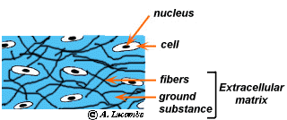
there are two main types :
1-Fixed cells (such as Fibroblasts (Fibrocytes), Macrophages, Mast Cells, adipose cell).
2-Wandering cells (such as plasma cells ,lymphocytes ,neutrophils, eosinophils, basophils ,monocytes) .

- Fibers and ground substance (extracellular matrix)
Extracellular matrices consist of different combinations of protein fibers (collagen and elastic fibers) and ground substance.

The Fibers, there are three types of fibers secreted by connective tissue .
- White Fibers or Collagen Fibers
- Yellow Fibers or Elastic Fibers
- Reticular Fibers

Tissue | Purpose | Location
Collagenous fibers | Bind bones and other tissues to each other | Tendon, ligament, skin, cartilage, bone, blood vessels, gut, and intervertebral disc.
Elastic fibers | Allow organs like arteries and lungs to recoil | extracellular matrix
Reticular fibers | Form a scaffolding for other cells | liver, bone marrow, and lymphatic organs

Ground substance: the ground substance occupies the space between the cell and fibers of connective tissues. Consists of proteoglycans and hyaluronic acid .
Ground substance may be highly modified in the special forms of connective tissue.
- In blood, the ground substance lacks stabilizing macromolecules. We call this free- flowing ground substance plasma.
Ground substance: the ground substance occupies the space between the cell and fibers of connective tissues. Consists of proteoglycans and hyaluronic acid .

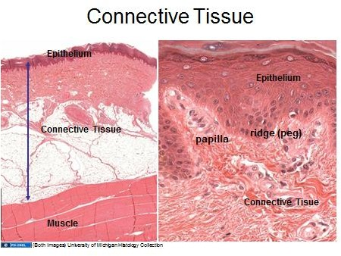

Classification of connective tissues:
Connective tissues classified to proper ,specialized and embryonic connective tissues.
- Proper connective tissues include loose and dense connective tissues.
- Loose connective tissues include: biological packing material; supports epithelia lining gut, respiratory & urinary tracts, etc.

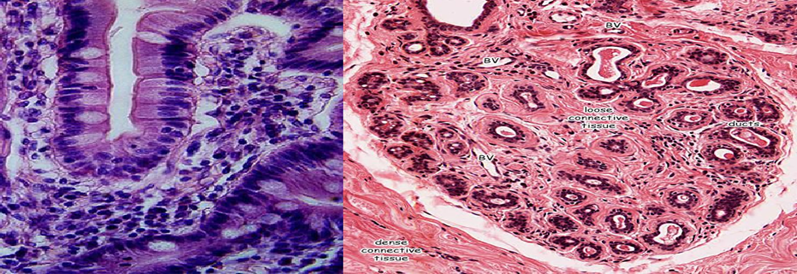

Types
- Areolar con. T. hypodermis
- Mucoid con. T. (umbilical cord)
- Reticular con T. (lymph node)
- Adipose con. T. (under the skin)
- Mesenchymal con. T. (embryo)

- Dense connective tissue also called dense fibrous tissue
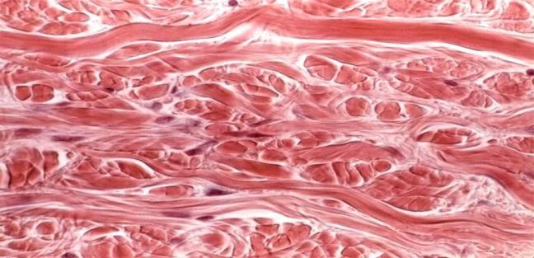
- Irregular con. T. (dermis)

- Regular con. T. include:

Types
- White fibrous con. T. (tendon)
- Elastic con. T. (ligament of the vertebral column).

II) Specialized connective tissue includes: includes tendons and ligaments, Bone and Cartilage, haemopoetic tissue, blood and adipose tissue.
III) Embryonic connective tissue includes: mesenchyme and mucous connective tissue

Muscular tissue
Is composed of cells that have the special ability to shorten or contract in order to produce movement of the body parts.
Muscle occurs in three distinct types:
- Skeletal muscle.
- Smooth muscle.
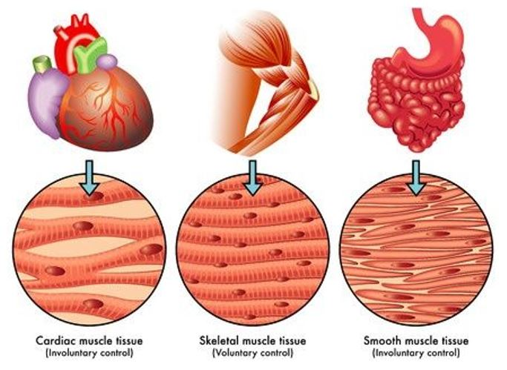
- Cardiac muscle.

Muscle type | Structural elements | Function | Location
Skeletal | - Long cylindrical fiber  - striated  - many peripherally located nuclei | - Voluntary movement,  - produces heat  - protects organs | Attached to bones
Cardiac | - Short  - branched  - striated  - single central nucleus | Contracts to pump blood | Heart
Smooth | - Short  - spindle-shaped  - no striation  - single nucleus in each fiber | - Involuntary movement  - moves food  - involuntary control of respiration  - moves secretions  - regulates flow of blood in arteries by contraction | Walls of major organs and passageways

The Nervous tissue
Is composed of interconnecting network of specialized cells called neurons (nerve cells), found in the brain, spinal cord, and nerves. It is responsible for coordinating and controlling many body activities.
Nervous tissue consists of two major types of cells:
1. Neurons - responsible for conduction, propagation, and reception of nervous impulses. Processes called axons or dendrites extend from these cells.
2. Glial cells - (neuroglia) cells associated with neurons. No axons or dendrites. These cells are involved in nutrition, support, protection of neurons.
The nerve tissue or the nervous tissue consist of the two major parts of the nervous tissue
- Central nervous system(CNS) formed by the spinal cord and the brain
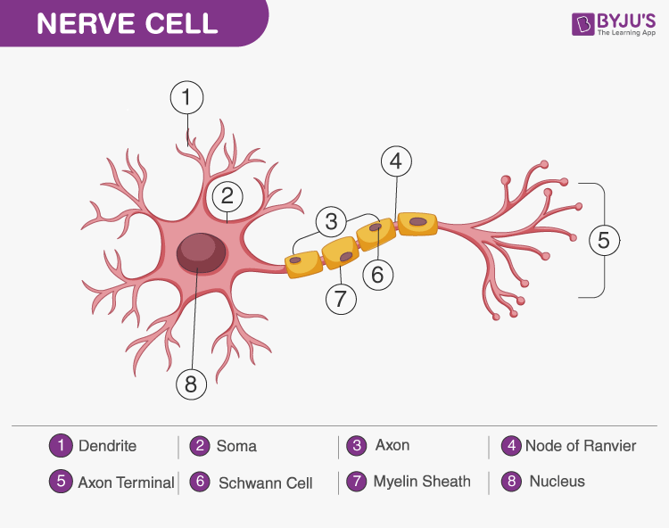
- Peripheral nervous system (PNS) that control and regulate the functions of the body and their activities.
Function Of Nervous Tissue
- Neurons generate and carry out nerve impulses.
- Responds to stimuli
- Carries out communication and integration
- Provides electrical insulations to nerve cells and removes debris
- Carries messages from other neurons to the cell body

