**Bacteria**

**Microbiology** study of microorganisms that are too small to be visible with the naked eye. This includes bacteria, viruses, fungi and others microbes.

**Prokaryotes** are organisms made up of cells that lack a cell nucleus or any membrane-bound organelles. Most prokaryotes are made up of just a single cell (unicellular).

**Bacteria**

Bacteria Bacteria are a large group of microscopic, occur almost everywhere.

They have a simple internal structure, including capsule, cell wall, DNA, flagellum, pili, cytoplasm, and ribosomes.

* are unicellular
* have both DNA and RNA
* Prokaryotic cells
* 70s ribosomes
* No mitochondria
* Some have capsule
* Have cell wall
* Some motility (flagellum, pili)
* Replicate by binary fission.
* Vary in sizes, measure approximately 0.1 to 10.0 μm.
* Some bacteria can cause diseases for human, animals and plants.
* Widely distributed. It can be found in soil, air, water, and living bodies.
* Some bacteria are harmless (i.e. live in human bodies as normal flora).

Prokaryotic cell structure

* **Shape** 
  + Cocci – round
  + Bacilli – rods
  + Spirochetes – spiral shaped
  + Pleomorphic – bacteria that have many different shapes (like jello – spreads out in different shapes)
  + The shape is determined by the rigidity of the cell wall
* **Arrangement** 
  + Pairs – Diplo
  + Chains – Strepto
  + Grape cluster – Staphylo
  + Arrangement is determined by degree of attachment at time of cell division. E.g. cocci, diplococci, streptococci, staphylococci .
* **Size**

-Range from 0.2 ~ 5 µm.

* + The smallest bacteria, Mycoplasma, are about the same size as the largest virus (Pox).
  + A largest bacterium is Bacillus Anthracis .

Cell shape is generally characteristic of a given bacterial species, but can vary depending on growth conditions.

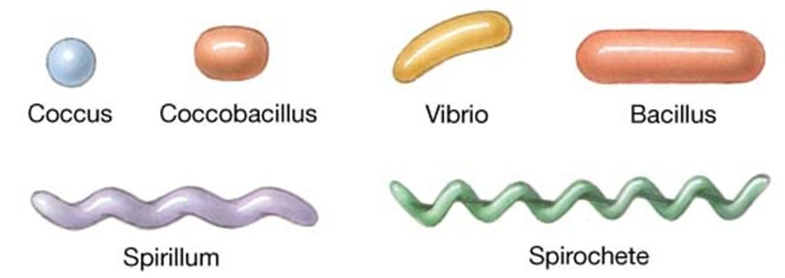

Structurally, a bacterial cell has three architectural regions:

**1. Appendages** (attachments to the cell surface) in the form of **flagella** and **pili (or fimbriae)**.

2. **Cell envelope** consisting of a **capsule**, **cell wall** and **plasma membrane**.

**3**.**Cytoplasmic region** that contains the cell **chromosome** (**DNA**) and **ribosomes** and various sorts of **inclusions.**

**Bacterial motility**

The ability of an organism to move by itself is called **motility**. *

* Prokaryotes move by means of propeller-like **flagella**.

*Almost all spiral bacteria and about half of the bacilli are motile, whereas essentially none of the cocci are motile.

**Site of flagella**

1-Peritrichous 2- Monotrichous

3. Amphitrichous 4. Lophotrichous



**Difference between Gram-Positive and Gram-Negative Bacteria**

|  |  |
| --- | --- |
| **Gram-Positive bacteria** | **Gram-Negative bacteria** |
| **Cell Wall** | |
| **Their cell wall is smooth and single-layered** | **They have a wavy and double-layered cell- wall** |
| **Peptidoglycan Layer** | |
| **It is a thick layer** | **It is a thin layer** |
| **Teichoic acids** | |
| **Presence of teichoic acids** | **Absence of teichoic acids** |
| **Outer membrane** | |
| **The outer membrane is absent** | **The outer membrane is present** |

|  |  |
| --- | --- |
| **Lipid content** | |
| **Very low** | **20 to 30%** |
| **Lipopolysaccharide** | |
| **Absent** | **Present** |
| **Toxin Produced** | |
| **Exotoxins** | **Endotoxins or Exotoxins** |
| **Resistance to Antibiotic** | |
| **More susceptible** | **More resistant** |
| **Examples** | |
| **Staphylococcus, Streptococcus, etc.** | **Escherichia, Salmonella, etc.** |
| **Gram Staining** | |
| **appear as purple-coloured when examined under the microscope after gram staining.** | **appear as pink-coloured when examined under the microscope after gram staining.** |

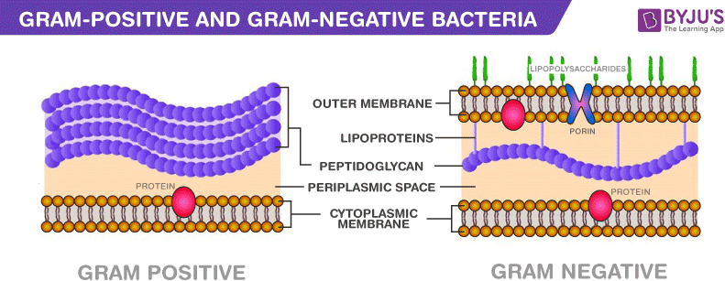

METHODS OF ISOLATION OF BACTERIA

Methods of isolation of bacteria can be broadly classified into two

* **Culture methods**
* On Solid media
* On Liquid media
* Automated systems
* **Non-culture methods** Isolation of bacteria can also be carried out by non-culture methods. In particular the more advanced Amplification techniques like Polymerase chain reaction (PCR), being used in clinical laboratories for isolation and identification of bacteria.