**Lec 8: Immunology**

**Immunology:** is the study of host's defense mechanisms against disease, also study the interaction between human and disease agents (pathogenic microbes).

***Or***

The capacity of immune system to recognize and tolerate the self-cells, and reject foreign non-self-cells.

**Immunity**: refers to the general ability of the host to resist a particular infection or disease.

**Antibody (Ab):** a protein present in the blood produce as a result of interaction with an Ag. It has the ability to combine with Ag that stimulated its production.

**Antigen (Ag) Or immunogen:** it is a foreign substance such as protein (pathogen) that reacts with Ab.

* **Function of Immune system**

1. Distinguish between self and non self antigen
2. Protect the body and defense against infection and disease

**Difference between Innate and Adaptive Immunity**

|  |  |  |  |
| --- | --- | --- | --- |
|  | **Characteristics** | **Innate Immunity** | **Adaptive immunity** |
| 1. | Presence | Innate immunity is something already present in the body. | Adaptive immunity is created in response to exposure to a foreign substance. |
| 2. | Specificity | Non-Specific | Specific |
| 3. | Response | Fights any foreign invader | Fight only specific infection |
| 4. | Response | Rapid | Slow (1-2 weeks) |
| 5 | Inheritance | Innate immunity is generally inherited from parents. | Adaptive immunity, is not passed from the parents, hence it cannot be inherited. |
| 6 | Memory | No memory | Long term memory |
| 7 | Presence | Present at birth | Develops during a person’s lifetime. |
| 8 | Used Against | For microbes | Microbes and non-microbial substances called antigens |
| 9 | Diversity | Limited | High |
| 10 | Speed | Faster response | Slower response |
| 11 | Composition | The innate immune system is composed of physical and chemical barriers, phagocytic leukocytes, dendritic cells, natural killer cells, and plasma proteins. | Adaptive immune system is composed of B cells and T cells, Antibody. |

**The immune response**

The immune response beginning with elements of the innate immune system followed by the adaptive immune system.

The interrelationship of these two arms of our immune system is hematopoietic precursor, stem cell. Cells of the innate immune system derive from myeloid precursors whereas cells associated with the adaptive immune system are derived from common lymphoid precursors

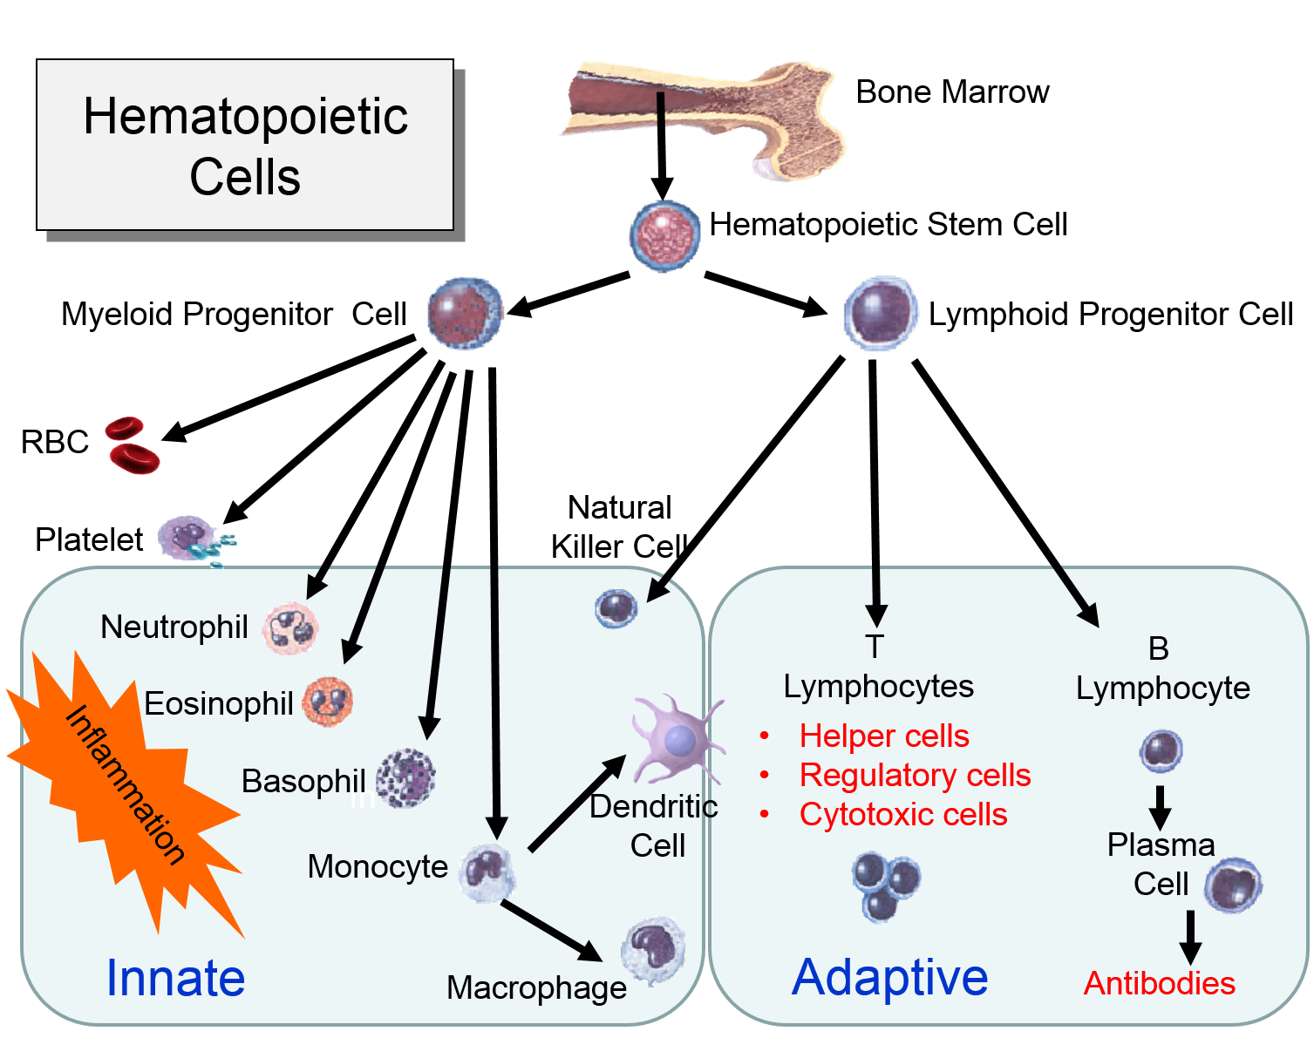

**Innate (non specific) immunity**

* **A-Non – specific innate defenses**

The body has a number of built in defense mechanisms, which provide protection against

a wide range of pathogens , it is includes general mechanisms inherited as part of innate

structure and **act as a first line of defenses called non - specific innate defenses .**

**Mechanism of Innate Immunity**

1. **Anatomic or physical** (skin, mucous membranes ,Waxes in ears)
2. **Physiologic or chemical** (temperature, pH, lysozyme, complement, and some interferons)
3. **Biological factors**: include the normal flora of the (skin, GIT) can prevent the colonization of pathogenic microbes by secreting toxin substances or by competing with pathogens for nutrient or attachment to host cells.
4. **Phagocytic** (monocytes, neutrophils, macrophages)
5. **Inflammatory and fever action**

* **Innate immune cells include:**

1. Neutrophils
2. Natural killer cell
3. 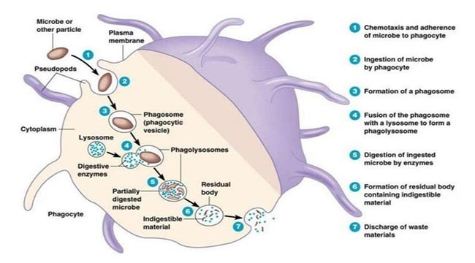 Macrophage
4. Eosinophils

* **Adaptive Immune System**

*Classification of* **acquired or adaptive (specific) immunity according to the nature of components of immune mediated reactions:**

1. **Humoral immunity (HI):** mediated by specific glycoproteins (immunoglobulins or Ab), which are B-lymphocytes.
2. **Cell mediated immunity (CMI):** mediated by specific cells, which are T lymphocytes.

* **Adaptive immune cells include:**

**The cells involved in this type of immunity are lymphocytes both T and B cells.**

1. 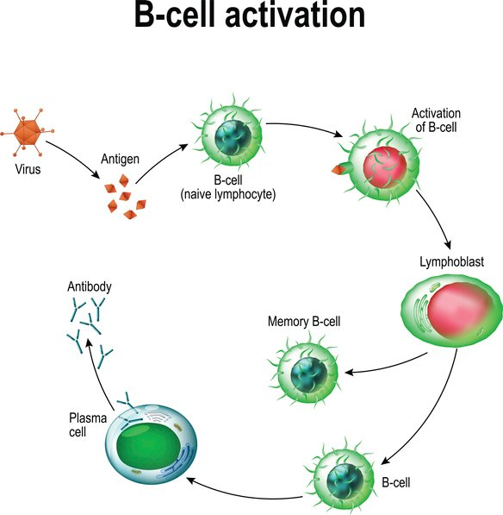**B-lymphocytes:** it recognizes antigens and develop into antibody- secreting cells IgG, IgM, IgA, IgE, IgD.
2. **T-lymphocytes**
3. **Helper T** lymphocytes recognize antigens on the surfaces of antigen-presenting cells and secrete cytokines, which stimulate different mechanisms of immunity and inflammation.
4. **Cytotoxic T lymphocytes** recognize antigens on infected cells and kill these cells.
5. **Regulatory T cells** suppress and prevent immune responses (e.g., to self antigens

