
AL-MUSTAQBAL UNIVERSITY COLLAGE
Department of Pharmacy

Glycosides

Exp.No. 4
[Lab.6] Tannins
Tannins compromise a large group of complex substances that are widely distributed in the plant kingdom. Chemically tannins are complex substances; they usually occur as mixtures of poly hydroxyl phenols that are difficult to separate because they do not crystallize. Tannins are divided according to the identity of the phenolic nuclei involved, and on the way they are joined into two classes:
1 .Hydrolysable tannins:
This class consists of gallic acid and related polyhydroxy compounds (hexahydroxydiphenic acid) and theirderivatives esterified with glucose. They are termed hydrolysable tannins due to ease of esters to hydrolyze to phenolic acids and sugar. They were formerly known as pyrogallol tannins.
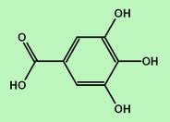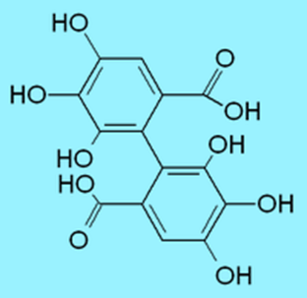
Gallic acid Hexahydroxydiphenic acid
2. Nonhydrolysable tannins or condensed tannins:
This class contains onlyphenolic nuclei but frequently linked to carbohydrates or proteins. When treated with hydrolytic agents, these tannins tend to polymerize, yield insoluble usually red-colored products known as phlobaphenes.
The name (condensed tannins) is due to the fact that on the treatment with hot acid some of C-C bonds are broken yielding anthocyanidin monomers.These tannins are sometimes called catechol tannins.
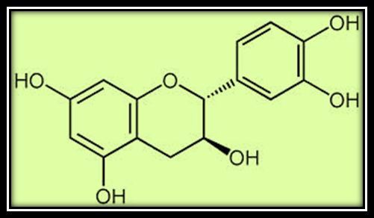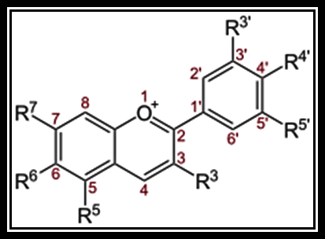
Catechin Anthocyanins
(Are glucosides of anthocyanidins)

General properties of Tannins:
- Tannins are non–crystallizable compounds that,with water .form colloidalsolution possessing acid reaction and sharp "puckering "taste.
- They cause precipitation of solution of gelatin as well as alkaloids.
- They form dark blue, greenishblack soluble compounds with ferric salts.
- They produce deep red color with potassium ferricyanide and ammonia.
- They are precipitated by salts of copper, lead and tin by strong aqueous potassium dichromate or 1%chromic acid solution. In alkaline solutions; many of their derivatives readily absorb oxygen.
- Tannins precipitate proteins from solution and can combine with proteins, rendering them resistant to proteolytic enzymes .when applied to living tissue this action is known as an"astringent" action and form the basis for therapeutic application of tannins.

Uses of tannins:
- Astringents, used in the gastrointestinal tract and on the skin abrasion.
- In the treatment of burns, the proteins of the exposed tissue are precipitated and form amildly antiseptic protective coat under which the regeneration of new tissue may take place.
- Use in the process of vegetable- tanning which converts animal hides to leather (leather industry).
- Antidote treatment of alkaloids poisoning.
- Ink industry.
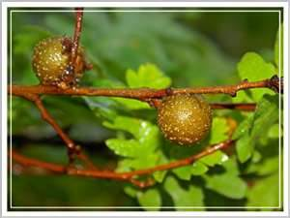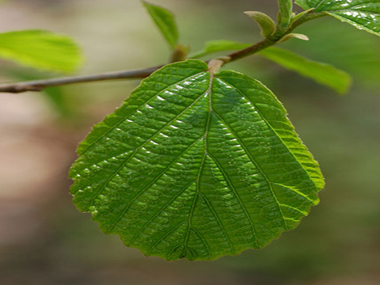
Pyrogalloltannins(Nut gall) Catechole tannins(Hamamelis leaf)

Tests on Tannins
I.Catechole tannins:
Plant used: Hamamelis leaf or witch hazel leaves:
Is the dried leaf of Hamamelis virginiana of the family Hamamelidaceae.
- Microscopically Examination:
Examine the powder drug microscopically for the trichomes and notice the type of stellate, the form-branched stellate trichomes consisting of 4-12 unicellular branches united by their bases.
- Chemical Tests:
Aim: Identity test for Catechol Tannins.
Procedure:
Boil 5gm hamamelis leaf, coarsely powdered, with 50 ml of water. Cool and filter. To 2 ml portions add the following reagents and notice the results:
- Few drops solution of ferric chloride.
- 1ml solution of lead sub acetate.
- 1ml solution of potassium dichromate.
- 2ml solution of gelatin.
- 2ml solution of quinine dihydrochloride.(or any alkaloid).
- 0.5ml solution of sodium acid phosphate, warm, cool and filter. To the filtrate add solution of phenazone.
- Bromine solution.
- 5ml Mitchell's reagent (5 ml of a 0.2% solution of iron and ammonium citrate) and add 1gm sodium acetate. Boil, cool and filter.
Results:
Notice the colors and precipitates obtained.
II. PyrogallolTannins:
Plant used: Gulls, Nutgall.
Is the excrescence obtained from the young twigs of Quercus infectoria of the family Fagaceae.
- Microscopically Examination:
Examine the powdered drug microscopically and notice the following:
- Fairly numerous sclerenchymatous cells.
- Lignin bodies.
- The presence of only a few small vessels.
- A few starch grains.
- Tannin flakes, visible in clove oil mount.
- Thick -walled, pitted parenchyma with both cluster and prismatic crystals of calcium oxalate.
- Occasional insect fragments.
B.Chemical Tests:
Aim: Identity test for Pyrogallol Tannins.
Procedure:
Prepare 0.1% suspension of powdered nutgall in water and is treated with:
- A saturated solution of potassium dichromate plus a trace of acetic acid.
- A 1% solution of sodium carbonate.
- A 5% ferric sulphate solution.
- A 1% ferric acetate solution.
- Shake 0.1gm powdered nutgall with 1ml of water, micro filter one drop into an evaporating dish. Add one drop of a 5% ferric chloride solution.
- Repeat the test no.5 with bromine water.
Results:
Notice the colors and precipitates obtained.

Study problems:
Q1. How many kinds of Tannins according to the phenolic nuclei? Explain with structures?
Q2 .How can you identify an extract containing Pyrogallol tannins?
Q3 .How can you identify an extract containing Catechol tannins?

