

**ALMUSTAQBAL UNIVERSITY COLLAGE PHARMACY DEPARTMANT**

**Practical pharmacognosy / Second year**

**EXPERIMENT NO.6:**

**PAPER CHROMATOGRAPHY FOR THE SEPARATION OF NATURAL PRODUCTS**

**Method:**

Separation of a mixture of natural products (Leucine and Cysteine) uses ascending paper and their identification.

Technique: one way ascending. Paper: Whatman no.1.

Mobile phase (solvent): n-butanol: glacial acetic acid: water (4: 1:5) Temperature: at lab.emperature.

Reference solution: 0.5% Leucine and 1%Cystein in aqueous isopropanol. Examination: Day light after spraying and heating.

Spray: 0.1% Ninhydrine in n-butanol.

Requirement: calculate Rf values, note all colors and tabulate, the results.

What conclusions may be drawn from these results? The extracts provided contains amino acids, which are the building blocks for extracts provided contains amino acids, which are the building blocks for proteins and alkaloids, and which are readily separated by paper chromatography.

·*Note that amino acids and the spray reagent may produce different colors. Draw the chemical reaction between Ninhydrin and amino acids.

O

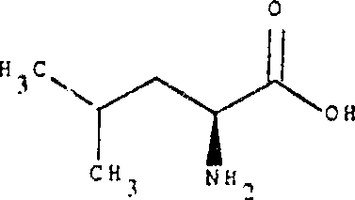+

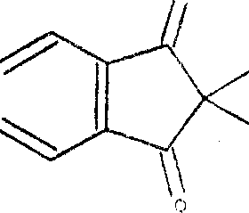

·

Ninhydrin Leucine

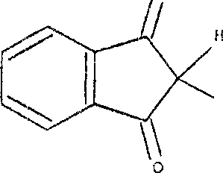O

OH + 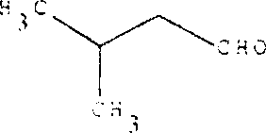 + NH3 + CO2

Ninhydrine oxidatively dcarboxylate aminoacids to CO2 and NH3 and an aldehyde with less carbon atom than the parent aminoacids and reacted ninhydrine that react with liberated ammonia forming blue complex.

*Note: Cysteine is freely soluble in water, slightly soluble in alcohol, practically in soluble in ether. While Leucine sparingly soluble in water, practically insoluble in alcohol and in ether, it dissolves in dilute mineral acids and in dilute solutions of alkali hydroxide.