

**ALMUSTAQBAL UNIVERSITY COLLAGE PHARMACY DEPARTMANT**

**Practical pharmacognosy / Second year**

**Lab.4 Extraction Methods**

Extraction involves the separation of the medicinally active constituents of plants or animal tissues from the active or inert component by using solvent (s) and by using one of the standard extraction procedures.

The products that obtained from plants are relatively impure liquids, semisolid or powders, intended only for oral or external use. These total extractive products are called Galenical, Which came from the name Galen, the 2nd century Greek physician.

Methods of extraction can be divided into:

* 1. Cold Methods.
  2. Hot methods.

Cold extraction methods:

Is the process whereby a substance is extracted from a mixture via cold solvent. The procedure carried out at room temperature (15-25 0 C).

* + 1. **Maceration:**
* This simple widely used procedure involves leaving the pulverized plant to soak in a suitable solvent in a closed container .simple maceration is performed at room temperature by mixing the ground drug with the solvent (drug solvent ratio : 1:5 or 1:10) and leaving the mixture for several days with occasional shaking or stirring. The main disadvantage of maceration is that the process can be quite time-consuming, taking from a few hours up to several weeks.
  + 1. 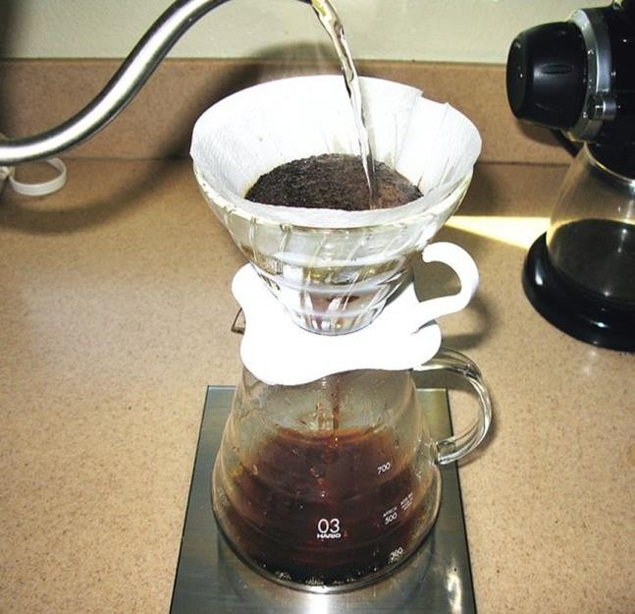**Percolation:**

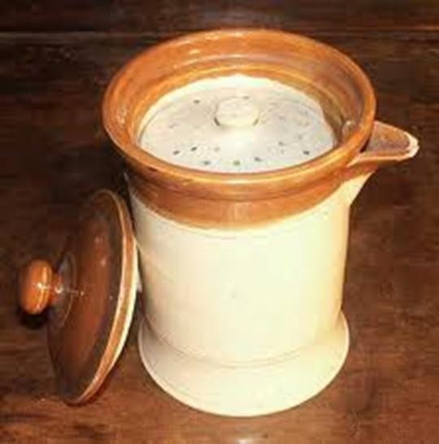**Percolation** (from Lat. *percōlāre*, to filter) concerns the movement and [filtering](http://en.wikipedia.org/wiki/Filtration) of fluids through porous materials. The powdered plant material is soaked initially in a solvent. In a percolator, additional solvent is then poured on top of the plant material and allowed to percolate slowly (drop wise) out of the bottom of the percolator. Additional filtration of the extract is not required because there is a filter at the outlet of the percolator.

Hot Extraction Methods:

1. **Infusion:**

Infusion is the process of extracting chemical compounds or flavors from plant material in a solvent such as water,

oil or alcohol by allowing the material to remain suspended

in the solvent over time. In this procedure we have special container called ‘Infusion pot’ which contain sieves and cover with heavy lid. After the addition of the solvent ,boiling water, left for a while for the extraction of active constituent during that time the volatile oil evaporated with steam and condenses on the lid, after that we take the solvent which contain the active constituent.

* 1. 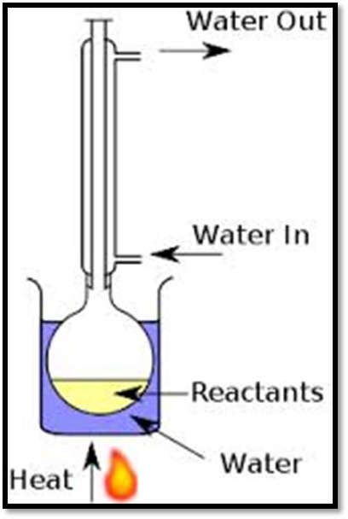**Decoction:**

The term dates back to 1350–1400 ,from present participle stem of Latin decoquere (meaning to boil down), de "from"+ coquere "to cook". Decoction is a method of extraction by boiling, of dissolved chemicals, from hard plant material, which may include stems, roots, bark and rhizomes on a source of heat or direct flame then agitating until the active constituents will be dissolved in the solvent. Here the solvent used depend on the active constituent and source of heat e.g. chloroform and ether can’t be used because we used direct source of heat. In addition to that the active constituent should be heat stable.

* + 1. **Digestion:**

In this method the plant material is placed together with the solvent and application of gentle heat, so that the solvent will increase its power for extraction and this method is used in cases were moderately

elevated temperature is required. e.g. Tea is the brew made from the leaves of the Camellia sinensis plant. It is the beverage most consumed worldwide, after water.

* + 1. **Contiuous hot extraction methods:**
       1. Reflux condenser:

Plant material is immersed in a solvent in

a round-bottomed flask, which is connected to a condenser. The solvent is heated until it reaches its boiling point. As the vapor is

condensed, the solvent is recycled to the flask.

* + - 1. Soxhlet apparatus:

The plant powder is placed in a cellulose thimble in an extraction chamber, which is placed on top of a collecting flask beneath a reflux condenser. A suitable solvent is added to the flask, and the setup is heated under reflux. When a certain level of condensed solvent has accumulated in the thimble, it is siphoned into the flask beneath.

-The main advantage of Soxhlet extraction is that it is a continuous process for the extraction of active constituents decomposed by direct heat.

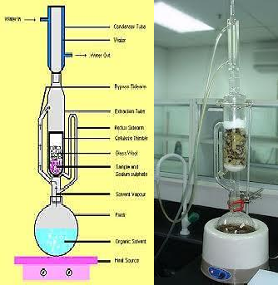

b) Clavenger:

In this method we used a special apparatus which is called ‘Clavenger’, it is used mainly for extraction of volatile compounds,

e.g. orange peels has been used for the extraction of orange oil.

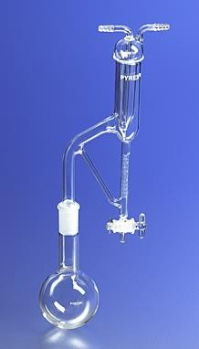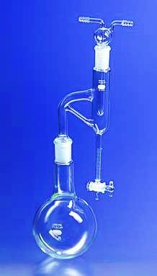

Clevenger Apparatus Clevenger Apparatus

(Oil heavier than Water) (Oil lighter than water)