
AL-MUSTAQBAL UNIVERSITY COLLAGE
Department of Pharmacy

Glycosides

Exp.No. 3
[Lab.5] Saponin Glycosides
This group of glycoside is widely distributed in higher plants. Saponin glycosides form colloidal solution in water that foam upon shaking, this is due to a decrease in the surface tension action done by saponin glycosides, as a result of the hydrophobic/ hydrophilic characteristics of the saponin, and due to this property the saponins are used in the manufacturing of beer, and soap.
Saponins have a bitter, acrid taste, and drugs containing them are usually sternutatory and otherwise irritating the mucus membrane.
They destroy red blood corpuscles by hemolysis and are toxic especially to cold blooded animals therefore many saponins are used as fish poisons. The more poisonous saponin is often called sapotoxin, many are toxic to insects and mollusks, and some are used to control schistosomiasis snails.
Saponin upon hydrolysis yield an aglycone known as sapogenin, which are crystallized upon acetylation, therefore this process is used for purification.
According to the structure of the aglycone, two kinds of saponin are recognized:
1. Pentacyclictriterpenoid saponins (acidic, and the C-atom is C₃₀)
2. Steroidal saponins (neutral C- atom is C₂₇).
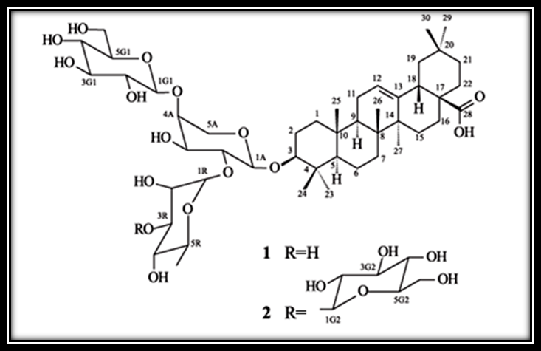
Pentacyclictriterpenoid saponin
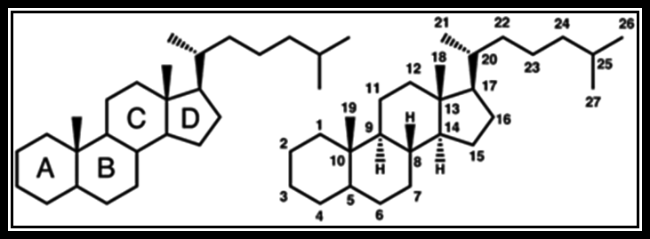
Steroidal saponin
Isolation &Identification of the SaponinGlycosides:
Procedure:
Method of extraction: Decoction.
Plant used: Saponaria officinalis family Caryophyllaceae.
Part used: Dry root.
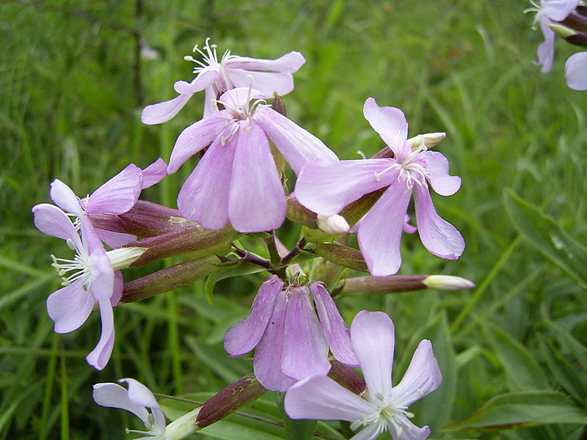
Saponaria officinalis
Add 0.1 gm of saponaria root in coarse powder to 20 ml distilled water in a beaker and boil gently for 2-3 minutes. Filter hot and allow cooling:
- Dilute 5ml of the filtrate with water and shake vigorously.
- To the remaining of the filtrate add 5ml of dilute H₂SO₄ acid and boil gently for 3-5 min_{s} .The aglycones are obtained by acid hydrolysis and are insoluble in water but are soluble in 90% alcohol.
- Make the filtrate obtained from (b) alkaline with NaOH, (litmus paper) and then carry Fehling's test or Benedict's test (5ml filtrate + 2ml of Benedict's reagent heat for 10min_{s} on boiling water bath ).
Specific Reaction:
1.TheHemolytic Test
Aim:Identity test (specific) for saponin glycosides
Equipments& Reagents:
- Two test tube.
- 10% solution of blood in normal saline.
- Normal saline.
Procedure:
Take two test tubes and place in each one 5ml of a 10% solution of blood in normal saline. To one of them, add 5ml of normal saline solution and to the other one add 5ml of the extract of Saponaria root .Shake both tubes gently and notice the result.
Results:
The test tube containing 5ml of the extract of Saponaria will cause blood hemolysis.

2.Foam Index (according to Kofler)
Foam index is a value, which is used to express the quantity of the saponin glycosides in the crude drugs. The method is based upon the property of saponin to form foam when shaken with water. The foam index signifies the dilution of the substance or drug to be tested which gives alayer of foam 1cm high if the aqueous solution is shaken for 15 seconds, and then allow standing for 15 minutes before reading is made.

Foam Index
Aim:Identity test (specific) for saponin glycosides
Equipments& Reagents:
- 10 Test tubes having the same diameter.
- Graduated pipette.
- 0.1% decoction from the powdered drug.
- 1% solution of sodium carbonate.

Procedure:
- Prepare 0.1% decoction from the powdered drug, neutralized it by adding solution of 1% sodium carbonate drop wise (litmus paper) and filter.
- Into 10 test tubes having the same diameter, 1 to 10 ml of this decoction is added respectively using a graduated pipette, complete the volume to 10 ml with distilled water.
- Shake the content of each test tube thoroughly for 15 seconds and allow to stand for 15 minutes.
- After this time, the reading is made in the test tube containing the most dilute solution with a ring of foam1 cm height.
For example: When this is occur in the test tube number 8, which contains 8ml of the decoction and 2 ml of water, then 8 ml of 0.1% decoction corresponds to 0.008 gm of the drug and the dilution is calculated from the following calculation:
gm ml
  - 100
X 8 X= 0.008 gm. of saponin in 8ml of decoction.

gm ml
.008 10
1 X X= 10/0.008
X=1250 ml
.
That means the ring of foam 1cm high is formed by a solution diluted 1:1250. The foam index is therefore 1250.
Note/The addition of sodium carbonate is to convert the acidic saponins that may be present in the decoction, to salts, which are soluble in water.

Study problems:
Q1. How many kinds of sapo genin are found in the medicinal plants? Explain with structures?
Q2.Give the reasons of:
- The addition of H ₂SO ₄ and boiling during the extraction of Saponaria root?
- Alkalinization with NaOH in Fehling's or Benedict's tests?
Q3.How can you identify an extract containing saponin glycosides?

