

**ALMUSTAQBAL UNIVERSITY COLLAGE PHARMACY DEPARTMANT**

**Practical pharmacognosy / Second year**

**EXPERIMENT NO.7**

THIN LAYER CHROMATOGRAPHY (TLC)

Is a method for identifying substances and testing the purity of compounds.

TLC is a useful technique because it is relatively quick and requires small quantities of material.

Separations in TLC involve distributing a mixture of two or more substances between a stationary phase and a mobile phase.

**The stationary phase:**

Is a thin layer of adsorbent (usually silica gel or alumina) coated on a plate.

**The mobile phase:**

Is a developing liquid which travels up the stationary phase, carrying the samples with it.

Components of the samples will separate on the stationary phase according to how much they adsorb on the stationary phase versus how much they dissolve in the mobile phase.

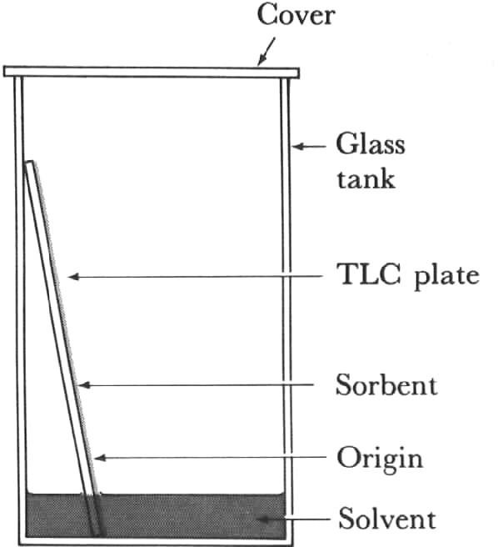

ADVANTAGES OF TLC OVER PC:

* 1. Fractionations can be effected more rapidly with smaller quantities of a mixture.

1. The separated spots are usually more compact and more clearly Identified from one another.
2. The nature of the film is often such that drastic reagents such as H2S04 which would destroy a paper chromatogrnm , can be used for the location of separated substances.

TLC ADSORBENTS:

The grain sizes of most TLC adsorbent lie between 5-50 µm. There are different types of adsorbents that have been used in TLC:

1. Silica gel is amorphous porous substances formed from polysillicic gel.

OH OH O O

polymerization

HO Si OH + HO Si OH O…Si...O….Si….O

OH OH O O

Di- or higher polysilicilic acid

* 1. Alumina oxides used in chromatography containing either –Al2O3 or X Al2O3.
  2. Kieselguhr: Naturally occurring amorphous silicic acid of fossil origin referred to as diatomaceous earth. It has a lot of impurities, water,and organic substances consist of small only slightly active surface and relatively large pore volume (used for partition chromatography).
  3. Kieselguhr G: Finally divided powder of grain size less than 60 µm, use in TLC with Gypsum used as binder.

The stationary phase in TLC is a solid stationary phase , used as a thin film and we can use plastic or glass sheath as an inert support for coating material which does not involve in the separation technique.

We can use Silica gel GF (G = Gypsum and F=Flourescence).In addition to that Alumina can be used as a coating material in TLC depending on the type or the chemical nature and the solubility of the separated compounds.

The mobile phase in TLC is a liquid and it could be a mixture of liquids or a single liquid. We have to know the solubility of the compound and determine what type of stationary phase and mobile phase should be used.

We have different types of silica gel depending on the number of free hydroxyl groups left on the silica gel:

* + 1. Activated.
    2. Inactivated. By the addition of water to silica gel we block the active sites of silica gel. If the silica gel have a large content of water, the water content is considered as a stationary phase and the mechanism of separation is partition.

Development Technique in TLC:

Usually the same technique used in PC can be used in TLC but mainly we are going to use ascending technique in which the TLC plates are placed in a chamber contain the mobile phase.

Detection methods in TLC:

1- Physical detection.

1. Chemical detection.
2. Biological detection.
3. Radioactive detection.