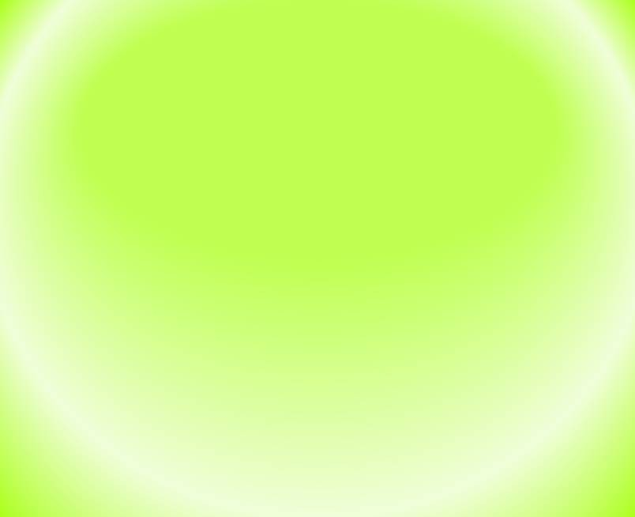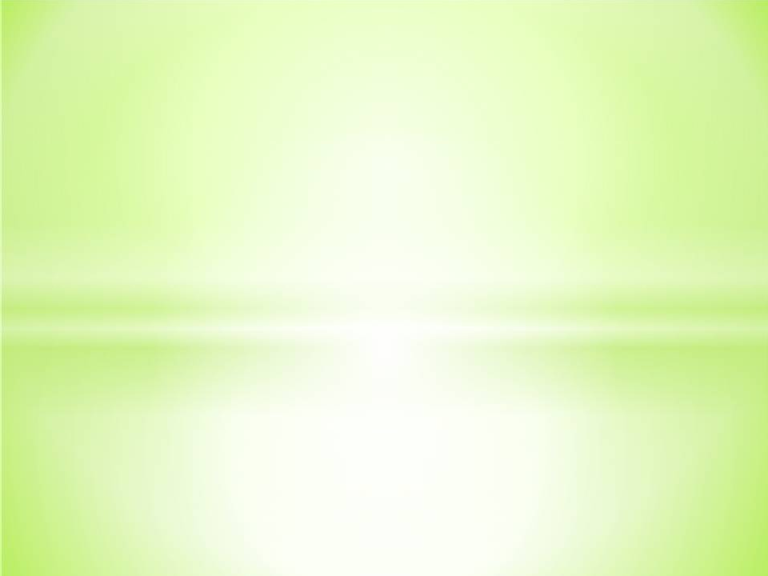

Practical Pharmacognosy

2nd Stage

**2nd semester**

***Dr. Hayder Ridha***

# Lab.2

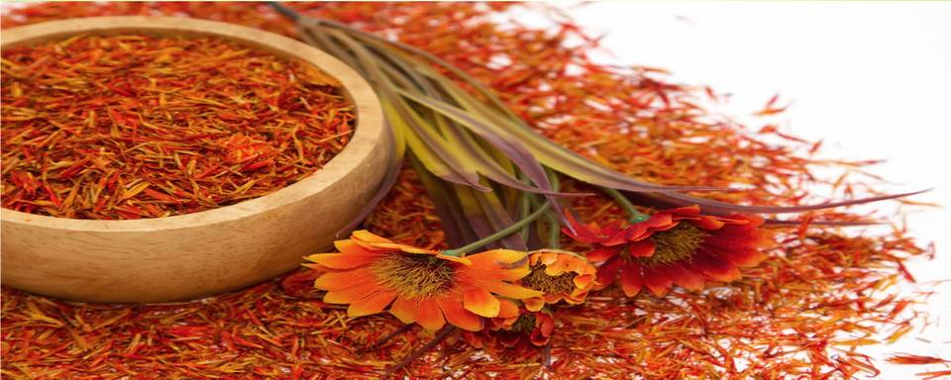



**Morphological and microscopically examination of crude drugs and cell inclusions**

* For convenience of study, drugs may be arranged not only according to families and chemical constituents, but also into such **morphological groups** as barks, roots, leaves, seeds, etc. in another word drugs can be arranged into :

### Organized.

1. **Non-organized drugs.**



# Organized drugs:

### Leaves and tops (herbs)

These consist of stems and leaves often associated with flowers and young fruits.

### Barks

Barks consist of all tissues outside the cambium.

### Woods

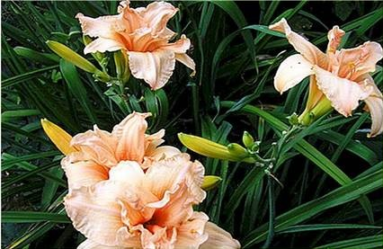Wood consists of the secondary tissues produced by the cambium or its inner surface.

### Leaves or leaflets.

1. **Inflorescences and flowers. 6- Fruits.**

**7- Seeds.**



# Unorganized drugs:

These include:

**fixed oils, fats and waxes; volatile oils; resins, oleoresins, oleo-gum-resins, balsams and gums, dried juices, extracts.**

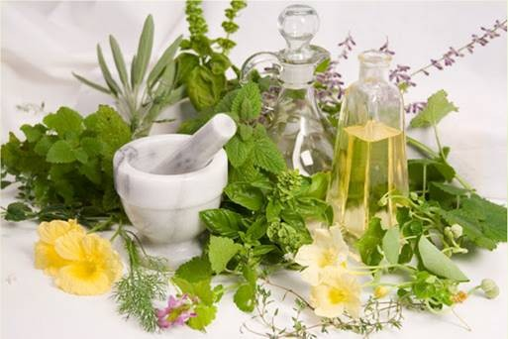



***Cell differentiation:***

* The cell wall
* Parenchymatous tissue
* 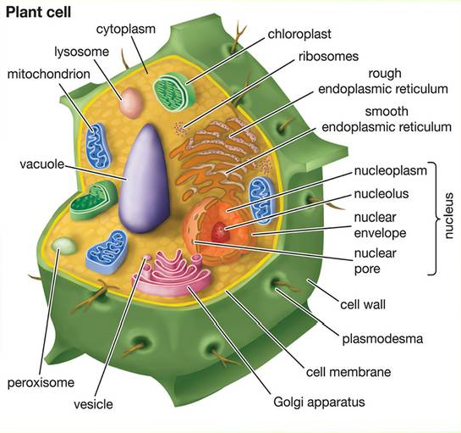The epidermis
* Epidermal trichomes
* The endodermis
* Cork tissue
* Collenchyma
* Sclereids
* Fibers
* Xylem
* Secretory tissue



## 1-The cell wall

There are different types of cell wall:

* 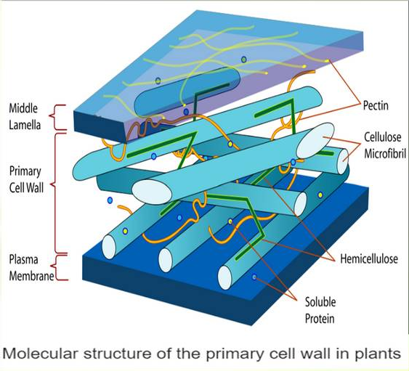Cellulose wall
* Lignified wall
* Chitinom wall
* Cutinized wall
* Mucillaginum wall



## 2) Paranchymatous tissue

* In plants, **"parenchyma**" is one of the three main types of ground tissue, and the most common.
* It can be distinguished through their **thin cell wall**

as compared to other cells.

* 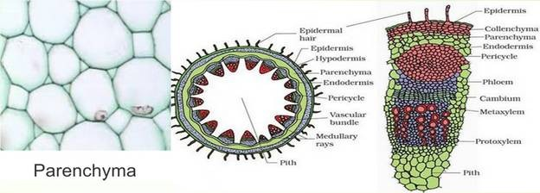Parenchyma cells make up the **bulk of the soft parts of plants**, including the insides of leaves, flowers and fruits (but not the epidermis or veins of these structures).



## The epidermis

Single layer of cells covering the whole plant, the structure of the **epidermis and stomata** are of first important in the microscopically identification of **leaves.**

e.g. Strait – walled epidermis in Senna leaves, waxy walled in Belladonna leaves and beaded wall in digitalis.

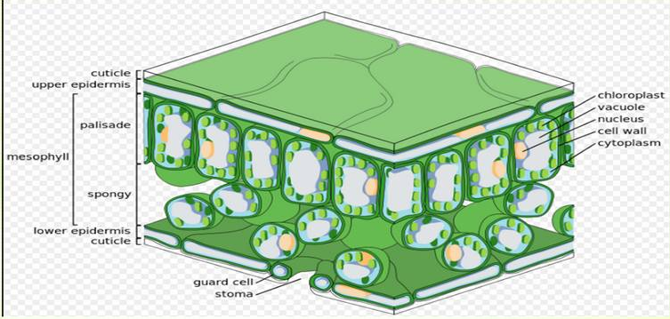



**Types of Stomata:**

* + **Anomocytic stomata:** Cells resembling the other epidermal cells may surround stomata.

e.g. Digitalis purpurea leaves.

▪ **Anisocytic stomata:** With the stomata surrounded by 3 or 4 subsidiary cells, one of which is markedly smaller than other.

e.g. Hyoscymus niger and Atropa belladonna leaves.

* + **Paracytic stomata:** With two subsidiary cells with their long axis parallel to the pore. e.g. Cassia acutifolea ( Senna leaves).
  + **Diacytic stomata:** With two subsidary cells with their long axis at right angles to the pore of the stomata.

e.g. Mentha piperita ( Pepperment).

* + **Actinocytic stomata:** Subsidary cells are arranged along the radii of the circle. e.g. Pilocarpus jaborandi.

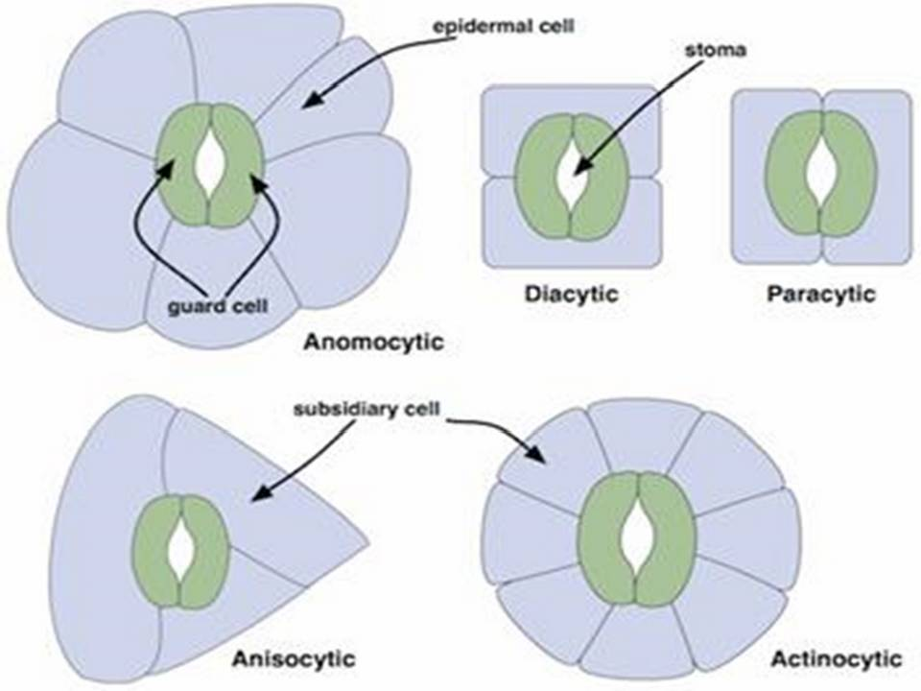

1. ***Epidermal Trichomes:***

Most leaves, stems , flowers ,fruit and seeds possess hairs or trichomes one kind or another . Many show hairs of more than one type .

### Covering Trichomes – example 1- Unicellular

From Senna leaves.

1. **Multicellular Unbranched**, Uniseriate From Digitalis leaves.

### Multicellular Branched

Stellate. From Witch – Hazel leaves.

### Multicellular Branched, Candelabra



1. **Muticellular Branched, T-Shaped**

From Pyrethrum.

### Cystolytic Trichomes

From Cannabis

### Glandular Trichomes – Example 1- Unicellular stalk with

From Digitalis leaves.

### Multicellular Uniseriate Stalk

From Hyoscymus niger.

### Multicellular Multiseriate Stalk

.

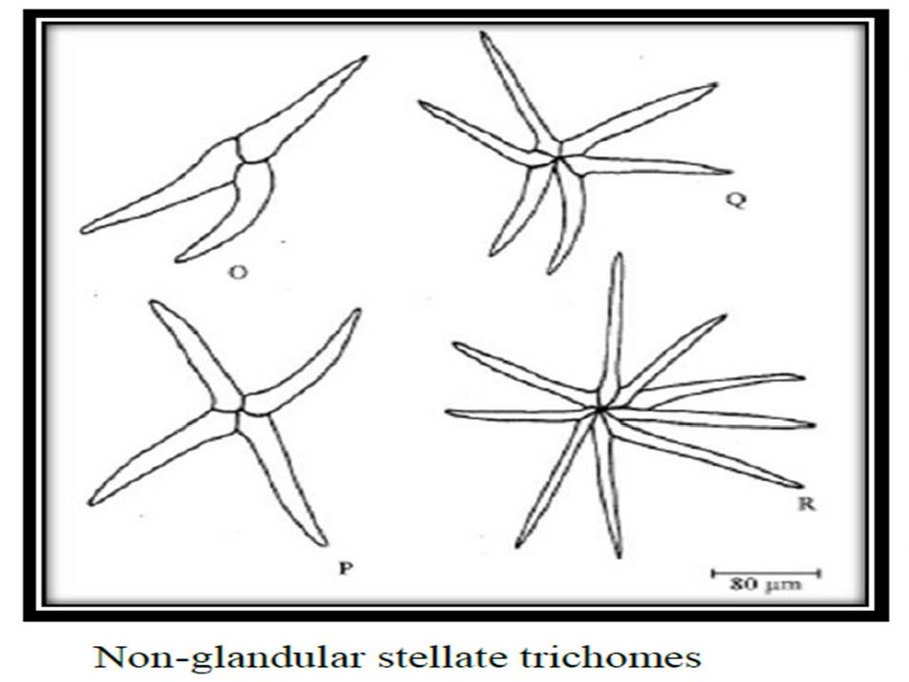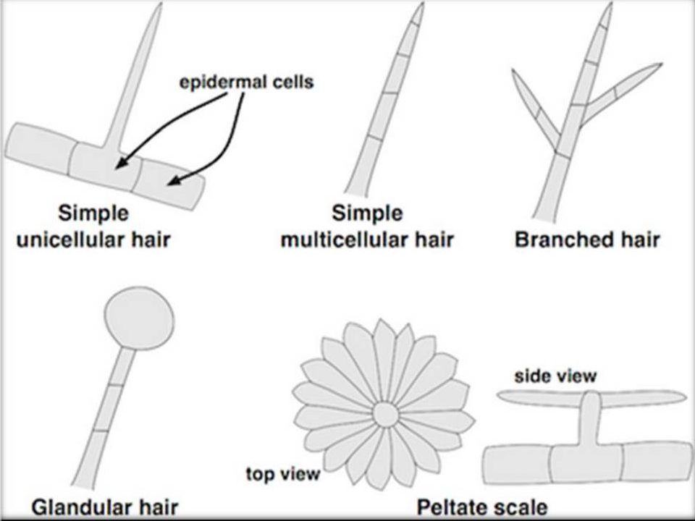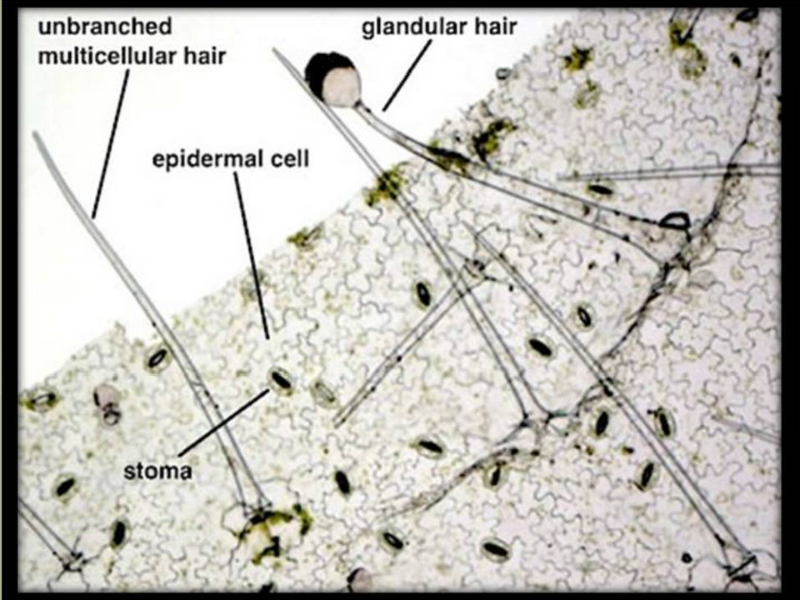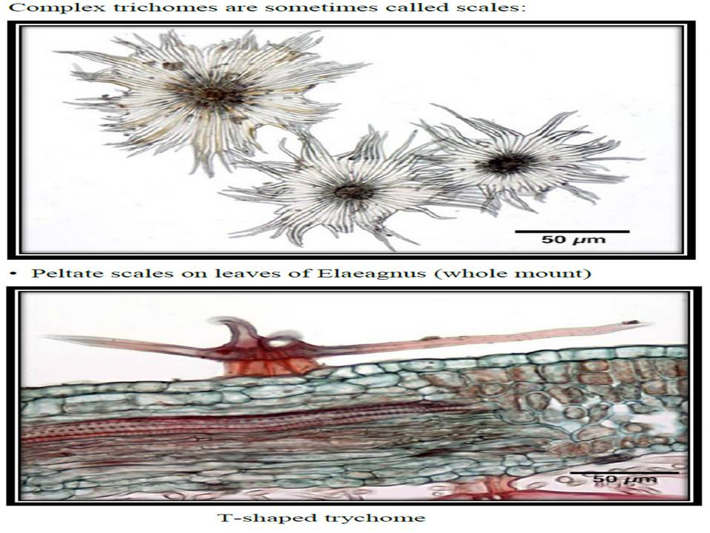

1. ***Cork tissue:*** is made up of dead cells with thick walls, with no intercellular spaces, found in older stems and roots of dicot plants.



1. ***Collenchyma:*** Is the tissue frequently found underneath the epidermis of many stems and leaf stalks.
2. ***Fibers:*** Tissue composed of spindle- shaped or elongated cells with pointed ends and thick walled.

e.g. ginger.

***Fibers*** are best differentiated on the basis of the tissue in which they occur. e.g. ***Cortical fibers, pericyclic fibers, xylem fibers and phloem fibers.***



## Xylem:

Elongated water- conducting cell with lignified and thickened – pitted cell wall.

1. 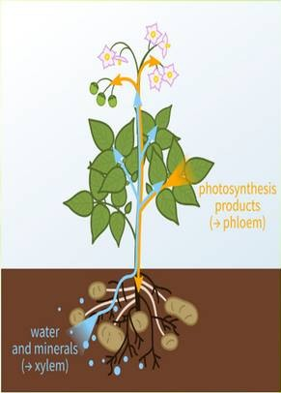***Vessels:*** Are the fundamental conducting elements of the xylem of the angiosperms. There are different types of vessels:

a-Spiral (Senna and Belladonna).

1. Annular (Senna and belladonna).
2. Reticulate ( Gentian, Ginger, Rhubarb).
3. Pitted vessels.

