
AL-MUSTAQBAL UNIVERSITY COLLAGE
Department of Pharmacy

Glycosides

Glycosides
Glycosides are compounds that yield on hydrolysis, one or more sugar part and another non-sugar part. The sugar part is known as glycone , and the non-sugar part is the aglycone. In general there are two basic classes of glycosides: C- glycosides, in which the sugar is attached to the aglycone through C-C bond, and the O- glycosides in which the sugar is connected to the aglycone through oxygen –carbon bond.
Chemically the glycosides are acetals in which the hydroxyl group (OH) of the glycone is condensed with the hydroxyl group of aglycone. More simply the glycosides may be considered as sugar ether. Two forms of glycosides are present, the α-form and the β-form, but the β-form is the one that occur in plants, even the hydrolytic enzymes act on this type.
O OH ORe
Re C H Re C ORe Re C ORe
H H
Hemiacetal Acetal
Inside the body the glycosides will be cleaved to glycone and aglycone parts, the glycone part confers on the molecule solubility properties, thus is important in the absorption and distribution in the body, while the aglycone part is responsible for the pharmacological activity.
Generally all glycosides are hydrolyzed by boiling with mineral acids , on the other hand the presence of specific enzyme in the plant tissue, but in different cells from those that contain the glycosides, are able to hydrolyzed the glycosides, such as the emulsin enzyme which is present in the almond kernel, and the myrosin enzyme which is found in the black mustard seeds.
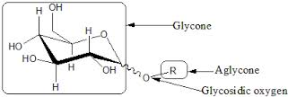
(Fig.1) General Structure of Glycosides
Generally in the extraction of glycosides we have to consider the following points:
- Apolar solvent, which is mostly alcohol, but not water, since water may
induce fermentation, in addition water need high temperature due to its
high boiling point.
- Neutralization of the extract with base, since the presence of acid lead
to hydrolysis of the glycoside.
- Use of heat is to inhibit the activity of hydrolytic enzymes that present in
the plant cell.
The glycosides are classified according to the chemical structure of the aglycone to:
- Cardioactive glycosides. 7. Alcohol glycosides.
- Anthraquinone glycosides. 8. Aldehyde glycosides.
- Saponin glycosides. 9. Lactone glycosides.
- Cyanophore glycosides. 10. Phenol glycosides.
- Isothiocyanate glycosides. 11. Miscellaneous glycosides.
- Flavonoid glycosides.

Exp. No.1
[Lab.1] Cardioactive Glycosides
They are named so, due to their action on the heart muscle. The aglycone part here is steroid, which is chemically cyclopentaphenanthrene .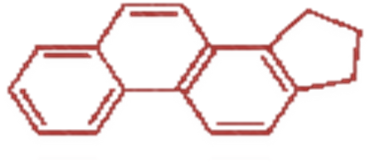
cyclopentaphenanthrene nucleus
The steroidal aglycones are of two types:
- Cardinolides(α-β unsaturated 5 – member lactone ring).
- Bufadienolides (doubly unsaturated 6-member lactone ring).
The more prevalent in nature is cardinolides type.
For maximum activity of cardioactivce glycosides the following points are important:
- 17 -β –lactone ring (cardinolide or bufadinolide).
- 3 -β - OH.
- 14 -β-OH.
- CATSC (C= cis between two rings (A&B). A= Anti in one ring (5&19).
T=Trans between two rings (B&C). S= Syn in one ring (8&18).
As represented bellow:
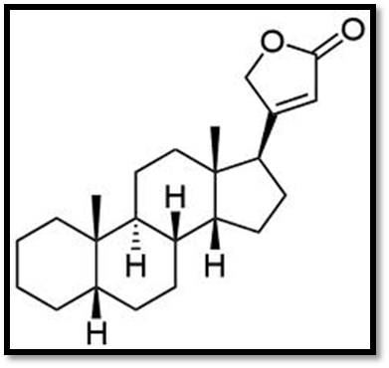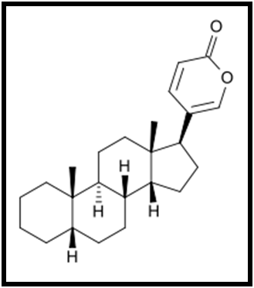
Cardenolide Bufadienolide
Plants Containing CardioactiveGlycosides:
- Digitalis (digitalis or foxglove) Digitalis purpurea of the family Scrophulariaceae.
The name digitalis is from Latin digitus which means finger refers to finger – shaped, while purprea refers to purple color of their flower. This plant contains anumber of glycosides as digitoxin , gitoxin and getaloxine.
- Digitalis lanata of the same family, from which the digoxin is obtained.
- The plant used in our laboratory is Nerium oleander of the family Apocyanaceae. The main glycoside of which is oleandrin.
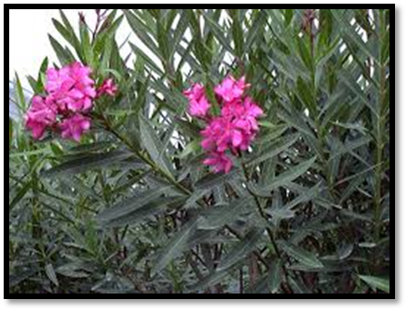
Nerium oleander
Isolation and Identification of the Cardioactive Glycosides:
- Extraction:
Aim: To isolate the cardioactive glycosides.
Equipments:
- Large beaker & two medium size beakers.
- Two conical flasks.
- Centrifuge & Centrifuge tubes.
- Separatory funnel.
- Water bath.
Reagents:
- 70% ethanol.
- Lead sub acetate.
- 10% sodium phosphate solution.
- Chloroform: Ethanol (3:1 v/v).
- Anhydrous sodium sulphate.
- 4N HCl acid.
- Chloroform.
Procedure:
Method of extraction: Maceration.
Plant used: Nerium oleander.
Part used: dry leaves.
Maceration 10 gm of the powdered leaf in 100 ml of 70%ethanol for 24 hrs. (Prepared previously)
Take 10 ml of alc. Extract in conical flask

Add

10 ml of lead sub acetate solution
(Mixing& standing for 5 min_{s.})

Centrifuge
(5 min_{s.})

Decant and take the supernatant (upper layer)

Add

10 ml of 10%sodium phosphate solution

Centrifuge
(5 min_{s.})

Take supernatant and divide in to two divisions

-------------------------------------------------------------------

Fraction A

Take one division and put in a separatory funnel

Add

[10 ml of Chloroform: Ethanol (3:1 v/v)] two times

(Shake& stand)

Combine the organic lower layer and put it in the conical flask

Add

Small quantity of Anhydrous sod. Sulphate & allow standing for few minutes until get a clear solution, decant the Chloroform-ethanol extract and reduce the volume on water bath to get:

Fraction A
Fraction B
Place the other division of the extract in the conical flask

Add

3 ml of 4N HCl

Boiling in water bath
(15 min_{s})

Cool &transfer to a separatory funnel

Add

[10 ml of Chloroform] tow times
Combine the chloroform extracts (lower layers)
Add
Small quantity of Anhydrous sod. Sulphate & allow standing for few minutes until get a clear solution then decant the chloroform layer and concentrated on water bath to about 1ml. and we get:

Fraction B
Results:
Fraction A : Contain the whole glycosides.
Fraction B : Contain the aglycone (genin) part only.

