
AL-MUSTAQBAL UNIVERSITY COLLAGE
Department of Pharmacy

Glycosides

Exp.No. 2
[Lab.3] Anthraquinone Glycosides
Anthraquinone and related glycosides, are stimulant cathartics, and exert their action by increasing the tone of the smooth muscle in the wall of colon and stimulate the secretion of water and electrolytes into the large intestine.
After the oral administration, the anthraquinone glycosides are hydrolyzed in the colon by the action of enzymes of the micro flora, to the pharmacologically active free aglycones which usually produce their effect in 8 -12 hrs. After administration, these agents are indicated for constipation in patient who do not respond to milder drugs and for bowel evacuation before investigational procedure or surgery.
Stimulant laxative are habit forming so the long-term use may result in laxative dependence and loss of normal bowel function. The glycosides of anthranols and anthrones elicit a more drastic reaction than do corresponding anthraquinone glycosides and cause discomforting and gripping action.
The drugs mostly used are cascara,frangula,hypericum and Senna.
Aloe and Rhubarb are not recommended due to their irritating actions which increase the chance for gripping effect.
The anthraquinone hydrolyzed to give aglycone which are di, tri, or tetra –hydroxyanthraquinone .Also there are antherone, dianthrones and oxanthrones.
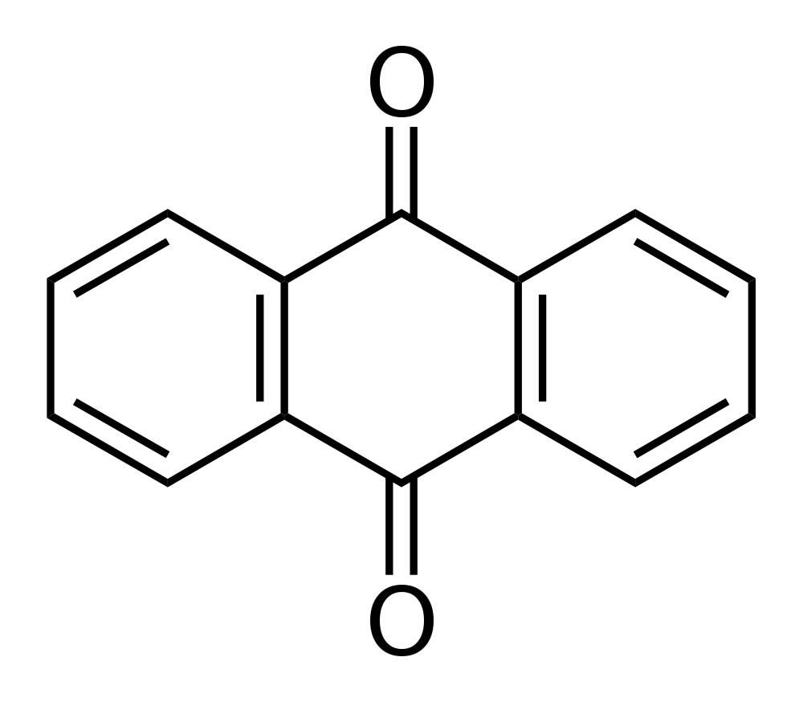
Fig (1): Chemical Structure of Anthraquinone
Isolation and Identification of the Anthraquinone Glycosides:
1. Extraction:
Aim: To isolate the anthraquinone glycosides.
Equipments:
- Large beaker & two medium size beakers.
- Two conical flasks.
- Centrifuge & Centrifuge tubes.
- Separatory funnel.
- Water bath.
- Round bottom flask.
- Filter paper.
- Reagent bottle.

Reagents:
- Conc.HCl acid.
- Chloroform.
- 60% w/v ferric chloride solution.

Procedure:
Method of extraction:Decoction.
Plant used: Senna Cassiaa cutifolia, Cassia angustifolia
Family: Leguminosaea.
Part used: Dry leaves.
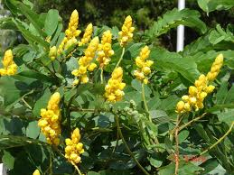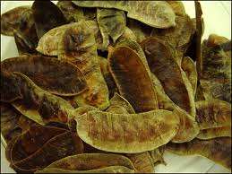
Senna

Place 0.5 gm of powdered dry leaves of Senna in 50 ml of water
Boiling (15 min_{s})
Cool & filter

Place the filtrate in separatory funnel and extract by shaking with
[10 ml of Chloroform] two times

Upper layer Combine lower layer
(Aqueous layer) (Chloroform layer Devided into two portions [Free aglycone (dianthrone)]
Fraction B

(Whole Glycosides) Other part of the aq. Layer
Fraction A Reflux (20min_{s})
[Put in reagent bottle] Add
1) 3.5 ml of Ferric Chloride sol.(60 %w/v ).
2) 2ml of Conc. HCl acid.
Cool Place in a separatory funnel and extracted with
[10 ml of Chloroform] tow times
Aqueous layer Chloroform layer
Glycone part Aglycone part (monoanthrone) Fraction C
Results:
Fraction A : Contain the whole glycosides.
Fraction B : Contain the aglycone (dianthrone) .
Fraction C: Contain the aglycone part (monoanthrone).

