

**ALMUSTAQBAL UNIVERSITY COLLAGE PHARMACY DEPARTMANT**

**Practical pharmacognosy / Second year**

**Experiment No.10**

Column Chromatography

Introduction:

This includes chromatographic methods in which: The stationary phase is packed into a column. The mobile phase is a moving liquid or gas.

According to the mechanism of separation of solutes, five major types of CC are ditinguished. Usually, one mechanism predominates but does not exclude the others.

**Different Types of Column chromatography**

|  |  |  |  |
| --- | --- | --- | --- |
| **Mode or type** | **Stationary phase** | **Mobile phase** | **Mechanism** |
| **Adsorption** | **Solid that attracts the** | **Liquid or gas** | **Solutes move at** |
| **Chromatography** | **solutes** |  | **different rates** |
|  |  |  | **according to the forces** |
|  |  |  | **of attraction to the** |
|  |  |  | **stationary phase.** |
| **Partition** | **Thin film of liquid** | **Liquid or gas** | **Solutes equilibrate** |
| **Chromatography** | **formed on the surface** |  | **between the 2 phases** |
|  | **of a solid inert** |  | **according to their** |
|  | **support** |  | **partition coefficients** |
| **Ion Exchange** | **Solid resin that** | **Liquid** | **Solute ions of charge** |
| **Chromatography** | **carries fixed ions &** | **containing** | **opposite to the fixed** |
|  | **mobile couterions of** | **electrolytes** | **ions are attracted to** |
|  | **opposite charge** |  | **the resin by** |
|  | **attached by covalent** |  | **electrostatic forces &** |
|  | **bonds** |  | **replace the mobile** |
|  |  |  | **counterions.** |

|  |  |  |  |
| --- | --- | --- | --- |
| **Molecular Exclusion Chromatography** | **Porous gel with no attractive action on solute molecules** | **Liquid** | **Molecules separate according to their size:**   1. **Smaller molecules enter the pores of the gel, and need a larger volume of eluent.** 2. **Larger molecules pass through the column at a faster rate.** |
| **Affinity Chromatography** | **Solid on which specific molecules are immobilized** | **Liquid or gas** | **Special kind of solute molecules interact with those immobilized**  **on the stationary phase** |

**Column chromatography**

Stationary phase is held in a narrow tube through which the mobile phase is forced under pressure or under the effect of gravity.

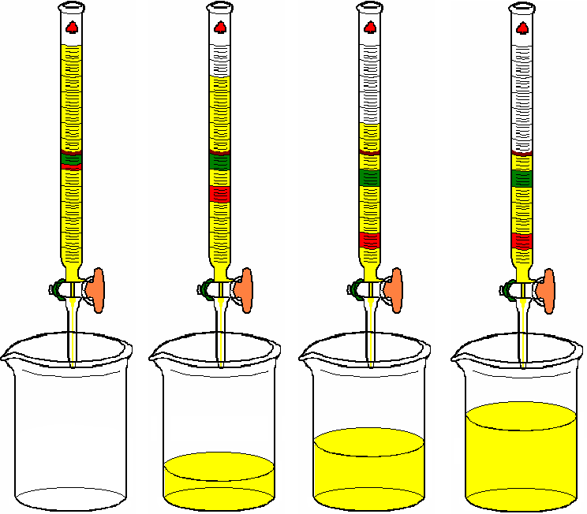

|  |  |
| --- | --- |
| **Term** | **Definition** |
| **Solvent** | **Mobile liquid phase with no affinity to the stationary phase (i.e. inert towards it) & no effect on solutes.** |
| **Developer** | **Any liquid with more affinity to the stationary phase than the solvent but less than solutes and just capable to move them through the column.** |
| **Effluent** | **Any liquid that passes out of the column.** |
| **Eluent** | **Any liquid that has lesser affinity to the stationary phase than solutes but is capable to move them out of the column.** |
| **Eluate** | **Fraction of eluent containing a required specific substance.** |
| **Retention volume**  ***(VR*)** | **(or retardation volume): Volume of mobile phase that passes out of the column, before elution of a specific substance.** |

**Packing & operating the column:**

1- Packing

The selection of the method of packing depends mainly on the density of the solid. Techniques used are the wet, dry & slurry methods.

In all cases avoid inclusion of air bubbles. 2- Sample Application

Apply evenly & in a concentrated solution to the top of the column which is protected from disturbance (e.g. add glass wool or filter paper).

1. Elution techniques:

|  |  |
| --- | --- |
| **Technique** | **Procedure** |
| **Isocratic elution** | **Addition of solvent mixture of fixed composition during the whole process.** |
| **Gradient elution** | **Continuous or linear elution: in which there is continuous change in the composition of the mobile phase over a period of time (e.g. polarity, pH or ionic strength).** |
| **Step wise or fractional elution: in which the change is not continuous**  **i.e. a sudden change in the composition of the mobile phase is followed by a period where the mobile phase is held constant.** |

1. Detection:

On column detection for colored or fluorescent compounds directly after developing the chromatogram.

1. Monitoring of eluted fractions (PC or TLC).Using special detectors connected to the column such as refractive index, UV detectors, etc