

**ALMUSTAQBAL UNIVERSITY COLLAGE PHARMACY DEPARTMANT**

**Practical pharmacognosy / Second year**

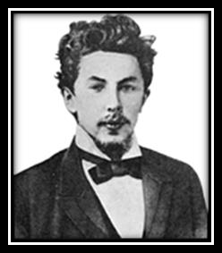**Exp. No.5 Chromatography**

**History:**

Mikhail Tswett, Russian Botanist (1872-1919).

In 1906 Tswett used the chromatography to separate plant pigments He called the new technique chromatography because the result

of the analysis was 'written in color' along the length of the adsorbent column. Chroma means “color” and graphein means to “write”.

**Importance:**

Chromatography has application in every branch of the physical and biological sciences. 12 Nobel prizes were awarded between 1937 and 1972 alone for work in which chromatography played a vital role.

The main uses of chromatography involve: Analytical procedures, scientific research and Purification.

**Definition:**

Chromatography is a physical method of separation in which the components to be separated are distributed between two phases.

One of which is stationary (stationary phase) while the other (the mobile phase) moves through it in a definite direction.

The chromatographic process occurs due to differences in the distribution constant of the individual sample components. It is used for large and small quantities so it is used quantitatively and qualitatively and proved to be more effective from the other means of separation and identification.

The separation of a mixture of compounds in chromatography to its components depends on the action of two forces:

1. Mobile force (driving force) that will try to move the components of mixture.
2. Opposing force (stationary or retardation force) that will try to keep components in their places depending on many factors:
   1. Solubility in mobile phase.
   2. Adsorption ability of component to be separated.
   3. Ionic forces.

**Classification:**

There are different types of chromatography classification.

* + - Classification of chromatography according to mobile phase:

1- Liquid chromatography: mobile phase is a liquid. (LLC, LSC). 2- Gas chromatography: mobile phase is a gas. (GSC, GLC).

* + - Classification according to the packing of the stationary phase:

1-Thin layer chromatography (TLC): the stationary phase is a thin layer supported on glass, plastic or aluminum plates.

1. Paper chromatography (PC): the stationary phase is a thin film of liquid supported on an inert support.
2. Column chromatography (CC): stationary phase is packed in a glass column.
   * Classification according to the force of separation:
3. Adsorption chromatography.
4. Partition chromatography
5. Ion exchange chromatography. 4- Gel filtration chromatography. 5- Affinity chromatography

6- Electrophoresis.

PYPER CHROMATOGRAPHY

Paper chromatography is a method of partition chromatography using filter paper strips as carrier or inert support. The factor governing separation of mixtures of solutes on filter paper is the partition between two immiscible phases. One is usually water adsorbed on cellulose fibers in the paper (stationary phase).The second is the organic solvent flows past the sample on the paper (stationary phase).

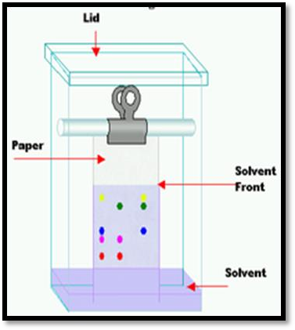

Partition occurs between the mobile phase and the stationary aqueous phase bound by the cellulose. The isolation depends on partition coefficient of the solute.

*K*  *c*(*stationary*)

*c*(*mobile*)

**General Procedure :**

1- Choice of paper and solvent to be used. 2- Desalting of sample.

3- Application of the sample. 4- Equilibration of paper.

1. Development.
2. Detection.
3. Identification of substances.

**Techniques of development with various flow directions:**

**Ascending development**

The paper will be dipped in the solvent mixture so that the solvent front travels up the paper.

**Descending development**

When the through of solvent will be supported at the top of the chamber. In this case the solvent travels down the paper.

**Radial development**

Circular or horizontal paper chromatography is another technique used, in which circular filter paper bearing a wick at the center of the paper is placed in a petri dish and the solvent system supplementation is through the central wick.

**Multiple developments**

Multiple chromatography includes all procedures in which the development is repeated after one development is completed.

A- Multiple developments: the chromatogram is repeatedly developed in the same direction and thus the complete resolution of two or more substances which have R F values close together can be obtained.

As the mobile phase one can use either the same solvent system or different solvent systems.

B- two- dimensional chromatography:

When large numbers of substances are to be separated on a single chromatogram.

Development in a direction perpendicular to the first, and with a solvent system different from that used initially is often necessary.

The sample is applied on one corner of a square piece of paper and after development with the first solvent; the paper is dried, rotated 90o and developed in the second direction.

Usually, different types of solvents systems are used in each direction. It is essential that the first solvent be completely volatile.

Retardation factor can be defined as the distance moved or traveled by the compound to the distance moved by the solvent and it is constant for each compound when chromatography is carried out using the same technique.

Mobile phase and the same conditions. Usually the RF value is used for the identit1cation of the separated compound by comparison with the RF value of a standard. The RF value is going to change if we:

l) Change the solvent.

1. Aging.
2. Impurities.
3. Temperature.
4. Saturation.
5. Solvent front must be uniform Methods of detection:
6. Chemical detection by using chemical reagents.
7. Physical detection by using UV light.
8. Radioactive method: specific detection procedures when we use to detect separated compounds having some radioactivity or labeled' compounds.
9. Biological methods by using certain microorganisms and are especially used' for the detection of antibiotics.

Identification of isolated compounds:

Identifying the Spots by visualization, if the spots can be seen, outline them with a pencil.

If no spots are obvious, the most common visualization technique is to hold the plate under a UV lamp. Then the RF (retention factor) value for each spot should be calculated.

It is characteristic for any given compound on the same stationary phase using the same mobile phase for development of the plates.

Hence, known RF values can be compared to those of unknown substances to aid in their identifications.

rf

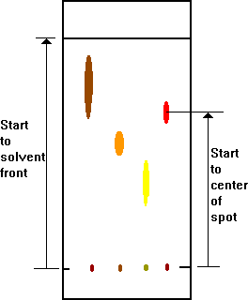

*Note: RF values often depend on the temperature and the solvent used in the TLC experiment.

**CIRCULAR FILTER PAPER CHROMATOGRAPHY**

(HORIZONTAL PAPER CHROMATOGRAPHY)

**Method:**

l) Prepare a circular filter paper and insert a wick in the center of the paper. Mark four pencil dots (starting points), approximately 1 cm from the wick.

1. Apply the sample on pencil dot (3 different magic colors and ink).
2. Place a chromatographic paper over the dish that contains the mobile phase in such a way that develops to about 4-5cm.
3. Remove the chromatogram, mark the solvent front and dry at room temperature.
4. Examine the chromatogram by the daylight and calculate the RF value for each separated spot.
5. Make full report.

Not: mobile phase is prepared by shaking n-butanol, acetic acid, and water (4:1:5) for 3min in a separatory funnel and collect the upper phase.