
AL-MUSTAQBAL UNIVERSITY COLLAGE
Department of Pharmacy

Glycosides

Exp.No. 6
[Lab.8] Flavonoid glycosides
Flavonoids (from the Latin word flavus meaning yellow, their color in nature) are polyphenols of plant origin that are among the most important compounds in human diet due to their widespread distribution in foods and beverages. They can occur both in the free form (aglycones) and as glycosides, and differ in their substituents (type, number and position) and in their instauration. The most common classes are the flavones, flavonols, flavanones, catechins, isoflavones and anthocyanidins, which account for around 80 % of flavonoids. All flavonoids share a basic C6-C3-C6 phenyl-benzopyran backbone. The position of the phenyl ring relative to the benzopyran moiety allows a broad separation of these compounds into flavonoids (2-phenyl-benzopyrans), isoflavonoids (3-phenyl-benzopyrans) and neoflavonoids (4-phenyl-benzopyrans) . Division into further groups is made.
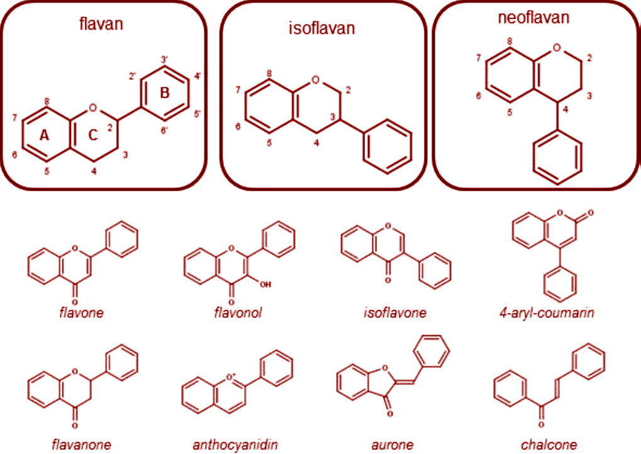Fig.1. Structure of the structural backbones of the main flavonoid groups (flavan, isoflavan and neoflavan) and of relevant flavonoid classes. Atom numbering and ring nomenclature are also included.
They have been used extensively as chemotaxonomic markers and are abundant in the Polygonaceae, Rutaceae, Legaminosae, Umbellifereae and Compositae. They occur both in the Free State and as glycosides; most are O-glycosides but a considerable number of flavonoid C-glycosides are known. The glycosides are generally soluble in water and alcohol, but insoluble in organic solvents; the genins are only sparingly soluble in water but are soluble in ether. Flavonoids dissolve in alkalis, giving yellow solutions which on the addition of acid become colorless.

Pharmacological activity of flavonoids:
A number of flavonoid-containing herbs have now been included in the BP/ EP, examples are Birch leaf, Calendula Flower and Elder flower.The group is known for its anti-inflammatory and anti- allergic effects, for antithrombotic and vasoprotective properties, for inhibition of tumor promotion and as protective for the gastric mucosa. Some of these pharmacological properties can be explained on the bases of antioxidant activity. Many flavonoid -containing plants are diuretic (e.g. buchu and broom) or antispasmodic (e.g. liquorice and parsley). Some flavonoids have antitumour, antibacterial or antifungal properties.
Isolation and Identification of Flavonoids:
Aim: Isolation method of flavonoids from Ruta.
Equipments and reagents:-
- Large beaker.
- Water bath.
- Two medium size beakers.

Reagents:
- Petroleum ether.
- 70 % aqueous methanol.
- 5 % HCl.
- Chloroform.
Procedure:
Method of extraction: Maceration.
Plant used: Ruta graveolens family Rutaceae.
Part used: Dry leaves.

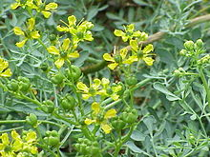
Ruta graveolens

SCHEME FOR ISOLATION OF FLAVONOID GLYCOSIDE
Maceration 10 gm. of the powdered leaves in 100ml of petroleum ether overnight. (Prepared previously)
The residue is dried
Macerated again with 70 % aqueous methanol overnight ( prepared previously)
Filter
Concentrated the extract to small volume (15ml)
Divided into two parts

5ml 10ml
Fraction A Add 5ml of 5% HCl
Boil for 20min.
Cool& transfer to a separatory funnel

Shake with
(15ml of Chloroform) two times

Aqueous layer Chloroform layer
(Concentrated)
Fraction B Results:
Fraction A : Contain the whole glycosides.
Fraction B : Contain the aglycone part.
[Lab.9] TheChemical Tests
A.General Reaction:
1-Cyanidin reaction with magnesium powder. Flavanonones and dihydroflavanols at the presence of HCl produce bright red colour; isoflavonoids and flavanes develop yellow, sometimes red colour, flavonoles do intensive red colour.
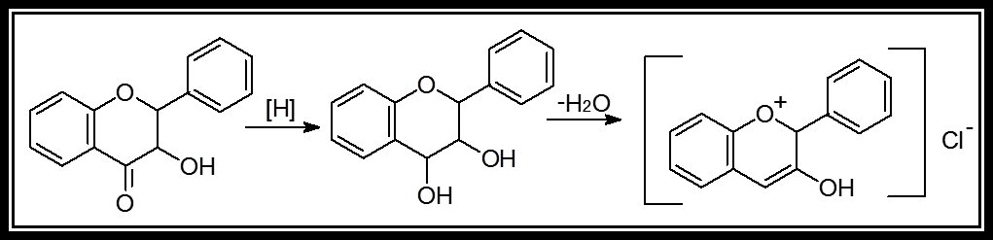

2-Reaction of flavonoids with two o-oxygroups in B cycle with lead acetate causes precipitation. Flavones produce intensive yellow, aurones - red, anthocyanes red or blue precipitates.
3-Wilson’s reaction: 5-oxyflavones and 5-oxyflavonoles with Wilson's reagent (boric and citric acids in anhydrous acetone) develop brightly yellow colour with yellowish-green fluorescense.
4-alkaline solution: In alkaline solutions flavanones produce uncoloured or yellow precipitates, that for some time become brightly yellow or yellow (isomerization to formation of chalkones); chalkones and aurones develop red or purple (it's their specific reaction), flavones and flavonoles produce yellow coloured precipitates.
5-Mineral acids: Flavones and flavonoles with mineral acids form oxonic (flavic) salts of brightly yellow or red colour, chalkones and aurones produce intensive colour of raspberry or red.

6-Other methods: Other methods of identification include chromatography,.colorimetric or spectrophotometric analysis after reaction with aluminium chloride.

A.Special Reaction:
1-Shinoda test
Four pieces of magnesium fillings (ribbon) are added to the ethanolic extract followed by few drops of concentrated hydrochloric acid. A pink or red colour indicates the presence of flavonoids. Colours varying from orange to red indicated flavones, red to crimson indicated flavonoids, crimson to magenta indicated flavonones.
2-Sodium hydroxide test
About 5 mg of the compound is dissolved in water, warmed and filtered. 10% aqueous sodium hydroxide is added to 2 ml of this solution. This produces a yellow coloration. A change in color from yellow to colorless on addition of dilute hydrochloric acid is an indication for the presence of flavonoids.

3-p-Dimethyl amino cinnamaldehyde test
A colorimetric assay based upon the reaction of A-rings with the chromogen p-dimethylaminocinnamaldehyde (DMACA) has been developed for flavanoids in beer that can be compared with the vanillin procedure.

Identification of Flavonoids By Chromatography:
1-By the use of Paper chromatography (P.C):
- The stationary phase = Filter paper ( Whatman no.1).
- The mobile phase = n-BuOH:HOAc:H ₂O (4:1:5).
- The standard compound = Rutin.
- The spray reagent = 5% alcoholic KOH.
- Mechanism of separation = Partition.
- Developing = Ascending.

2-By the use of Thin layer chromatography (T.L.C):
- The stationary phase = Silica gel G.
- The mobile phase = Ethyl acetate -formic acid - glacial acetic acid - water(100:11:11:26).
- The standard compound = Rutin.
- The spray reagent = flavonoids spot on TLC plates produce a yellow-brown
Spots when reacted with Iodine vapor.
- Mechanism of separation = Adsorption.
- Developing = Ascending.
- Detection: Flavonoids may appear as dark spots on a green background fluoresce when observed in UV light at 254 nm UV-plates containing fluorescent indicator (such as silica gel F254). If under 365 nm UV light, spot colors depending on the structure of flavonoids, can be yellow, green or blue fluorescent. It would be more clear and intense after being sprayed with the reagent.
- Colors can be observed at 365 nm UV light are as follows:

• Quercetin, myricetin, and 3 & 7-O-glycosides: orange-yellow
• kaempferol, isorhamnetin, and 3 & 7-O-glycosides: yellow-green
• Luteolin and 7-O-glycosides: orange
• Apigenin and 7-O-glycosides: yellow-green

Study problems:
Q1. How many types of flavonoids are their according to the conjugation of basic nuclei? Explain with structures?
Q2 .How can you identify an extract containing flavonoids?

