
AL-MUSTAQBAL UNIVERSITY COLLAGE
Department of Pharmacy

Glycosides

Exp.No. 5
[Lab.7] Volatile Oils
They are odorous principles found in various plant parts. Because they evaporate when exposed to the air at room temperatures, they are called volatile oils; they are also called essential or ethereal oils.
Volatile oils are colorless as a rule, particularly when they are fresh, but on long standing they may oxidize and resinify, thus darkening in color, to prevent thisdarkening, they should be stored in a cool, dry place in tightly stoppard, preferably full, amber glass containers.
As a rule, volatile oils are immiscible with water, but they are sufficiently soluble to impart their odor to water. They are soluble in ether, alcohol and most organic solvents.
Many volatile oils consist largely of terpenes (terpenes are natural products whose structures may be divided into isoprene units).
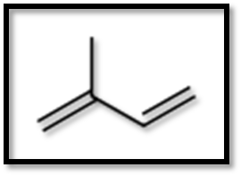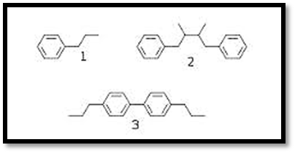
Isoprene unit Phenylpropanoids

Another major group of volatile oil constituents are the phenylpropanoids. (Thesecompounds contain the C₆ phenyl ring with an attached C₃ propane side chain).

Generally volatile oils and volatile oil-containing drugs are divided in to the following classes:
- Hydrocarbons.
- Alcohols.
- Aldehydes.
- Ketones.
- Phenols.
- Phenolic ethers.
- Oxides.
- Esters.

Essential oils are derived from various sections of plants:
- Leaves- Rosemary, Basil, Eucalyptus.
- Flowers- Rose, Lavender, Clove.
- Seeds- Almonds, Anise, cumin.
- Bark- Cinnamon.
- Rhizome- Ginger.
Pharmacological Uses of Volatile Oils:
- Carminative as for Rosemary oil.
- Antitussive as for Eucalyptus.
- Antiseptic as Clove oil.
- Aromatherapy, alternative medicine as Lavender Oil.

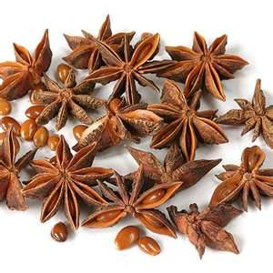
Anise
Isolation and Identification of the Volatile Oils:
Aim: Determination of the volatile content of crude drugs by steam distillation method.
Equipment : Clavenger type as an apparatus.
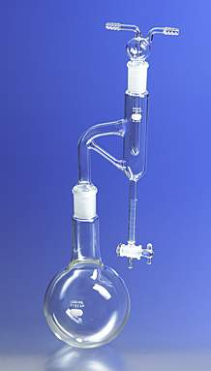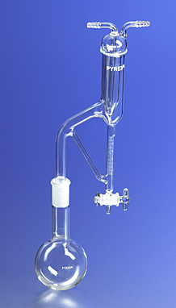
Clevenger Apparatus Clevenger Apparatus
(Oil heavier than Water) (Oil lighter than water)
Procedure:
- Weigh out 20 gm of the plant material (coarse powder) and place into a distilling flask; add few pieces of porous earthenware.
- Add 200 ml distilled water to the flask and shake well. Add another 200ml of water by rinsing the neck of the flask.
- Connect the distilling flask with the still head of the apparatus. By the means of the pipette or washing bottle, fill the receiver with water until over flows.
- Connect the condenser of the apparatus with the cooling water (from the tap).
- Heat the distilling flask until the boiling starts. Record the time of the beginning of distillation, and continue the distillation for one hour.
- Switch off heating. Allow the graduated receiver to cool. Read off the volume of the volatile oil (count all small divisions in the receiver of the layer of oil).
- Calculate the %v/w of the volatile oil content of drug.

Identification of Volatile Oils By Chromatography:
By the use of thin layer chromatography (T.L.C).
- The stationary phase = Silica gel G.
- The mobile phase = Chloroform: Benzene (3:1).
- The standard compound = Peppermint Oil.
- The spray reagent =Vanilline _Sulphuric acid / Ethanol (10%v/v).
- Mechanism of separation = Adsorption.
- Developing = Ascending.

Procedure:
- Prepare 100ml of mobile phase, and place it in the glass tank.
- Cover the tank with glass lid and allow standing for 45 minutes before use.
- Apply the sample spot and the standard spot on the silica gel plates, on the base line.
- Put the silica gel plate in the glass tank and allow the mobile phase to rise to about two-third the plate.
- Remove the plate from the tank, and allow drying and then detecting the spots by the use of the spray reagent and heat the plates at 120◦C until the spot’s color intensity is reached in the oven. Detect the spot and calculate the Rf value.

Determination of the Refractive Index of the Volatile Oils:
Refractive index:
When a ray of light passes from a less dense to a denser medium, it will bend or refract toward the normal. If (e) represents the angle of refraction and (i) the angle of incidence according to law of refraction:
Sin i/ Sin e =N/n
Where (n) is the index of refraction of the less dense and (N)is the index of the refraction of the denser medium.

Procedure:
- Connect the abbe refractometer with the cooling water system and record the temperature.
- Wash the prism of the apparatus with absolute alcohol and dry it.
- Illuminate the field so that the cross is clear.
- Introduce 2 drops of volatile oil carefully on the surface of the prisms and cover it with another prism.
- Turn the knob so that the line of the dark field reaches the center of the intersection bars of the cross.
- Read off the refractive index (nD) on the scare at a given temperature.
- Calculate the refractive index at 20⁰C (nD²⁰) corrections for the temp.

Study problems:
Q1. How many kinds of Volatile-oil according to the basic nuclei? Explain with structures?
Q2 .How can you determine the volatile content of crude drugs?
Q3 .How can you identify an extract containing Volatile oils?
Q4. Define the Refractive index? How it can be measured?

