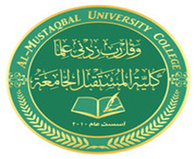

***AL- Mustaqbal University College***

**Optometry Department Lec.1**

*Anatomical Terminology*

**Teaching assistant Ali Hadi Al-Husseini**

*2021-2022*

***Cavities***

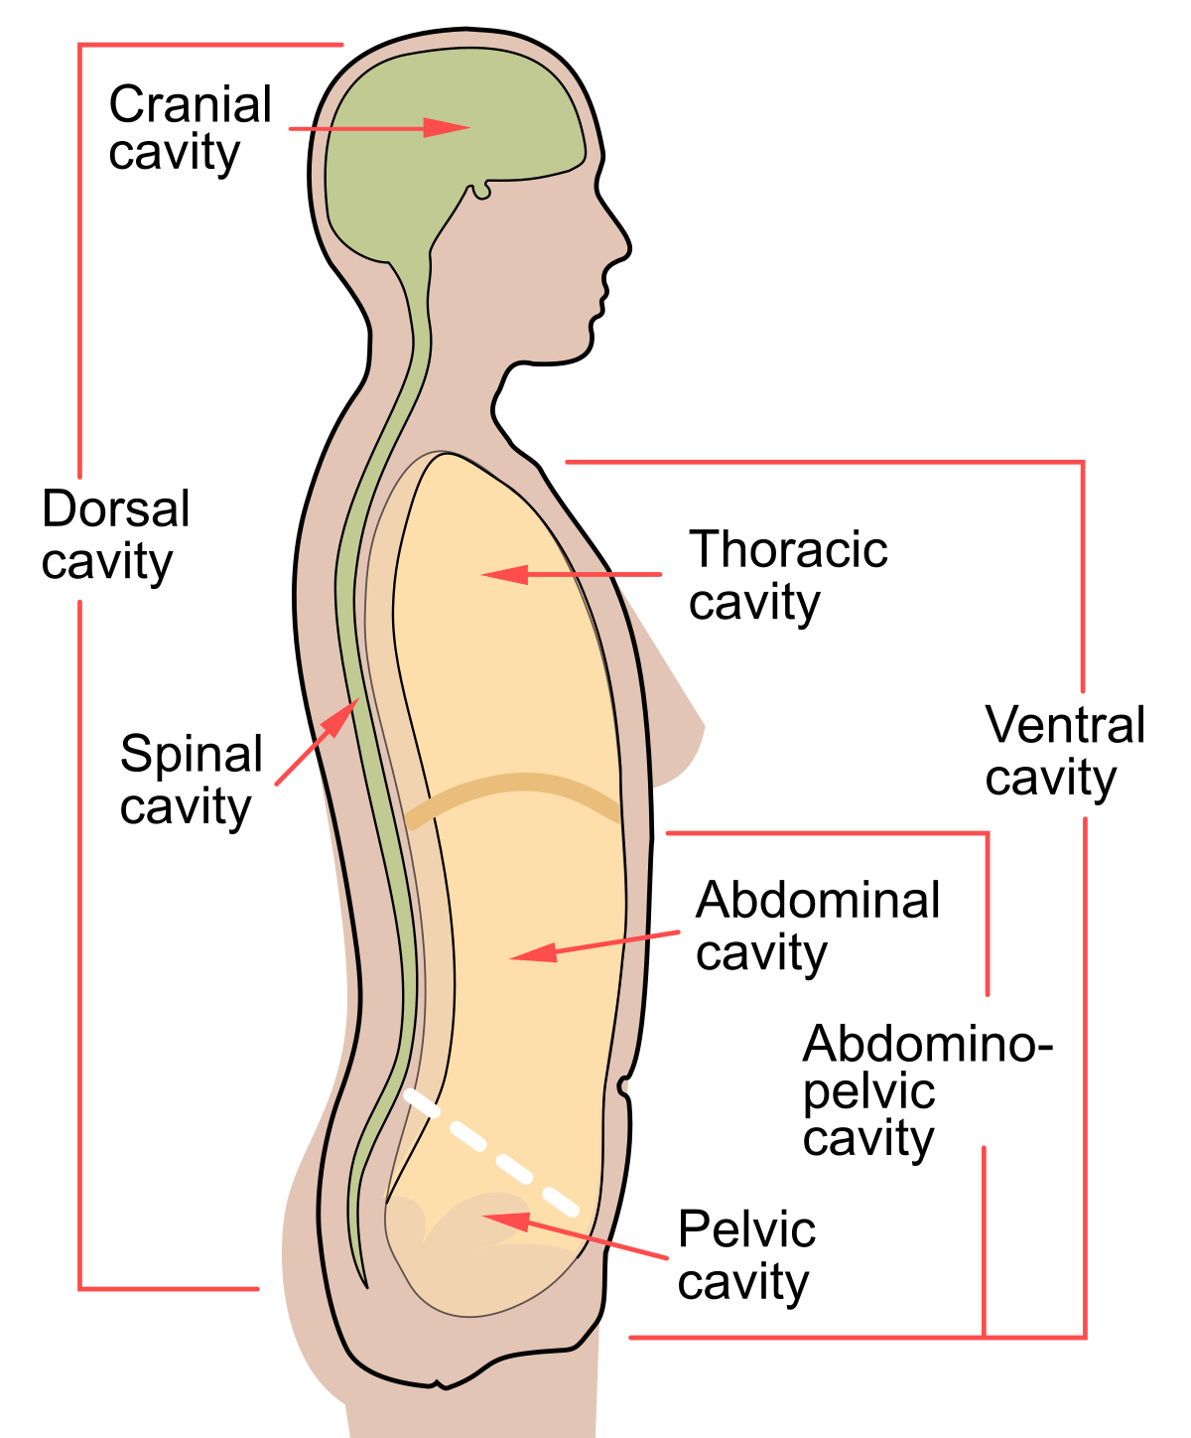

*Thoracic cavity*

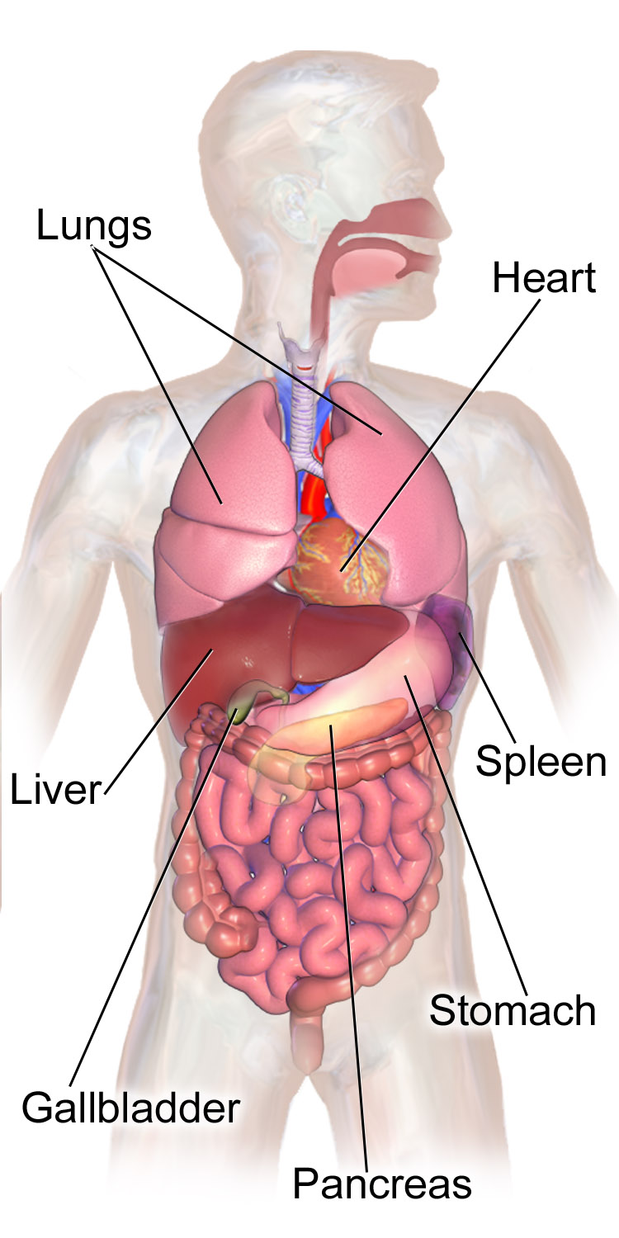

cranial cavity

