

***AL- Mustaqbal University College***

**Optometry Department**

**Lec.4**

Anatomical Terminology

**Teaching assistant**

**Ali Hadi Alhussainy**

*2021-2022*

*Human Eye Anatomy*

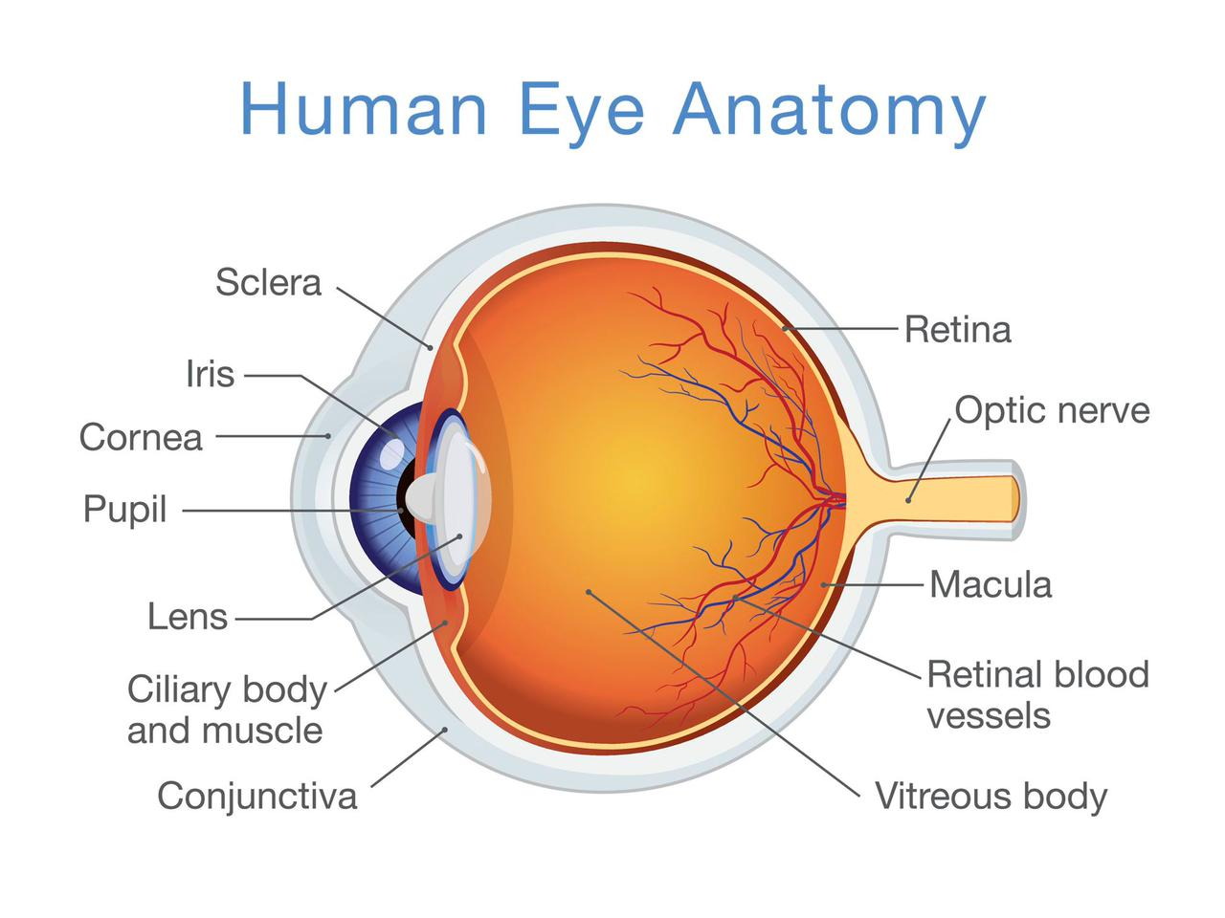

***THANK YOU***