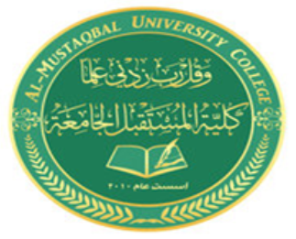

***AL- Mustaqbal University College***

**Optometry Department**

**Lec.10**

Part of the eye ball

**Teaching assistant**

**Ali Hadi Alhussainy**

*2021-2022*

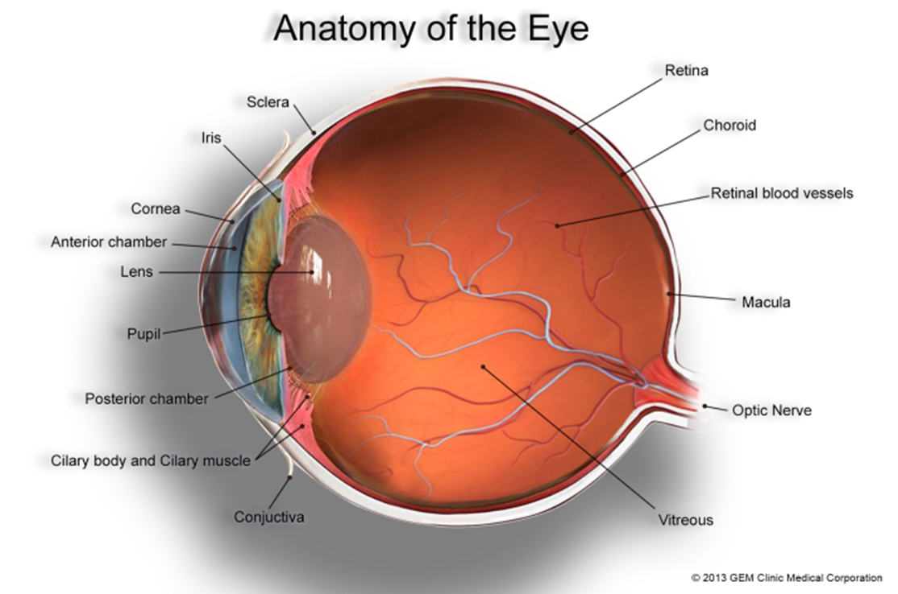

***THANK YOU***