**Lec.8**

**Transistor**

**What is a Transistor?** A transistor is a type of a [semiconductor](https://byjus.com/jee/semiconductors/) device that can be used to both conduct and insulate electric current or voltage. A transistor basically acts as a switch and an amplifier. In simple words, we can say that a transistor is a miniature device that is used to control or regulate the flow of electronic signals.

Transistors are one of the key components in most of the electronic devices that are present today. Developed in the year 1947 by three American physicists John Bardeen, Walter Brattain and William Shockley, the transistor is considered as one of the most important inventions in the history of science.

**Parts of a Transistor**

A typical transistor is composed of three layers of semiconductor materials or more specifically terminals which helps to make a connection to an external circuit and carry the current. A voltage or current that is applied to any one pair of the terminals of a transistor controls the current through the other pair of terminals. There are three terminals for a transistor. They are:

* Base: This is used to activate the transistor.
* Collector: It is the positive lead of the transistor.
* Emitter: It is the negative lead of the transistor

## Parts of a Transistor

## Types of Transistors

Based on how they are used in a circuit there are mainly two types of transistors.

### 1-Bipolar Junction Transistor (BJT)

The three terminals of BJT are base, emitter and collector. A very small current flowing between base and emitter can control a larger flow of current between the collector and emitter terminal.

Furthermore, there are two types of BJT. These include;

* P-N-P Transistor: It is a type of BJT where one n-type material is introduced or placed between two p-type materials. In such a configuration, the device will control the flow of current. PNP transistor consists of 2 crystal diodes which are connected in series. The right side and left side of the diodes are known as the collector-base diode and emitter-base diode, respectively.
* N-P-N Transistor: In this transistor, we will find one p-type material that is present between two n-type materials. N-P-N transistor is basically used to amplify weak signals to strong signals. In NPN transistor, the electrons move from the emitter to collector region resulting in the formation of current in the transistor. This transistor is widely used in the circuit.

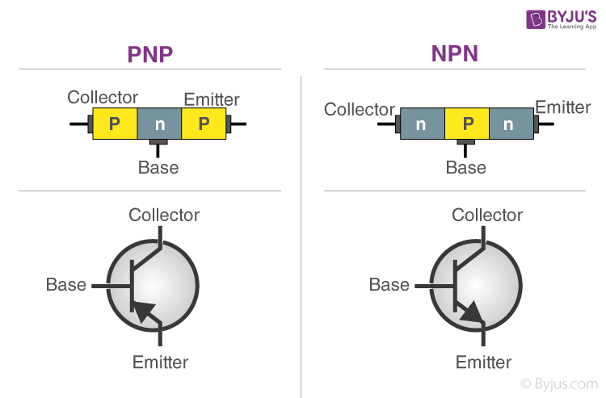

### 2- Field Effect Transistor (FET)

**Small-signal model**

**Small-signal modeling** is a common analysis technique in [electronics engineering](https://en.wikipedia.org/wiki/Electronics_engineering) used to approximate the behavior of [electronic circuits](https://en.wikipedia.org/wiki/Electronic_circuit) containing [nonlinear devices](https://en.wikipedia.org/wiki/Nonlinear_device) with [linear equations](https://en.wikipedia.org/wiki/Linear_equations). It is applicable to electronic circuits in which the AC [signals](https://en.wikipedia.org/wiki/Signal_(electrical_engineering)) (i.e., the time-varying currents and voltages in the circuit) are small relative to the DC [bias](https://en.wikipedia.org/wiki/Bias_(electrical_engineering)) currents and voltages. A small-signal model is an AC [equivalent circuit](https://en.wikipedia.org/wiki/Equivalent_circuit) in which the nonlinear circuit elements are replaced by linear elements whose values are given by the first-order (linear) approximation of their characteristic curve near the bias point.

## Differences between small signal and large signal

A large signal is any signal having enough magnitude to reveal a circuit's nonlinear behavior. The signal may be a DC signal or an AC signal or indeed, any signal. How large a signal needs to be (in magnitude) before it is considered a large signal depends on the circuit and context in which the signal is being used. In some highly nonlinear circuits practically all signals need to be considered as large signals.

A small signal is an AC signal (more technically, a signal having zero average value) superimposed on a bias signal (or superimposed on a DC constant signal). This resolution of a signal into two components allows the technique of superposition to be used to simplify further analysis. (If superposition applies in the context.)

In analysis of the small signal's contribution to the circuit, the nonlinear components, which would be the DC components, are analyzed separately taking into account nonlinearity.

------------------------------

**Transient Response**

In [electrical engineering](https://en.m.wikipedia.org/wiki/Electrical_engineering) and [mechanical engineering](https://en.m.wikipedia.org/wiki/Mechanical_engineering), a **transient response** is the response of a system to a change from an equilibrium or a [steady state](https://en.m.wikipedia.org/wiki/Steady_state_(electronics)). The transient response is not necessarily tied to abrupt events but to any event that affects the equilibrium of the system. The [impulse response](https://en.m.wikipedia.org/wiki/Impulse_response) and [step response](https://en.m.wikipedia.org/wiki/Step_response) are transient responses to a specific input (an impulse and a step, respectively.