

***AL- Mustaqbal University College***

**Head and neck anatomy**

**Optometry Department Lec.2**

*Anatomical Terminology*

*Dr. Marrwan Hisham Mohamed*

*2021-2022*

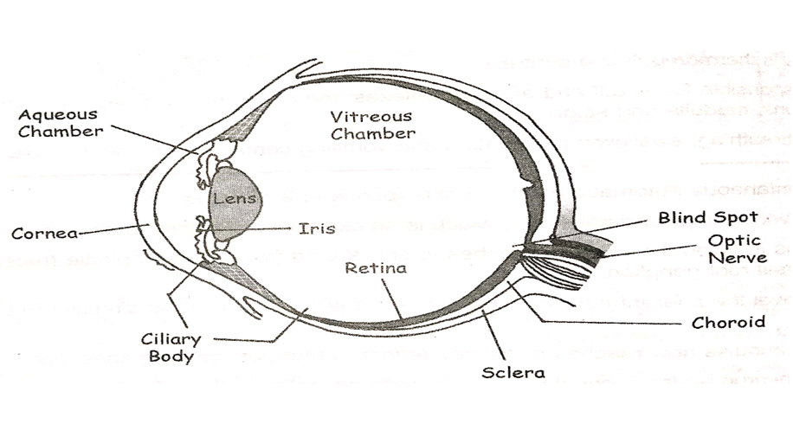

**Body Cavities**

**Thoracic cavity**

Organs found in thoracic cavity : the chest; contains

trachea, bronchi, lungs, esophagus, heart, blood

vessels, thymus gland, lymph nodes and nerves.

**It can be subdivided into three main portions:**

**1. The left pleural cavity,** which houses the left lung

**2. The mediastinum (comes from a Latin word**

**meaning “midway”)** houses organs such as the heart,

esophagus, thymus gland, and trachea. The heart is

surrounded by its own cavity called the pericardial cavity

(peri = around; cardi = heart).

**3. The right pleural cavity**, which houses the right lung.

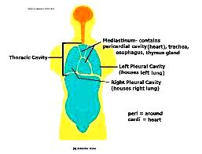

**Abdominal and pelvic cavity**

The lower part of the ventral (abdominopelvic) cavity can be further divided into two portions:

**Abdominal portion** and **Pelvic portion**.

**1. The abdominal cavity ( superior)** is the largest body cavity of the human body and contains several organs

such as the liver, stomach, pancreas, spleen, gallbladder, intestines, and kidneys.

**2. The pelvic cavity (inferior),** which contains the bladder, reproductive organs, and the distal portions of the large intestine (sigmoid colon and rectum).

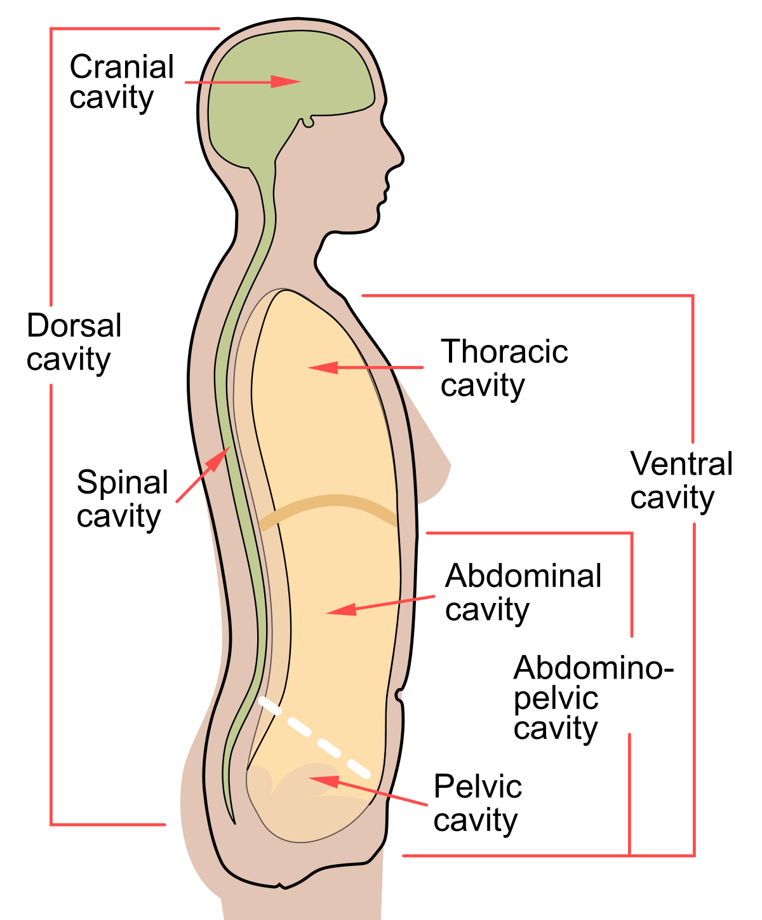

**Dorsal cavity**

The smaller of the two main cavities is called the dorsal cavity. As its name implies, it contains organs lying more posterior in the body. The dorsal cavity, again, can be divided into two portions.

**The upper portion**, or the **cranial cavity**, houses the brain, and

**the lower portion**, or **vertebral canal** houses the spinal cord.

_________________________________________________________________

**The Face**

**1-Skin of the Face.**

The skin of the face is:

¬ Elastic

¬ Vascular (bleed profusely however heal rapidly)

¬ Rich in sweat and sebaceous glands

¬ (Can cause acne in adults).

It is connected to the underlying bones by loose connective tissue, in which are embedded the muscles of facial expression.

**2-Superficial fascia of the face Contains:**

A- facial muscles

B- vessels & nerves

C- fat tissue (absent in the eyelids but it is well developed in the cheeks)

3- Deep fascia: is absent (except over the parotid gland & buccopharyngeal fascia covering the buccinators muscle).

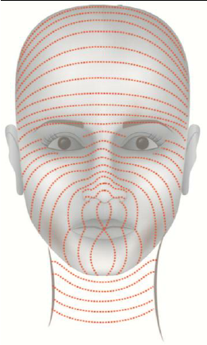 **Relaxed skin tension lines**

Skin tension lines that follow the furrow (a line or wrinkle on a person's face) formed when the skin is relaxed are known as ‘relaxed skin tension lines’ In the living face, these lines frequently (but not always) coincide with wrinkle lines and can therefore act as a guide in planning elective incisions.

**Muscles of the Face (Muscles of Facial Expression)**

1-They lie within the superficial fascia.

2-They take their origin from the facial bones.

3-They are inserted into the skin.

4- They are arranged around the three openings of the face namely, the orbit, nose, and mouth either as sphincters or dilators.

5- They are supplied by the facial nerve.

6- Embryologically, they are originating from the mesoderm of the second branchial arch and therefore are supplied by the facial nerve.

7. The function of the facial muscles serves as sphincters or dilators of these structures. A secondary function of the facial muscles is to modify the expression of the face.

**Muscles of the Eyelids**

¬ Occipitofrontalis (frontals contributes to this functional group)

¬ orbicularis oculi

¬ Levator palpebrae superiors

¬ Corrugator supercilious

As well as controlling the movement of the eyelids, these muscles also play a role in protecting the cornea from injury.

**The Occipitofrontalis muscle** comprises of two main sections.

These sections include the occipital (located posteriorly) and frontal (located anteriorly) bellies. The frontal belly is the major contributor to facial expression.  **Origin**: The occipital belly originates from the occipital bone, as well as the mastoid process of the temporal bone.

**Action**: Contraction of this muscle raises the eyebrows and wrinkles the forehead. **Innervation**: The temporal branch of the facial nerve.

**orbicularis oculi**

This muscle comprises of three main sections. These sections include the orbital orbicularis, palpebral orbicularis and lacrimal orbicularis.

**Origin**: This muscle originates from the nasal portion of the frontal bone, frontal process of the maxilla.

**Action**: **Palpebral part** – gently closes the eyelids, lacrimal part – involved in the drainage of tears, **Orbital part** – tightly closes the eyelids.

**Innervation** The temporal and zygomatic branches of the facial nerve.

**Corrugator supercilii**

This muscle is a much smaller muscle and is located posteriorly to the orbicularis oculi.

**Origin**: This muscle originates at the medial end of the supraorbital ridge.

**Action**: Acts to draw the eyebrows together, creating vertical wrinkles on the bridge of the nose and assist in shielding the eyes from bright light.

**Innervation**: The temporal branch of the facial nerve.

**Levator palpebrae superiors**

Thin muscle located in the bony orbit above the eyeball.

**Origin**: Lesser wing of sphenoid bone.

**Action**: Elevates superior eyelid.