**Lec.9**

**What is MOSFET?**

The **metal–oxide–semiconductor field-effect transistor** (**MOSFET**, **MOS-FET**, or **MOS FET**), also known as the **metal–oxide–silicon transistor** (**MOS transistor**, or **MOS**) is a type of insulated-gate [field-effect transistor](https://en.m.wikipedia.org/wiki/Field-effect_transistor) that is fabricated by the [controlled oxidation](https://en.m.wikipedia.org/wiki/Thermal_oxidation) of a [semiconductor](https://en.m.wikipedia.org/wiki/Semiconductor), typically [silicon](https://en.m.wikipedia.org/wiki/Silicon). The voltage of the [gate terminal](https://en.m.wikipedia.org/wiki/Gate_oxide) determines the [electrical conductivity](https://en.m.wikipedia.org/wiki/Electrical_conductivity) of the device; this ability to change conductivity with the amount of applied voltage can be used for [amplifying](https://en.m.wikipedia.org/wiki/Amplifier) or switching [electronic signals](https://en.m.wikipedia.org/wiki/Signal_(electrical_engineering)).

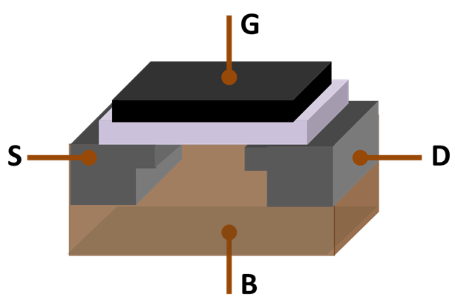

|  |  |
| --- | --- |
| MOSFET, showing [gate](https://en.wikipedia.org/wiki/Metal_gate) (G), body (B), source (S) and drain (D) terminals. The gate is separated from the body by an [insulating layer](https://en.wikipedia.org/wiki/Gate_oxide) (pink). | |
|  |  |

**MOS  field-effect transistor (FET)** is a type of [transistor](https://en.wikipedia.org/wiki/Transistor) that uses an [electric field](https://en.wikipedia.org/wiki/Electric_field) to control the flow of [current](https://en.wikipedia.org/wiki/Electric_current) in a semiconductor. FETs are devices with three terminals: source, gate, and drain. FETs control the flow of current by the application of a voltage to the gate, which in turn alters the [conductivity](https://en.wikipedia.org/wiki/Electrical_resistivity_and_conductivity) between the drain and source.

FETs are also known as **unipolar transistors** since they involve single-carrier-type operation. That is, FETs use either [electrons](https://en.wikipedia.org/wiki/Electron) or [holes](https://en.wikipedia.org/wiki/Hole_(semiconductor)) as [charge carriers](https://en.wikipedia.org/wiki/Charge_carrier) in their operation, but not both. Many different types of field effect transistors exist. Field effect transistors generally display very [high input impedance](https://en.wikipedia.org/wiki/High_impedance) at low frequencies. The most widely used field-effect transistor is the [MOSFET](https://en.wikipedia.org/wiki/MOSFET) (metal-oxide-semiconductor field-effect transistor)

