

***AL- Mustaqbal University College***

**Head and neck anatomy**

**Optometry Department Lec.1**

*Anatomical Terminology*

*Dr. Marrwan Hisham Mohamed*

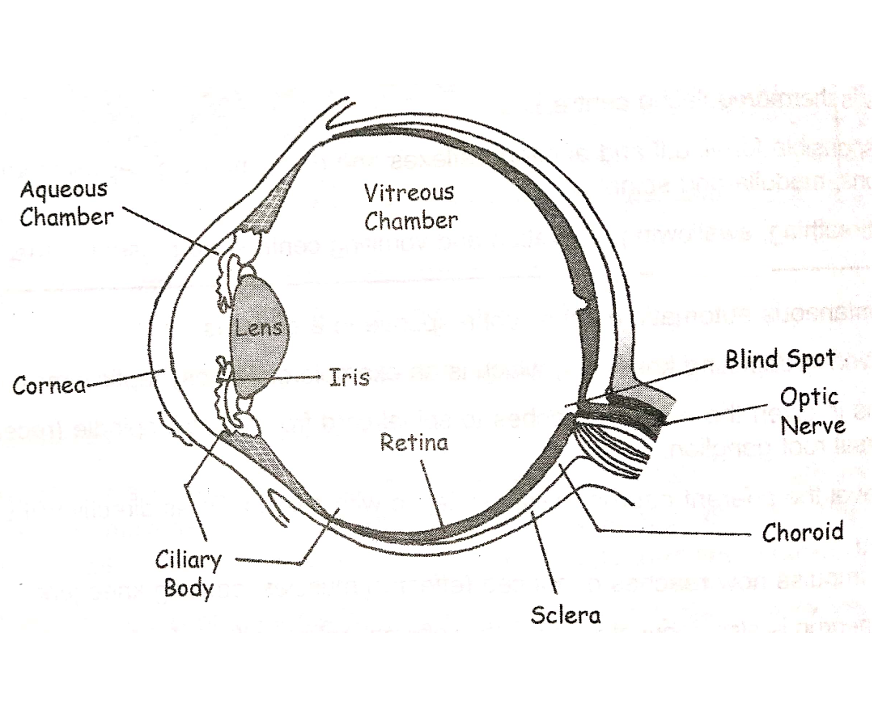

Anatomy

**Anatomy** is the branch of biology concerned with the study of the structure of organisms and their parts.

**Anatomy** is the scientific study of the structure of organisms including their systems, organs and tissues.

*Types of anatomy*

1. **Gross anatomy** : is the study of structures large enough to be seen with the naked eye, and also includes superficial anatomy or surface anatomy, the study by sight of the external body features.

2. **Microscopic anatomy:** is the study of structures on a microscopic scale, along with histology (the study of tissues), and embryology (the study of an organism in its immature condition).

**Three groups of terms are introduced here:**

A. Directional Terms : is describe the positions of structures relative to other structures or locations in the body.

B. Planes of the Body An anatomical plane: is a hypothetical plane used to transect the body, in order to describe the location of structures or the direction of movements.

C. Body Cavities: The cavities, or spaces, of the body contain the internal organs, or viscera. The two main cavities are called the ventral and dorsal cavities.

Directional Terms

• Superior or cranial - toward the head end of the body; upper (example, the hand is part of the superior extremity).

• Inferior or caudal - away from the head; lower (example, the foot is part of the inferior extremity).

• Anterior or ventral - front (example, the kneecap is located on the anterior side of the leg). • Posterior or dorsal - back (example, the shoulder blades are located on the posterior side of the body).

• Medial - toward the midline of the body (example, the middle toe is located at the medial side of the foot).

• Lateral - away from the midline of the body (example, the little toe is located at the lateral side of the foot).

• Proximal - toward or nearest the trunk or the point of origin of a part (example, the proximal end of the femur joins with the pelvic bone).

• Distal - away from or farthest from the trunk or the point or origin of a part (example, the hand is located at the distal end of the forearm)

*Planes of the Body*

• Coronal Plane (Frontal Plane) - A vertical plane running from side to side; divides the body or any of its parts into anterior and posterior portions.

• Sagittal Plane (Lateral Plane) - A vertical plane running from front to back; divides the body or any of its parts into right and left sides.

• Axial Plane (Transverse Plane) - A horizontal plane; divides the body or any of its parts into upper and lower parts.

• Median plane - Sagittal plane through the midline of the body; divides the body or any of its parts into right and left halves.

