**Babylon University**

**Faculty of Nursing**

**Report about Family Planning in Primary Health Care**

**(Specialty: Clinical Requirement)**

**Prepared by Ph.D. student of Family and Community Health Nursing, Faculty of Nursing / University of Babylon**

**Husain Mansour Ali**

**Supervision**

**Prof. D. Amin Ajeel Al-Yasiri**

**What is Family Planning?**

***Family planning is when both the husband and wife together discuss and mutually decide how many children they would like to have and when, so that they can give sufficient love, care, attention and good education to each of their children.***

· Family planning is achieved through the use of contraceptive methods and the treatment of infertility (inability to have children)

· Planning when and how many children to have is the couple's responsibility, not just the man's or woman's

· Family planning is just as important for newly married couples as it is for those who already have one or more children. It enables young people to delay their first child till they are prepared to take up the responsibilities of raising a child.

**Five situations to avoid when planning a pregnancy**

**1.** When women are too young (less than 20 years)

**2.** When women are too old (more than 35 years)

**3.** When pregnancies are too close together (less than two years difference between two children)

**4.** When pregnancy is too soon after a miscarriage or an abortion (less than six months)

**5.** When pregnancies are too many (four or more children)

**Family Planning Goals and Contraceptive Methods**

**Family planning goals** of individuals and couples may vary and can include:

— Delaying the first pregnancy

— Spacing between births

— Limiting family size (not having any more children)

* Contraceptive choices available to couples are to either postpone the first pregnancy, space between pregnancies or limiting family size Methods for spacing pregnancies or delaying first pregnancy:
* Condoms
* Pills
* LAM
* SDM ( also called *Mala Chakra)*
* Injectables
* IUD (Copper-T) (long acting method)
* Limiting Method
* Female Sterilization or Tubectomy
* Male Sterilization or Vasectomy

**Benefits of family planning / contraception**

Promotion of family planning – and ensuring access to preferred contraceptive methods for women and couples – is essential to securing the well-being and autonomy of women, while supporting the health and development of communities.

***Preventing pregnancy-related health risks in women***

A woman’s ability to choose if and when to become pregnant has a direct impact on her health and well-being. Family planning allows spacing of pregnancies and can delay pregnancies in young women at increased risk of health problems and death from early childbearing. It prevents unintended pregnancies, including those of older women who face increased risks related to pregnancy. Family planning enables women who wish to limit the size of their families to do so. Evidence suggests that women who have more than 4 children are at increased risk of maternal mortality.

By reducing rates of unintended pregnancies, family planning also reduces the need for unsafe abortion.

**Reducing infant mortality**

Family planning can prevent closely spaced and ill-timed pregnancies and births, which contribute to some of the world’s highest infant mortality rates. Infants of mothers who die as a result of giving birth also have a greater risk of death and poor health.

***Helping to prevent HIV/AIDS***

Family planning reduces the risk of unintended pregnancies among women living with HIV, resulting in fewer infected babies and orphans. In addition, male and female condoms provide dual protection against unintended pregnancies and against STIs including HIV.

***Empowering people and enhancing education***

Family planning enables people to make informed choices about their sexual and reproductive health. Family planning represents an opportunity for women to pursue additional education and participate in public life, including paid employment in non-family organizations. Additionally, having smaller families allows parents to invest more in each child. Children with fewer siblings tend to stay in school longer than those with many siblings.

***Reducing adolescent pregnancies***

Pregnant adolescents are more likely to have preterm or low birth-weight babies. Babies born to adolescents have higher rates of neonatal mortality. Many adolescent girls who become pregnant have to leave school. This has long-term implications for them as individuals, their families and communities.

***Slowing population growth***

Family planning is key to slowing unsustainable population growth and the resulting negative impacts on the economy, environment, and national and regional development efforts.

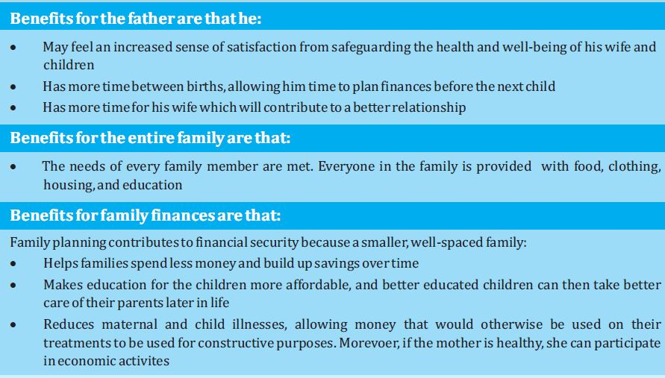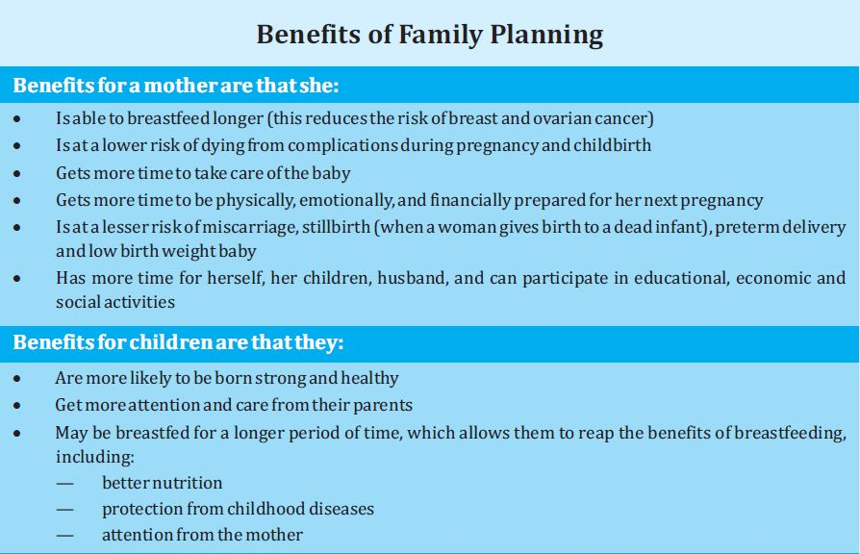

References

1. *Bajos, Nathalie; Le Guen, Mireille; Bohet, Aline; Panjo, Henri; Moreau, Caroline (2014).*[*"Effectiveness of Family Planning Policies: The Abortion Paradox"*](https://www.ncbi.nlm.nih.gov/pmc/articles/PMC3966771)*. PLoS ONE.****9****(3): e91539.*[*doi*](https://en.wikipedia.org/wiki/Digital_object_identifier)*:*[*10.1371/journal.pone.0091539*](https://doi.org/10.1371%2Fjournal.pone.0091539)*.*[*PMC*](https://en.wikipedia.org/wiki/PubMed_Central)[*3966771*](https://www.ncbi.nlm.nih.gov/pmc/articles/PMC3966771)*.*[*PMID*](https://en.wikipedia.org/wiki/PubMed_Identifier)[*24670784*](https://www.ncbi.nlm.nih.gov/pubmed/24670784)*.*
2. [**^**](https://en.wikipedia.org/wiki/Family_planning#cite_ref-6) *Centers for Disease Control and Prevention. (2006).*[*"Recommendations to improve preconception health and health care — United States: a report of the CDC/ATSDR Preconception Care Work Group and the Select Panel on Preconception Care"*](http://www.famplan.org/Resources/Docs/cdc_mmwr.pdf)*(PDF). MMWR.****55****(RR-6).*
3. ^ [Jump up to:***a***](https://en.wikipedia.org/wiki/Family_planning#cite_ref-USDAChildExpense_7-0) [***b***](https://en.wikipedia.org/wiki/Family_planning#cite_ref-USDAChildExpense_7-1) [***c***](https://en.wikipedia.org/wiki/Family_planning#cite_ref-USDAChildExpense_7-2) [*"Expenditures on Children by Families, 2007; Miscellaneous Publication Number 1528-2007"*](http://www.cnpp.usda.gov/ExpendituresonChildrenbyFamilies.htm)*. United States Department of Agriculture, Center for Nutrition Policy and Promotion.*