**Babylon University**

**Faculty of Nursing**

**Report about referral system of Iraqi Primary Health Care program**

**(Specialty: Clinical Requirement)**

**Prepared by Ph.D. student of Family and Community Health Nursing, Faculty of Nursing / University of Babylon**

**Husain Mansour Ali**

**Supervision**

**Prof. D. Amin Ajeel Al-Yasiri**

**Introduction**

Under supervision of Prof. (Amin Ajeel Al-Yasiri), a visit done to the Al-Kawther Primary Health Care Center in Babylon City on Sunday 1/4/2019 within the activities of practical training for doctoral students in the branch of Family and Community Health Nursing.

During this visit, the standard units and services provided for Iraqi clients at the community level detected and briefed as much as possible in this report.

***Definition:*** Primary Health Care is essential health care made universally accessible to individuals & acceptable to them, through their full participation & at a cost the community & country can afford.

* **Elements of Primary Health Care:**

1. Education concerning prevailing health problem & the methods of preventing & controlling them.
2. Promotion of food supply & proper nutrition.
3. An adequate supply of safe water & basic sanitation.
4. Maternal & child health care, including family planning.
5. Immunization against major infectious diseases.
6. Prevention & control of locally endemic diseases.
7. Appropriate treatment of common diseases & injuries.
8. Provision of essential drugs.

These services provided under following principles:

* **Principles of Primary Health Care:**

1. Equitable distribution:
2. Community participation:
3. Inter-sectoral coordination:
4. Appropriate technology:

5. Prevention:

*Primary prevention*

*Secondary prevention*

*Tertiary prevention*

So that, the services in every Typical Primary Health Care Center in Iraq are derived from abovementioned elements of Primary Health Care (PHC).

* **Services or Units of Typical Primary Health Care Center:**

1. Family medicine.
2. Physician and gynecologist clinics.
3. Registered nurse clinic.
4. Integrated management of newborn child health (IMNCH) & Nutrition.
5. Immunization.
6. Health promotion and communicable disease control.
7. Laboratory and ultrasound.
8. Maternal & child health care, including family planning (MCH).
9. Early detection of breast cancer, hypertension and D.M.
10. Provision of essential drugs (fundamental pharmacy for primary level of care).
11. Dental care.
12. School health.
13. Mental health unit.

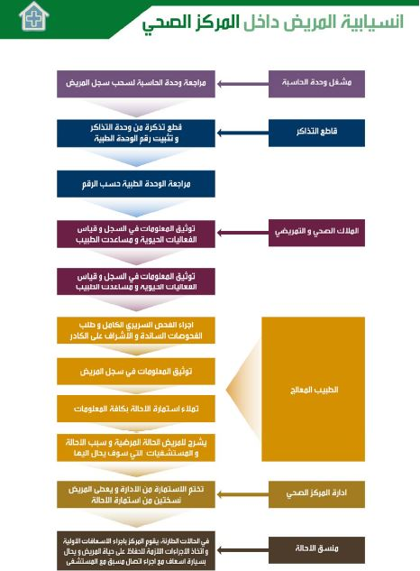In the following report only few units of primary health care center, who are the most important, will be mentioned.

**Current Situation of Referral System in Iraq**

Some Observations about the Referral System2

• Most referred cases are due to the preference of clients because they are not satisfied with the quality of services received at PHC centers.

• Due to a stock out of referral forms in the PHCs, staff are forced to utilize any available paper for referral. The Kirkuk Committee Team reported that “they need five months of paper work to obtain approval to print new forms”.

• There is no clear list of “criteria or indication for referral” available that can be followed by staff at the level of PHC centers.

• The medical record system in the PHCs is weak; when a patient returns from a referral, PHC staff either do not have or cannot locate the patient’s record to know why the patient was referred in the first place.

• There is contradiction and overlap in the instructions issued by different authorities when making or documenting a referral.

• There is no follow up to the referral system at the level of the MOH; only three DOHs have continued working within the system while other DOH have stopped.

• A lack of awareness exists concerning the basis and application of the referral system among both health care providers and health care receivers.

• In most cases full details about the patient are lacking on the referral form and sometimes even the name of the PHC center requesting the referral is missing. The reason for the referral is also usually missing.

• There is weak coordination between different offices that are directly concerned with the implementation and application of the referral system.

• There is weak compliance of the PHC centers and the hospitals in terms of data and its relationship to the referral system. A secondary issue is the incompleteness of information in the referral form.

• There is no policy that directs the PHC staff where to keep the feedback documents and for how long.

• There was a copy of an order signed by previous Minster of Health, stating that “health provider staff needs to offer services to any clients who attend the PHC or hospital even if he/she doesn’t have a referral paper”. Providers perceive that this order enable patients to bypass the referral system.

**PHCPI Recommendations**

1. There should be a modification of the table of the referral sheet used by the health offices in order to include all the needed information and to make it more applicable and understandable.

2 These observations and recommendations were drawn from PHCPI team meetings with PHC medical staff from health centers all over Iraq, they do not represent the formal views of the MOH.

2. In order to organize the feedback from the hospitals to the PHCs, the timing and scheduling of the feedback should be restricted to the previous month only in order to prevent any misunderstanding and overlapping of data that are related to different months.

3. There is an acute and urgent need for a nationwide health education campaign in order to explain to both the people and the health workers the nature and the benefits of the referral system. This need is being addressed in the Referral System Orientation Guide that has been developed in conjunction with the MOH and now being translated in English. The Guide will be rolled out nationwide under PHCPI Component 3 Community Outreach and Engagement.

4. All required information listed in the referral form needs to be completed by both the PHC center and the personnel of the hospitals.

**Characteristics of a Referral System:**

Linking the different levels of care is an essential element of primary health care. The referral system complements the PHC principle of treating patients as close to their homes as possible at the lowest level of care with the needed expertise3. As emphasized by the WHO, this back-up function of referral is of particular importance in pregnancy and childbirth, as a range of potentially lifethreatening complications requires management and skills that are only available at higher levels of care4. The following levels of care have been identified: (1) PHC sub-centers, (2) health centers (sub district) and (3) district hospital.

Health facilities allocated at the sub-district level are linked to those at the district level usually; practically speaking, health facilities functioning at the sub district level are mainly PHC centers, some of which are providing more advanced services in terms of delivery care, emergency obstetric care, and emergency care. Health facilities located at the sub-district level are to be linked to the district hospital. This means that patients with unsolved health problems at the sub district level will be referred to the district level (district hospital) for more advanced health care and services. At the same time patients seeking care at the PHC center at the district level whose problems were unsolved or need more advanced care are to be referred to the district hospital for the completion of care and management.

Patients whose health problems are not fully resolved at the district hospital and are in need of more specialized and advanced care are to be referred to the provincial level, where more advanced health services are usually available. In some cases, patients or clinical conditions fail to find the proper care and services at the provincial level may be referred to the tertiary care level in Baghdad where highly specialized centers are available.

A referral system is a two-way system, i.e. patients and conditions referred from primary health care center with a special completed form and in compliance with certain rules and instructions are to be received at the referral level in an appropriate manner and provided with the necessary care or services needed. The referring PHC center should be informed about all the details of the patient's condition, investigation done for the patient and their findings and procedures and interventions.

**Objectives of the Referral Strategy**

• Clients receive optimal care at the appropriate level and at an affordable cost.

• Hospital facilities are used optimally and cost-effectively by improving the continuum of care for patients.

• Clients in need of specialized services can access them in a timely way.

• Primary health services are well utilized and their role in both prevention and curative aspects is enhanced.

**Conceptual Framework for Referral from Primary to Secondary Level**

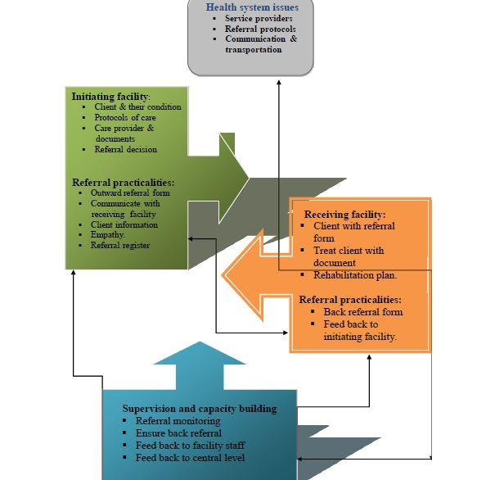

**References:**

Abbood, R. K. (2018) *Primary Health Care Programs Learner’s Guide*. 1st ed. Edited by University Research Company. USA: URC.

Centers for Disease Control and Prevention. (2012c). *Epidemiology and prevention of vaccine preventable diseases: the Pink Book* (12th ed.). Washington, DC: Public Health Foundation.

Hixon, A. L. and Maskarinec, G. G. (2008) ‘The Declaration of Alma Ata on its 30th anniversary: relevance for family medicine today’, *Fam Med*, 40(8), pp. 585–588.