**Primary Health Care & Health Care System in IRAQ**

**Specialty Seminar**

**Salim ALjepory**

**-------------------------------------------------------------------------------------------------------------**

* **Definition**: “Primary Health Care is essential health care made universally accessible to individuals & acceptable to them, through their full participation & at a cost the community & country can afford”.
* **Characteristics Of PHC**

1. **General:** (patients have not been pre-selected according to their medical condition).
2. **Continuous:** (the same physician cares for same patient over time).
3. **Comprehensive:** (covers all conditions).
4. **Coordinated and Collaborative:** (doctors are linked to other sources of care and are the case-managers for that patient).
5. **Family-oriented:** (ideally, patient and other family members treated by same health care team).
6. **Community-oriented.**

* **Nature Of PHC:**

1. Preventive.
2. Promotive.
3. Curative.
4. Supporative.
5. Rehabilitative.

* **Elements of Primary Health Care:**

1. Education concerning prevailing health problem & the methods of preventing & controlling them.
2. Promotion of food supply & proper nutrition.
3. An adequate supply of safe water & basic sanitation.
4. Maternal & child health care, including family planning.
5. Immunization against major infectious diseases.
6. Prevention & control of locally endemic diseases.
7. Appropriate treatment of common diseases & injuries.
8. Provision of essential drugs.

The role of a nurse to deal health needs and health problems of people at community level done through variety of functions such as 1. Direct care provider 2. Health educator & teacher 3. Planner & care manager 4. Guide & supervisor 5. Researcher.

**Health Care System in Iraq**

A formal health care system in Iraq began with British occupation following the end of the First World War in 1918. In 1921 the first Directorate of Public health Services was formed .In 1952 the Ministry of Health was re-established and its organizational structure was formalized in 1959.

**The main functions of the Ministry of Health in IRAQ**

1. Establishment and management of health facilities.
2. Control of communicable diseases.
3. School health and maternal and child health services.
4. Promotion of nutritional
5. Provision of mental health services
6. Supply of drugs, vaccines, sera and other medical goods

**Principles Guiding National Health Policy in Iraq**

1. Health is a right guaranteed to every human being.
2. Justice.
3. Sustainable, high-quality health care services are accessible to all.
4. Decentralized approach.
5. Accountability and transparency.
6. Family Health Approach.
7. Safety and rights of the patient and health care provider.

**Trends in** **National Health Policy of Iraq:**

The national health policy orientations are based on the main components of the health system, which are universally adopted according to the WHO classification (governance, financial resources, human resources, health information system, service delivery, medical technologies and medicines).

1. ***Regulatory policy:*** The Health Sector applies a decentralized approach to health sector management, strengthening organizational structures and human capacity building.
2. ***Policy for the provision of health care services:*** Levels of health care services (Primary health care, Secondary health care and Tertiary health care).
3. ***Health Financing Policy:***
   1. ***Financial resources:*** The state provide health services and training and development of human.
   2. ***Financial management:*** developing the financial management system, improving efficiency, responsiveness, accountability and transparency through increased coordination between health, finance and planning.
   3. ***Financial protection in health:*** Providing financial protection in order to ensure health care for all citizens.
4. ***Human resources policy: planning, management and development.***
5. ***Infrastructure Policy:***
6. ***Emergency preparedness, crisis and disaster preparedness policy:***
7. ***Mental health policy and the fight against addiction:***
8. ***Research Policy:***
9. ***Health promotion and environmental safety policy:***
10. ***Quality Management Policy:***

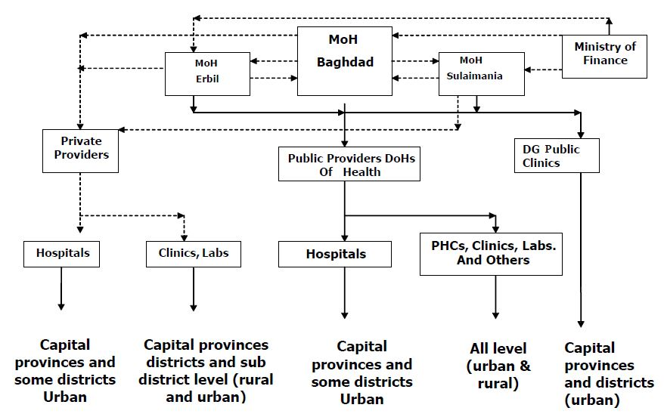**Design of Overall Health Care System in Iraq:**

**References:**

Allender, J. A., Warner, K. D. and Rector, C. (2014) *Community and public health nursing: promoting the public’s health*. 8th ed. Hong Kong: Lippincott Williams & Wilkins.

Alwan, A. D. (2008) ‘Health-sector funding: Options for funding health care in Iraq’, *Eastern Mediterranean Health Journal*, 14(6), pp. 1372–1379.

EMRO and WHO (2006) *Health Systems Profile Iraq*, *Regional Health Systems Observatory- EMRO*. Cairo: WHO.

Hixon, A. L. and Maskarinec, G. G. (2008) ‘The Declaration of Alma Ata on its 30th anniversary: relevance for family medicine today’, *Fam Med*, 40(8), pp. 585–588.

Jerome-D’Emilia, B. (2012) ‘Public Health and Primary Health Care Systems and Health Care Transformation’, in Stanhope, M. and Lancaster, J. (eds) *Public health nursing: population-centered health care in the community*. 8th ed. Maryland Heights, Missouri: Elsevier, Mosby, pp. 44–62.

Katz, D. L. and Ali, A. (2009) ‘Preventive medicine, integrative medicine, and the health of the public’, *Invited paper at the IOM Summit on Integrative Medicine and the Health of the Public*.

MOH Iraq (2014) *National Health Policy For All Iraqi Citizens 2014-2023*. Baghdad. Available at: http://www.nationalplanningcycles.org/sites/default/files/planning_cycle_repository/iraq/iraqs_national_health_policy_2014-2023.pdf.

World Health Organization (1978) ‘Declaration of Alma-Ata. Adopted at the International Conference on Primary Health Care, Alma-Ata, USSR, September 1978’, in. Alma-Ata: WHO.

World Health Organization (2018) *Primary Health Care (PHC)*, *Pimary Health*. Available at: http://www.who.int/primary-health/en/ (Accessed: 28 September 2018).