**University of kufa**

**College of nursing**

**Clinical Report about TB (Tuberculosis Case Management in Primary Health Care and Related Nursing Roles)**

**Prepared by Ph.D. Student of Family and Community Health Nursing Branch**

**Husain Mansour Ali**

**Supervision**

**Prof. D. Amin Ajeel Al-Yasiri**

Tuberculosis (TB) is an infectious disease usually caused by Mycobacterium tuberculosis (MTB) bacteria. Tuberculosis generally affects the lungs, but can also affect other parts of the body. Most infections do not have symptoms, in which case it is known as latent tuberculosis. About 10% of latent infections progress to active disease which, if left untreated, kills about half of those affected. The classic symptoms of active TB are a chronic cough with blood-containing sputum, fever, night sweats, and weight loss. It was historically called "consumption" due to the weight loss. Infection of other organs can cause a wide range of symptoms.

Tuberculosis is spread through the air when people who have active TB in their lungs cough, spit, speak, or sneeze. People with latent TB do not spread the disease. Active infection occurs more often in people with HIV/AIDS and in those who smoke. Diagnosis of active TB is based on chest X-rays, as well as microscopic examination and culture of body fluids. Diagnosis of latent TB relies on the tuberculin skin test (TST) or blood tests.

**TB Diagnostics**

As noted above, there is a reasonably high level of activity in TB diagnostics, with new tests at every stage of the R&D pipeline from proof of principle through to Phase III trials. Although currently too expensive and technically difficult for resource-poor TB settings, many tests have potential for such use, if adapted. Diagnostics of particular interest include:

a) Rapid culture and DST systems (rapid detection of organisms and drug resistance)

* Oxygen quenching MGIT
* Colorimetric liquid culture
* Nitrase reduction assays
* Colorimetric solid culture

b) Culture surrogates

* Phage amplification: FastPlaque
* Luciferase reporter-phages

c) Molecular methods

* Inno-LIPA
* PCR

d) Tests detecting antigen or volatile gases. This work is at an earlier stage, just short of proof of principle and, although technically challenging, is considered promising.

* Blood based tests to detect TB antigens
* “Electronic noses” to detect antigens in breath
* Tests for latent TB infection, capable of distinguishing it from prior BCG vaccination or infection with non-tuberculous species of mycobacteria.
* Whole blood IFN- test: Quantiferon
* ELISPOT

f) Laboratory free tests for active infection using transient cellular immunity

* Skin patch test using MPT64 (Sequella Inc., US), now in Phase II trials

**TB Drugs**

As seen from the Matrix below, all stages of the TB drug pipeline are thin. The discovery and lead identification stages, which provide new compounds to enter the TB pipeline, have only a handful of projects; and the few compounds that are in development tend to be at the earliest pre-clinical stages. This means we cannot expect a **novel** TB drug, active against both MDR-TB and drug-sensitive TB, until at least 2010.

From a first glance at this matrix, the late pipeline appears to be relatively full, however it should be noted that these products are **existing antibiotics** in clinical trials for a new TB indication, rather than genuinely novel anti-TB drugs. The final products will therefore probably be unsuitable for MDR-TB use, although they are promising in terms of simplifying and shortening non-MDR TB treatment, and may be available as early as 2007-2008. See Table 3 matrix.

**TB Vaccines**

Development of new TB vaccines has reached an important turning point, with a decade of experimental laboratory modelling now leading to entry of the first vaccine candidates into clinical trials. If successful, delivery of a final vaccine will take at least 10 years (2014).

**PHC Provider Functions May Include The Following:**

• **Suspect** TB and react quickly when patients present with symptoms suspicious of TB;

• **Ensure** collection of high quality sputum for microscopy as the basic tool for detection of TB and monitoring of treatment;

• **Ensure** that every patient with a productive cough of greater than 2 to 3 weeks has three sputum samples examined for acid-fast bacilli (AFB) in a designated laboratory;

• **Send** the collected diagnostic material for examination to a clinical diagnostic laboratory;

• **Order or refer** for X-ray examination;

• **Refer** TB suspects to the specialized TB services for diagnosis and treatment;

• **Communicate** to patients that TB is curable and emphasize the importance of regular and complete treatment in curing TB;

• **Communicate** with specialized TB services to be aware of diagnosis of patients who have been referred for diagnosis and treatment;

• **Emphasize** the importance of screening household and close contacts of smear-positive cases and ensuring that symptomatic contacts are evaluated, including tuberculin (Mantoux) skin testing in children;

• **Educate** the community about the signs and symptoms of TB and the need to seek medical care if these symptoms occur;

• **Provide** directly observed therapy to completion during the continuation phase of treatment under the supervision of the TB services;

• **Report** any default or complications in directly observed treatment to the TB services immediately;

• **Complete** all essential forms and return to the TB services;

• **Monitor** patients from risk groups for TB according to the national regulations; and

• **Perform** BCG vaccination and revaccination as well as tuberculin skin testing in children (according to national regulations).

**To conduct a primary evaluation of a patient presenting with symptoms suggestive of TB:**

**1. Obtain** an accurate medical history.

**2. Complete** a physical exam.

**3. Ensure (or refer** to appropriate services for)

– **AFB microscopy** of three good quality sputum smears; and

– **Chest X-ray** examination.

**4. Refer** the patient to the nearest facility in which a TB diagnosis can be confirmed or ruled out. The algorithm in Figure 3 depicts additional information on the use of these steps in detecting and diagnosing pulmonary TB.

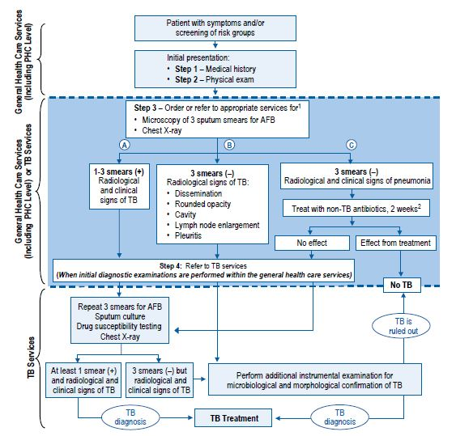

**Algorithm for Detecting and Diagnosing Pulmonary TB**

**References**

Crofton J, Horne N, Miller F. *Clinical Tuberculosis*, The Macmillan Press Limited, 1992.

*DOTS Expansion Plan to Stop TB in the WHO European Region 2002-2006.*

WHO Regional Committee for Europe-Fifty-second Session, Copenhagen, 16-19 September 2002.

Freiden T. *Toman’s Tuberculosis: Case Detection, Treatment and Monitoring-Questions and Answers,* 2nd ed. (WHO/HTM/TB/2004.334)

Rieder HL*. Epidemiologic Basis of Tuberculosis Control*. Paris, International Union Against Tuberculosis and Lung Disease, 1999.

Toman K. *Tuberculosis Case-Finding and Chemotherapy.* Geneva, World Health Organization, 1979.

WHO Regional Office for Europe. *TB Manual-National Tuberculosis Programme Guidelines.* Warsaw, World Health Organization Regional Office for Europe, 2001. (EUR/01/5017620).

World Health Organization. *Treatment of Tuberculosis: Guidelines for National Programmes.* Geneva, World Health Organization, 2003.