Lecture8a: Nursing care during obstetrical operation

* Episiotomy, forceps delivery

# Operative obstetrics (obstetric forceps, vacuum extraction of fetus, , operations in III period of labor and postpartum period)

.The expectation of every pregnant woman is to undergo a spontaneous vaginal delivery with minimal or no resort to operative procedures at the end of pregnancy. For the majority of women this expectation becomes a reality. But

pathological progress of pregnancy, labor and postpartum period sometimes requires surgical interventions. The decision about the performance of any kinds of surgery is made by the physician or multidisciplinary team of doctors depending on the obstetric circumstances and guided by the interests of the mother and the fetus.

## Classification of the obstetric surgical procedures

### Pregnancy-saving operations

cervical cerclage (McDonald’s or a Shiradkor’s procedure)

### Operations to prepare birth canal

* 1. Amniotomy:
     + early amniotomy;
     + timely amniotomy;
     + late amniotomy.
  2. Dilatation of the cervix:
* manual dilatation of the cervix
* cervical dilatation by the Hegar's dilator
* incisions of the cervix
  1. Surgical incision of the perineum:
     + perineotomy;
     + episiotomy

### Correction of the abnormal fetal position

External cephalic version:

* in pelvic presentation
* in the transverse and oblique lie of the fetus Internal podalic version.

### Instrumental delivery

* 1. Obstetric forceps:
     + outlet forceps
     + low or mid-cavity forceps*.*
  2. Vacuum extraction
  3. Fetal extraction:
     + breech extraction
     + total breech extraction.
  4. Cesarean section.

### Embryotomy:

* 1. Craniotomy.
  2. Decapitation.
  3. Cleidotomy.
  4. Spondylotomy.
  5. Evisceration.

### Operations, performed in the third stage of labor and early postpartum period:

* 1. Manual detachment of the placenta and removal of the afterbirth.
  2. Manual inspection (revision) of the uterine cavity.
  3. Instrumental revision of the uterine cavity.
  4. Suturing of the cervical lacerations and perineal tears.
  5. Supravaginal uterectomy.
  6. Hysterectomy.

## INSTRUMENTAL DELIVERY

**Obstetric forceps**

***–*** outlet forceps;

– low or mid-cavity forceps

## Vacuum extraction Fetal extraction:

*–* breech extraction;

– total breech extraction

**Cesarean section**

# 1. Obstetric forceps

Forceps are instruments designed to provide traction and/or rotation of the fetal head when the expulsive efforts of the mother are insufficient to accomplish safe delivery of the fetus. There are two classes of obstetric forceps: classical forceps and specialized forceps..

Classic or standard forceps are used to facilitate delivery by applying traction to the fetal skull. The components of each blade are illustrated in figure 44.

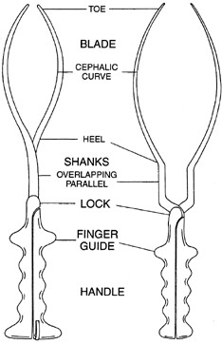 Fig. 44. Obstetric forceps The blades have a **cephalic curve** designed to conform to the curvature of

the fetal head. Simpson forceps (an example of classic or standard forceps) have a tapered cephalic curve that is designed to fit on a molded fetal head. The **pelvic curve** of classic forceps approximates the shape of the birth canal (see fig.45).

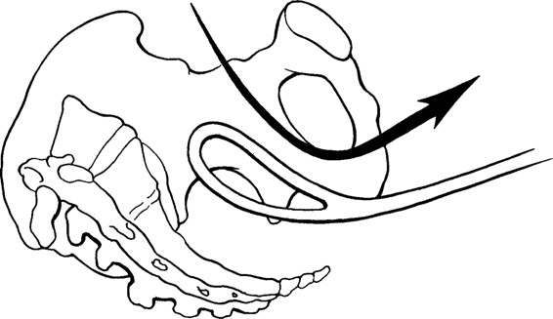

Fig. 45. The shape of the birth canal

## Types of obstetrical forceps

1. **Outlet forceps:** The scalp is visible at the introitus without separating the labia, fetal head at perineum, fetal skull at pelvic floor, sagittal suture in antero- posterior or right/left occipitoanterior or posterior position, and rotation of the fetal head not exceeding 45 degrees.
2. **Low forceps:** The leading part of the fetal skull is at station +2 cm or more (using the 5-point scale of 0 cm, +1, +2, +3, +4, and +5). Low forceps have two subdivisions: rotation of 45 degrees or less and rotation of more than 45 degrees.
3. **Mid forceps:** The fetal head is engaged, but the leading point of the skull is above station +2 cm.

## Maternal indications for forceps delivery.

* 1. **Pregnancy and labor complications:**
     1. Severe preeclampsia or eclampsia.
     2. Premature placental abruption in the second stage of labor when the fetal head is in the cavity of the true pelvis.
     3. Intrapartum endometritis.
     4. Uterine inertia in the second stage of labor when medicamentous therapy fails to be effective. ***In nulliparous women, this is defined as lack of continuing progress for 2 hours without regional anesthesia or 3 hours with regional anesthesia. In multiparous women, it is defined as lack of continuing progress for 1 hour without regional anesthesia or 2 hours with regional anesthesia.***
     5. Amniotic fluid embolism and other critical conditions.

## Severe extragenital pathology that requires exclusion or shortening of the second stage of labor:

1. Decompensated heart diseases (valvular heart disease, cardiac rhythm disturbance, angina pectoris, cardiac infarction, hypertensic crisis, etc.).
2. Threatened or the onset of retinal detachment.
3. Cerebral hemorrhage (stroke).
4. Acute respiratory, hepatic, renal failure.
5. Pulmonary embolism.
6. Haemoptysis, pulmonary edema, etc.

## Fetal indications for forceps delivery*:*

1. Second or third degree of fetal distress that can occur during labor in the prolapse and compression of the loop of the umbilical cord; its membrane attachment; cord entanglement of parts of the fetus during traction; due to hemorrhage in premature placental abruption or partial placental presentation.
2. Difficulty in the birth of the head during a breech delivery (application of forceps to the subsequent head)

## The conditions for forceps-assisted delivery:

* + alive mature fetus;
  + the fetal head must correspond to the medium size;
  + amniotic sac must be ruptured;
  + full dilatation of the cervix;
  + cephalopelvic proportion;
  + empted urinary bladder;
  + the head of the fetus must be positioned in the pelvic outlet in the plane of the narrow part of the pelvis;
  + the patient must have adequate analgesia;
  + the midwife should be competent in the use of the forceps.

## The contraindications to forceps-assisted vaginal deliveries:

1. Dead fetus.
2. Premature fetus (birth weight is less than 2000 g) or macrosomic fetus (birth weigh more than 5000 g). This is crucial due to dimensions of the forceps which are the most favorable for the head of the mature medium-sized fetus; otherwise their application is traumatic for the fetus and the mother.
3. Fetal malformations (hydrocephaly, anencephaly).
4. Anatomically (II, III and IV degree) and clinically narrow pelvis.
5. Fetal head malpositions (occipito- anterior, brow, face).
6. The fetal head is positioned under the pelvic outlet, is adpressed, fitted by the small or big segment in the true pelvis outlet.
7. High straight position of the head.
8. Pelvic presentation.
9. The cervix is not fully dilated.
10. Big caput succedaneum on the fetal head.

## Techniques of forceps operation:

* + Introduction of the blades.
  + Articulation of the forceps.
  + Testing traction.
  + Traction for delivery of the head.
  + Removal of the forceps.

## Guidelines and technique of application of forceps

If the head of the fetus is in the plane of the outlet of the small pelvis, the outlet obstetrical forceps (typical) are applied in the transversal size of the pelvis, and if the head is still in the narrow part of the small pelvis cavity the cavity obstetrical forceps (atypical) are applied in one of the oblique sizes of the pelvis.

The forceps-assisted extraction is performed in the following order:

## Preparation to the operation:

* Urinary bladder catheterization.
* Cleansing of the external genitals.
* Anesthesia.
* Thorough vaginal examination is performed before operation to confirm the availability of the required prerequisites for application of forceps: detection of fully dilated cervix, raptured membranes, position of the head, determination of the sutures and vertices. Depending on the position of the head the variant of the operation is determined: cavity forceps application when the head is positioned in the narrow part of the true pelvis cavity or outlet forceps application if the head descends in the pelvic floor, i.e., in the outlet of the true pelvis.

Placement of forceps in locked position, identification of the left and right branches.

## Undertaking procedure:

1. Introduction and placement of the forceps.
2. Locking of the forceps branches.
3. Testing traction.
4. Working traction – fetal extraction;
5. Removal of the forceps.
6. Birth of the shoulders.

# Rules of application of forceps

While studying the techniques of the operations one should be guided by the rule of three according to M.S. Malinovskiy.

**The first rule** of the rule of three is “three on the left, three on the right”. The left blade is introduced first by the left hand in the left side of the pelvis. The right blade is introduced secondly by the right hand in the right side of the pelvis.

**The second rule** of the rule of three is the “three axes”: in application of forceps three axes must coincide, i.e., longitudinal axis of the pelvis, head and forceps. For this purpose the forceps are introduced with the cephalic curve up, the blades should be placed on the head biparietally and the leading point should be in the same plane with the lock portion of the forceps.

**The third rule** of the rule of three is the “three positions-three tractions”.

* first position: position of the fetal head is at the inlet to the true pelvis by the small or large segment. Tractions are directed to the toes of the midwife who is in the sitting position. Forceps, applied at such position of the head are called high forceps and currently are not used.
* second position: the head is in the pelvic cavity. Tractions are directed to the knees of the midwife who is in the standing position. Forceps, applied at such position of the head are called cavity forceps.
* third position: the head is at the outlet of the true pelvis. Tractions are directed to the midwife himself/herself, and upwards after the point of fixation has been reached. Forceps, applied at such position of the head are called outlet forceps.

Operation technique is showed by figures 46:I-VIII.

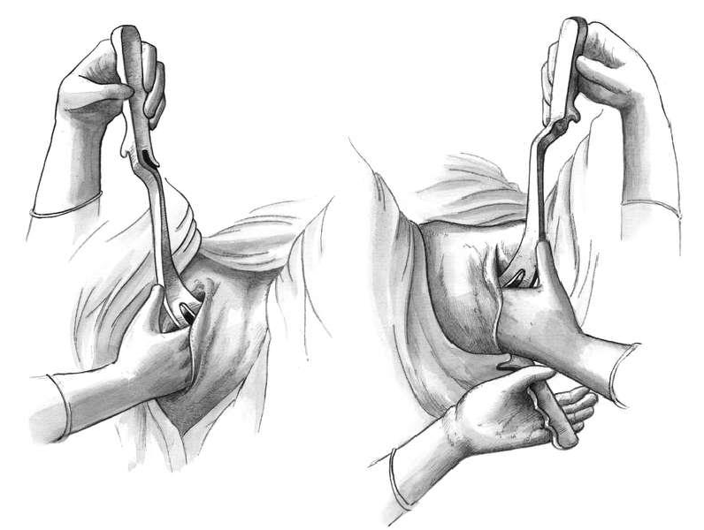**I II**

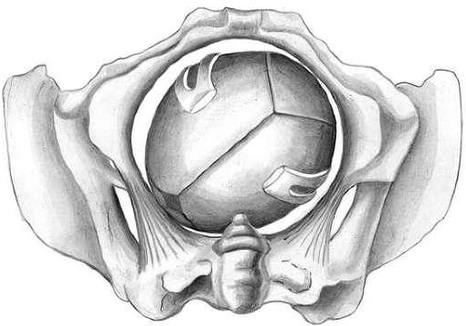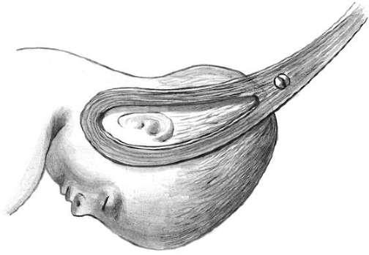**Introduction of the left blade (I) and right blade (II)**

**III**

**Placement of blades on the head of fetus**

**IV 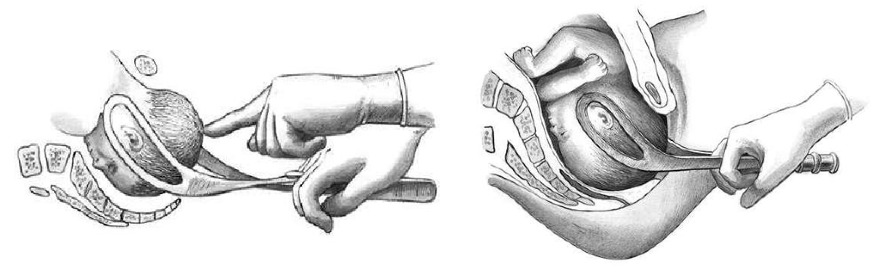V**

**The testing traction (IV) and working tractions (V-VII )**

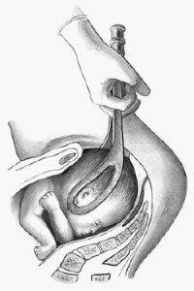VI

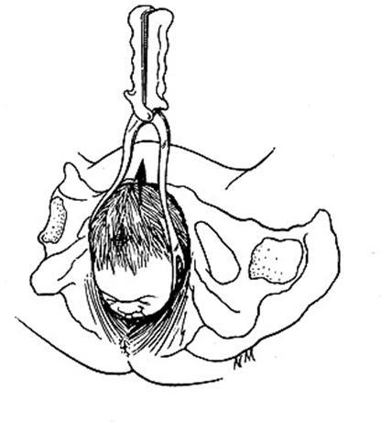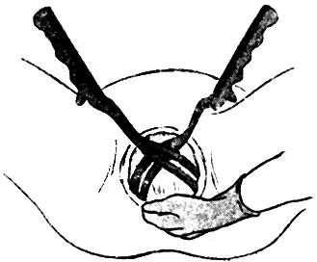

**VII VIII (The removal of blades)**

Fig.46 Techniques of forceps operation

## Possible complications during the forceps-assisted delivery

* Injury of soft tissues of the parturient’s birth canal.
* Urinary incontinence is common after operative vaginal delivery with spinal anaesthetic or an epidural (31%-38%)
* Sub-clinical sphincter defects (80% of primiparous delivered by forceps),
* Neonatal cerebralhemorrhage. (approximately 12%)
* Neonatal asphyxia.
* Skull fractures, injuries of eyes, nerves, clavicles of the newborn.

**Afterbirth *procedures***

* Manual revision of the uterine cavity (for excluding rupture of uterus)
* Expanding of soft birth way (vagina, vulva, perineum)
* Episyoraphy (if episiotomy has been)
* The timing and volume of the first void urine should be monitored and documented. Should be offered an indwelling catheter for at least 12 hours post-delivery to prevent asymptomatic bladder overfilling followed by fluid balance charts to ensure good voiding volumes.
* Thromboprophylaxis should be prescribed

# 2. Vacuum extraction

***Vacuum extraction*** is the vacuum-assisted vaginal delivery when the baby is artificially extracted from the natural birth canal using a vacuum extractor. The principle of operation of the vacuum device is based on the creation of the vacuummetric pressure between the inner surface of the suction cup and the head of the fetus. The adhesive force occurs, enabling to make tractions, required for the extraction of the fetus (see fig.47).

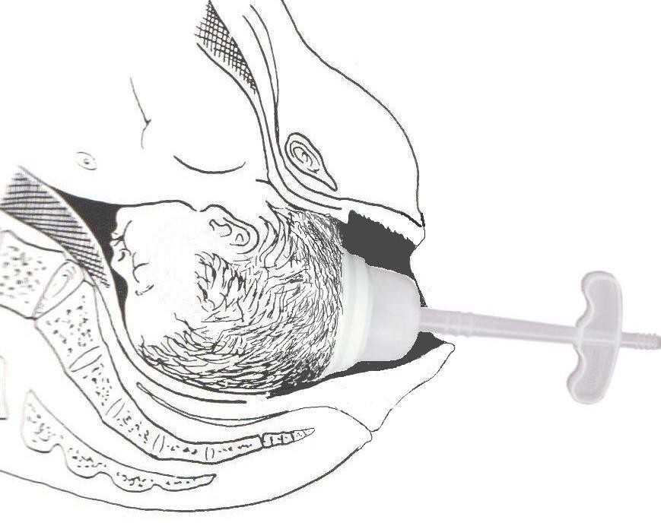Fig. 47. Vacuum extraction

Traction is then applied using principles similar to those described above for a forceps delivery. Flexion of the fetal head must be maintained to provide the smallest diameter to the maternal pelvis by placing the posterior edge of the suction cup 3 cm from the anterior fontanel squarely over the sagittal suture. With the aid of maternal pushing efforts, traction is applied parallel to the axis of the birth canal. Detachment of the suction cup from the fetal head during traction is termed a “pop-off.” If progress down the birth canal is not obtained with appropriate traction, or if two “pop-offs” occur, the procedure should be discontinued in favor of a cesarean delivery.

## Major indications for vacuum extraction:

1. ***Maternal:*** complications during pregnancy, labor or somatic pathology that require shortening of the second stage of labor:

* uterine inertia in the second stage of labor;
* septic infectious diseases leading to deterioration of the maternal overall health, fever;

1. ***Fetal:*** progressing acute fetal hypoxia (distress) in the second stage of labor when the cesarean section is impossible.

## Contraindications for vacuum extraction:

* 1. Cephalopelvic disproportion, namely: hydrocephalus; narrow pelvis of the 3, 4 degree or clinically narrow pelvis.
  2. Dead fetus.
  3. Face or brow presentation.
  4. High straight standing of the head.
  5. Pelvic presentation.
  6. The cervix is not fully dilated.
  7. Premature fetus (less than 30 weeks of gestation).
  8. Obstetric or extragenital pathology that required exclusion of the second stage of labor.

## Prerequisites:

* alive fetus;
* ruptured membranes;
* fully dilated cervix;
* cephalopelvic proportion;
* vertex presentation;
* active participation of the parturient woman in labor;
* the head of the fetus must be in the true pelvis cavity or in the plane of the pelvic outlet;
* anesthesia: pudendal block.

There are two general categories of vacuum cup: the rigid, mushroom- shaped cups patterned after the original Malmstrom cup; and the soft, bell- or trumpet-shaped cups. Selection of the kind of cups is purely individual.

## Possible complications

1. Slide down of the suction cup of the vacuum extractor. In the repeated slide downs the tractions must be ceased and finish the delivery by the application of forceps.
2. Fetal craniocerebral injury (hemorrhage), cephalohematoma.

## Comparision of forceps and vacuum delivery

Vacuum and forceps delivery can be associated with significant complications, both maternal and fetal. Forceps have a higher overall success rate for vaginal delivery. The failure rate for forceps is 7%, whereas the failure rate for vacuum

extraction is 12%. In general, forceps deliveries cause higher rates of maternal injury, and vacuum extraction causes higher rates of fetal morbidity. Forceps have an increased risk of trauma to vaginal and perineal tissues and damage to the maternal anal sphincter. In contrast, neonates delivered by vacuum have more cephalohematomas (accumulation of blood beneath the periosteum) and exclusively have subgaleal hematomas (blood in the space above the periosteum that has a large potential space and can allow significant blood loss) and retinal hemorrhages. Sequential use of one instrument followed by the other has been associated with a disproportionately high fetal morbidity rate and should be approached with extreme caution. Long-term retrospective studies of adolescents who were delivered by normal vaginal delivery, forceps, vacuum extractions, and cesarean delivery have shown little difference in physical or cognitive outcomes.

Two maternal deaths have been described in association with tearing of the cervix at vacuum delivery and a further maternal death has been described following uterine rupture in association with forceps delivery. Neonatal intracranial and subgaleal haemorrhage are life-threatening complications of particular concern.. In a review of liveborn singleton infants born to nulliparous women, the rate of subdural or cerebral haemorrhage in vacuum deliveries did not differ significantly from that associated with forceps use (one in 664) or caesarean section during labour. However, risks increased significantly among babies exposed to attempts at both vacuum and forceps delivery (one in 256)

## OPERATIONS IN THE THIRD STAGE OF LABOR AND EARLY POSTPARTUM PERIOD

* Manual detachment of the placenta and extraction of the afterbirth.
* Manual inspection of the uterine cavity walls.
* Instrumental revision of the uterine cavity.
* Suturing of the cervical and perineal lacerations.
* Supravaginal uterine amputation
* Hysterectomy

***Operations are made at general anesthesia keeping to the aseptic and antiseptic regulations*.**

## Manual detachment of the placenta and extraction of the afterbirth Indications:

* + hemorrhage on the third stage of labor if the placenta is not detached;
  + retention of the placental expulsion if another mode was ineffective (see fig. 52)

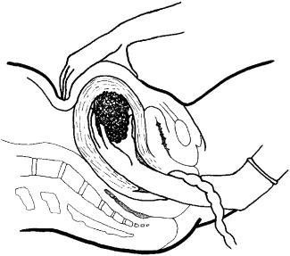

Fig.52. Manual detachment of the placenta

## 2, Manual inspection of the uterine cavity walls Indications:

* retention of the placental fragment or its suspected disintegration;
* uterine hemorrhages;
* after obstetric operations;
* after destructive operations;
* uterine rapture or its suspected disintegration;
* third-degree cervical rapture.

## Instrumental revision of the uterine cavity

Instrumental revision of the uterine cavity is performed by the big (obstetric) curette under general anesthesia, keeping to the aseptic and antiseptic regulations.

## Supravaginal uterine amputation Indications for the operation:

* after cesarean section in the uterine hypotonia or atonia;
* in the presence of uterine myoma and pregnancy;
* hypotonic subcompensated hemorrhage in the placental stage of labor;
* during cesarean section in woman’s infection.

## Hysterectomy

**Indications:**

* hypo- and afibrinogenemiс uterine hemorrhage;
* obstetric peritonitis;
* uterine rapture.

## TESTS

* 1. woman, aged 40, primigravida, with infertility in the medical history, on the 42- 43 week of pregnancy. Labour activity is weak. Longitudinal presentation of the fetus, I position, anterior position. The head of the fetus is engaged to pelvic inlet. Fetus heart rate is 140 bmp, rhythmic, muffled. Cervix dilation is 4 cm. On amnioscopy: greenish colour of amniotic fluid and fetal membranes. Cranial bones are dense, cranial sutures and small fontanel are diminished. What should be tactics of delivery?

## caesarean section

* + 1. amniotomy, labour stimulation, fetal hypoxia treatment
    2. fetal hypoxia treatment, in the ІІ period - forceps delivery
    3. fetal hypoxia treatment, conservative delivery
    4. medication sleep, amniotomy, labour stimulation

1. Which of the following statements about episiotomy if FALSE:

## the earlier the episiotomy is done during delivery, generally the more beneficialit will be unspeeding delivery

1. median (midline) episiotomy is generally considered to be less painful themediolateral episiotomy
2. mediolateral or lateral episiotomy may be associated with more bloodloss than median one
3. indications for episiotomy include avoiding an imminent Perineal tear, the use of forceps, breech delivery, the delivery of premature infants
4. episiotomy incisions are repaired anatomically in layers
5. Regarding Episiotomy:

## It is done after the head crowning

1. commonly done in left medio lateral side
2. external anal sphincter is included in episiotomy
3. all of the above
4. none of the above
   1. primpara is in labor and an episiotomy to be cut. Compared with a midline episiotomy, an advantage of medio-lateral episiotomy is:

## less extension of then incision

* + 1. ease of repair
    2. fewer break downs
    3. lower blood loss
    4. less dyspareunia
  1. 28-year-old parturient complains about headache, vision impairment, psychic inhibition. Objectively: AP- 200/110 mm Hg, evident edemata of legs and anterior abdominal wall. Fetus head is in the area of small pelvis. Fetal heartbeats is clear, rhythmic, 190/min. Internal examination revealed complete cervical dilatation, fetus head was in the area of small pelvis. What tactics of labor management should be chosen?

## forceps operation

* + 1. **c**esarean
    2. **e**mbryotomy
    3. **c**onservative labor management with episiotomy
    4. **s**timulation of labor activity
  1. 30 y.o. primigravida woman has got intensive labor pain every 1-2 minutes that lasts 50 seconds. The disengagement has started. The perineum with the height of 4 cm has grown pale. What actions are necessary in this situation?

## episiotomy

* + 1. perineum protection
    2. perineotomy
    3. vacuum extraction of fetus
    4. expectant management
  1. 30-year-old gravida consulted a gynecologist about bright red bloody discharges from the vagina in the 32 week of gestation. She was hospitalized with a suspicion of placental presentation. Under what conditions is it rational to conduct the internal examination in order to make a diagnosis?

## in the operating room prepared for the operation

* + 1. in the examination room of antenatal clinic
    2. in the admission ward of maternity hospital
    3. in the delivery room keeping to all the aseptics regulations
    4. the examination is not to be conducted because of risk of profuse haemorrhage
  1. 30 y.o. woman has the 2-nd labour that has been lasting for 14 hours. Hearbeat of fetus is muffled, arrhythmic, 100/min. Vaginal examination: cervix of uterus is completely opened, fetus head is level with outlet from small pelvis. Saggital suture is in the straight diameter, small crown is near symphysis. What is the further tactics of handling the delivery?

## use of obstetrical forceps

* + 1. stimulation of labour activity by oxytocin
    2. cesarean section
    3. cranio-cutaneous (Ivanov's) forceps
    4. use of cavity forceps
  1. 32-year-old G3P2 at 39 weeks gestation with an epidural has been pushing for 30 minutes with good descent. The presenting fetal head is left occiput anterior with less than 45° of rotation with a station of +3 of 5. The fetal heart rate has been in the 90s for the past 5 minutes and the delivery is expedited with forceps. Which of the following best describes the type of forceps delivery performed?

## low forceps

* + 1. outlet forceps
    2. midforceps
    3. high forceps
    4. rotational forceps
  1. 38-year-old G6P4 is brought to the hospital by ambulance for vaginal bleeding at 34 weeks. She undergoes an emergency cesarean delivery for fetal bradycardia under general anesthesia. In the recovery room 4 hours after her surgery, the patient develops respiratory distress and tachycardia. Lung examination reveals rhonchi and rales in the right lower lobe. Oxygen therapy is initiated and chest x-ray is ordered. Which of the following is most likely to have contributed to her condition?

## extubation with the patient in the semierect position (semi-Fowler position)

* + 1. fasting during labor
    2. antacid medications prior to anesthesia
    3. endotracheal intubation
    4. extubation with the patient in the lateral recumbent position with her head lowered

## SITUATIONAL TASKS

1.A 24-year-old primigravid woman, at term, has been in labor for 16 hours and has been dilated to 9 cm for 3 hours. The fetal vertex is in the right occiput posterior position, at +1 station, and molded. There have been mild late decelerations for the past 30 minutes. Twenty minutes ago, the fetal scalp pH was 7.27; it is now 7.20. The most appropriate procedure is?

2.You have just delivered an infant weighing 2.5 kg (5.5 lb) at 39 weeks gestation. Because the uterus still feels large, you do a vaginal examination. A second set of membranes is bulging through a fully dilated cervix, and you feel a small part presenting in the sac. A fetal heart is auscultated at 60 beats per minute. The most appropriate procedure is?

3.A 24-year-old woman (G3P2) is at 40 weeks gestation. The fetus is in the transverse lie presentation. The most appropriate procedure is?

4.A 28-year-old G1 at 38 weeks had a normal progression of her labor. She has an epidural and has been pushing for 2 hours. The fetal head is direct occiput anterior at

+3 station. The fetal heart rate tracing is 150 beats per minute with variable decelerations. With the patient’s last push the fetal heart rate had a prolonged deceleration to the 80s for 3 minutes. You recommend forceps to assist the delivery owing to the nonreassuring fetal heart rate tracing. Compared to the use of the vacuum extractor, forceps are associated with an increased risk of which neonatal complications?

5.Pregnant P. in a term of 32 weeks had the attack of eclampsia at home. Entered intensive therapy department of perinatal center. At the admitting: edema of the face and hands, BP 180/110 mm Hg, albumen in urine 0,128 g/l, cervix is closed. Intensive complex therapy is begun. What is subsequent tactic?