**Lecture9 Physiology of the Puerperium and Lactation**

**UTERUS, CERVIX AND VAGINA**

**Tonic contractions help prevent postpartum hemorrhage**

Immediately after delivery, tonic-like activity is required from the uterine muscle, the myometrium, to constrict the blood vessels coursing through it.[1](https://www.glowm.com/article/heading/vol-15--the-puerperium--physiology-of-the-puerperium-and-lactation/id/415293#r1) This occlusion is the major way of reducing flow and preventing postpartum hemorrhage (PPH). Thrombosis at the ex-placental site also helps stem blood loss. It is usual for contractions to be felt as after-pains for several days postdelivery. The contractions are augmented by the hormone oxytocin stimulating the myometrium, as it is released during suckling (see below). During the first 12 hours postpartum, uterine contractions remain regular, strong, and coordinated, before their regularity and strength decrease with involution. Pain relief may be required during this period – more discomfort is experienced by multipara than in primiparous mothers.

**Lochia removes waste**

The puerperal uterine contractions also help in the expulsion of blood, membranes and vernix from the uterine cavity, in a vaginal discharge known as lochia.[2](https://www.glowm.com/article/heading/vol-15--the-puerperium--physiology-of-the-puerperium-and-lactation/id/415293#r2) The red colored discharge (*lochia rubra*) typically lasts 3–5 days. The discharge then becomes thinner and browner, as blood contributes less to it, (*lochia serosa*) and by around day 10 is followed by a yellow to white discharge, composed of leukocytes and mucus but possibly also fat and cholesterol (*lochia alba*). The amount of lochia has been shown to be reduced in women who delivered smaller babies, had a cesarean section, and those who were not first time mothers.[3](https://www.glowm.com/article/heading/vol-15--the-puerperium--physiology-of-the-puerperium-and-lactation/id/415293#r3) Green discolouration and malodorous lochia can be a sign of infection. A heavy discharge beyond 6 weeks can signal complications. Unusual persistence of red lochia can also indicate retained placental tissue or fetal membranes, and requires investigation.

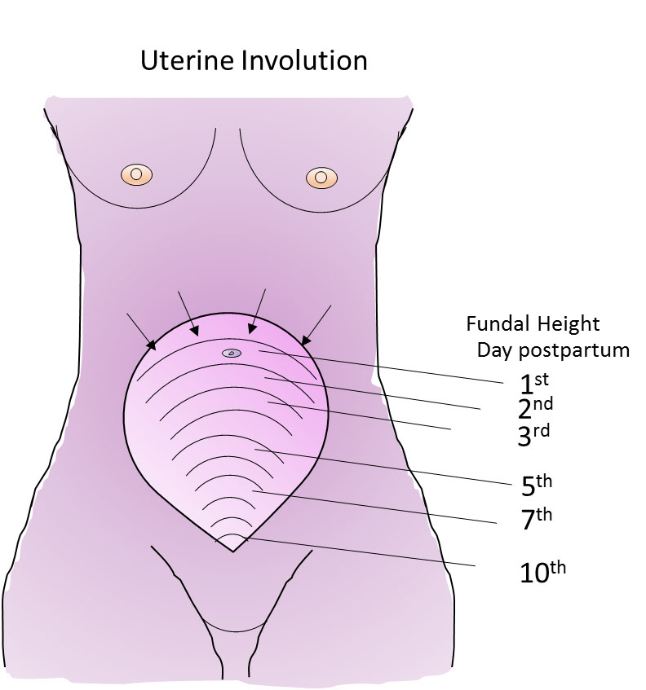

1

Fundal height as the uterus involutes.

**Uterine involution is highly dynamic**

If we are impressed at how much the uterus has grown during the 9 months of pregnancy, we should be even more impressed with how quickly it reverses this growth. The uterus decreases from a weight of around 1 kg to less than 100 g. The uterus returns to around its pre-pregnant state in just 6 weeks. Despite this, the turnover of muscle proteins, connective tissue and cellular remodeling occurring during involution is relatively under-appreciated and under-researched, which perhaps can be said of the whole puerperium, compared with pregnancy. Much has been made of how to assess the rate of involution by palpation and tape measure to determine the distance between the symphysis pubis and uterine fundus. Deviation from accepted normal values could indicate an abnormality and the need for clinical investigation. Studies over the past 20 years or so have indicated that there is so much normal variation between women, and error in the measurements, that these manual measurements of involution are rarely worth doing..[4](https://www.glowm.com/article/heading/vol-15--the-puerperium--physiology-of-the-puerperium-and-lactation/id/415293#r4),[5](https://www.glowm.com/article/heading/vol-15--the-puerperium--physiology-of-the-puerperium-and-lactation/id/415293#r5) Sonographic data are more reliable, but not warranted for routine use. Palpation, however, showing an increase in fundal height needs further evaluation. Delayed involution may be a sign of retained products of conception or endometritis, or a high uterus due to pelvic hematoma or abscess.

The reduction in muscle mass and fiber size in involution, is not just stimulated by the large changes in the hormones that were supporting pregnancy (see below) but also the loss of mechanical stimulation, stretch.[6](https://www.glowm.com/article/heading/vol-15--the-puerperium--physiology-of-the-puerperium-and-lactation/id/415293#r6) There is catabolism of the muscle as its mass reduces, and the extracellular matrix is remodeled by metalloproteinases. Coordinated apoptosis and proliferation results in the myometrium returning to its non-pregnant state.

The endometrium regenerates in 3–6 weeks, and menstruation can occur within this time. The decidua has been cast off in the lochia, and new endometrial growth occurs from the basal layers. The mechanisms governing endometrial puerperal repair in women are not well understood. It is thought that imperfect repair is a cause of future fertility problems and recurrent miscarriages. Recent scientific studies, however, have indicated the involvement of a major pathway important in cell–cell communication, which involves gene regulation mechanisms that control multiple cell differentiation processes during embryonic and adult life – the Notch signaling pathway.[7](https://www.glowm.com/article/heading/vol-15--the-puerperium--physiology-of-the-puerperium-and-lactation/id/415293#r7)

**Cervix and vagina: the rigors of labor take their toll on the cervix and vagina**

The repair of the cervix during the puerperium is vital to stop infection and hemorrhage. Its remodeling and return to a rigid non-pregnant state from its flaccid postdelivery state, is vital to future term pregnancies, and involves physiological, biochemical and biophysical changes. The internal os of the cervix should have closed by second week postpartum. The external os may remain somewhat open for many weeks.

Given the extensive collagenous composition of the cervix, it is metalloproteinases and collagenases, and then extracellular matrix protein synthesis, along with cells of the immune and inflammation systems, that play the predominant role in this reconstruction of the cervix.[8](https://www.glowm.com/article/heading/vol-15--the-puerperium--physiology-of-the-puerperium-and-lactation/id/415293#r8) Interestingly, a recent proteomic analysis of mouse postpartum cervix, identified four pathways that were significantly differentially upregulated during remodeling and warrant further investigation: intermediate filaments, actin-binding proteins, hypoxia-induced proteins, and proteins involved in immune modulation and/or wound healing.[9](https://www.glowm.com/article/heading/vol-15--the-puerperium--physiology-of-the-puerperium-and-lactation/id/415293#r9)

The vagina and vulva will initially be edematous, and enlarged but return to their usual state over the first few weeks of the puerperium. The vaginal walls will weaken slightly with each pregnancy, contributing to the age-related risk of genital prolapse.

Tears and episiotomies, depending upon their size, will heal within the next 2–3 weeks but obviously need to be kept clean and dry, and reassurance given to the mother about healing. Pelvic pain resolves in most women by 6 weeks. Pain on intercourse during the first weeks and months of the puerperium is likely due to tears and episiotomies, as well as the trauma to the vagina during delivery. There is a correlation between the extent of perineal trauma and the presence and intensity of dyspareunia for 3–6 months postpartum. Maternal exhaustion and sleep deprivation may also impact on sexual function. A recent cohort study of women in Holland found that most women quickly resume sexual activity after childbirth; 74.2% by 6 weeks postpartum.[10](https://www.glowm.com/article/heading/vol-15--the-puerperium--physiology-of-the-puerperium-and-lactation/id/415293#r10) An earlier prospective study of Australian women found it took 12 weeks for 78% to have commenced intercourse.[11](https://www.glowm.com/article/heading/vol-15--the-puerperium--physiology-of-the-puerperium-and-lactation/id/415293#r11)

**URINARY SYSTEM**

**There are three main conditions that affect the puerperium and the urinary system: urinary retention, incontinence and diuresis.** Urinary retention is common, and the bladder can easily become over-distended in days 1–2 of the puerperium. The reasons for this are physiological, neurological, and mechanical. Physiologically, there is a persistent reduction in the bladder’s smooth muscle tone. This starts in pregnancy and has an associated increased postvoid residual volume. Neurologically, epidural analgesia temporarily further impairs bladder function, and micturition reflexes may be inhibited with suturing of the peritoneum. Mechanically, edema in the urethra, or urethral compression from postdelivery vulval edema, can contribute to retention. The overfilled bladder can lead to overflow incontinence, which is why within a few hours of delivery women are encouraged to try to pass urine. Emptying the bladder will also prevent its mechanical interference with uterine contractions. Inappropriate or delayed diagnosis and management of puerperal urinary retention can lead to bladder dysfunction, urinary tract infection, and catheter-related complications. The dilation in the renal calyces that occurs with pregnancy reverses by the end of the puerperium.

Leak of urine often accompanies laughing, straining or coughing in the puerperal woman (stress incontinence), but this will naturally resolve in most women. It is assumed to occur due to the stretching of the base of the bladder during both pregnancy and delivery. Pelvic floor exercises will help. Specialist help should be provided if the problem persists. Women should also know that pain or burning on micturition can be signs of a urinary infection in the bladder.

It is normal for there to be diuresis starting around day 2 and lasting 3–4 days, as fluid and salt balance return to non-pregnant values. There will be a fall in plasma volume and hematocrit may therefore rise, unless there was excessive blood loss during delivery (see Table 1 below).

**GASTROINTESTINAL TRACT**

**Although gastrointestinal symptoms are common postnatally, most are mild and resolve spontaneously**. The new mother may experience thirst, hemorrhoids, hunger, flatulence or constipation, but all pass. In some cases stool softeners and topical anesthetic may be helpful. The most serious condition at this time and beyond is fecal incontinence. The muscles and nerves in the pelvic floor that control bowel movements and the anal sphincter will have been stretched and perhaps damaged during delivery. It is also the case that where forceps or vacuum delivery modes have been used, or a significant tear extends backwards, damage to nerves and muscle can occur. Although embarrassing, fecal incontinence usually resolves after several months, but needs specialist attention if it persists. Cases which do not resolve may require surgical repair.

**SKIN, HAIR AND JOINTS**

**The skin, hair, and nails rapidly reverse any changes that occurred in pregnancy**. The dark pigmentation that occurs in the vulva, abdominal wall and face in some women, passes. Any edema of pregnancy is quickly dissipated. Stretch marks (striae gravidarum), become less apparent as the puerperium progresses. Most women experience hair loss over the first few months postpartum, which although potentially upsetting, is only restoring growth to non-pregnant levels. The loosening of ligaments and muscles, especially the diastasis recti, that has occurred with pregnancy, gradually reverse in the puerperium. Exercise and sporting activity should be reintroduced during the early postpartum period. This may be within a week following a normal vaginal delivery but delayed by a few weeks following a cesarean section delivery. The American College of Obstetricians and Gynecologists advises postpartum women should get at least 150 minutes of moderate-intensity aerobic activity every week.[12](https://www.glowm.com/article/heading/vol-15--the-puerperium--physiology-of-the-puerperium-and-lactation/id/415293#r12) The general benefits of exercise on health and well-being underlie this advice, especially as a way to help increase mood, lose weight and strengthen muscle.[13](https://www.glowm.com/article/heading/vol-15--the-puerperium--physiology-of-the-puerperium-and-lactation/id/415293#r13),[14](https://www.glowm.com/article/heading/vol-15--the-puerperium--physiology-of-the-puerperium-and-lactation/id/415293#r14)

**RESPIRATORY SYSTEM**

**Although respiratory problems may be common in pregnancy, the respiratory system is little affected by the puerperium.**Abnormal breathing patterns should alert clinicians to postpartum complications, such as infection.

**ENDOCRINE CHANGES**

**Marked endocrine changes in the puerperal period affect physiology and emotions.** Significant modification of the maternal endocrine system occurs to enable a successful pregnancy. The hormones estrogen and progesterone are both produced by the corpus luteum during the first few weeks of gestation, but the placenta takes over production soon after implantation. Levels of both these hormones rise steadily throughout pregnancy but after parturition and delivery of the placenta, the levels drop rapidly.[15](https://www.glowm.com/article/heading/vol-15--the-puerperium--physiology-of-the-puerperium-and-lactation/id/415293#r15) Cortisol and prolactin are other hormones that exhibit a dramatic concentration rise during pregnancy. The placenta produces corticotropin-releasing hormone (pCRH), which stimulates placental release of cortisol. This process is independent of the usual hypothalamic–pituitary–adrenal axis (HPA axis) that generates cortisol in non-pregnant individuals. At parturition, there is a marked further increase in cortisol concentrations, which is believed to help mature the fetal systems ready for birth, but delivery of the placenta removes pCRH and plasma CRH levels return to normal within 15 hours postpartum. Cortisol levels fall rapidly in the first days and weeks postpartum.[16](https://www.glowm.com/article/heading/vol-15--the-puerperium--physiology-of-the-puerperium-and-lactation/id/415293#r16) Prolactin is secreted by the anterior pituitary gland, and by the end of gestation, levels are 10–20 times higher than non-pregnant levels.[15](https://www.glowm.com/article/heading/vol-15--the-puerperium--physiology-of-the-puerperium-and-lactation/id/415293#r15) The actions of prolactin are inhibited by the presence of progesterone, but once progesterone levels drop, prolactin stimulates milk production. Suckling causes further release of prolactin and levels will remain elevated until such time as breastfeeding stops. If a woman does not breastfeed, prolactin levels go back to normal within 2–3 weeks.

Parturition is accompanied by a large amount of oxytocin secretion from the posterior pituitary. In addition to its peripheral roles in myometrial contractility during labor, and milk ejection during lactation, oxytocin has a critical central role in the development of maternal behavior: attachment and bond formation.[17](https://www.glowm.com/article/heading/vol-15--the-puerperium--physiology-of-the-puerperium-and-lactation/id/415293#r17) Both animal and human studies point to the role of oxytocin in the initiation of maternal behavior. There is recent suggestion that administration of exogenous oxytocin (Pitocin), as a means to augment labors, is negatively correlated with oxytocin release in breastfeeding mothers and a difficulty with suckling behavior in newborn infants.[18](https://www.glowm.com/article/heading/vol-15--the-puerperium--physiology-of-the-puerperium-and-lactation/id/415293#r18),[19](https://www.glowm.com/article/heading/vol-15--the-puerperium--physiology-of-the-puerperium-and-lactation/id/415293#r19)

The dramatic hormonal changes that occur in the puerperium are linked to the development of mood disorders, ranging from the ‘baby blues’ to postpartum depression and postpartum psychosis. There is recent evidence linking the sudden withdrawal of estradiol or abnormally low levels of oxytocin with development of these maternal mental health issues.[20](https://www.glowm.com/article/heading/vol-15--the-puerperium--physiology-of-the-puerperium-and-lactation/id/415293#r20),[21](https://www.glowm.com/article/heading/vol-15--the-puerperium--physiology-of-the-puerperium-and-lactation/id/415293#r21)

**OVARIAN FUNCTION AND CONTRACEPTION**

**Mothers should receive contraceptive counseling.** In non-lactating women, the first menstruation occurs 45–64 days postpartum and the first ovulation occurs between 45 and 94 days postpartum.[22](https://www.glowm.com/article/heading/vol-15--the-puerperium--physiology-of-the-puerperium-and-lactation/id/415293#r22) Between 20 and 80% of first menses are anovulatory. However, the earliest ovulations reported were at 25–27 days postpartum, meaning that women who do not breastfeed their infants, risk conceiving again rapidly, unless alternative methods of contraception are used. In women who breastfeed, the return of ovulation and menses are delayed, potentially for long periods of time. Suckling suppresses the pulsatile release of gonadotropin-releasing hormone, which in turn inhibits the pulsatile release of luteinizing hormone, leading to depression of ovarian activity.[23](https://www.glowm.com/article/heading/vol-15--the-puerperium--physiology-of-the-puerperium-and-lactation/id/415293#r23) There is a direct relationship between the intensity of breastfeeding and the length of time before ovulation resumes.[24](https://www.glowm.com/article/heading/vol-15--the-puerperium--physiology-of-the-puerperium-and-lactation/id/415293#r24) Reducing breastfeeding duration or frequency and introducing supplementary feeds are all associated with earlier return of ovulation.[25](https://www.glowm.com/article/heading/vol-15--the-puerperium--physiology-of-the-puerperium-and-lactation/id/415293#r25) The Lactational Amenorrhea Method of contraception (LAM) is effective during the first 6 months postpartum and has the benefit of being low cost and available to all. However, mothers should receive contraceptive counseling to ensure they are aware of the need for alternative contraception as soon as they reduce the intensity and frequency of the feeds.

It should be noted that the Faculty of Sexual and Reproductive Healthcare (FSRH) guidelines on Contraception after Pregnancy (2017),[26](https://www.glowm.com/article/heading/vol-15--the-puerperium--physiology-of-the-puerperium-and-lactation/id/415293#r26) indicate that there are restrictions on the use of combined hormonal contraception in the first 3–6 weeks postpartum due to the increased risk of venous thromboembolism.

**CARDIOVASCULAR SYSTEM**

**Significant changes in cardiovascular parameters occur in the puerperium and beyond.** Major adaptations to the maternal cardiovascular system occur during pregnancy, which are necessary to ensure adequate blood supply to the placenta and fetus. By the third trimester of pregnancy, heart rate, stroke volume and cardiac output are increased; there is an increased plasma volume and decreased peripheral vascular resistance. Table 1 demonstrates that significant changes occur to these parameters immediately after parturition. While much of the cardiovascular system has returned to normal by 6 weeks after birth, cardiac output does not normalize until 24 weeks after birth, and peripheral vascular resistance remains elevated and is still higher than normal at 6 weeks.

There is considerable variation in the scientific literature regarding the extent and time courses of some of these hemodynamic changes (particularly in relation to stroke volume and cardiac output). Much of the variation is related to the posture of the mother when measurements were made,[27](https://www.glowm.com/article/heading/vol-15--the-puerperium--physiology-of-the-puerperium-and-lactation/id/415293#r27) the use of invasive techniques (that have subsequently been superseded by more reliable, non-invasive techniques such as Doppler echocardiography) and whether non-pregnant, pre-conception or postpartum values are used for the control/reference group. Recent meta-analyses and comprehensive reviews can help clarify these data.[28](https://www.glowm.com/article/heading/vol-15--the-puerperium--physiology-of-the-puerperium-and-lactation/id/415293#r28),[29](https://www.glowm.com/article/heading/vol-15--the-puerperium--physiology-of-the-puerperium-and-lactation/id/415293#r29),[30](https://www.glowm.com/article/heading/vol-15--the-puerperium--physiology-of-the-puerperium-and-lactation/id/415293#r30)

It is important to note that hypertension may appear for the first time during the puerperium. One study has shown that 12% of previously normotensive women developed raised diastolic blood pressure in the first few days following parturition, possibly due to raised plasma volume.[31](https://www.glowm.com/article/heading/vol-15--the-puerperium--physiology-of-the-puerperium-and-lactation/id/415293#r31) Women who exhibited hypertension during pregnancy may be even more at risk in early puerperium and should therefore be carefully monitored. On average, time to normalization of blood pressure is 5.4 ± 3.7 weeks after a pregnancy complicated with hypertensive disorders of pregnancy (HDP), but roughly 20% of women remained hypertensive at 6 months.[32](https://www.glowm.com/article/heading/vol-15--the-puerperium--physiology-of-the-puerperium-and-lactation/id/415293#r32) A recent national cohort study of >1 million women noted that rates of postpregnancy hypertension in the first year after birth are 12–25 fold higher in women whose pregnancy was complicated by HDP than in women who had a normotensive pregnancy.[33](https://www.glowm.com/article/heading/vol-15--the-puerperium--physiology-of-the-puerperium-and-lactation/id/415293#r33) In the long term, 14–32% of women (depending on age) with HDP in their latest pregnancy, develop hypertension in the decade after the birth, compared with 4–11% in women with a normotensive pregnancy.[33](https://www.glowm.com/article/heading/vol-15--the-puerperium--physiology-of-the-puerperium-and-lactation/id/415293#r33)

**COAGULATION SYSTEM**

**Maternal blood in the puerperium is in a hypercoagulable state, putting mothers at risk of thromboembolism.** Multiple changes occur to the coagulation system during pregnancy (Table 1). Levels of clotting factors are increased (fibrinogen, factor VII, VIII, IX, X and von Willebrand factor) and the natural anticoagulants are reduced (protein S and tissue plasminogen activator).[34](https://www.glowm.com/article/heading/vol-15--the-puerperium--physiology-of-the-puerperium-and-lactation/id/415293#r34),[35](https://www.glowm.com/article/heading/vol-15--the-puerperium--physiology-of-the-puerperium-and-lactation/id/415293#r35) All these aid the functioning of the placenta and prevent postpartum hemorrhage. In early puerperium, the blood remains in a hypercoagulable state and therefore mothers are still at an increased risk of thromboembolism (deep vein thrombosis and pulmonary embolism). Venous thromboembolism remains a leading cause of maternal death in the UK, with no decrease in mortality rates over the past 20 years.[36](https://www.glowm.com/article/heading/vol-15--the-puerperium--physiology-of-the-puerperium-and-lactation/id/415293#r36) Indeed, as the maternity population is getting older, obesity levels rise and increasing numbers of cesarean sections carried out, the risk of thromboembolism will only increase.

As the plasma volume increases at a greater rate than red blood cell volume in pregnancy, a physiological hemodilution occurs. Conversely, decreases in plasma volume in the puerperium, lead to an elevated hematocrit.

1

Summary of the maternal cardiovascular and coagulation changes that occur in late pregnancy and during the puerperium.

|  | **Late pregnancy** | **Early puerperium** | **Late puerperium** |
| --- | --- | --- | --- |
| ***Cardiovascular*** |  |  |  |
| Heart rate | Elevated[37](https://www.glowm.com/article/heading/vol-15--the-puerperium--physiology-of-the-puerperium-and-lactation/id/415293#r37),[38](https://www.glowm.com/article/heading/vol-15--the-puerperium--physiology-of-the-puerperium-and-lactation/id/415293#r38) | Falls after delivery but remains elevated compared to normal[39](https://www.glowm.com/article/heading/vol-15--the-puerperium--physiology-of-the-puerperium-and-lactation/id/415293#r39),[40](https://www.glowm.com/article/heading/vol-15--the-puerperium--physiology-of-the-puerperium-and-lactation/id/415293#r40) | Normal by 10 days[28](https://www.glowm.com/article/heading/vol-15--the-puerperium--physiology-of-the-puerperium-and-lactation/id/415293#r28),[39](https://www.glowm.com/article/heading/vol-15--the-puerperium--physiology-of-the-puerperium-and-lactation/id/415293#r39),[41](https://www.glowm.com/article/heading/vol-15--the-puerperium--physiology-of-the-puerperium-and-lactation/id/415293#r41) |
| Stroke volume | Elevated[28](https://www.glowm.com/article/heading/vol-15--the-puerperium--physiology-of-the-puerperium-and-lactation/id/415293#r28),[29](https://www.glowm.com/article/heading/vol-15--the-puerperium--physiology-of-the-puerperium-and-lactation/id/415293#r29),[42](https://www.glowm.com/article/heading/vol-15--the-puerperium--physiology-of-the-puerperium-and-lactation/id/415293#r42) | Initial sharp increase, then falls[38](https://www.glowm.com/article/heading/vol-15--the-puerperium--physiology-of-the-puerperium-and-lactation/id/415293#r38),[39](https://www.glowm.com/article/heading/vol-15--the-puerperium--physiology-of-the-puerperium-and-lactation/id/415293#r39),[43](https://www.glowm.com/article/heading/vol-15--the-puerperium--physiology-of-the-puerperium-and-lactation/id/415293#r43) | Normal by 4–12 weeks[29](https://www.glowm.com/article/heading/vol-15--the-puerperium--physiology-of-the-puerperium-and-lactation/id/415293#r29)  Normal by 24 weeks[39](https://www.glowm.com/article/heading/vol-15--the-puerperium--physiology-of-the-puerperium-and-lactation/id/415293#r39) |
| Cardiac output | Elevated[28](https://www.glowm.com/article/heading/vol-15--the-puerperium--physiology-of-the-puerperium-and-lactation/id/415293#r28),[39](https://www.glowm.com/article/heading/vol-15--the-puerperium--physiology-of-the-puerperium-and-lactation/id/415293#r39),[42](https://www.glowm.com/article/heading/vol-15--the-puerperium--physiology-of-the-puerperium-and-lactation/id/415293#r42) | Initial sharp increase, then falls[28](https://www.glowm.com/article/heading/vol-15--the-puerperium--physiology-of-the-puerperium-and-lactation/id/415293#r28),[39](https://www.glowm.com/article/heading/vol-15--the-puerperium--physiology-of-the-puerperium-and-lactation/id/415293#r39),[40](https://www.glowm.com/article/heading/vol-15--the-puerperium--physiology-of-the-puerperium-and-lactation/id/415293#r40),[43](https://www.glowm.com/article/heading/vol-15--the-puerperium--physiology-of-the-puerperium-and-lactation/id/415293#r43)  Returns to normal[29](https://www.glowm.com/article/heading/vol-15--the-puerperium--physiology-of-the-puerperium-and-lactation/id/415293#r29) | Normal by 24 weeks[39](https://www.glowm.com/article/heading/vol-15--the-puerperium--physiology-of-the-puerperium-and-lactation/id/415293#r39),[41](https://www.glowm.com/article/heading/vol-15--the-puerperium--physiology-of-the-puerperium-and-lactation/id/415293#r41)  Elevated[29](https://www.glowm.com/article/heading/vol-15--the-puerperium--physiology-of-the-puerperium-and-lactation/id/415293#r29) |
| Blood pressure | Unchanged or minimal decrease[28](https://www.glowm.com/article/heading/vol-15--the-puerperium--physiology-of-the-puerperium-and-lactation/id/415293#r28),[29](https://www.glowm.com/article/heading/vol-15--the-puerperium--physiology-of-the-puerperium-and-lactation/id/415293#r29),[42](https://www.glowm.com/article/heading/vol-15--the-puerperium--physiology-of-the-puerperium-and-lactation/id/415293#r42) | Initial elevation (1 h), pre-labor values by 24 h[43](https://www.glowm.com/article/heading/vol-15--the-puerperium--physiology-of-the-puerperium-and-lactation/id/415293#r43)  Rises over first 4 days[31](https://www.glowm.com/article/heading/vol-15--the-puerperium--physiology-of-the-puerperium-and-lactation/id/415293#r31) | Normal by 6–8 weeks  Normal by 4–12 weeks[28](https://www.glowm.com/article/heading/vol-15--the-puerperium--physiology-of-the-puerperium-and-lactation/id/415293#r28) |
| Plasma volume | Elevated[30](https://www.glowm.com/article/heading/vol-15--the-puerperium--physiology-of-the-puerperium-and-lactation/id/415293#r30) | Initial decrease due to blood loss but rises again 2–5 days postpartum[44](https://www.glowm.com/article/heading/vol-15--the-puerperium--physiology-of-the-puerperium-and-lactation/id/415293#r44) | Normal by 6 weeks[30](https://www.glowm.com/article/heading/vol-15--the-puerperium--physiology-of-the-puerperium-and-lactation/id/415293#r30) |
| Peripheral vascular resistance | Decreased[29](https://www.glowm.com/article/heading/vol-15--the-puerperium--physiology-of-the-puerperium-and-lactation/id/415293#r29),[42](https://www.glowm.com/article/heading/vol-15--the-puerperium--physiology-of-the-puerperium-and-lactation/id/415293#r42) | Elevated[29](https://www.glowm.com/article/heading/vol-15--the-puerperium--physiology-of-the-puerperium-and-lactation/id/415293#r29) | Still higher than normal at 6 weeks[29](https://www.glowm.com/article/heading/vol-15--the-puerperium--physiology-of-the-puerperium-and-lactation/id/415293#r29) |
|  |  |  |  |
| ***Coagulation*** |  |  |  |
| Hematocrit | Decreased[45](https://www.glowm.com/article/heading/vol-15--the-puerperium--physiology-of-the-puerperium-and-lactation/id/415293#r45) | Elevated[45](https://www.glowm.com/article/heading/vol-15--the-puerperium--physiology-of-the-puerperium-and-lactation/id/415293#r45) |  |
| Fibrinogen | Elevated[34](https://www.glowm.com/article/heading/vol-15--the-puerperium--physiology-of-the-puerperium-and-lactation/id/415293#r34),[46](https://www.glowm.com/article/heading/vol-15--the-puerperium--physiology-of-the-puerperium-and-lactation/id/415293#r46) | Further elevation initially[34](https://www.glowm.com/article/heading/vol-15--the-puerperium--physiology-of-the-puerperium-and-lactation/id/415293#r34),[46](https://www.glowm.com/article/heading/vol-15--the-puerperium--physiology-of-the-puerperium-and-lactation/id/415293#r46) | Normal by 3–5 weeks[46](https://www.glowm.com/article/heading/vol-15--the-puerperium--physiology-of-the-puerperium-and-lactation/id/415293#r46),[47](https://www.glowm.com/article/heading/vol-15--the-puerperium--physiology-of-the-puerperium-and-lactation/id/415293#r47) |
| Clotting factors (VII, VIII, IX, X, XII,VWF) | Elevated[44](https://www.glowm.com/article/heading/vol-15--the-puerperium--physiology-of-the-puerperium-and-lactation/id/415293#r44),[48](https://www.glowm.com/article/heading/vol-15--the-puerperium--physiology-of-the-puerperium-and-lactation/id/415293#r48) | Some remain elevated[48](https://www.glowm.com/article/heading/vol-15--the-puerperium--physiology-of-the-puerperium-and-lactation/id/415293#r48) | Normal by 8 weeks[48](https://www.glowm.com/article/heading/vol-15--the-puerperium--physiology-of-the-puerperium-and-lactation/id/415293#r48) |
| Protein S  (anticoagulant factor) | Reduced[34](https://www.glowm.com/article/heading/vol-15--the-puerperium--physiology-of-the-puerperium-and-lactation/id/415293#r34),[46](https://www.glowm.com/article/heading/vol-15--the-puerperium--physiology-of-the-puerperium-and-lactation/id/415293#r46) | Remains low[34](https://www.glowm.com/article/heading/vol-15--the-puerperium--physiology-of-the-puerperium-and-lactation/id/415293#r34),[46](https://www.glowm.com/article/heading/vol-15--the-puerperium--physiology-of-the-puerperium-and-lactation/id/415293#r46) | Not normalized by 5 weeks[46](https://www.glowm.com/article/heading/vol-15--the-puerperium--physiology-of-the-puerperium-and-lactation/id/415293#r46) |
| Tissue plasminogen activator (tPA)  (Anticoagulant factor) | Elevated[34](https://www.glowm.com/article/heading/vol-15--the-puerperium--physiology-of-the-puerperium-and-lactation/id/415293#r34) | Falls[34](https://www.glowm.com/article/heading/vol-15--the-puerperium--physiology-of-the-puerperium-and-lactation/id/415293#r34) |  |
| Platelet count | Decreased[49](https://www.glowm.com/article/heading/vol-15--the-puerperium--physiology-of-the-puerperium-and-lactation/id/415293#r49)  Decreased but within normal range[46](https://www.glowm.com/article/heading/vol-15--the-puerperium--physiology-of-the-puerperium-and-lactation/id/415293#r46) | Rises but still low[49](https://www.glowm.com/article/heading/vol-15--the-puerperium--physiology-of-the-puerperium-and-lactation/id/415293#r49)  Normal[46](https://www.glowm.com/article/heading/vol-15--the-puerperium--physiology-of-the-puerperium-and-lactation/id/415293#r46) | Normal at 4–8 weeks[49](https://www.glowm.com/article/heading/vol-15--the-puerperium--physiology-of-the-puerperium-and-lactation/id/415293#r49)  Normal[46](https://www.glowm.com/article/heading/vol-15--the-puerperium--physiology-of-the-puerperium-and-lactation/id/415293#r46) |
| Fibrinolytic activity | Reduced[46](https://www.glowm.com/article/heading/vol-15--the-puerperium--physiology-of-the-puerperium-and-lactation/id/415293#r46),[50](https://www.glowm.com/article/heading/vol-15--the-puerperium--physiology-of-the-puerperium-and-lactation/id/415293#r50) | Increased[50](https://www.glowm.com/article/heading/vol-15--the-puerperium--physiology-of-the-puerperium-and-lactation/id/415293#r50),[51](https://www.glowm.com/article/heading/vol-15--the-puerperium--physiology-of-the-puerperium-and-lactation/id/415293#r51) | Normal by 3 weeks[47](https://www.glowm.com/article/heading/vol-15--the-puerperium--physiology-of-the-puerperium-and-lactation/id/415293#r47)  Normal by 4–6 weeks[50](https://www.glowm.com/article/heading/vol-15--the-puerperium--physiology-of-the-puerperium-and-lactation/id/415293#r50) |

**LACTATION AND BREAST FEEDING**

**The major physiological event of the puerperium is the establishment of lactation**

The World Health Organization (WHO) now recommends exclusive breast feeding for 6 months, as there is increasing evidence for short- and long-term health benefits. However, recent numbers indicate that only 40% of mothers worldwide attain this goal (WHO and Unicef, 2017)[52](https://www.glowm.com/article/heading/vol-15--the-puerperium--physiology-of-the-puerperium-and-lactation/id/415293#r52).

***Physiology of lactation***

**Preparation for lactation occurs during puberty and pregnancy, well before puerperium and the initial latch of the newborn infant.** It is important to appreciate the structure and cellular components of the lactating breast in order to fully understand the physiology of lactation (see Figure 2). During puberty, increasing estrogen and progesterone levels stimulate development of new alveolar buds from which milk-secreting mammary gland lobules will evolve. During pregnancy, the volume of breast tissue increases and formation of new alveolar-lobular structures continues alongside further maturation of the milk-producing apparatus. Estrogen, progesterone and prolactin are necessary for such development in pregnancy; however, other factors including placental lactogen and growth hormone also play a role. Little or no milk is produced during pregnancy because high levels of progesterone and estrogen block the secretory activity of the cells in the alveoli. During labor and lactation, further growth and differentiation occurs increasing the glandular component of the breast.

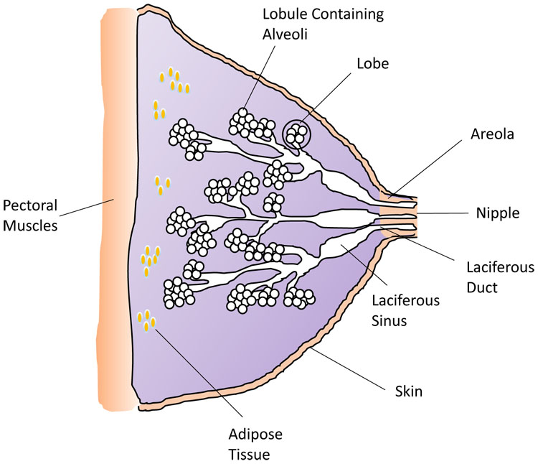

2

Diagram of the breast structure and tissues. (Credit: H Wallace)

***Milk production***

**Prolactin stimulates mammary gland ductal growth, epithelial cell proliferation and induces milk production and secretion**. After parturition, removal of the placenta stimulates a significant drop in progesterone, estrogen, and human placental lactogen,[53](https://www.glowm.com/article/heading/vol-15--the-puerperium--physiology-of-the-puerperium-and-lactation/id/415293#r53) coinciding with an increase in prolactin, cortisol and insulin. Prolactin concentration increases rapidly by the tactile stimulation of the nipple-areolar complex with suckling of the nipple, stimulating nerve endings and subsequent release from the anterior pituitary regulated by the hypothalamus. Suckling, via neural connections, inhibits dopamine secretion which normally inhibits prolactin, thereby removing inhibition to allow increased prolactin secretion and stimulation of milk production.

Prolactin stimulates mammary gland ductal growth, epithelial cell proliferation and induces milk production and secretion. Within the alveoli, milk proteins are packed into secretory vesicles and milk is released into the lumen of the alveoli by exocytosis and budding.[54](https://www.glowm.com/article/heading/vol-15--the-puerperium--physiology-of-the-puerperium-and-lactation/id/415293#r54) Colostrum is the first milk produced by mothers during the first 4 days postpartum, and differs to mature milk in that it has more of an immunological function. It contains high levels of the antibody immunoglobulin A (IgA) and leukocytes, protecting the baby from infection and developmental factors including growth modulators. From day 5, the nutritional constituents of the milk increase and by 2 weeks the main components include protein, fat and lactulose. The milk also contains micronutrients including vitamins A, B and D, and microbiota to aid the establishment of the baby’s initial intestinal microbiome.

***Milk ejection***

**The second mechanism vital to successful lactation is the release of the hormone oxytocin, which is involved in the milk ejection or let down reflex.** The release of oxytocin occurs in a similar way to prolactin, but is mediated by an independent neuroendocrinological pathway (Figure 3). Infant suckling leads to afferent signals to the hypothalamus, which in turn triggers release of oxytocin from the posterior pituitary gland in a pulsatile manner.[12](https://www.glowm.com/article/heading/vol-15--the-puerperium--physiology-of-the-puerperium-and-lactation/id/415293#r12) Oxytocin then travels in the bloodstream and, in turn, stimulates the contractile myoepithelial cells in the alveolus. (Figure 3). The resulting contraction forces milk into the ducts from the alveolar lumens and out through the nipple. Oxytocin can also be released in response to various sensory inputs including hearing a baby cry. It also has a psychological effect, which includes inducing a state of calm, and reducing stress and anxiety. It may also enhance feelings of affection between mother and child, an important factor in bonding.

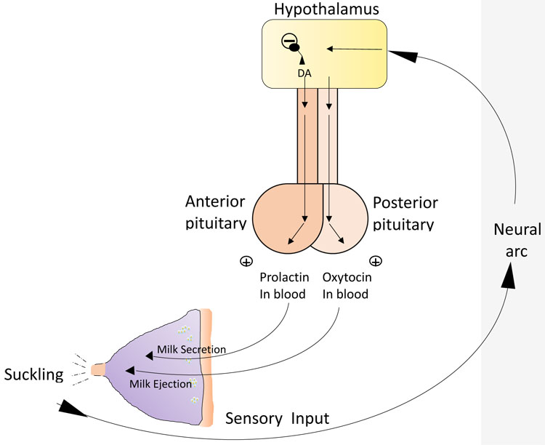

3

Relationship between pituitary hormones and milk secretion and ejection. (Drawing credit: H Wallace)

***Maintenance of lactation***

**Milk expulsion by day 3 is critical for the establishment of successful breastfeeding.**Subsequent regular removal of milk and stimulation of the nipple is essential to maintain the level of milk production. If milk is not removed, accumulation of a feedback inhibitor of lactation will lead to a fall in milk production and will initiate mammary involution. If breast milk is removed, the inhibitor is also removed, and secretion will resume. The physiological significance of the feedback inhibitor is to regulate the volume of milk produced to meet the needs of the baby; this is determined by how much milk the baby takes.

***Pathophysiology and management of breastfeeding***

**Milk ejection can be inhibited by emotional stress**. The process of lactation and breastfeeding can be negatively affected by factors that prevent normal breast development leading to insufficient breast tissue, or the production and/or secretion of milk which may be due to a hormone imbalance for example. For lactation to continue, necessary levels of hormone secretion must be maintained. Inadequate milk production may also be due to inefficient calorie intake to meet demands, and maternal nutrition affects both the quality and quantity of breast milk. The milk ejection reflex can be affected by incorrect fixing and suckling of the nipple or the infant’s inability to latch. Poor attachment or infrequent feeding can lead to breast engorgement and the development of mastitis, causing inflammation and swelling of the nipple which can also become infected.

Milk ejection can be inhibited by the emotional stress of the mother, which explains why the anxiety caused by the desire to breastfeed correctly can have an inhibitory effect. There can also be a perception of insufficient milk supply which, along with pain caused by incorrect suckling, can lead to the mother choosing to stop breastfeeding.[55](https://www.glowm.com/article/heading/vol-15--the-puerperium--physiology-of-the-puerperium-and-lactation/id/415293#r55) This emphasizes the importance of creating a supporting environment for new mothers providing encouragement from the healthcare team.