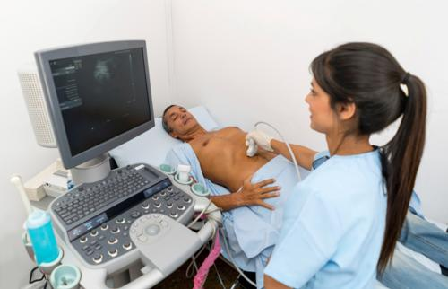

**Ultrasonography**

**المحاضرة الثالثة عشر / تشريح وفسلجه / قسم هندسة الاجهزة الطبية**

**الأستاذ الدكتور خيري عبدالله**

**الجهاز البولي**

**Urinary System / Renal System Organs : Consist of the following organs :**

**Kidneys , Ureters , Urinary bladder , Urethra .**

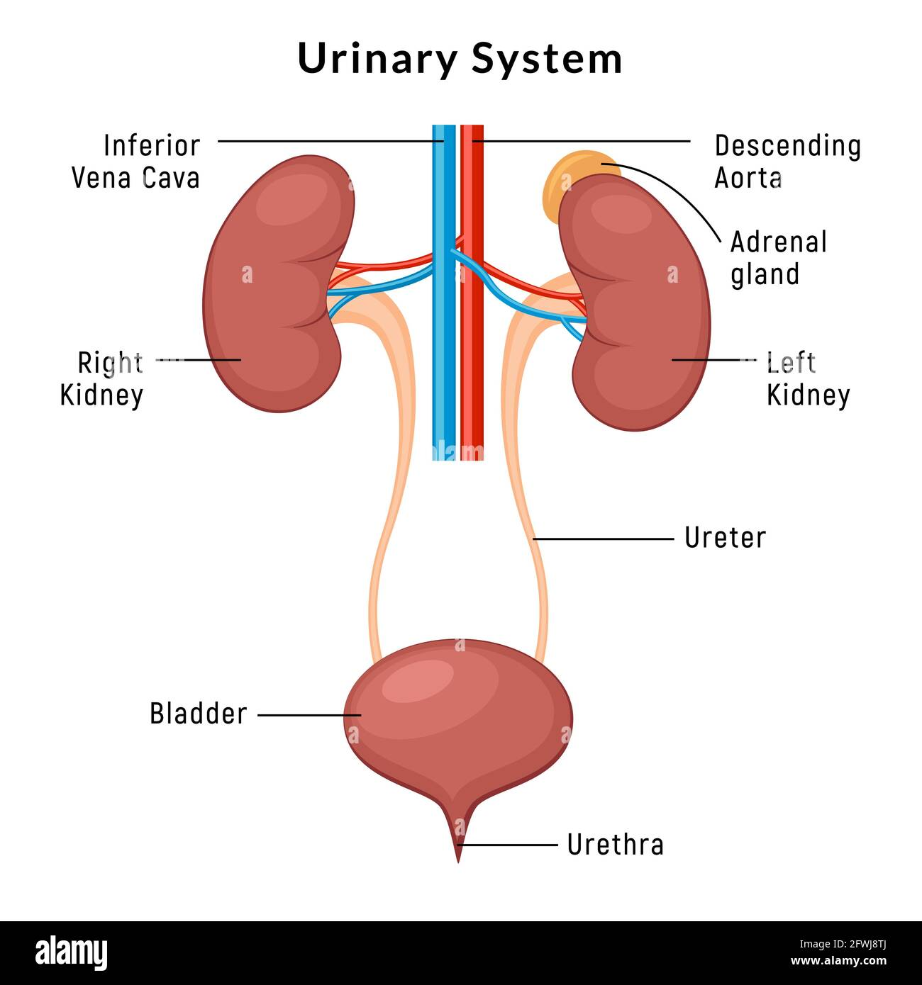

**Functions of Urinary system :**

**1 –Regulate blood volume due to eliminate waste products**

**2 – Regulate blood pressure**

**3 - Regulate the levels of electrolytes and metabolites and control Ph .**

**4 - Get rid of waste such as urea and uric Acid**

**5 - The urinary tract is the body drainage .**

**Kidneys : Anatomy**

**1 - Two reddish bean shaped about 12 cm in length with convex and concave border and surrounded by tough fibrous tissue ( renal capsule ) .**

**2 – Hilum of kidney present in concave border , it is the entrance of Blood supply of kidneys renal arteries and exit of renal veins ) .**

**3 - Cross section of kidney reveal from outside to inside , capsule , Cortex , Medulla , renal pelvis .**

**4 – Each kidney consists of functional units called nephrons about 1 million nephrons in each human kidney**

**5 – Each kidneys is attached to ureter , tubes made of smooth muscle fibers , these ureters connect urinary bladder down ward .**

**6 – Right kidney located lower than level of left kidney .**

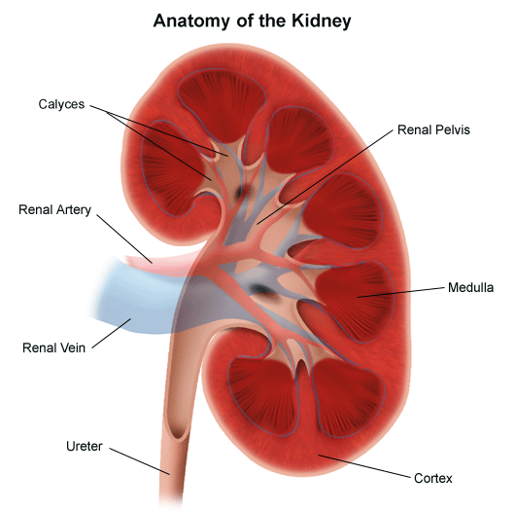



**Physiology of Kidney :**

**1 – Nephrons are the functional unit of kidney .Each kidney contain 1 million nephron .**

**2 – Parts of nephron , glomerulus ( tuft + Bomann’s capsule) , proximal convoluted tubule , loop of Henli , distal convoluted tubule , collecting tubules .**

**3 – Filteration of urine occur in glomerulus , substances which reabsorbed are water , Sodium , bicarbonate , glucose , and amino acids while substances secreted , ammonium , potassium urea and uric acid .**

**urethra is much shorter than male urethra and terminate at the vaginal vestibule .**

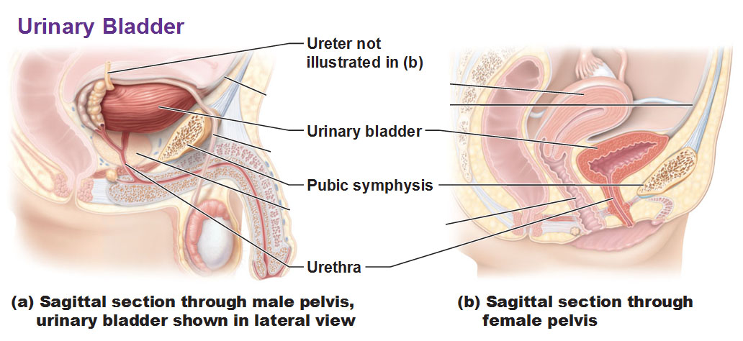

**Ureter : Two long thin tubes connect kidney with urinary bladder , ureters have smooth muscles contract and relax forcing urine downward away from kidneys**

**Urinary bladder : it is a hollow organ , situated at the base of pelvis . urinary bladder store urine from the kidney before dis posal by urination . Urine enters the bladder via the ureters and exists via urethra . It is wall transitional epithelial tissue .**

**Urethra :**

**It begins at the internal urethral orifice of the bladder continue and open at the external urethral orifice , in male urethra pass through prostate gland but in female .**

**Common disease of this System :**

**1 - Nephritis ( inflammation of kidney ) 2 – Glomerulonephritis ( autoimmune disease )**

**3 - Urolethiasis ( renal stone ) .**

**4 - Hematuria ( blood in urine ) .**

**5 - Hyperplasia of Prostate ( retention of urine ) .**

**6 – Tumors**

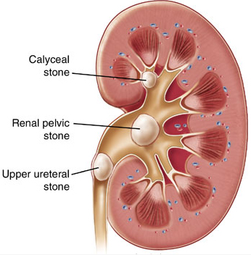

**Renal stone or renal calculi**

**Ultrasonography technique (Ultrasound instrument ) called medical sonar used for diagnosis pregnancy , tumors , calculi .**

