المحاضرة 14
Haemopoietic System , Lymphoid system , Immunity
جهاز الدم / الجهاز اللمفي / المناعه
Haemopoietic system : responsible for blood cell production.
Stem cell : It is a multipotential cell , present in bone marrow . This cell have several abilities :
1 – Give rise different mature blood cells .
2 – Self – renewing and produce 2 daughter cells .
Lymphatic System : produce Lymphocytes ( B – lymphocytes , T – lymphocytes ) produce antibodies and lympokines .
Organs of Lymphatic system (Immune system ) : Bone marrow , Thymus (Primary organs ) , Spleen , lymph nodes ( secondary organs ) .
Organs of Haemopoietic System : Yolk sac , Spleen , Liver , these organs during embryo . / Bone marrow during adult life .
Blood cells are erythrocytes ( Red blood cells ) Leukocytes ( white blood cells ) which is include neutrophils , basophils , eosinophils , Monocytes , Lymphocytes ( B- lymphocytes and T – Lymphocytes ) , then platelates .
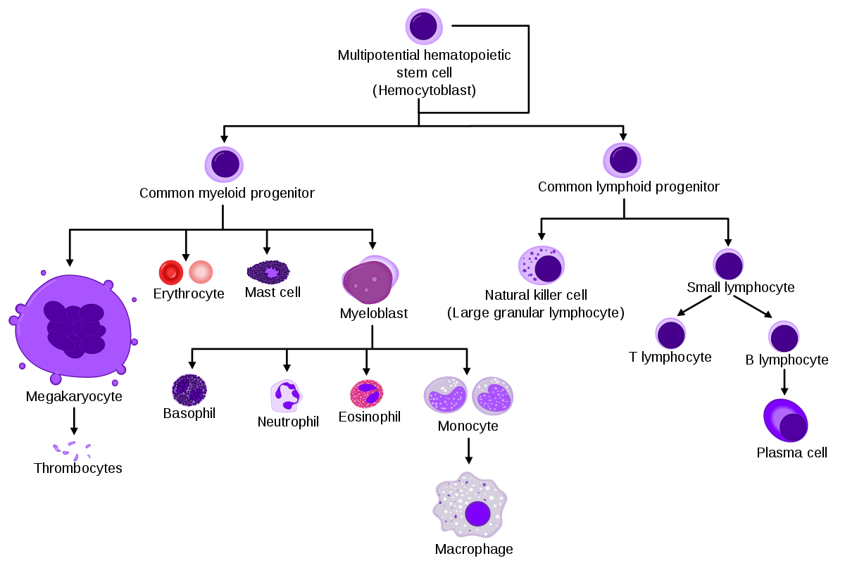

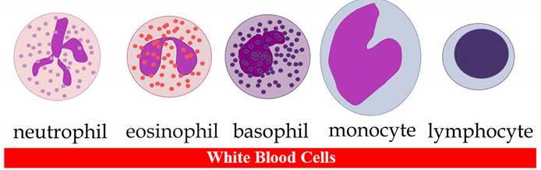
Five types of leukocytes ( white blood cells )
Neutrophil , esinophil , basophil ( Granulated)
Monocytes , Lymphocytes (Nongranulated )
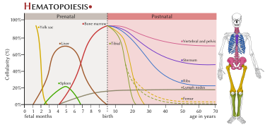

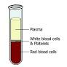
Immunity :
1 -It is ability of human body protect itself against foreign Antigens ( bacteria , viruses , parasites , fungus …. ) ,
2 - These agents stimulate immune cells (B – lymphocytes and T- lymphocytes ) to produce antibodies and lymphokines ( Interleukin , Interferon and prostaglandin ) .
3 – B – Lymphocytes produced from bone marrow and T – Lymphocytes produced from Thymus .

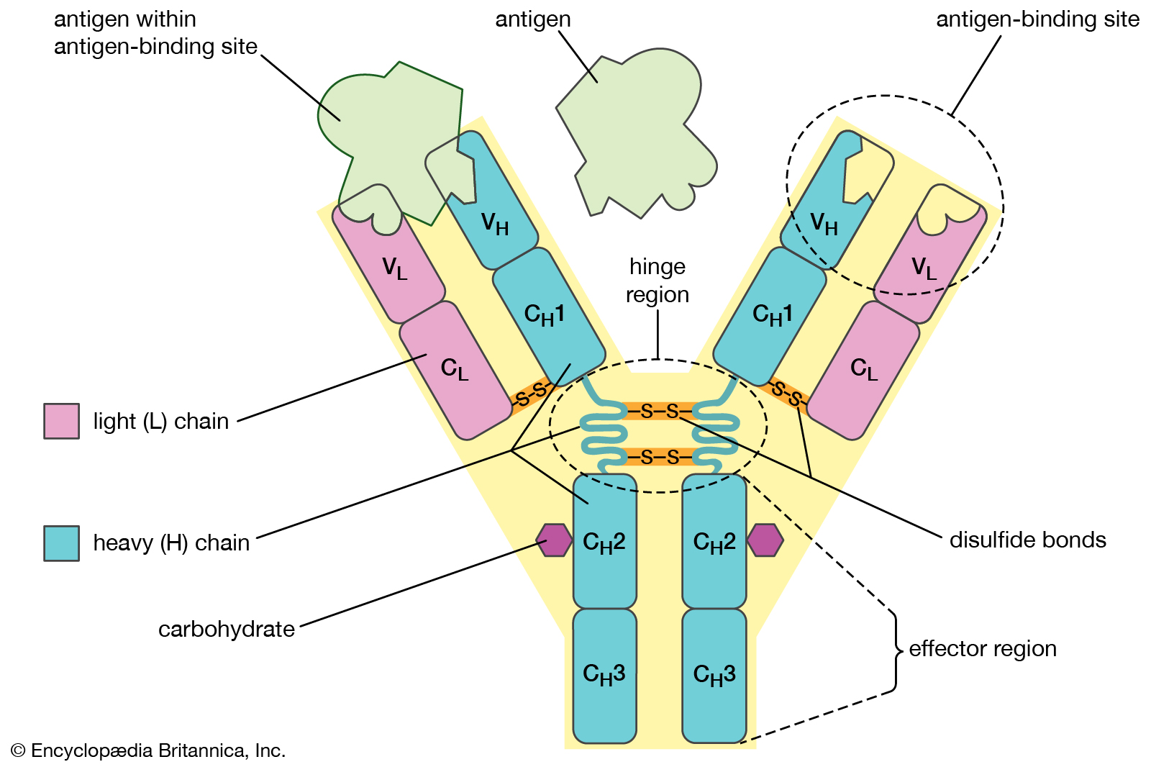

Antibodies ( Immunoglobulin ) : 1 - Antibody molecule is a protein molecule produced from B – lymphocytes in response to stimulation of Antigens .
2 – Antibody molecule is a Y shape formed of amino acids
3 - Consist of two identical heavy chain of immuno- acids and two identical light chain .
4 - Bottom arms called constant region .
5 - Top arms are highly variable region ( Antigen binding sites ) .
Antibodies :
1 - They are grouped ( Five classes ) of immune globulin ( Ig ) : IgG , IgA , IgE , IgM , IgD .
2 - Antibodies are present in blood serum .

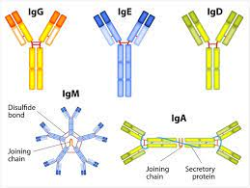
Autoanalyzer : is an automated analyzer using flow technique . Instrument was invented 1957 by leonard Skeggs / used for hematology analyzer ( electric Cell counter )
Leukocytosis , Leukemia
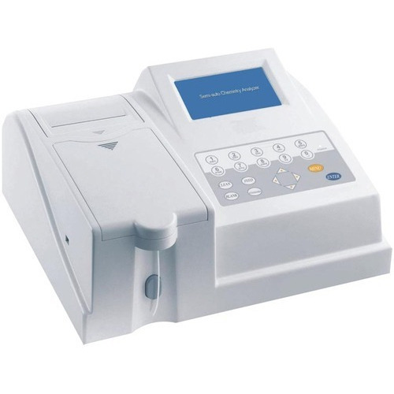

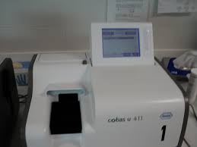
Autoanalyzer :

