**المحاضرة 5 / تشريح /قسم الأجهزة الطبية / تكملة الجهاز الهضمي**

**أ . د . خيري عبدالله داود**

**Lecture five / Anatomy and physiology**

**Digestive system . part two**

**Intestine : small intestine ( part of GIT ) .**

**Structures :**

**1 - Small intestine are divided ; duodenum , Jejunum , Ileum .**

**2 - Length of small intestine 3 – 10 m , while its width 3-4 cm .**

**3 - Wall of small intestine lined by mucous membrane .**

**4 – Mucous membrane have villi and microvilli , therefore its area about 30 sq. m .**

**5 – Mesentery is a membrane , part of peritoneum , arteries , veins , lymph vessels and nerve are travel within mesentery .**

**Functions :**

**1 - Digestion : digestion of stomach chym is completed in duodenum by bile and pancreatic juice ( trypsin , lipase and carbohydrase ) .**

**2 – Absorption : occur by villi and microvilli .**

**3 – Immunological functions : small intestine supports immune system by the presence of gut flora and Peyer’s patches ( lymph nodes ).**

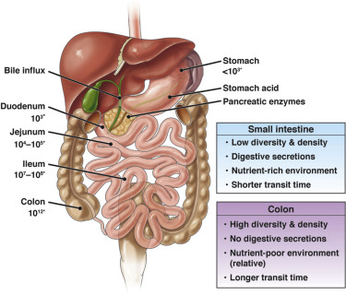

**Large Intestine : parts of large intestine :**

**1 - Cecum and appendix 2 – Ascending colon**

**3 - Transvers colon 4 - Descending colon**

**5 - Sigmoid colon 6 - Rectum**

**Length of large intestine about 1.5 m .**

**Colon connect small intestine with rectum .**

**Colon lined by mucous membrane . This membrane is invaginated forming crypts of colon**

**Functions of colon :**

**Absorption of remaining nutrient , water and vitamins , these vitamins produced by bacteria present in colon**

**Appendix : ( Vestigial organ )**

**1 – Appendix is located at the junction of small intestine with colon .**

**2 – Appendix have blind end , its length 4 inches .**

**3 – Appendix have plenty of lymphocytes (immunological cells)**

**Rectum : Final portion of large intestine , connect sigmoid colon with anal canal , its length 10 – 15 cm .**

**Liver : it is the largest gland In human body , its color reddish brown , 1.5 kg I weight .**

**Gross Anatomy : 1 - liver located In the right upper quadrant of abdominal cavity below diaphragm .**

**2 – Liver divided into two lobes ( right lobe and left lobe ) when viewed above , but if viewed below , there are two lobes between the left and right lobes .**

**3 – Hilum or hilus of the liver ; it is a region of entrance blood vessels , nerve and bile duct .**

**4 – Liver receive blood from hepatic portal vein and hepatic arteries .**

**Microscopic Anatomy : 1 – Each liver lobe is made up of hepatic lobules , hexagonal in shape 7 mm in length .**

**2 - At the center of lobule , central vein , hepatocytes ( liver cells ) radiating from the vein to the periphery of lobule .**

**3 – There are some cell phagocytic cells (Kupffer’s cells ) present between hepatocytes .**

**Functions of the liver :**

**1 – Bile production , produced by hepatocytes and collected by bile ducts and stored in gall bladder .**

**2 – Proteins synthesis in liver cells (Albumin and globulin ).**

**3 – liver store carbohydrate as glycogen .**

**4 – liver cells produce heparin .**

**Gall bladder : it is small hollow organ , pear in shape , it lies below the liver . bile store in gall bladder before release into the duodenum to digest fat . .**

**Pancreas : it is an organ for digestive system and endocrine system ( as exocrine gland and endocrine gland ) .**

**1 - Pancreas secrete enzymes into the duodenum , Lipase digest fat , protease digest proteins , Amylase digest carbohydrates .**

**2 – Pancreas Produce Insulin , hormone control the level of glucose in the blood .**

**This Image Stomach and Pancreas**

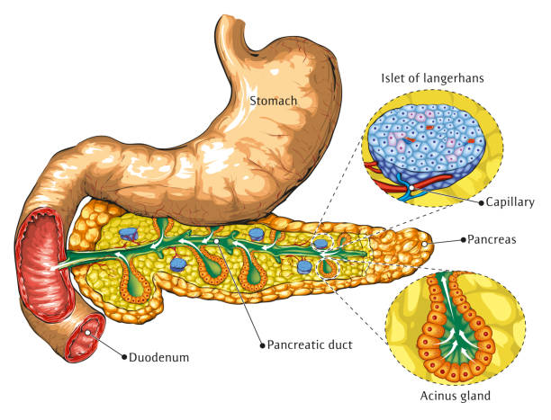

L**aparoscopy of gall bladder / operation with aid of a camera for diagnosis and therapeutic .**

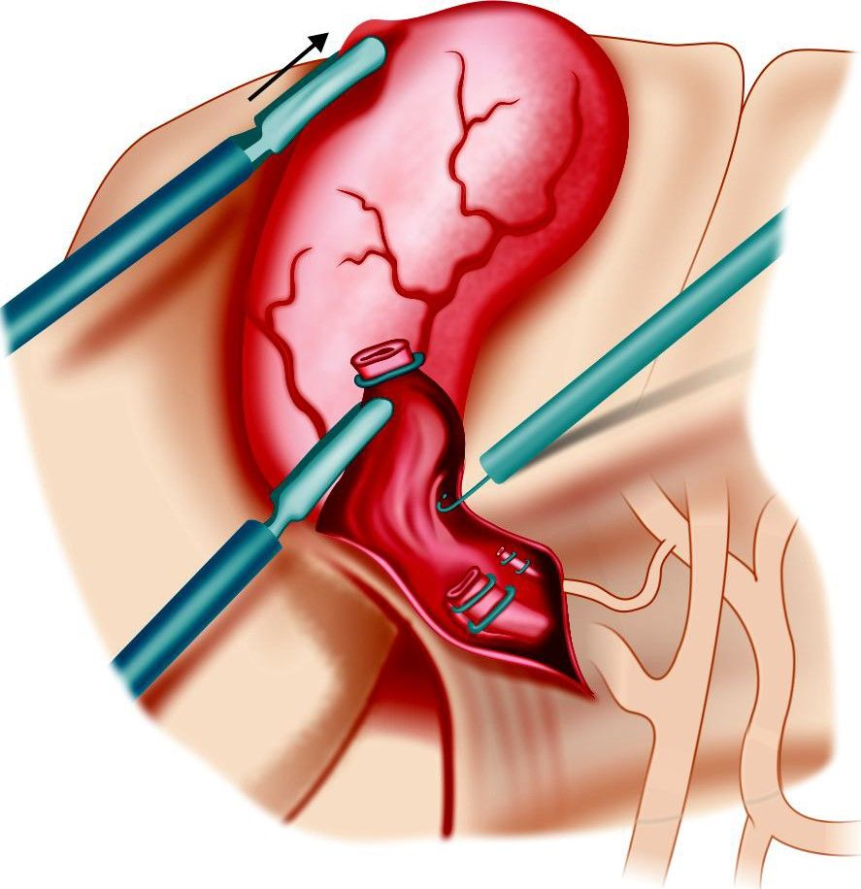

T**umor of Stomach**

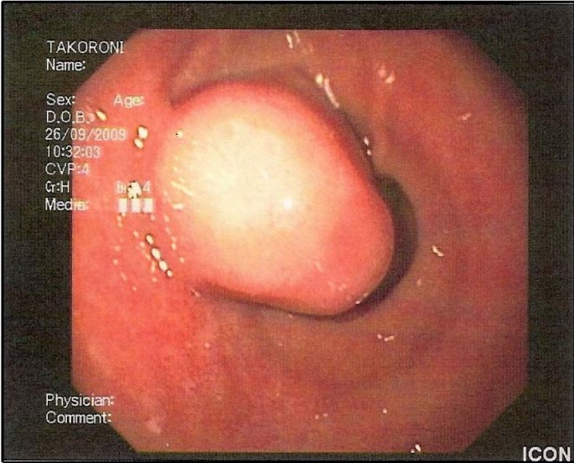

**Ulcer of Stomach**

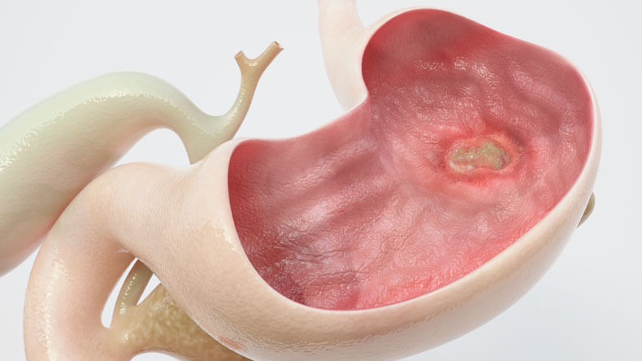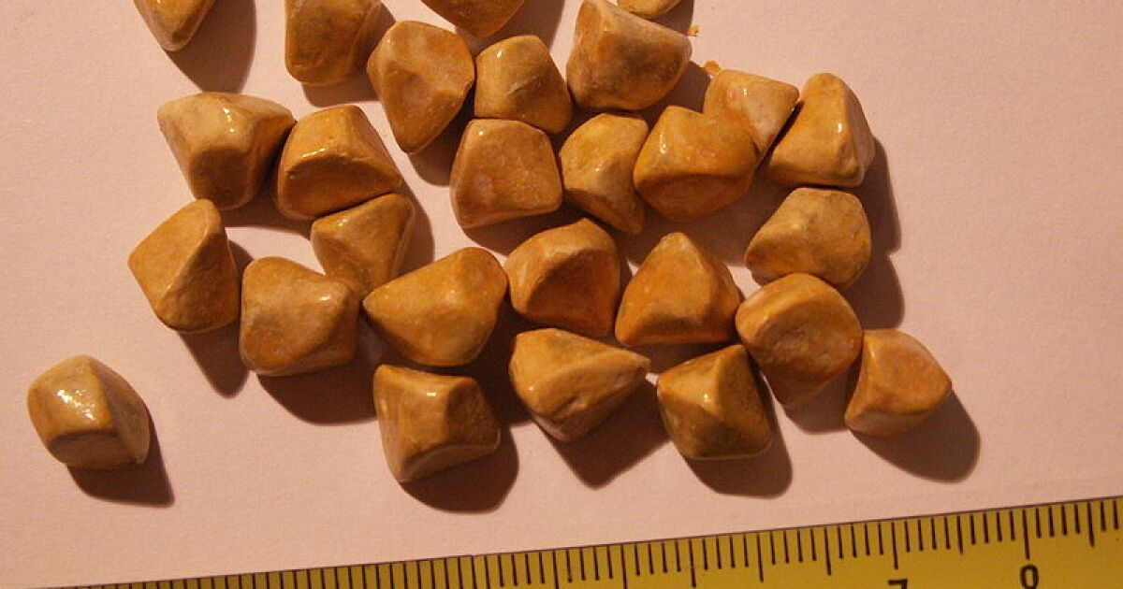

S**tones of gall bladder**