محاضرة ستة عشر / تشريح وفسلجه / قسم هندسة الاجهزة الطبية / مرحله ثانيه
الاستاذ الدكتور خيري عبدالله / جهاز التكاثر
Human Reproductive system
Female and Male Reproductive System
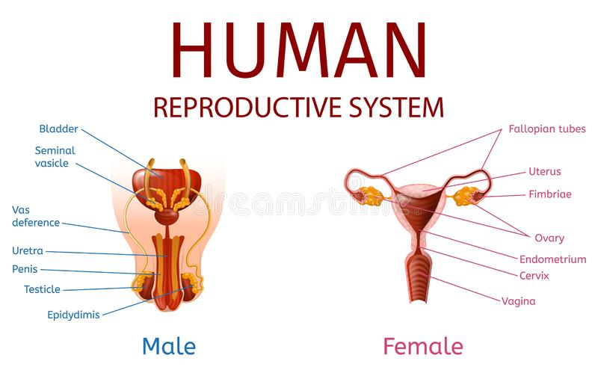
Functions of Reproductive System
1 - Function of male reproductive system , sperm production .
2 - Function of female reproductive system , production of ovum .
3 – Female nourish fetus until birth .
4 – Ovum fertilization occur in the fallopian tube , sperms pass through vagina , cervix , to the uterus , then to the fallopian tube , fertilization occur in Fallopian tube , Zygote produced .
5 - Beginning gestation , zygote implantation --- then pregnancy till birth day .
6 - During Labor ---- muscle of uterus contract --- cervix dilates ( over course of hours ) ---- baby pass out to the vagina .
7 - After birth baby need high level of care , cleaning , feeding ( breast feeding better than formulated milk ) .
Structures :
Male organs outside the body :
1 – Testes are housed in scrotum
2 – Spermatozoa ( immature sperm ) travel through epididymis for development and storage .
3 - Cowper’s gland ( bulbo- urethral gland ) secret lubricant and nourish sperm in urethra .
4 – Seminal vesicles store for sperms .
Female Reproductive organs ( Ovaries , oviducts , Uterus , Cervix , Vagina )present inside the body , in pelvis region (pelvic cavity ) . Breast ( mammary glands ) .
Male hormones , Testosterone and androgen ;
Female hormones , 1 - Estrogen = hormone of ovulation
2 - Progesterone = prepare uterus for pregnancy .
- 400 – 500 eggs ovulated during life of female .
- Conception = means implantation of embryo in the wall of uterus .
- Menstrual cycle about 28 days .

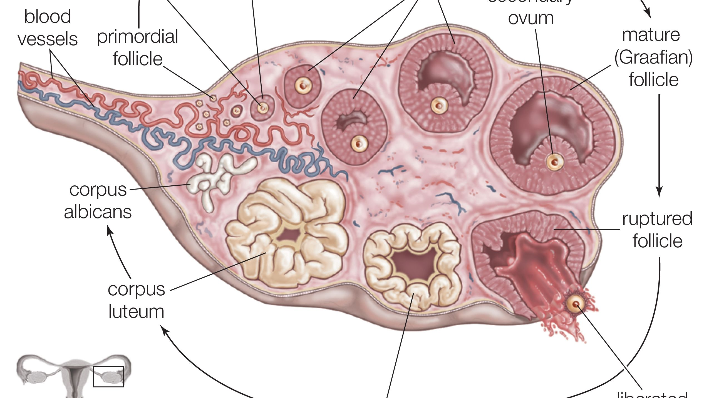

IUD = Intra-uterine device ; used to prevent pregnancy , look to its photo .
