المحاضرة 5 / تشريح /قسم الأجهزة الطبية / تكملة الجهاز الهضمي
أ . د . خيري عبدالله داود
Lecture five / Anatomy and physiology
Digestive system . part two
Intestine : small intestine ( part of GIT ) .
Structures :
1 - Small intestine are divided ; duodenum , Jejunum , Ileum .
2 - Length of small intestine 3 – 10 m , while its width 3-4 cm .
3 - Wall of small intestine lined by mucous membrane .
4 – Mucous membrane have villi and microvilli , therefore its area about 30 sq. m .
5 – Mesentery is a membrane , part of peritoneum , arteries , veins , lymph vessels and nerve are travel within mesentery .
Functions :
1 - Digestion : digestion of stomach chym is completed in duodenum by bile and pancreatic juice ( trypsin , lipase and carbohydrase ) .
2 – Absorption : occur by villi and microvilli .
3 – Immunological functions : small intestine supports immune system by the presence of gut flora and Peyer’s patches ( lymph nodes ).
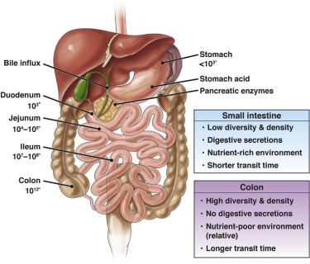

Large Intestine : parts of large intestine :
1 - Cecum and appendix 2 – Ascending colon
3 - Transvers colon 4 - Descending colon
5 - Sigmoid colon 6 - Rectum
Length of large intestine about 1.5 m .
Colon connect small intestine with rectum .
Colon lined by mucous membrane . This membrane is invaginated forming crypts of colon
Functions of colon :
Absorption of remaining nutrient , water and vitamins , these vitamins produced by bacteria present in colon
Appendix : ( Vestigial organ )
1 – Appendix is located at the junction of small intestine with colon .
2 – Appendix have blind end , its length 4 inches .
3 – Appendix have plenty of lymphocytes (immunological cells)
Rectum : Final portion of large intestine , connect sigmoid colon with anal canal , its length 10 – 15 cm .
Liver : it is the largest gland In human body , its color reddish brown , 1.5 kg I weight .
Gross Anatomy : 1 - liver located In the right upper quadrant of abdominal cavity below diaphragm .
2 – Liver divided into two lobes ( right lobe and left lobe ) when viewed above , but if viewed below , there are two lobes between the left and right lobes .
3 – Hilum or hilus of the liver ; it is a region of entrance blood vessels , nerve and bile duct .
4 – Liver receive blood from hepatic portal vein and hepatic arteries .
Microscopic Anatomy : 1 – Each liver lobe is made up of hepatic lobules , hexagonal in shape 7 mm in length .
2 - At the center of lobule , central vein , hepatocytes ( liver cells ) radiating from the vein to the periphery of lobule .
3 – There are some cell phagocytic cells (Kupffer’s cells ) present between hepatocytes .
Functions of the liver :
1 – Bile production , produced by hepatocytes and collected by bile ducts and stored in gall bladder .
2 – Proteins synthesis in liver cells (Albumin and globulin ).
3 – liver store carbohydrate as glycogen .
4 – liver cells produce heparin .
Gall bladder : it is small hollow organ , pear in shape , it lies below the liver . bile store in gall bladder before release into the duodenum to digest fat . .
Pancreas : it is an organ for digestive system and endocrine system ( as exocrine gland and endocrine gland ) .
1 - Pancreas secrete enzymes into the duodenum , Lipase digest fat , protease digest proteins , Amylase digest carbohydrates .
2 – Pancreas Produce Insulin , hormone control the level of glucose in the blood .
This Image Stomach and Pancreas
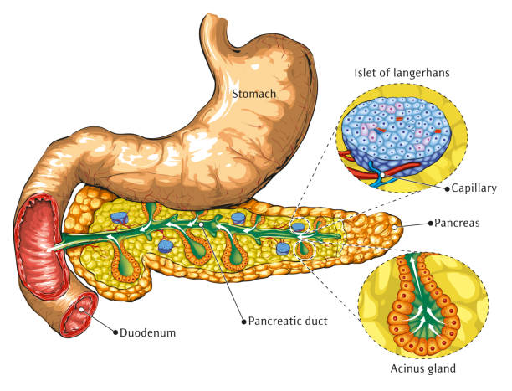
Laparoscopy of gall bladder / operation with aid of a camera for diagnosis and therapeutic .
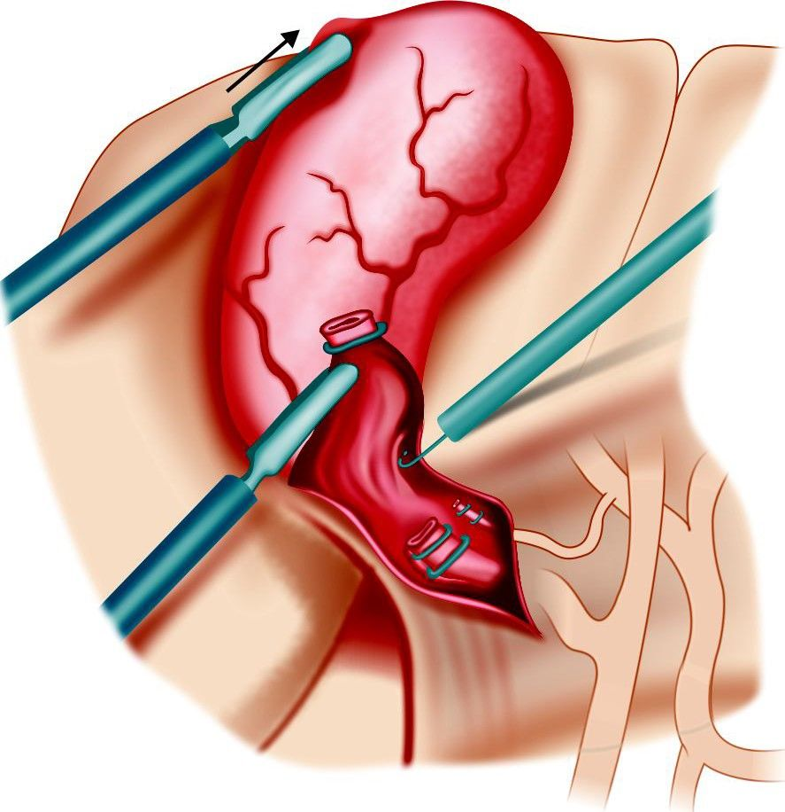

Tumor of Stomach
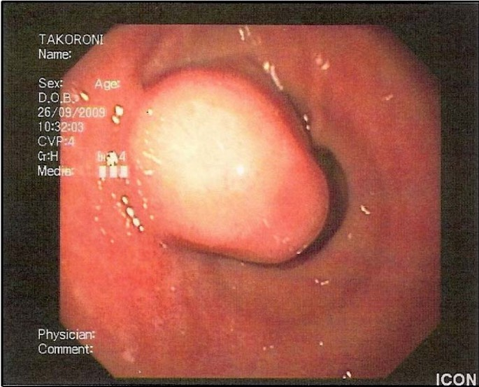

Ulcer of Stomach
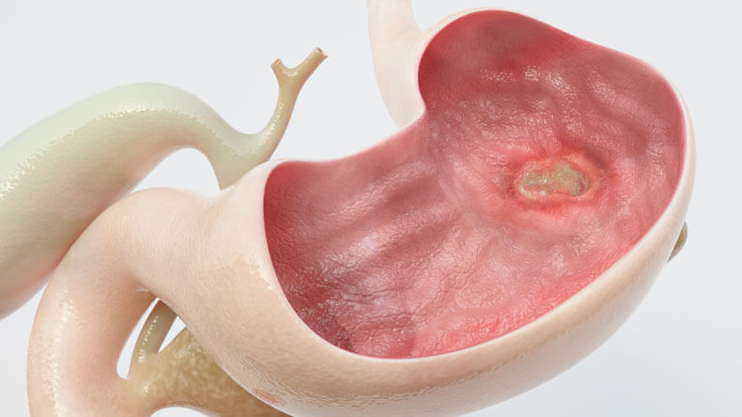

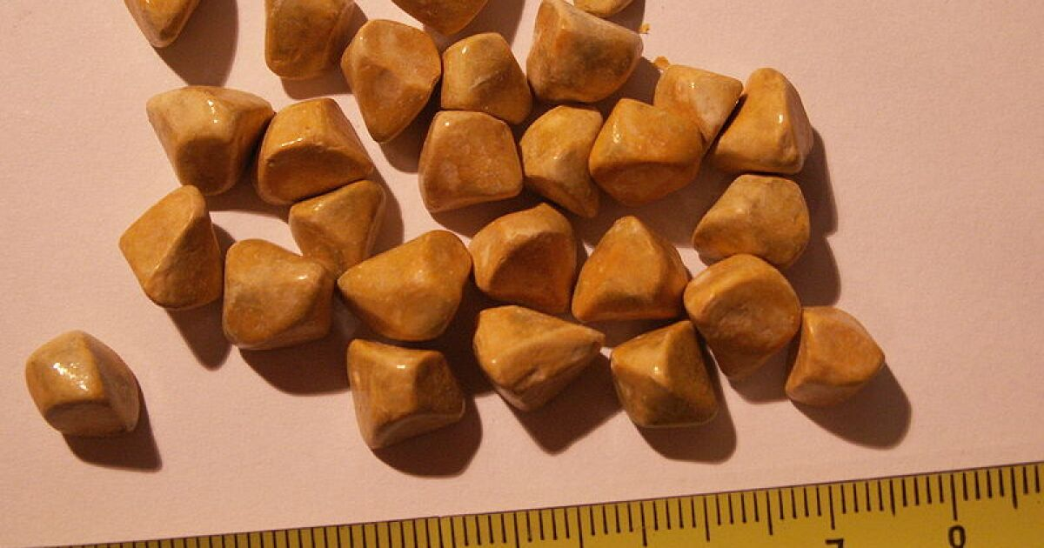
Stones of gall bladder

