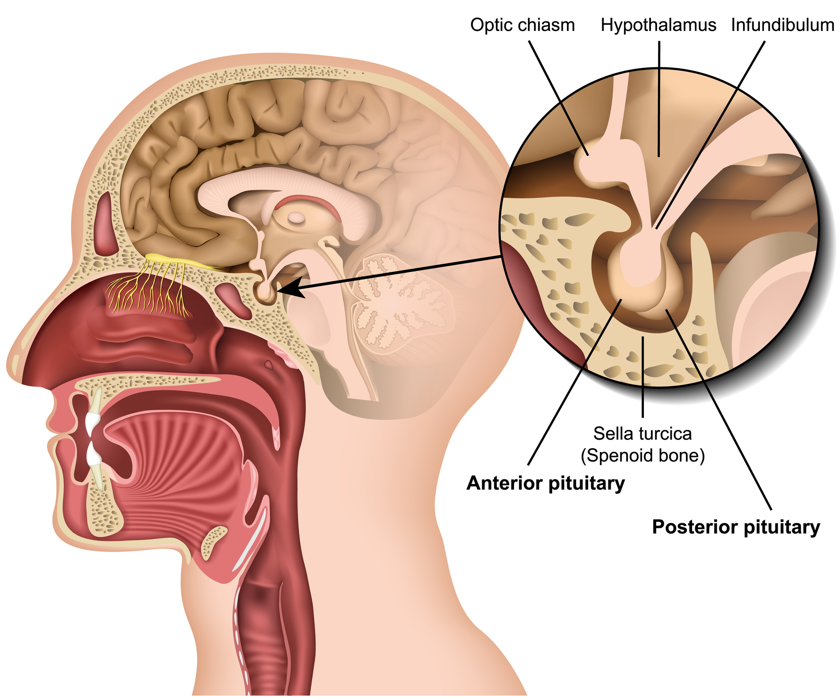المحاضرة 15 / تشريح وفسلجه / مرحلة ثانيه / قسم هندسة الاجهزة الطبية
الاستاذ الدكتور خيري عبدالله الغدد الصماء
Endocrine Glands :
These glands secrete hormones directly into the blood .
Types :
Pituitary gland , Thyroid gland , Parathyroid , Adrenal gland , Pineal gland , Hypothalamus , Pancreas , Ovaries , Testes .
Functions of Endocrine glands :
1 – Produce hormones .
2 – These hormons control growth and development .
3 – Control reproduction .
4 – Control our organs work , metabolism , mood .

Pituitary gland :
Pituitary gland attached to the base of brain in ( sella turcica ) of sphenoid bone , pea size it has two lobes posterior secret two hormones while anterior secret six hormones , four of six regulate the functions of other glands . Hormones of anterior lobe
1 – growth hormone 30 – 50 %
2 – Adrenocorticotropin 20 %
3 – Thyroid stimulating hormone 3-5 %
4 – Lutenizing hormone 3 – 5 % work on ovary
5 – Follicle stimulating hormone 3 – 5 % work on ovary
6 – Prolactin 3 – 5 % stimulate milk production
Hormones of posterior lobe
1 – Vasopressin (regulate urination) 2 - Oxytocin (Love hormone)
3 – Adrenocorticotropin 4 – Melanocyte stimulating hormone
Hypersecretion of growth hormone causes gigantism in children and acromegally in adult . hyposecretion in children cause dwarfism .
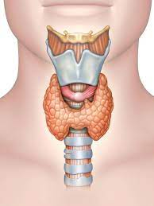

Thyroid gland :
Butterfly shaped organ located at the base of neck .
It release a hormones control on metabolism ( energy ) , regulate body function including breathing , heart beats …….. ?
Thyroid two lobes are connected by bridge called thyroid isthmus .
Microscopically , thyroid gland have functional units called thyroid follicles .
Thyroid gland secrete three hormones :
1 – Thyroxin ( T4 ) 2 – Tri-iodothyronin ( T3 ) 3 – Calcitonin
Enlargment of thyroid gland ( Goiter ) occur due to hypothyroidism ( decrease thyroxin production due to iodine deficiency ) and hyperthyroidism ( increase thyroxin production )
Auto – immune disease occur when thyroxin become as antigen ( Thyrotoxicosis ) , antibodies will produced .
Parathyroid gland :
Small pea shaped ( Cluster of cells ) behind thyroid gland , produce hormone calcitonin reglulate level of Calcium in the blood .
Adrenal Gland : small triangular shaped gland located at the top of kidney .
Adrenal gland produce several hormones that regulate metabolism , immune system , blood pressure .
Cortex of adrenal gland have three layers / outer layer produce oldosterone hormones , middle layer produce cortisol hormones , inner layer produce steroid hormones .
Hormones of adrenal medulla : Adrenalin ( Epinephrine) and
Noradrenalin ( Norepinephrine ) .

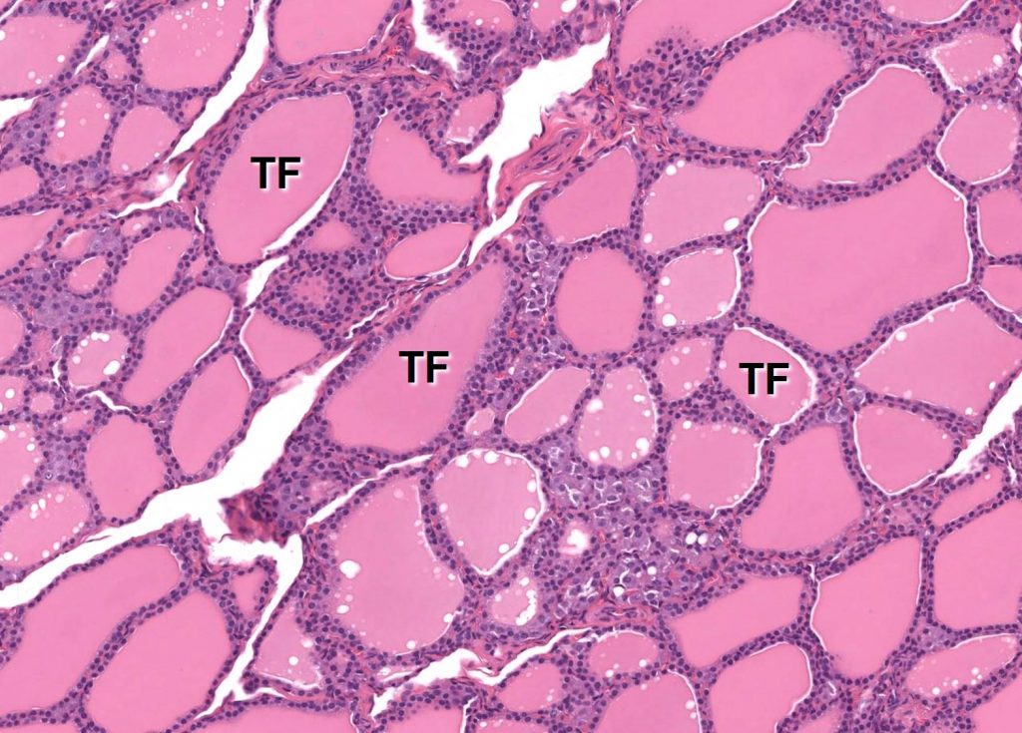

---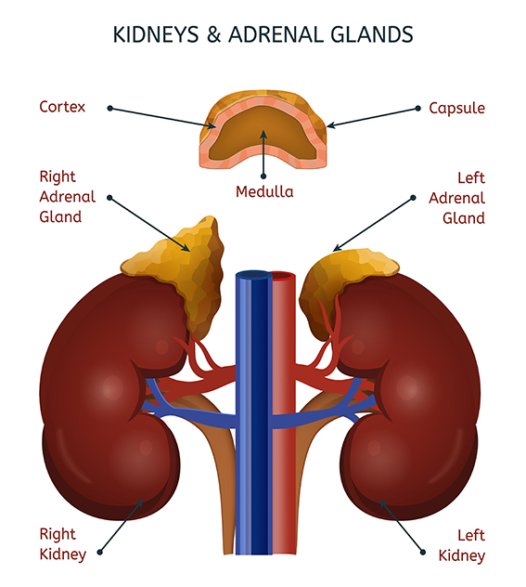
Diagnosis or tests used mostly tumors of thyroid , parathyroid and adrenal gland .
1 – Ultrsound ( sonar ) , 2 – CT scan ( Computerized Tomography )
3 – MRI Magnetic resonance image
4 – Radioactive iodine scan (RAI) for thyroid .
5 - Venous sampling ( for hormones and iodine ) .

