

Al-Mustaqbal University College

Department of Medical Instrumentation

Techniques Engineering- second Class

Subject: Measurements & medical Transducers

By

Dr.Zahraa hashim kareem

Raneen mouad

Sukaina Gassan

Blood Flow and Skin Temperature

Introduction

Homeostasis refers to the body’s ability to maintain internal conditions (e.g., temperature, pH,

hydration) within the narrow limits that are optimal for the continuation of metabolic processes.

When these optimal conditions are disturbed by a change in the environment, body systems work

to return them to normal.

Many of the chemical reactions and cellular processes necessary to sustain human life occur most

readily at a body temperature of approximately 37.0°C (98.6°F). Homeostatic mechanisms work to

maintain this temperature, regardless of changes in the external environment. Changes in

temperature are sensed by the skin, which is well designed to counteract these changes. Beneath

the protective epidermal layer of the skin lies the dermis, which contains sweat and oil glands and a

rich blood supply (see Figure 1)

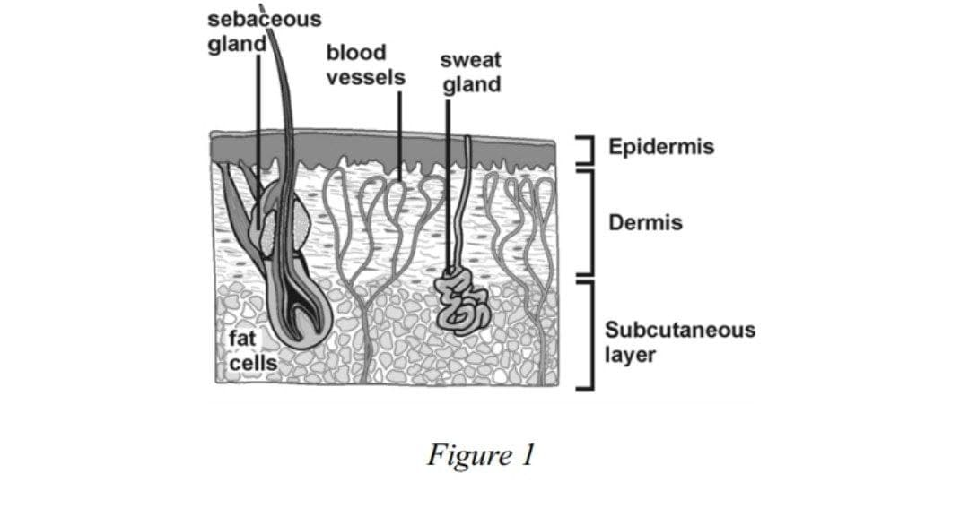

OBJECTIVES

l Compare the rate of recovery from cold in two different skin regions.

l Correlate rate of recovery with vascularity.

MATERIALS

* Chromebook, computer, or mobile device
* Graphical Analysis 4 app
* Go Direct Surface Temperature
* tape
* ice
* soap and water or rubbing alcohol
* towel (paper or cloth)

PROCEDURE

Part I Temperature recovery by skin of upper arm

1. Launch Graphical Analysis. Connect Go Direct Surface Temperature to your Chromebook,

computer, or mobile device.

2. Set up the data-collection mode.

a. Click or tap Mode to open Data Collection Settings.

b. Change End Collection to 120 s.

c. Click or tap Done.

3. Remove excess oil from the skin over the biceps brachii with soap and water or alcohol. Tape

the temperature sensor to the upper arm, over the area of the biceps. Be sure to tape the

thermistor end (the tip) of the sensor directly to the arm (see Figure 2)



Click or tap Collect to start data collection. Collect data for 50 s to obtain a baseline recording

of the temperature. Click or tap Stop to stop data collection after 50 s.

5. Determine the baseline temperature.

a. Examine the graph and identify the region of the graph where the temperature was constant

(baseline reg