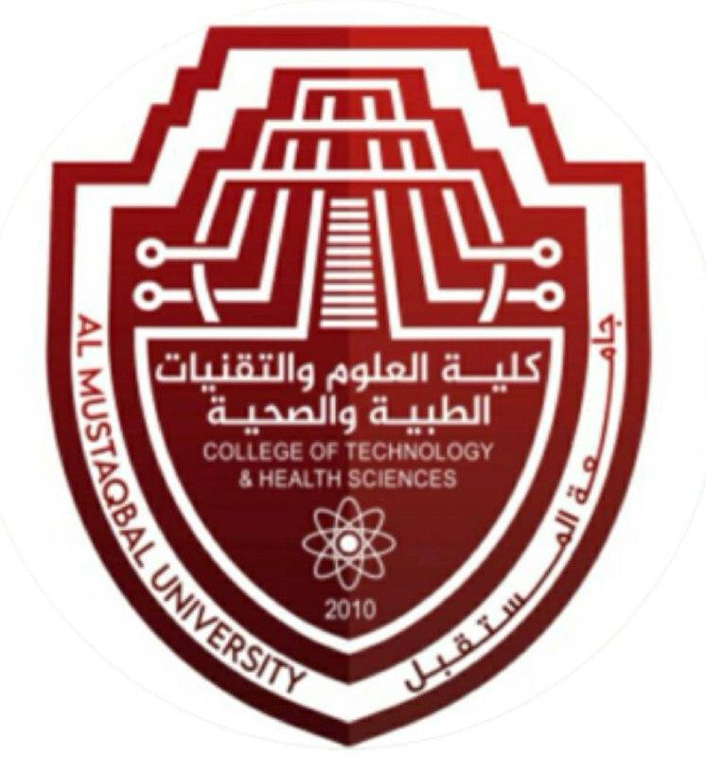 

**Oral Histology**

Prof. Dr.Muna Merza

Lecture 1

**Oral embryology:**

Is the study of the development of the oral cavity, and the structures within it, during the formation and development of the embryo in the first 8 weeks of pregnancy.

**Oral histology:**

is the study of anatomy that deals with the minute structure, composition

and function of the tissues of the teeth, periodontium and the surrounding oral mucosa.

**Development of the face**

After fertilisation of the ovum, a series of cell divisions gives rise to an egg cell mass known as the morula.

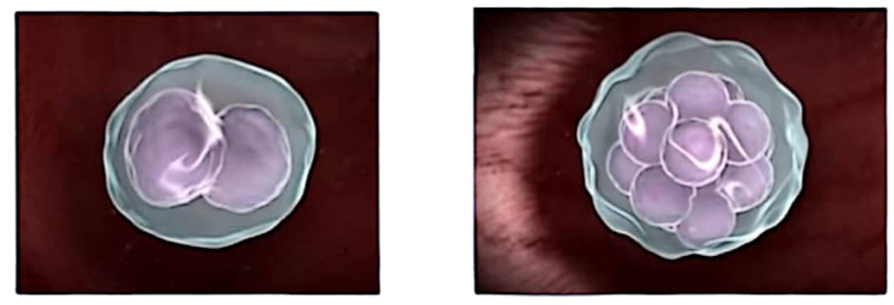

At about 6 days after fertilisation, the inner cell separates into two layers, the mass epiblast and hypoblast

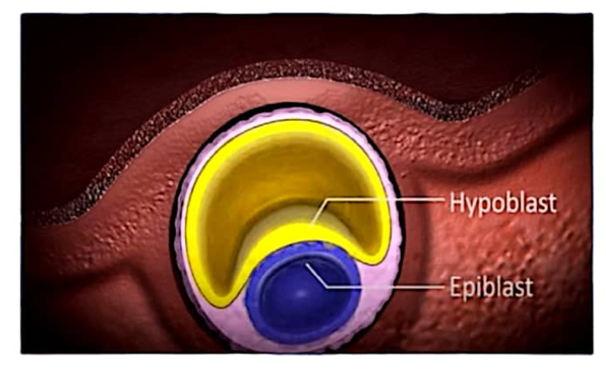

**Second week:**

The epiblast cells then organise themselves into a flat disc (bilaminar disc) two-layered, flattened, essentially circular plate of cells with superior epiblast layer (high columnar cells) and inferior hypoblast layer (small cuboidal cells)

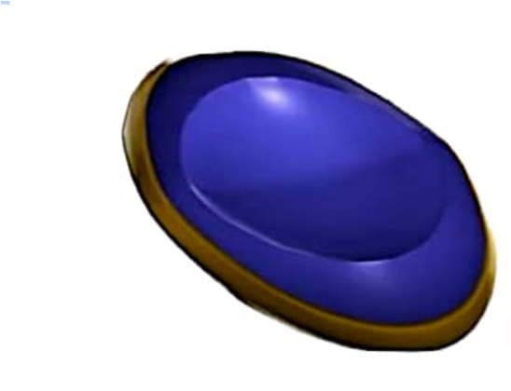

**Third week**

Cells from the epiblast layer migrate between the two layers, becoming mesenchyme, embryonic connective tissue leading to differentiation of the new embryonic layer within the disc from mesenchyme, called mesoderm.

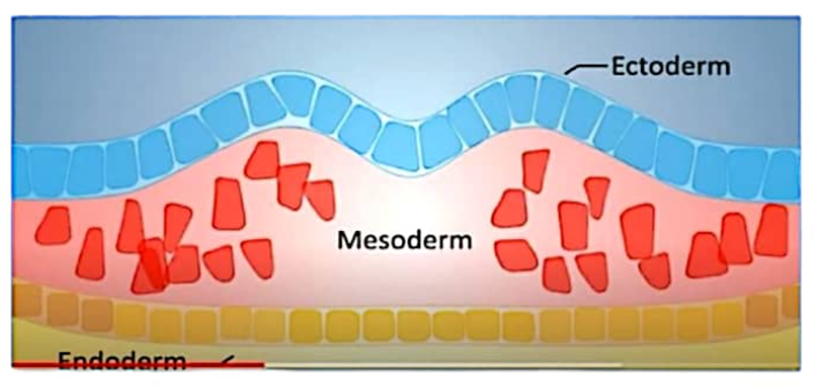

The embryo takes the shape of trilaminar disc, a three-layered disc with epiblast layer now ectoderm and hypoblast layer now endoderm.

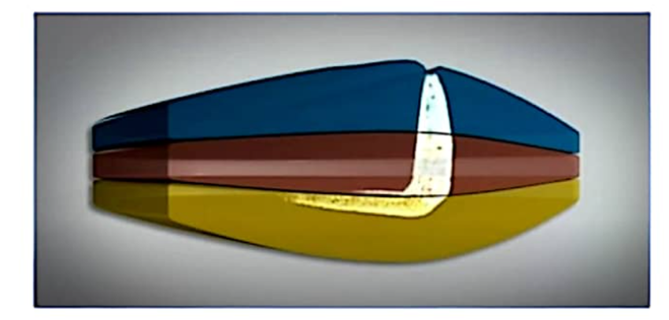

**1. Ectoderm layer- outer layer of cells,**

​​which form the outer skin layer, the sensory cells of the eyes, ears and nose, some of the nervous system and external skin glands

Neuroectoderm cells- specialised cells from the ectoderm layer, and which form connective tissue, cartilage, some bone and some dental tissues.

**2. Mesoderm layer - middle layer of cells,**

which form the deep skin layer, muscle, bone marrow and blood cells, lymphatic system, reproductive organs and excretory organs including the salivary glands.

**3. Endoderm layer - inner layer of cells,** which form the linings of the respiratory and digestive systems, liver and pancreas.